# Instructions on Using Tokens on API

## Step 1: Authenticate using the correct credentials

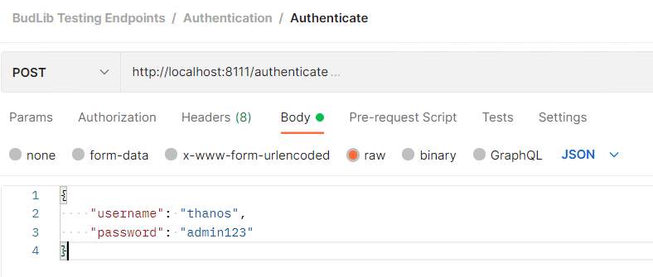

You will see the jwt token as output (different every session):

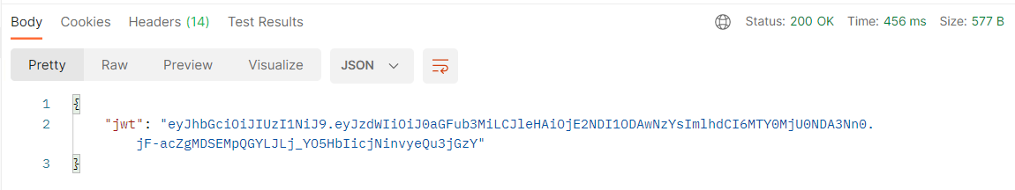

## Step 2: Put token in header

Add an authorization header like in this format:

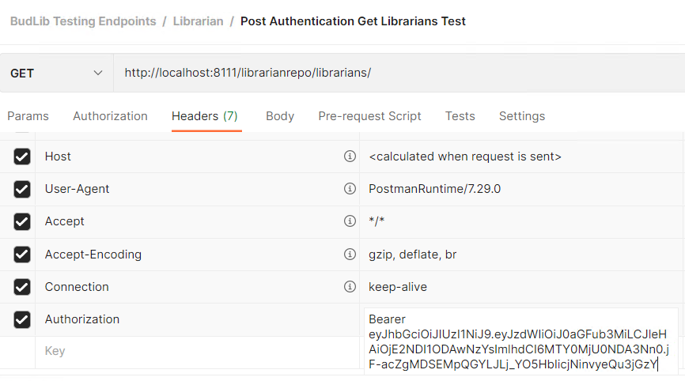

(Note: Might change to remove the word Bearer in next version)

