**Test Report**

**Project: To-Do**

1. ***Purpose***

The purpose of this report is to describe the ongoing testing and analysis of the product

1. ***Application overview***

Is a native application for creating various kinds of notes and to-do list, allowing the user to facilitate some elements of their daily life

1. ***Testing Scope***

In order to maximize efficiency, it was decided to pay special attention to the main functionality of the application, as well as the most necessary performance tests.

1. In scope:

*Functional testing*

creating, edition and deleting tasks  
sorting tasks  
  
*Performance / Stability/ Interrupt testing*

application behavior under different load conditions, background mode, various types of interrupts

minimum tests in installation / UI/UX testing / Globalization / Localization

1. Out of scope:

*Network testing*

*Security testing*

*Stress testing*

*Resources testing*

***4. Metrics***

No. of test cases planned vs executed

No. of test cases passed / failed

| **TC Planned** | **TC Executed** | **TC Passed** | **TC Failed** |
| --- | --- | --- | --- |
| 20 | 21 | 11 | 10 |

passed vs failed

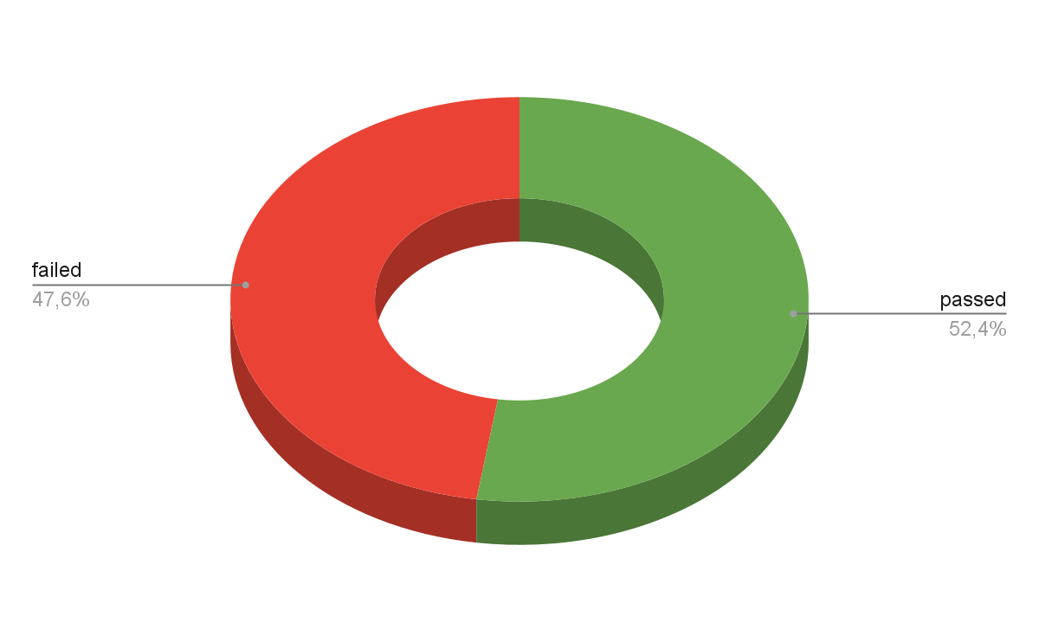

Status and severity bugs

| Severity | Blocker | Critical | Major | Normal | Minor | Total |
| --- | --- | --- | --- | --- | --- | --- |
| Quantity | 1 | 1 | 3 | 3 | 2 | 10 |

***5. Types of testing performed***

Functional testing, performance testing and exploratory testing have been carried out

***6. Test Environment & Tools***

File: Test App.apk

Devices: Samsung A50 4Gb 6.4" 1080x2340 Android 11

Environment: ASF v.2022.2.1

Emulators: Xiaomi Redmi Note 12R Pro 12Gb 6.67" 1080x2400 Android 13

Huawei Nova Lite 2Gb 5" 720x1280 Android 7

***7. Lessons Learnt***

During testing, critical errors and blockers were identified. to avoid such

cases, it is necessary to conduct earlier testing

***8. Recommendations***

After fixing application crashes and critical bugs, it makes sense to automate some frequently repeated tests

***9. Best Practices***

* automate the most repetitive cases
* It makes sense to write scripts to create random tasks using possible valid characters

***10. Exit Criteria***

All test cases should be executed

All defects in Critical, Major, Medium severity should be verified and

closed

Any open defects in trivial severity – Action plan prepared with expected dates

of closure.

***11. Conclusion/Sign Off***

The application is too raw and unfinished.

Not ready to enter the market and present it to a wide audience

Exit criteria not met

***12. Definitions, Acronyms and Abbreviations***

TC - test case

ASF - Android Studio Flamingo