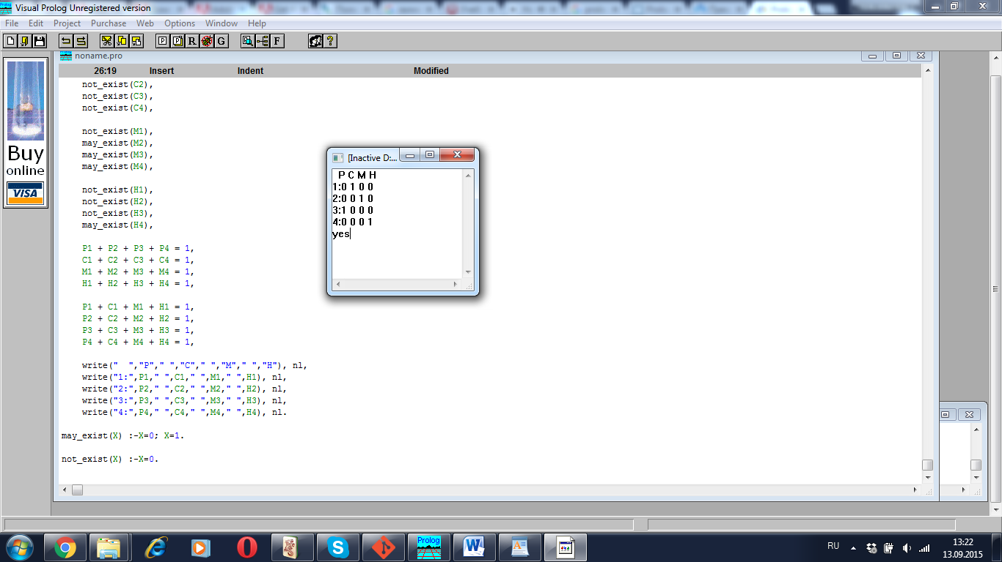

predicates
nondeterm equation
nondeterm may_exist(integer)
nondeterm not_exist(integer)

goal
equation.

clauses
equation:-
may_exist(P1),
may_exist(P2),
may_exist(P3),
not_exist(P4),

may_exist(C1),
not_exist(C2),
not_exist(C3),
not_exist(C4),

not_exist(M1),
may_exist(M2),
may_exist(M3),
may_exist(M4),

not_exist(H1),
not_exist(H2),
not_exist(H3),
may_exist(H4),

P1 + P2 + P3 + P4 = 1,
C1 + C2 + C3 + C4 = 1,
M1 + M2 + M3 + M4 = 1,
H1 + H2 + H3 + H4 = 1,

P1 + C1 + M1 + H1 = 1,
P2 + C2 + M2 + H2 = 1,
P3 + C3 + M3 + H3 = 1,
P4 + C4 + M4 + H4 = 1,

write(" ","P"," ","C"," ","M"," ","H"), nl,
write("1:",P1," ",C1," ",M1," ",H1), nl,
write("2:",P2," ",C2," ",M2," ",H2), nl,
write("3:",P3," ",C3," ",M3," ",H3), nl,
write("4:",P4," ",C4," ",M4," ",H4), nl.

may_exist(X) :-X=0; X=1.

not_exist(X) :-X=0.

