**Lesson 5: Continuity**

After completing this lesson, you should be able to

* discuss continuity at a particular number
* discuss continuity on an interval
* explain theorems on continuity

**Commentary**

**Topics**

1. [Continuity at a Particular Number](https://content.umuc.edu/file/7bdece95-b196-4233-9313-aa904663b08e/1/MATH140-0909.zip/Modules/M2-Module_2/Lesson_5/S3-Commentary.html#I)
2. [Continuity on an Interval](https://content.umuc.edu/file/7bdece95-b196-4233-9313-aa904663b08e/1/MATH140-0909.zip/Modules/M2-Module_2/Lesson_5/S3-Commentary.html#II)
3. [Theorems on Continuity](https://content.umuc.edu/file/7bdece95-b196-4233-9313-aa904663b08e/1/MATH140-0909.zip/Modules/M2-Module_2/Lesson_5/S3-Commentary.html#III)

**1. Continuity at a Particular Number**

**Continuity** means "a coherent whole" or "an interrupted succession or flow." In mathematics, when we use this term, we are referring to a particular behavior of a function. A function is said to be **continuous on an interval** if its graph has no holes, breaks, or jumps. In lesson 3, we identified some functions whose limits as *x*approached *c* could be found by directly substituting *c* into the equation of the function. A function with this quality is said to be **continuous at the point *c***.

Definition 16: Continuity at a Number

A function *f*(*x*) is continuous at *x* = *c*if and only if each of the following conditions is satisfied:

1. *f*(*c*) exists—that is, *c* is in the domain of *f*
2. https://content.umuc.edu/file/7bdece95-b196-4233-9313-aa904663b08e/1/MATH140-0909.zip/Modules/M2-Module_2/Lesson_5/images/limit-x-to-c.gif*f*(*x*) exists—that is, *f*has a limit as *x* → *c*
3. https://content.umuc.edu/file/7bdece95-b196-4233-9313-aa904663b08e/1/MATH140-0909.zip/Modules/M2-Module_2/Lesson_5/images/limit-x-to-c.gif*f*(*x*) = *f*(*c*)—that is, the limit can be found by computing the value of *f* at *c*

A function that does *not* satisfy Definition 16 is said to be **discontinuous at *x*** **= *c***. Geometrically, if the graph of a function can be drawn on an interval with no breaks or gaps, then the function is continuous on that interval.

As indicated in Definition 16, if *f* is continuous at *x* = *c*, there is no "break" in the graph of *f*. In this case, the point (*x*, *f*(*x*)) on the graph of *f* approaches the point (*c*,*f*(*c*)).

**Figure 2.5.1  
Continuous Function *f*(*x*)**

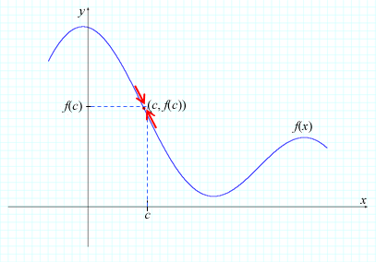

In continuous functions, a small change in *x* results in a small change in *f*(*x*). We can make the change in *f*(*x*) as small as we wish by making the appropriate change in *x*. To better understand continuity and discontinuity, we can apply the definition while considering the graphs of the discontinuous functions at *x* = *c* shown in figures 2.5.2a through 2.5.2d and determining why they are discontinuous.

Figure 2.5.2a shows what happens when condition 1 of Definition 16 fails: *f*(*c*) does not exist (there is a hole in the graph of *f* at *c*).

**Figure 2.5.2a  
*Function Not Continuous*: *f*(*c*) Does Not Exist**

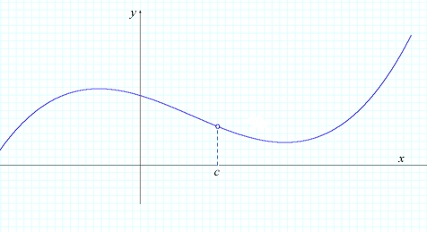

Figure 2.5.2b shows what happens when condition 2 of Definition 16 fails: *f*(*c*) exists; however, lim(*x*→*c*) does not exist (there is a jump in the graph of *f* at *c*).

**Figure 2.5.2b  
*Function Not Continuous*: *f*(*c*) Exists, but lim(*x*→*c*)*f*(*x*) Does Not Exist**

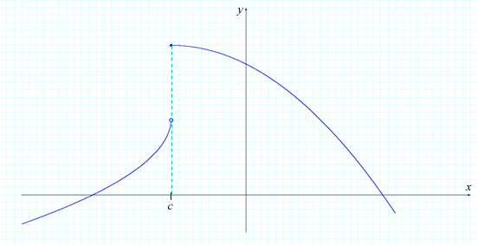

Figure 2.5.2c shows what happens when condition 2 of Definition 16 fails: https://content.umuc.edu/file/7bdece95-b196-4233-9313-aa904663b08e/1/MATH140-0909.zip/Modules/M2-Module_2/Lesson_5/images/limit-x-to-c.gif *f*(*x*) = ∞; therefore, the limit does not exist at *c* (the graph increases without bound at *c*).

**Figure 2.5.2c  
*Function Not Continuous*:*f*(*c*) Does Not Exist at *c* and *f* has an Infinite Limit at *c***

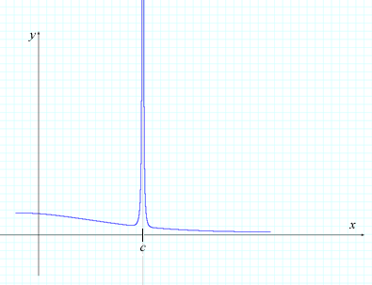

Figure 2.5.2d shows what happens when condition 3 of Definition 16 fails: *f*(*c*) exists and lim *f*(*x*) exists; however, lim(*x*→*c*) *f*(*x*) ≠ *f*(*c*).

**Figure 2.5.2d  
*f*(*c*) and lim *f*(*x*) Exist, but lim(*x*→*c*) *f*(*x*) ≠ *f*(*c*)**

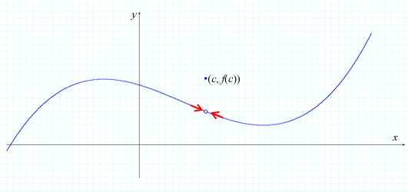

The discontinuity shown in figures 2.5.2a and 2.5.2d is a **removable discontinuity**: we can remove the discontinuity by redefining the function *f* at the point of discontinuity. The discontinuity shown in figure 2.5.2b is a **jump discontinuity**, as the graph of the function has a jump. The graph in figure 2.5.2c shows an **infinite discontinuity**, as the graph has an infinite limit at a point.

**Exercise 2.5.1: Find Discontinuity**

**Problem**

For which values of *x* is the function in figure 2.5.3 discontinuous? Explain your answer.

**Figure 2.5.3  
Values of *x***

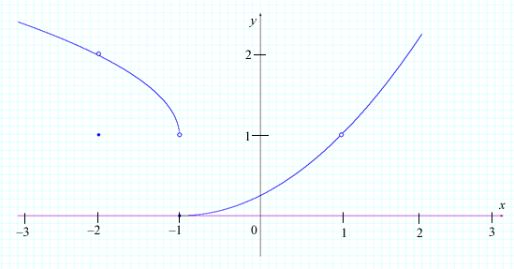

**Solution**

There appears to be a discontinuity at *x* = –2, as there is a "hole" in the graph at (–2, *f*(–2)). The function *f*(*x*) is discontinuous at *x* = –2 because it fails the third condition of the definition.

That is,

https://content.umuc.edu/file/7bdece95-b196-4233-9313-aa904663b08e/1/MATH140-0909.zip/Modules/M2-Module_2/Lesson_5/images/limit-x-to-minus2.gif*f*(*x*) = 2 WHILE *f*(–2) = 1

Therefore,

https://content.umuc.edu/file/7bdece95-b196-4233-9313-aa904663b08e/1/MATH140-0909.zip/Modules/M2-Module_2/Lesson_5/images/limit-x-to-minus2.gif *f*(*x*) ≠ *f*(–2)

There also appears to be a discontinuity at *x* = –1, as there is a break in the graph of *f* at *x* = –1. The function *f*(*x*) is discontinuous at *x* = –1 because it fails the second condition of the definition.

https://content.umuc.edu/file/7bdece95-b196-4233-9313-aa904663b08e/1/MATH140-0909.zip/Modules/M2-Module_2/Lesson_5/images/limit-x-to-1.gif *f*(*x*) does not exist, as https://content.umuc.edu/file/7bdece95-b196-4233-9313-aa904663b08e/1/MATH140-0909.zip/Modules/M2-Module_2/Lesson_5/images/limit-x-to-minus1-pos.gif*f*(*x*) ≠ https://content.umuc.edu/file/7bdece95-b196-4233-9313-aa904663b08e/1/MATH140-0909.zip/Modules/M2-Module_2/Lesson_5/images/limit-x-to-minus1-neg.gif*f*(*x*)

The graph of *f*(*x*) has a "hole" at (1, *f*(1)), and so *f*(1) does not exist. According to the first condition of the definition, as *f*(1) does not exist, *f* is not continuous at *x* = 1.

Definition 17: Right-Side Continuity

A function *f*(*x*) is **right-side continuous** at *x* = *c* if and only if

https://content.umuc.edu/file/7bdece95-b196-4233-9313-aa904663b08e/1/MATH140-0909.zip/Modules/M2-Module_2/Lesson_5/images/limit-x-to-c-plus.gif *f*(*x*) = *f*(*c*)

Definition 18: Left-Side Continuity

A function *f*(*x*) is **left-side continuous**at *x* = *c* if and only if

https://content.umuc.edu/file/7bdece95-b196-4233-9313-aa904663b08e/1/MATH140-0909.zip/Modules/M2-Module_2/Lesson_5/images/limit-x-to-c-minus.gif *f*(*x*) = *f*(*c*)

**Exercise 2.5.2: Show Continuity I**

**Problem**

Suppose *f*(*x*) = https://content.umuc.edu/file/7bdece95-b196-4233-9313-aa904663b08e/1/MATH140-0909.zip/Modules/M2-Module_2/Lesson_5/images/Math140-mo2-lessn5-ex2-5-2-prob.gif, where https://content.umuc.edu/file/7bdece95-b196-4233-9313-aa904663b08e/1/MATH140-0909.zip/Modules/M2-Module_2/Lesson_5/images/open-brackt-x.gifdenotes the greatest integer less than or equal to *x*. Show that *f* is right-side continuous and *not* left-side continuous.

**Solution**

Figure 2.5.4 shows the graph of *f*:

**Figure 2.5.4  
Graph of *f***

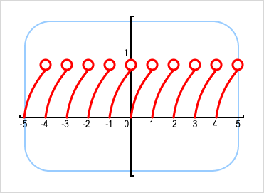

Let *k* be an integer. Then,

https://content.umuc.edu/file/7bdece95-b196-4233-9313-aa904663b08e/1/MATH140-0909.zip/Modules/M2-Module_2/Lesson_5/images/limit-x-to-k-plus.gif *f*(*x*) = 0 = *f*(*k*)

however,

https://content.umuc.edu/file/7bdece95-b196-4233-9313-aa904663b08e/1/MATH140-0909.zip/Modules/M2-Module_2/Lesson_5/images/limit-x-to-k-minus.gif *f*(*x*) = 1 ≠ *f*(*k*)

Now, we will move on to continuity of a function on an interval.

**2. Continuity on an Interval**

We will start with the definitions for continuity of a function *f*(*x*) on an interval.

Definition 19

A function *f* is **continuous on an open interval (*a*, *b*)** if it is continuous at every point *c* in the interval.

Definition 20

A function *f* is **continuous on a closed interval [*a*, *b*]** if it is continuous at every point *c* in the open interval (*a*, *b*), and if

https://content.umuc.edu/file/7bdece95-b196-4233-9313-aa904663b08e/1/MATH140-0909.zip/Modules/M2-Module_2/Lesson_5/images/limit-x-to-a-plus.gif *f*(*x*) = *f*(*a*) AND https://content.umuc.edu/file/7bdece95-b196-4233-9313-aa904663b08e/1/MATH140-0909.zip/Modules/M2-Module_2/Lesson_5/images/limit-x-to-b-minus.gif *f*(*x*) =*f*(*b*)

**Note This**

|  |  |
| --- | --- |
| https://content.umuc.edu/file/7bdece95-b196-4233-9313-aa904663b08e/1/MATH140-0909.zip/Modules/M2-Module_2/Lesson_5/images/NoteThisIcon.png | If a function *f* is continuous on the interval (–∞, ∞), then we say that *f* is continuous, and do not need to say that *f* is continuous everywhere. |

**Exercise 2.5.3: Show Continuity II**

**Problem**

Show that the function https://content.umuc.edu/file/7bdece95-b196-4233-9313-aa904663b08e/1/MATH140-0909.zip/Modules/M2-Module_2/Lesson_5/images/Math140-mo2-lessn5-ex2-5-3-prob.giffrom Exercise 2.4.3 is continuous on the closed interval [0, 6].

**Solution**

First, we need to show that *f* is continuous for all numbers *c* in the interval (0, 6). We suppose that *c* is a number so that 0 < *c* < 6, and we apply the Theorem 1 and Theorem 2 Limit Principles to the following:

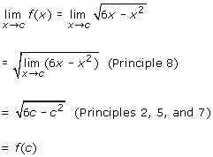

**Figure 2.5.5  
*f* for all Numbers *c* in (0, 6)**

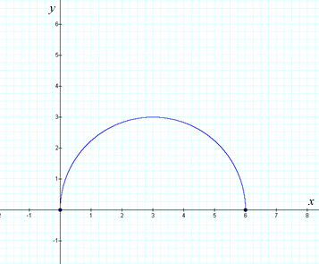

According to Definition 16, *f*(*x*) is continuous at *c* if *c* lies in the open interval (0, 6).

Similarly, we can show that *f*(*x*) is right-side continuous at 0:

https://content.umuc.edu/file/7bdece95-b196-4233-9313-aa904663b08e/1/MATH140-0909.zip/Modules/M2-Module_2/Lesson_5/images/limit-x-to-0-plus.gif *f*(*x*) = 0 = *f*(0)

and that *f*(*x*) is left-side continuous at 6:

https://content.umuc.edu/file/7bdece95-b196-4233-9313-aa904663b08e/1/MATH140-0909.zip/Modules/M2-Module_2/Lesson_5/images/limit-x-to-6-minus.gif *f*(*x*) = 0 = *f*(6)

Hence, according to Definition 20, *f*(*x*) is continuous on [0, 6].

Now that we have determined what we mean by *continuity*, we are ready for some theorems on continuity.

**3. Theorems on Continuity**

The definitions for continuous functions provided above are one set of tools we can use to determine the continuity of functions. The following theorems are also very useful in the study of continuity. We will start with the Theorem on the Principles of Continuous Functions.

Theorem 10: Principles of Continuous Functions

Let *f* and *g* be continuous at *c*. The following functions are then also continuous at *c*:

|  |  |
| --- | --- |
| 1. Sum Principle: | *f* + *g* |
| 2. Difference Principle: | *f* – *g* |
| 3. Product Principle: | *fg* |
| 4. Quotient Principle: | *f*/*g*, if*g*(*c*) ≠ 0 |
| 5. Constant Multiple Principle: | *rf*, for any constant *r* |
| 6. Power Principle: | *fn*, if *f*is defined on an open interval containing *c* for any natural number *n* |

**Proof:** Let *f* and *g* be continuous at *c*. Then,

https://content.umuc.edu/file/7bdece95-b196-4233-9313-aa904663b08e/1/MATH140-0909.zip/Modules/M2-Module_2/Lesson_5/images/limit-x-to-c.gif*f*(*x*) = *f*(*c*) AND https://content.umuc.edu/file/7bdece95-b196-4233-9313-aa904663b08e/1/MATH140-0909.zip/Modules/M2-Module_2/Lesson_5/images/limit-x-to-c.gif*g*(*x*) = *g*(*c*)

Consider,

https://content.umuc.edu/file/7bdece95-b196-4233-9313-aa904663b08e/1/MATH140-0909.zip/Modules/M2-Module_2/Lesson_5/images/limit-x-to-c.gif(*f* + *g*)(*x*) = https://content.umuc.edu/file/7bdece95-b196-4233-9313-aa904663b08e/1/MATH140-0909.zip/Modules/M2-Module_2/Lesson_5/images/limit-x-to-c.gif[*f*(*x*) + *g*(*x*)]

= https://content.umuc.edu/file/7bdece95-b196-4233-9313-aa904663b08e/1/MATH140-0909.zip/Modules/M2-Module_2/Lesson_5/images/limit-x-to-c.gif*f*(*x*) + https://content.umuc.edu/file/7bdece95-b196-4233-9313-aa904663b08e/1/MATH140-0909.zip/Modules/M2-Module_2/Lesson_5/images/limit-x-to-c.gif*g*(*x*) (Theorem 10 Principle 1)

= *f*(*c*) + *g*(*c*) = (*f* + *g*)(*c*)

As we have shown that https://content.umuc.edu/file/7bdece95-b196-4233-9313-aa904663b08e/1/MATH140-0909.zip/Modules/M2-Module_2/Lesson_5/images/limit-x-to-c.gif(*f* + *g*)(*x*) = (*f* + *g*)(*c*), we have demonstrated that the function *f* + *g* is continuous at *c*.

**Note This**

|  |  |
| --- | --- |
| https://content.umuc.edu/file/7bdece95-b196-4233-9313-aa904663b08e/1/MATH140-0909.zip/Modules/M2-Module_2/Lesson_5/images/NoteThisIcon.png | The six Principles of Continuous Functions have similar proofs that follow directly from the Theorem 1 Limit Principles in lesson 3. |

According to Definitions 19 and 20 and Theorem 1, if *f* and *g* are continuous *on an interval*, then the following functions are also continuous on an interval: *f* + *g*, *f* – *g*, *fg*, *f*/*g* (provided *g* is not 0 on the interval), *rf*, and *fn* (provided *f* is defined on an open interval containing *c*). Theorem 11 below follows directly from Theorem 2, given in lesson 3.

Theorem 11: Continuity of Polynomials

Suppose *p*(*x*) is a polynomial. Then *p*(*x*) is continuous.

**Note This**

|  |  |
| --- | --- |
| https://content.umuc.edu/file/7bdece95-b196-4233-9313-aa904663b08e/1/MATH140-0909.zip/Modules/M2-Module_2/Lesson_5/images/NoteThisIcon.png | Theorem 11 states that all polynomials are continuous everywhere. Another way to state this is that any polynomial *p*(*x*) is continuous on *R* = (–∞, ∞). |

**Proof:** Let *p*(*x*) be a polynomial. Then, *p*(*x*) = *anxn* + *an*– 1*xn*– 1 + ... + *a*1*x* + *a*, where *an*, *an*– 1, ... , *a*1, *a* are constants.

Consider the limit:

https://content.umuc.edu/file/7bdece95-b196-4233-9313-aa904663b08e/1/MATH140-0909.zip/Modules/M2-Module_2/Lesson_5/images/limit-x-to-c.gif*p*(*x*) = https://content.umuc.edu/file/7bdece95-b196-4233-9313-aa904663b08e/1/MATH140-0909.zip/Modules/M2-Module_2/Lesson_5/images/limit-x-to-c.gif*anxn* + *an*– 1*xn*– 1 + ... + *a*1*x* + *a*

= https://content.umuc.edu/file/7bdece95-b196-4233-9313-aa904663b08e/1/MATH140-0909.zip/Modules/M2-Module_2/Lesson_5/images/limit-x-to-c.gif(*anxn*) + https://content.umuc.edu/file/7bdece95-b196-4233-9313-aa904663b08e/1/MATH140-0909.zip/Modules/M2-Module_2/Lesson_5/images/limit-x-to-c.gif(*an*– 1*xn*– 1) + ... + https://content.umuc.edu/file/7bdece95-b196-4233-9313-aa904663b08e/1/MATH140-0909.zip/Modules/M2-Module_2/Lesson_5/images/limit-x-to-c.gif(*a*1*x*) + https://content.umuc.edu/file/7bdece95-b196-4233-9313-aa904663b08e/1/MATH140-0909.zip/Modules/M2-Module_2/Lesson_5/images/limit-x-to-c.gif*a* (Theorem 2 Principle 1)

=*an*https://content.umuc.edu/file/7bdece95-b196-4233-9313-aa904663b08e/1/MATH140-0909.zip/Modules/M2-Module_2/Lesson_5/images/limit-x-to-c.gif*xn* + *an*– 1https://content.umuc.edu/file/7bdece95-b196-4233-9313-aa904663b08e/1/MATH140-0909.zip/Modules/M2-Module_2/Lesson_5/images/limit-x-to-c.gif*xn*– 1 + ... + *a*1https://content.umuc.edu/file/7bdece95-b196-4233-9313-aa904663b08e/1/MATH140-0909.zip/Modules/M2-Module_2/Lesson_5/images/limit-x-to-c.gif*x* + https://content.umuc.edu/file/7bdece95-b196-4233-9313-aa904663b08e/1/MATH140-0909.zip/Modules/M2-Module_2/Lesson_5/images/limit-x-to-c.gif*a* (Theorem 2 Principle 5)

= *an* (*c*)*n* + *an*– 1 (*c*)*n*– 1 + ... + *a*1 (*c*) + *a* (Theorem 2 Principles 7 and 6)

= *p*(*c*)

As we have shown that https://content.umuc.edu/file/7bdece95-b196-4233-9313-aa904663b08e/1/MATH140-0909.zip/Modules/M2-Module_2/Lesson_5/images/limit-x-to-c.gif*p*(*x*) = *p*(*c*), we have proven that polynomials are continuous.

Although the above proof is instructional, we could also directly apply Theorem 5 (Substitution Property for Polynomials), given in lesson 3, to show that all polynomials *p*(*x*) are continuous.

Theorem 12 below follows directly from Theorem 3.

Theorem 12: Continuity of Rational Functions

If *p*(*x*) and *q*(*x*) are polynomials, then

https://content.umuc.edu/file/7bdece95-b196-4233-9313-aa904663b08e/1/MATH140-0909.zip/Modules/M2-Module_2/Lesson_5/images/px-or-qx.gif is continuous on its domain (*q*(*c*) ≠ 0)

**Note This**

|  |  |
| --- | --- |
| https://content.umuc.edu/file/7bdece95-b196-4233-9313-aa904663b08e/1/MATH140-0909.zip/Modules/M2-Module_2/Lesson_5/images/NoteThisIcon.png | Theorem 12 holds that all rational functions are continuous wherever the denominator is not zero. Another way to state this is that every rational function *p*(*x*)/*q*(*x*) is continuous on its domain. |

**Proof:** Let *p*(*x*) and *q*(*x*) be polynomials, and consider the rational function https://content.umuc.edu/file/7bdece95-b196-4233-9313-aa904663b08e/1/MATH140-0909.zip/Modules/M2-Module_2/Lesson_5/images/px-or-qx.gif. According to Theorem 12, *p*(*x*) and *q*(*x*) are continuous, and according to Theorem 10 (Principle 4), the function https://content.umuc.edu/file/7bdece95-b196-4233-9313-aa904663b08e/1/MATH140-0909.zip/Modules/M2-Module_2/Lesson_5/images/px-or-qx.gif is continuous wherever *q*(*c*) ≠ 0.

**Exercise 2.5.4: Find Continuity I**

**Problem**

Where is the function *f*(*x*) = https://content.umuc.edu/file/7bdece95-b196-4233-9313-aa904663b08e/1/MATH140-0909.zip/Modules/M2-Module_2/Lesson_5/images/x-ovr-x-sq-minus1.gif continuous?

**Solution**

According to Theorem 12, the function *f*(*x*) is continuous wherever the denominator is not zero. That is, *f* is continuous wherever *x*2– 1 ≠ 0 (i.e., wherever *x*≠ –1 or *x*≠ 1). Hence, *f* is continuous for all *x* so that *x*≠ –1 or *x* ≠ 1.

The following theorem helps us to make quick observations on the continuity of certain kinds of functions.

Theorem 13: Categories of Continuous Functions

The following types of functions are continuous at every number in their domain:

1. polynomials
2. rational functions
3. exponential and logarithmic functions
4. root functions
5. trigonometric functions

**Note This**

|  |  |
| --- | --- |
| https://content.umuc.edu/file/7bdece95-b196-4233-9313-aa904663b08e/1/MATH140-0909.zip/Modules/M2-Module_2/Lesson_5/images/NoteThisIcon.png | The functions listed in Theorem 13 are examples, and do not make up an exhaustive list of categories of continuous functions. |

**Exercise 2.5.5: Find Continuity II**

**Problem**

Where are the following functions continuous?

1. *p*(*x*) = *x*2007 + 2*x*1966 – 8*x*70 + 13
2. *R*(*x*) = https://content.umuc.edu/file/7bdece95-b196-4233-9313-aa904663b08e/1/MATH140-0909.zip/Modules/M2-Module_2/Lesson_5/images/Math140-mo2-lessn5-ex2-5-5b-prob.gif
3. *f*(*x*) = 2*x*
4. *g*(*x*) = https://content.umuc.edu/file/7bdece95-b196-4233-9313-aa904663b08e/1/MATH140-0909.zip/Modules/M2-Module_2/Lesson_5/images/sqrt-of-x.gif + ln(*x* – 1) – https://content.umuc.edu/file/7bdece95-b196-4233-9313-aa904663b08e/1/MATH140-0909.zip/Modules/M2-Module_2/Lesson_5/images/Math140-mo2-lessn5-ex2-5-5d-prob.gif
5. *h*(*x*) = sin *x* + cos *x*

**Solution**

1. According to Theorem 11, the polynomial *p* is continuous on (–∞, ∞).
2. According to Theorem 12, the rational function*R* is continuous on its domain *D* = {*x* | *x*2 – 4 ≠ 0} = {*x* | *x* ≠ ±2}. Hence, *g* is continuous on the intervals (–∞, –2) ∪ (–2, 2) ∪ (2, ∞).
3. According to Theorem 13, the exponential function *f*(*x*) = 2*x* is continuous on its domain, which is (–∞, ∞).
4. Consider *g*(*x*) = *a*(*x*) + *b*(*x*) + *c*(*x*), where *a*(*x*) = https://content.umuc.edu/file/7bdece95-b196-4233-9313-aa904663b08e/1/MATH140-0909.zip/Modules/M2-Module_2/Lesson_5/images/sqrt-of-x.gif, *b*(*x*) = ln(*x* – 1), and *c*(*x*) = https://content.umuc.edu/file/7bdece95-b196-4233-9313-aa904663b08e/1/MATH140-0909.zip/Modules/M2-Module_2/Lesson_5/images/Math140-mo2-lessn5-ex2-5-5d-prob.gif. According to Theorem 13,

*a*(*x*) = https://content.umuc.edu/file/7bdece95-b196-4233-9313-aa904663b08e/1/MATH140-0909.zip/Modules/M2-Module_2/Lesson_5/images/sqrt-of-x.gif is continuous on the interval [0, ∞)

Also, according to Theorem 13, *b*(*x*) is a logarithmic function. It is continuous for all numbers in the domain *x* – 1 > 0. That is,

*b*(*x*) = ln(*x* – 1) is continuous on the interval (1, ∞)

Theorem 13 tells us that

*c*(*x*) is continuous on the intervals (–∞, 3) ∪ (3, ∞)

In applying Theorem 10 (Principles 1 and 2), we find that the function *g*(*x*) = *a*(*x*) + *b*(*x*) – *c*(*x*) =https://content.umuc.edu/file/7bdece95-b196-4233-9313-aa904663b08e/1/MATH140-0909.zip/Modules/M2-Module_2/Lesson_5/images/sqrt-of-x.gif + ln(*x* – 1) –https://content.umuc.edu/file/7bdece95-b196-4233-9313-aa904663b08e/1/MATH140-0909.zip/Modules/M2-Module_2/Lesson_5/images/Math140-mo2-lessn5-ex2-5-5d-prob.gif is continuous on the intervals (1, 3) ∪(3, ∞).

1. According to Theorem 13, the trigonometric functions sin *x* and cos *x* are continuous on their domain, which is (–∞, ∞). Therefore, according to Theorem 10 (Principle 1), sin *x* + cos *x* is continuous on (–∞, ∞).

The theorems given below help us extend our ability to determine continuity of functions.

Theorem 14

Let *f* be continuous at *L* and lim(*x*→*c*) *g*(*x*) = *L*. Then,

lim(*x*→*c*)*f*(*g*(*x*)) = *f*(lim(*x*→*c*)*g*(*x*)) = *f*(*L*)

Theorem 14 says that, if *f* is continuous at the number *L*, and *g*(*x*) → *L*, then, as *x* → *c* gives *g*(*x*) → *L*, we have *f*(*g*(*x*)) → *f*(*L*). Intuitively, this is reasonable: if *x* is near *c*, then *g*(*x*) is near *L*; because *f* is continuous at *L*, if *g*(*x*) is close to *L*, then *f*(*g*(*x*)) is close to *f*(*L*). Theorem 13 allows us to bring the limit *inside* if *f* is continuous.

**Exercise 2.5.6: Find a Limit**

**Problem**

Find https://content.umuc.edu/file/7bdece95-b196-4233-9313-aa904663b08e/1/MATH140-0909.zip/Modules/M2-Module_2/Lesson_5/images/limit-x-to-1.gif *h*(*x*), where *h*(*x*) = https://content.umuc.edu/file/7bdece95-b196-4233-9313-aa904663b08e/1/MATH140-0909.zip/Modules/M2-Module_2/Lesson_5/images/Math140-mo2-lessn5-ex2-5-6-prob.gif.

**Solution**

Observe that *h*(*x*) = *f*(*g*(*x*)), where *g*(*x*) = *x*3 – 1 and *f*(*x*) = https://content.umuc.edu/file/7bdece95-b196-4233-9313-aa904663b08e/1/MATH140-0909.zip/Modules/M2-Module_2/Lesson_5/images/3-cubed-x.gif.

First, *g* is continuous on (–∞, ∞), as*g*is a polynomial and *f* is continuous on (–∞, ∞).

Because *f*is continuous,

https://content.umuc.edu/file/7bdece95-b196-4233-9313-aa904663b08e/1/MATH140-0909.zip/Modules/M2-Module_2/Lesson_5/images/limit-x-to-1.gif *f*(*g*(*x*)) = *f*(https://content.umuc.edu/file/7bdece95-b196-4233-9313-aa904663b08e/1/MATH140-0909.zip/Modules/M2-Module_2/Lesson_5/images/limit-x-to-1.gif*g*(*x*)) (Theorem 13)

Because *g* is continuous,

*f*(https://content.umuc.edu/file/7bdece95-b196-4233-9313-aa904663b08e/1/MATH140-0909.zip/Modules/M2-Module_2/Lesson_5/images/limit-x-to-1.gif*g*(*x*)) = *f*(*g*(1))

Therefore,

lim(*x*→ 1) *f*(*g*(*x*)) = *f*(*g*(1)) = *h*(1) = https://content.umuc.edu/file/7bdece95-b196-4233-9313-aa904663b08e/1/MATH140-0909.zip/Modules/M2-Module_2/Lesson_5/images/Math140-mo2-lessn5-ex2-5-6-prob.gif = 0

Theorem 15: Continuity of Composite Functions

Let *g* be continuous at *c*, and let *f* be continuous at *g*(*c*). The composite function *f* ◦ *g* is continuous at *c*. That is,

https://content.umuc.edu/file/7bdece95-b196-4233-9313-aa904663b08e/1/MATH140-0909.zip/Modules/M2-Module_2/Lesson_5/images/limit-x-to-c.gif(*f* ◦ *g*)(*x*) = (*f* ◦ *g*)(*c*)

**Proof:** Let *g* be continuous at *c* and let *f* be continuous at *g*(*c*), and consider the limit of the composite function:

https://content.umuc.edu/file/7bdece95-b196-4233-9313-aa904663b08e/1/MATH140-0909.zip/Modules/M2-Module_2/Lesson_5/images/limit-x-to-c.gif (*f* ◦ *g*)(*x*) = https://content.umuc.edu/file/7bdece95-b196-4233-9313-aa904663b08e/1/MATH140-0909.zip/Modules/M2-Module_2/Lesson_5/images/limit-x-to-c.gif*f*(*g*(*x*))

= *f*(https://content.umuc.edu/file/7bdece95-b196-4233-9313-aa904663b08e/1/MATH140-0909.zip/Modules/M2-Module_2/Lesson_5/images/limit-x-to-c.gif*g*(*x*)), according to Theorem 14, as *f* is continuous at *g*(*c*)

= *f*(*g*(*c*)), as*g*is continuous at *c*, https://content.umuc.edu/file/7bdece95-b196-4233-9313-aa904663b08e/1/MATH140-0909.zip/Modules/M2-Module_2/Lesson_5/images/limit-x-to-c.gif*g*(*x*) = *g*(*c*)

= (*f* ◦ *g*)(*c*)

As we have shown that https://content.umuc.edu/file/7bdece95-b196-4233-9313-aa904663b08e/1/MATH140-0909.zip/Modules/M2-Module_2/Lesson_5/images/limit-x-to-c.gif(*f* ◦ *g*)(*x*) = (*f* ◦ *g*)(*c*), we have proven that the composite function (*f*◦*g*) is continuous at *c*.

**Exercise 2.5.7: Find Continuity III**

**Problem**

Where is *h*(*x*) = sin(2*x* + 1) continuous?

**Solution**

Observe *h*(*x*) = *f*(*g*(*x*)), where

*g*(*x*) = 2*x* + 1 AND *f*(*x*) = sin *x*

The function*g*is continuous on (–∞, ∞) because it is a polynomial (linear equation), and *f* is continuous on (–∞, ∞) because there is no restriction on the domain of *f*(*x*) = sin *x*.

Hence, according to Theorem 15, *h* = *f* ◦ *g* is continuous on (–∞, ∞).

The next theorem is an important result that follows naturally from our understanding of continuity.

Theorem 16: Intermediate Value Theorem

Suppose *f* is continuous on the closed interval [*a*, *b*], and *y* is any number between *f*(*a*) and *f*(*b*), where *f*(*a*) ≠ *f*(*b*). There then exists a number *c* in the open interval (*a*, *b*) such that *f*(*c*) = *y*.

The Intermediate Value Theorem states that a continuous function on [*a*, *b*] must take on *every* value between *f*(*a*) and *f*(*b*) at least once. Geometrically, the theorem states that the graph of *f* cannot skip or jump over a horizontal line *y* = *y* that lies between *y* = *f*(*a*) and *y* = *f*(*b*).

Intuitively, this makes sense, as we think of continuous functions as functions whose graphs do not have a break, jump, or hole. A function can take on a given value *y*once (see figure 2.5.6a) or more than once (see figure 2.5.6b). Although Theorem 16 is fairly intuitive, the proof of it is fairly advanced, and beyond the scope of this course.

**Figure 2.5.6a**

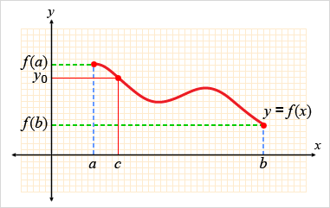

**Figure 2.5.6b**

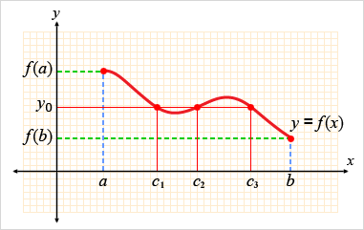

We call a solution *x* to *f*(*x*) = 0 a **zero of the function *f***. One immediate and useful application of Theorem 16 is to locate the zeros of functions. The Intermediate Value Theorem tells us that if *f* is continuous, any interval on which *f* changes sign contains a zero of the function *f*. Consider the following exercise.

**Exercise 2.5.8: Use the Intermediate Value Theorem**

**Problem**

Let *p*(*x*) = *x*5 – 3*x*4 + 2*x* – 1. Use the Intermediate Value Theorem to show that there is a zero of the polynomial *p*(*x*) in the interval (2, 3).

**Solution**

We need to show that there exists a number *c* in the interval (2, 3) such that *p*(*c*) = 0.

First, we note that *p* is a polynomial, and is therefore continuous.

Now, by letting *y* = 0 and *a* = 2, *b* = 3, we can consider

*p*(2) = –13 < 0

*p*(3) = 5 > 0

*p*(2) < 0 < *p*(3), and so *y* = 0 is a number between *p*(2) and *p*(3). Hence, according to the Intermediate Value Theorem, there exists a number *c* in the interval (2, 3) such that *p*(*c*) = 0.

[*Return to top of page*](https://content.umuc.edu/file/7bdece95-b196-4233-9313-aa904663b08e/1/MATH140-0909.zip/Modules/M2-Module_2/Lesson_5/S3-Commentary.html#pagetop)

[**Report broken links or any other problems on this page.**](http://help.umuc.edu/)  
  
[**Copyright © by University of Maryland University College.**](https://content.umuc.edu/file/7bdece95-b196-4233-9313-aa904663b08e/1/MATH140-0909.zip/common/copyright.html)