英语 · 四上 · 第二单元练习
（图题已按原卷重绘高清版）
小学________ 四年级____班 姓名____________ 成绩________
听力部分
一、听句子，选择正确的图片，在方框里画“√”。
1.
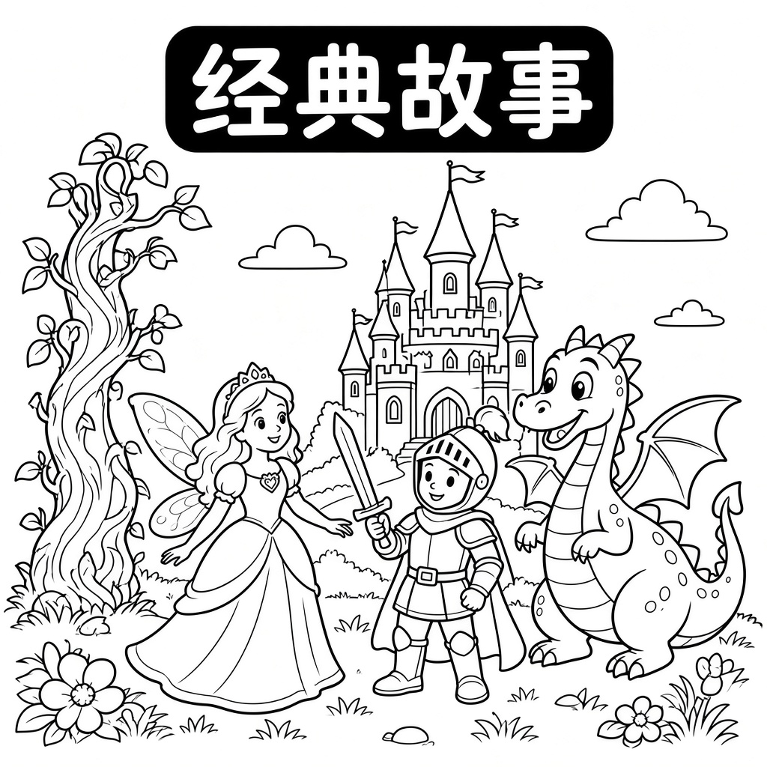 | 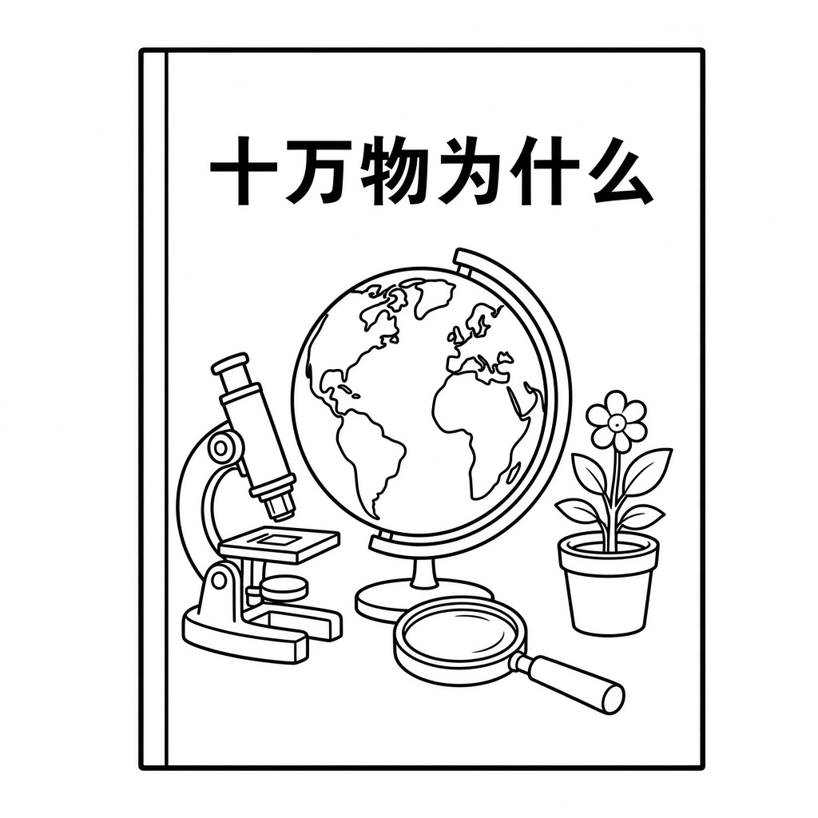
□ A | □ B

2.
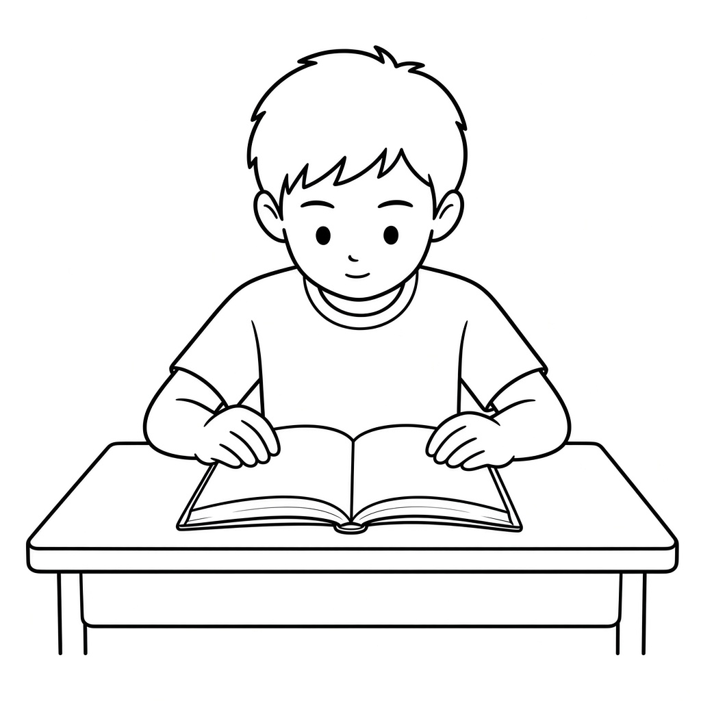 | 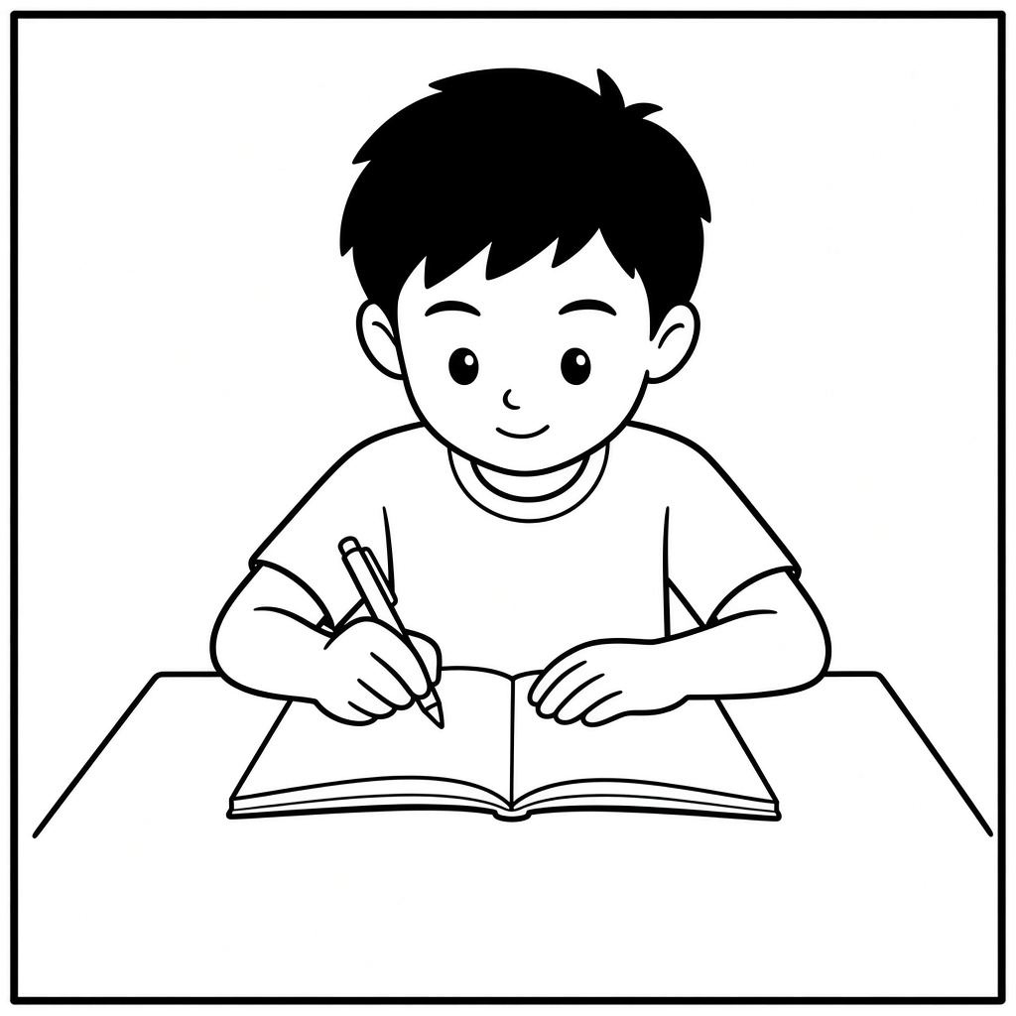
□ A | □ B

3.
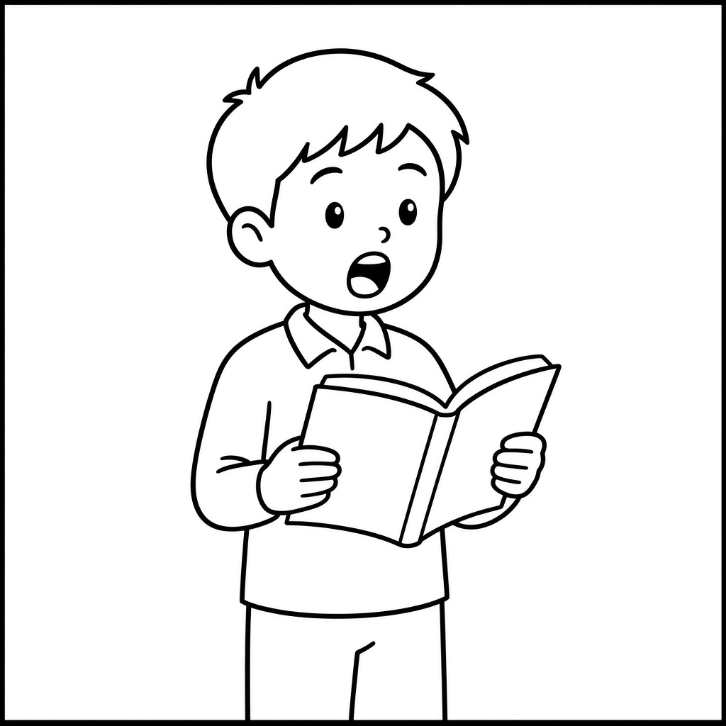 | 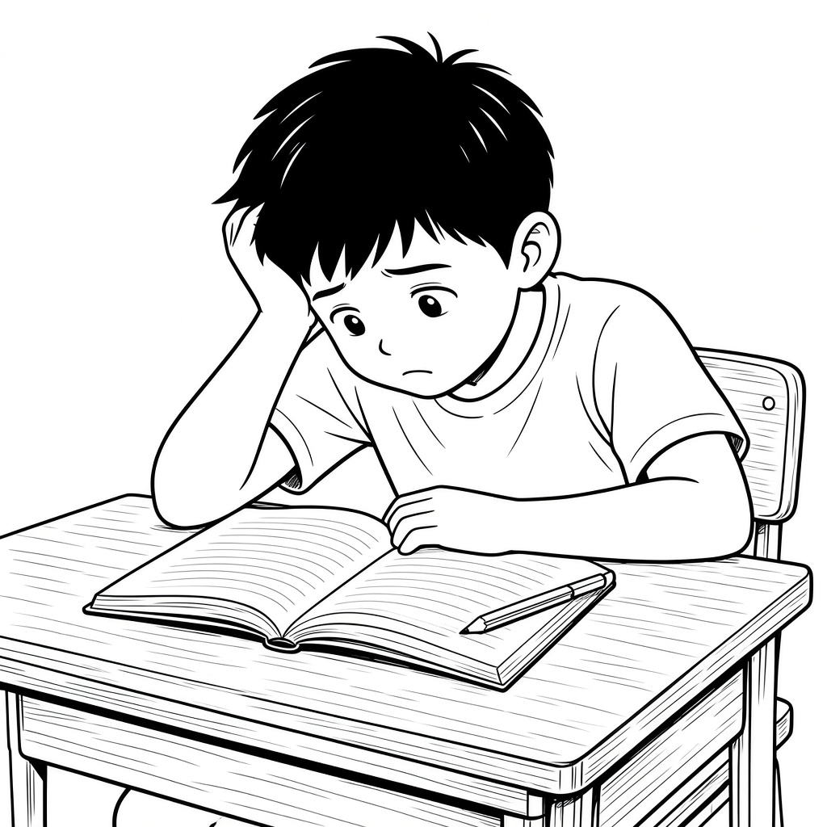
□ A | □ B

4.
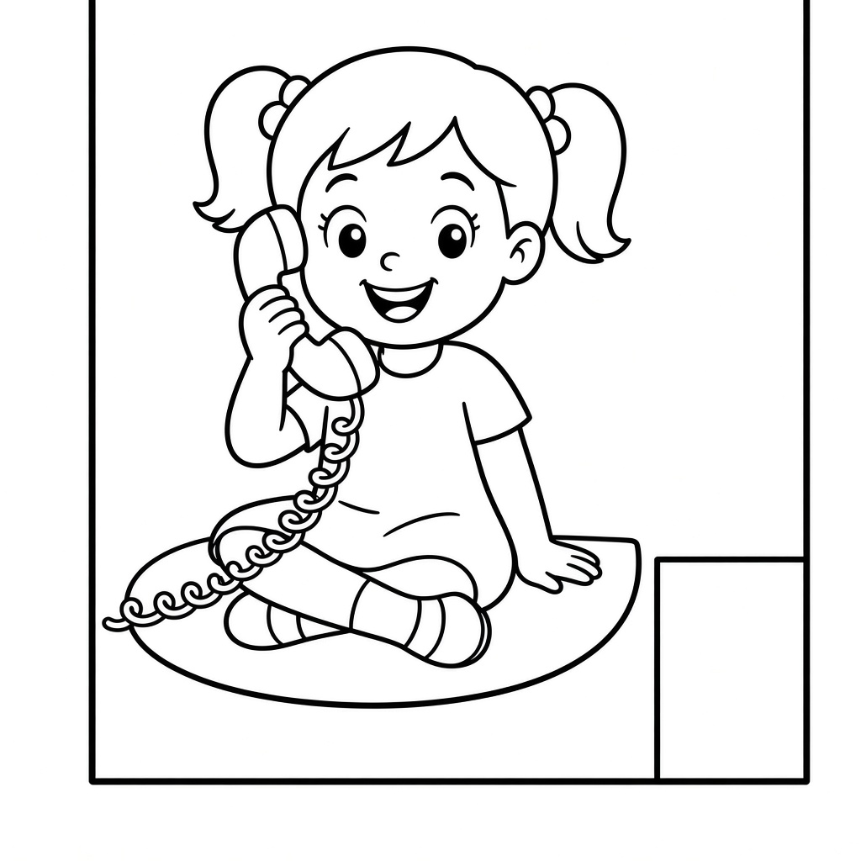 | 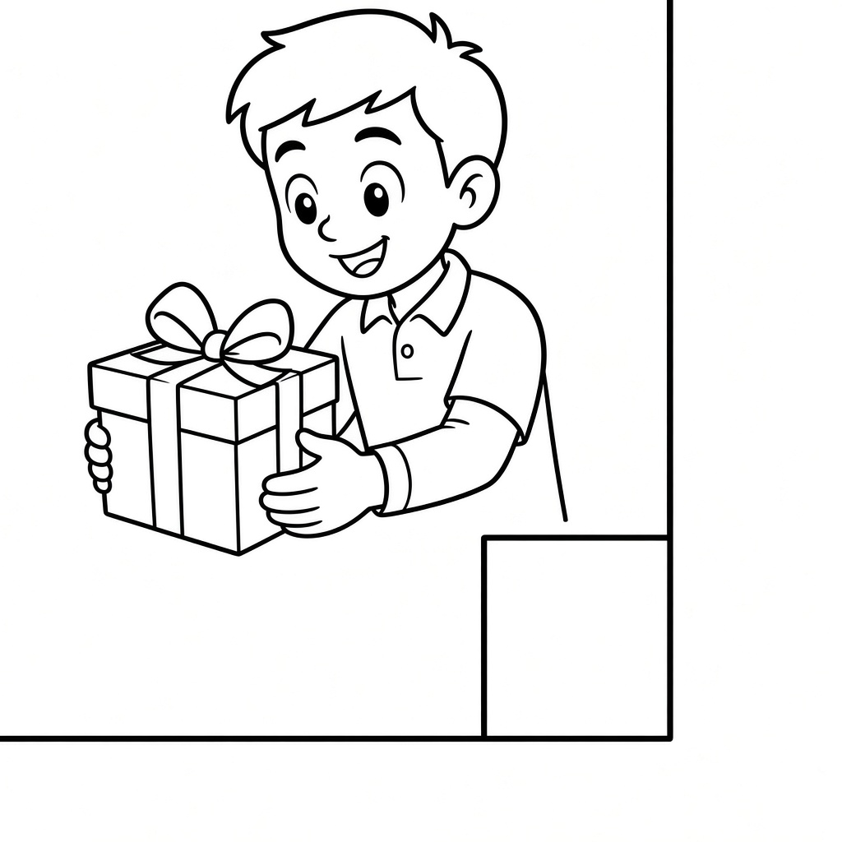
□ A | □ B

5.
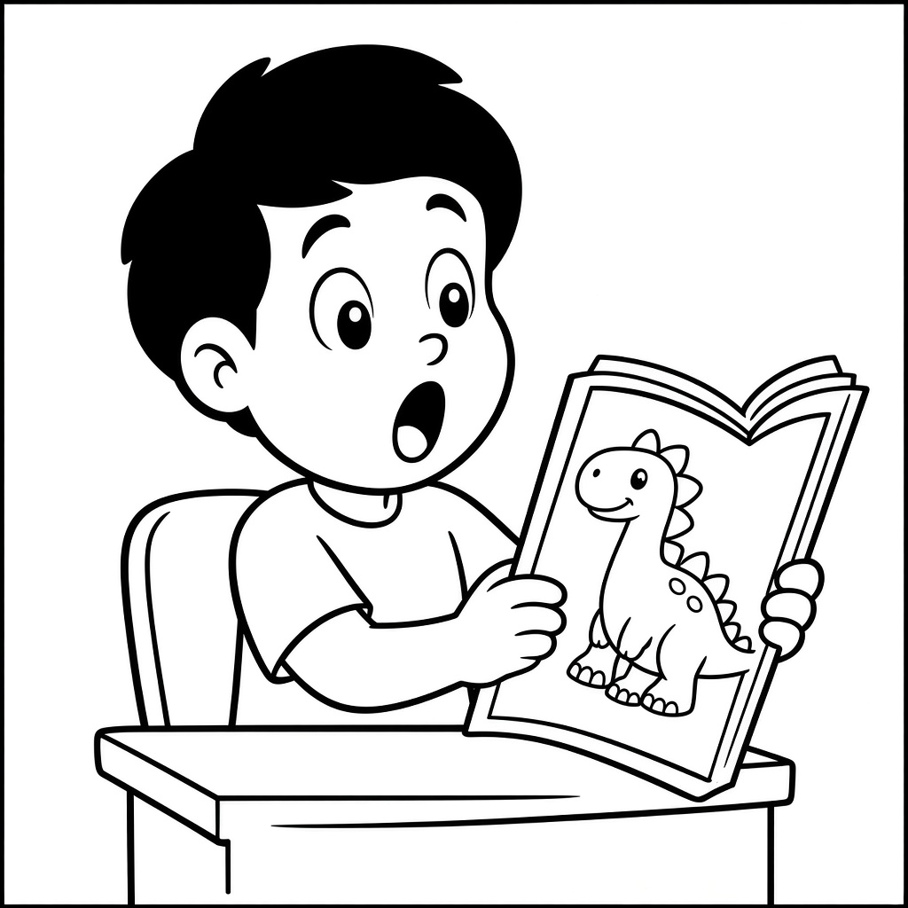 | 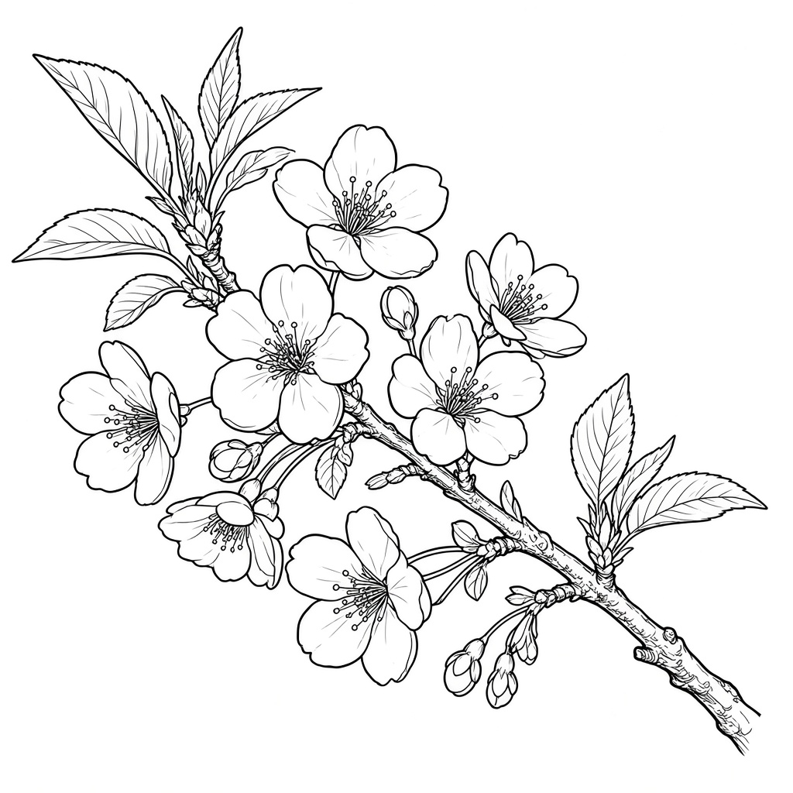
□ A | □ B

6.
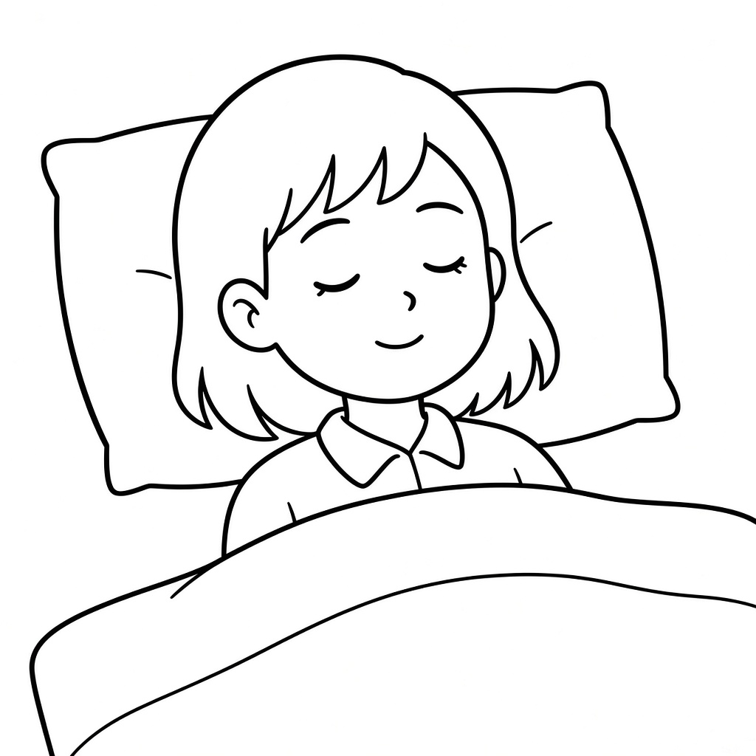 | 
□ A | □ B

二、听对话，判断图片与所听内容是否相符，相符的画“√”，不相符的画“×”。
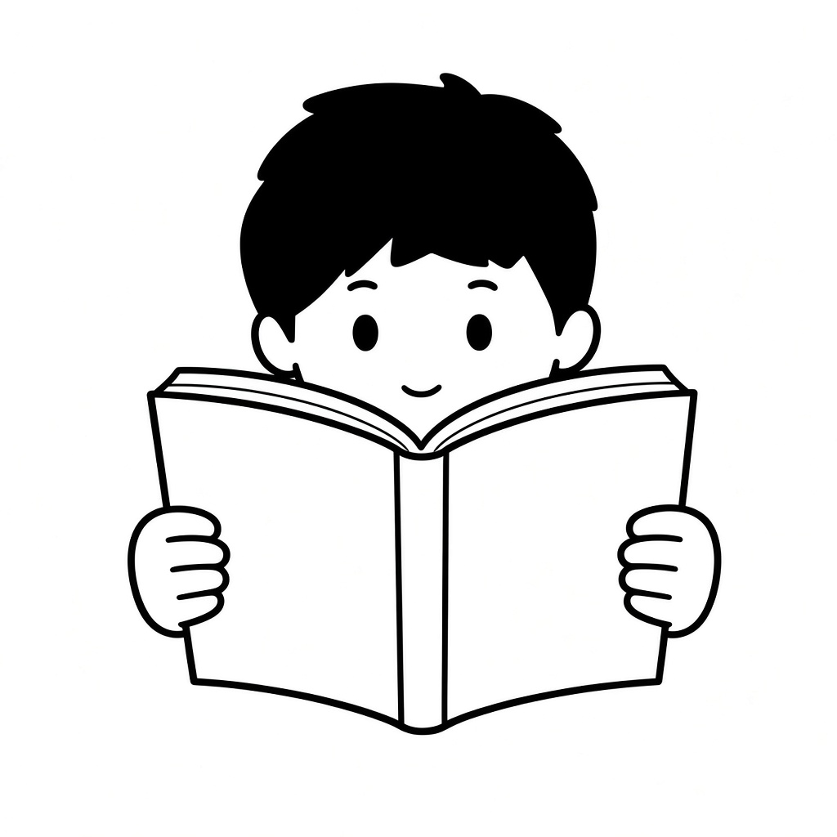 | 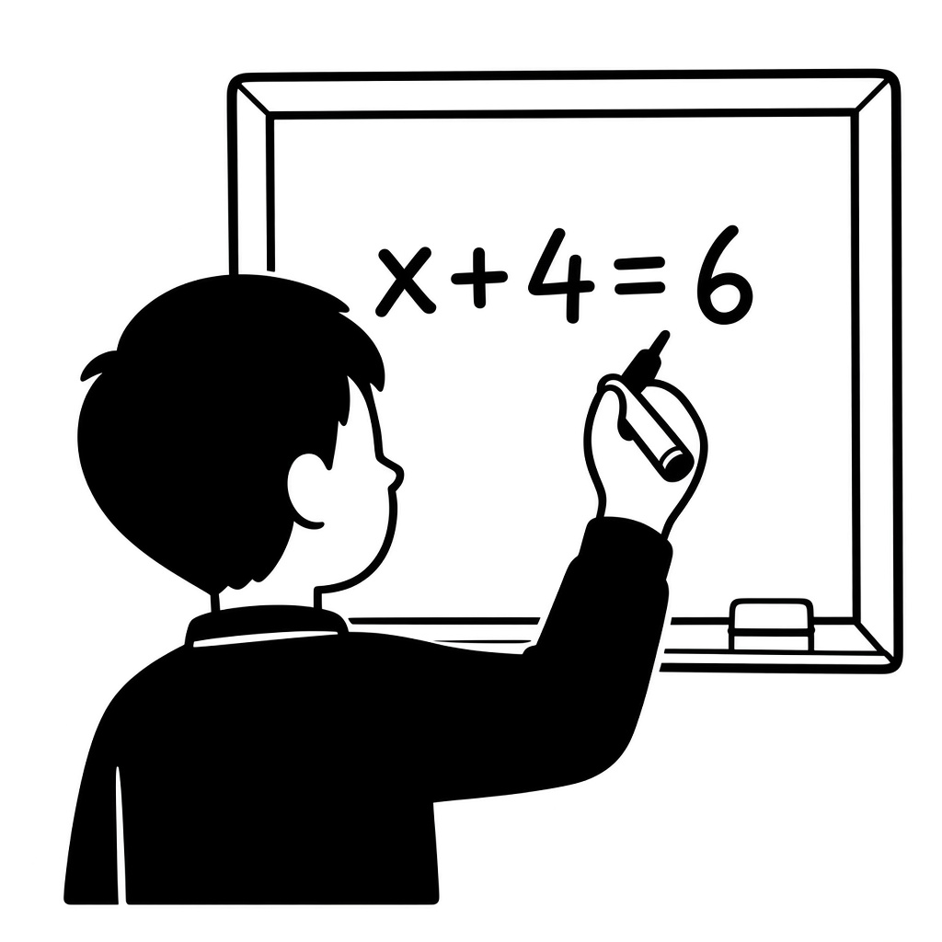 | 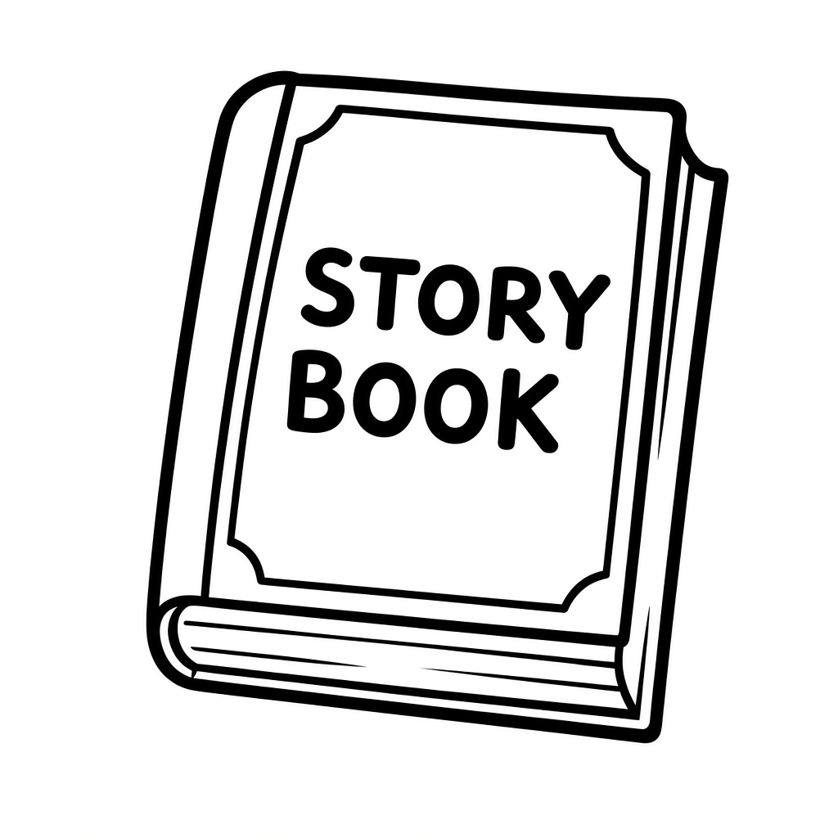 | 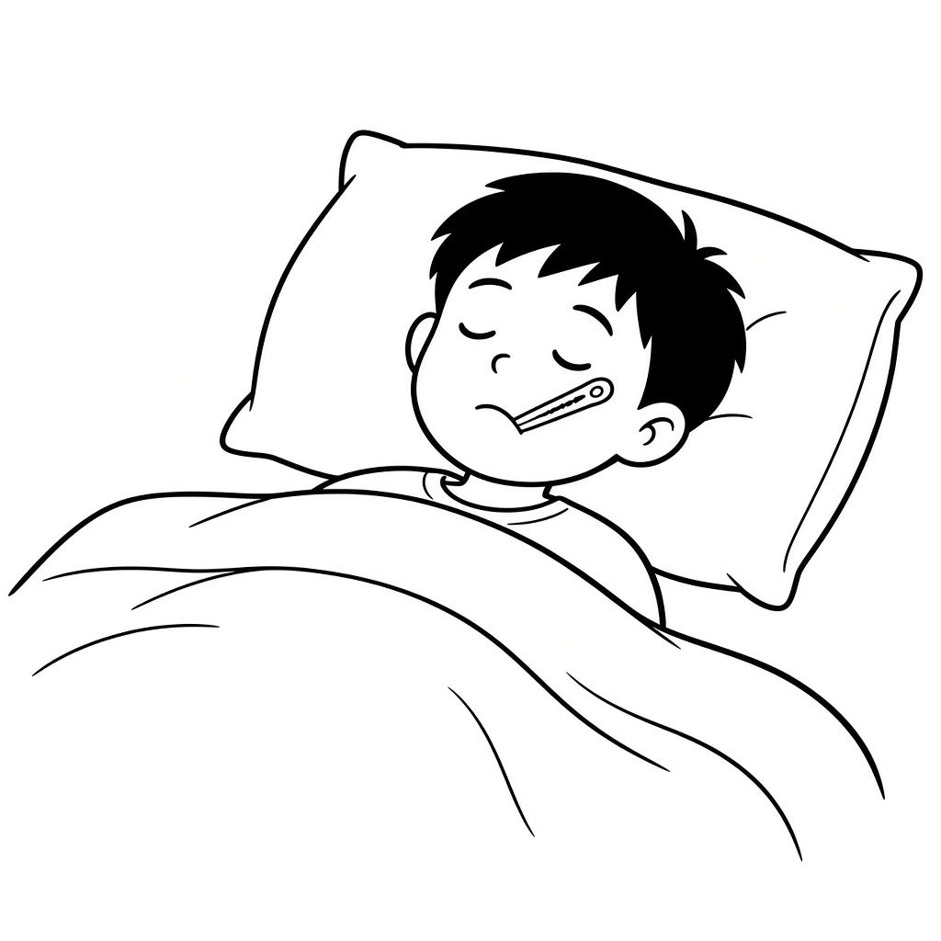 | 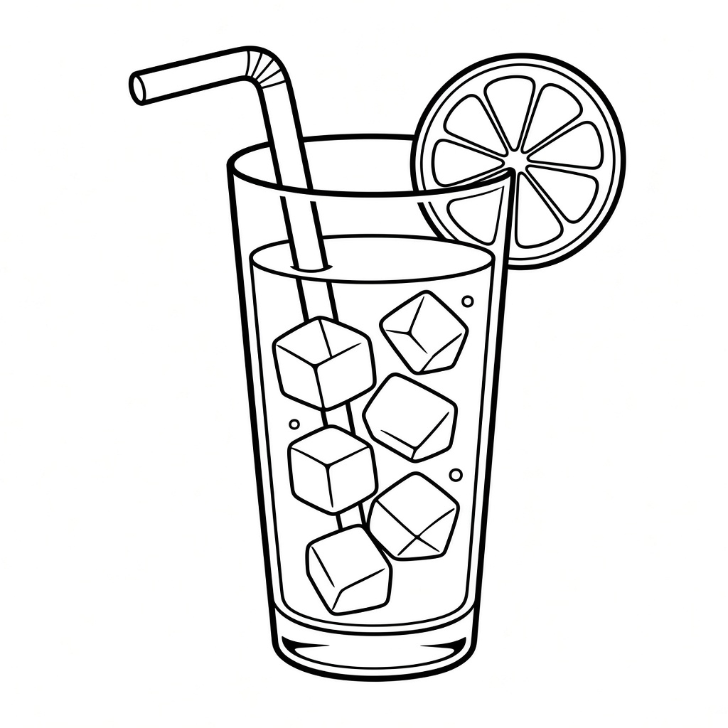
( ) 1. | ( ) 2. | ( ) 3. | ( ) 4. | ( ) 5.
三、听问句，选择正确的答语，将序号写在题前括号内。
( ) 1.
A. I am Sara.
B. Sorry, she is not home.
( ) 2.
A. I can't remember the poem.
B. She can't remember the poem.
( ) 3.
A. She is doing homework.
B. He is doing homework.
( ) 4.
A. Sure.
B. Sorry, I can't.
( ) 5.
A. I'm drawing a picture.
B. I'm going to the park tomorrow.
英语 · 四上 · 第二单元 第 1 页（共 4 页）· 高清图题版

四、听短文，判断句子正误，正确的写“T”，错误的写“F”。
( ) 1. Tina is my good friend.
( ) 2. We go to school by car every day.
( ) 3. Art is our favourite class.
( ) 4. We help each other only in art class.
( ) 5. We go to the zoo and fly kites on weekends.
笔试部分
五、判断下列单词画线部分发音是否相同，相同的画“√”，不相同的画“×”。
( ) 1. no / not
( ) 2. five / mice
( ) 3. set / sit
( ) 4. go / ago
六、读单词，选出不同类的一项，将序号写在题前括号内。
( ) 1. A. remember B. help C. hard D. try
( ) 2. A. sleeping B. reading C. telling D. sing
( ) 3. A. story B. visit C. book D. gift
( ) 4. A. good B. call C. hear D. speak
( ) 5. A. friend B. mother C. brother D. grandpa
七、看图读句子，选择与图片相符的句子，将序号写在括号内。
A. The book is about airplane.
B. Bill is sleeping. He is ill.
C. You can draw a picture for a poem.
D. Kevin has a bad cold.
E. You can drink some warm water.
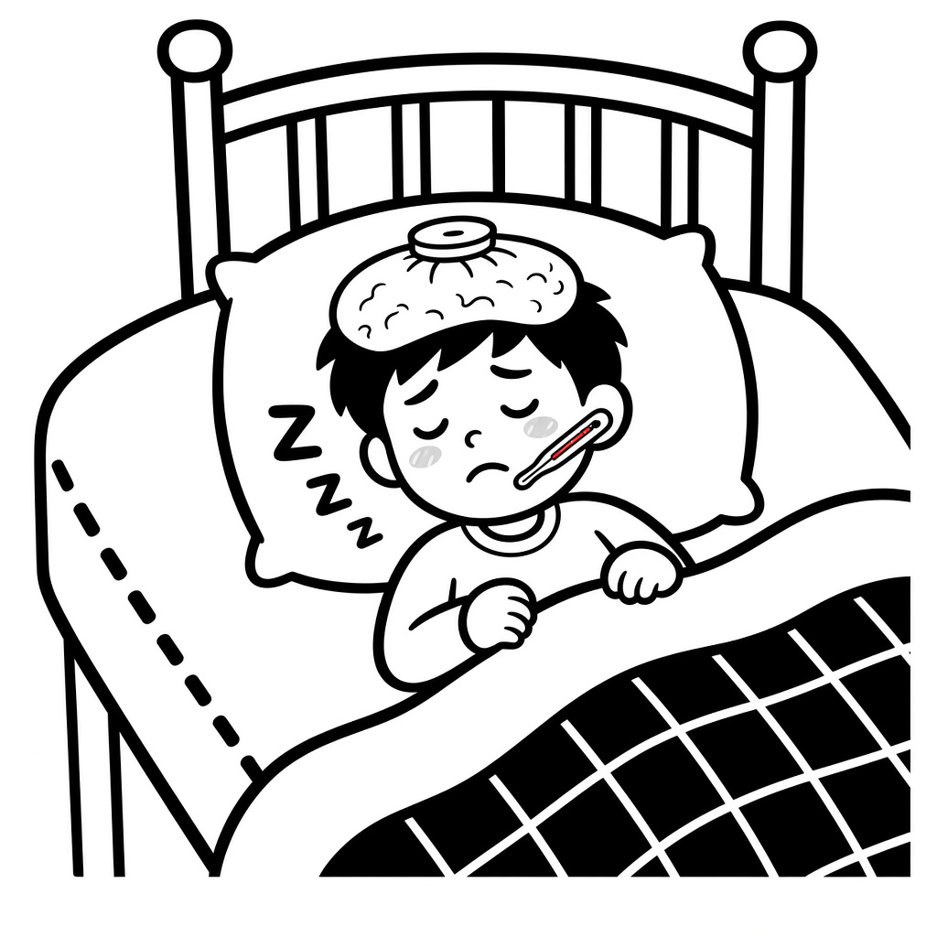 | 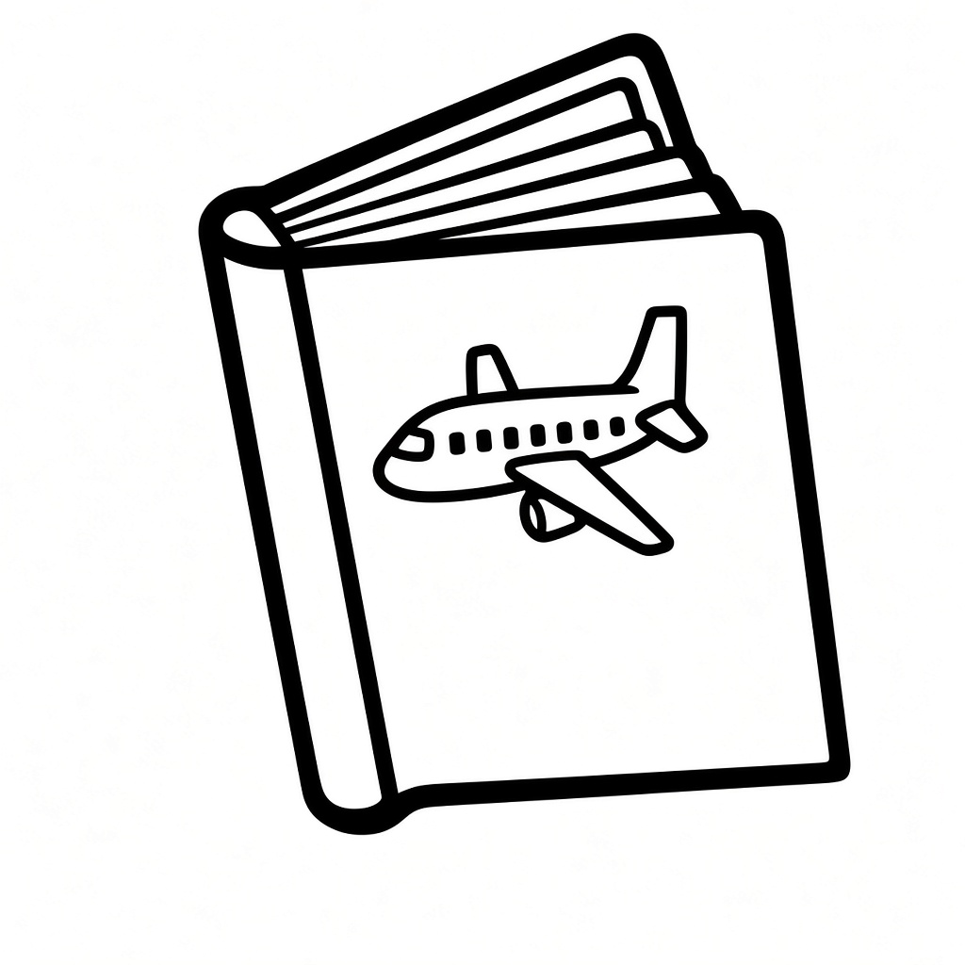 |  | 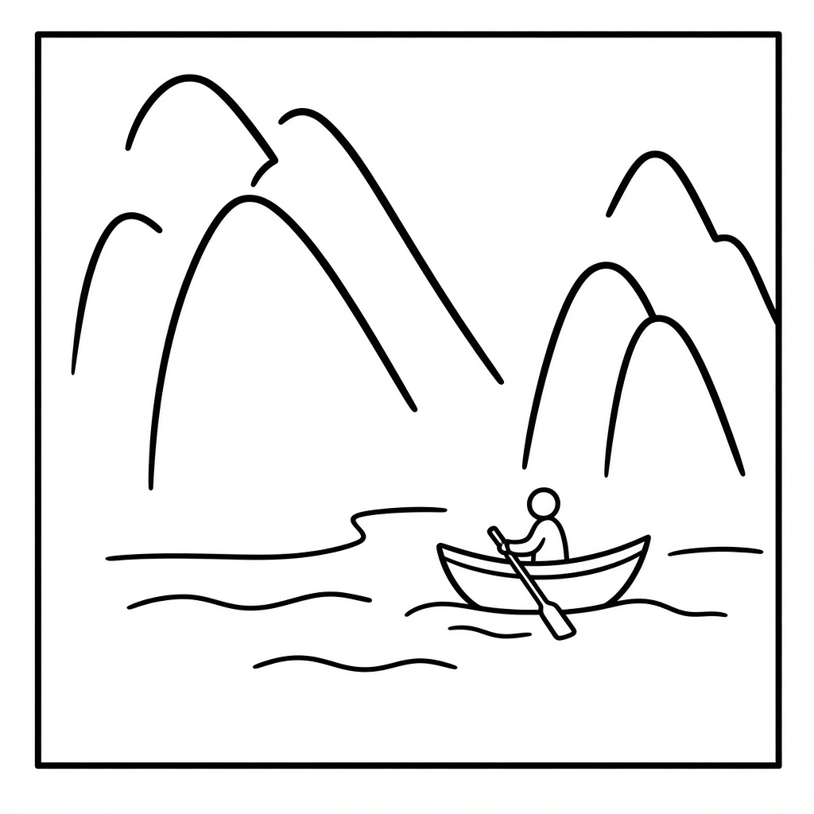 | 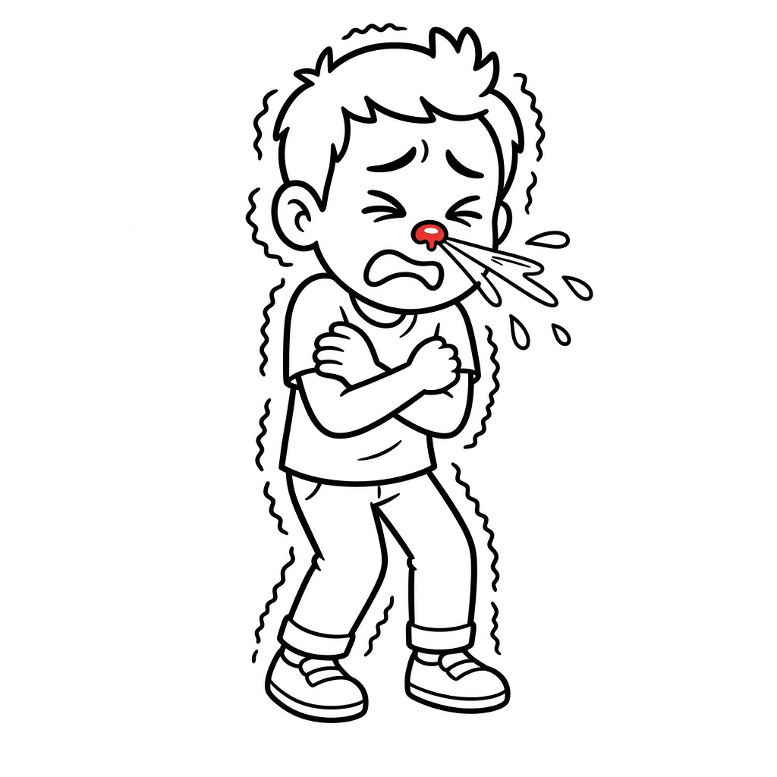
( ) 1. | ( ) 2. | ( ) 3. | ( ) 4. | ( ) 5.
英语 · 四上 · 第二单元 第 2 页（共 4 页）· 高清图题版

八、读句子，从方框中选择正确的答语，将序号写在题前括号内。
A. He is reading a science book.
B. I can't remember the poem.
C. Not so good.
D. Sorry, she is sleeping.
E. I often play football with him.
F. Thank you so much.
( ) 1. What's the matter, Alice?
( ) 2. May I speak to Lucy?
( ) 3. What do you often do with him?
( ) 4. How are you feeling?
( ) 5. What is he reading?
( ) 6. You should have a good rest.
九、读对话，从方框中选择合适的句子补全对话，将序号写在横线上。
A. I have some new story books.
B. I'll tell her.
C. Can you ask her to call me back?
D. We can read books together.
E. May I speak to Sophia?
Emma: Hello, Auntie. This is Emma. 1. ________
Mrs Smith: Sorry, Emma. She is not home.
Emma: Oh, I see. 2. ________
Mrs Smith: Sure. 3. ________
Emma: Thank you, Auntie.
Sophia: Hi, Emma! 4. ________ Do you want to read with me?
Emma: Yes. Will you bring them to school tomorrow?
Sophia: Certainly.
Emma: Great! 5. ________
十、阅读短文，完成任务。
Friends Help Each Other
I am Lucy. I have a great friend named Lily. We are in the same class. Last Monday, we had a big maths test. I was so nervous because I lost my ruler. Lily gave me her spare ruler. Lily is not good at drawing. I often help her draw. We always help each other and our friendship is getting stronger.
英语 · 四上 · 第二单元 第 3 页（共 4 页）· 高清图题版

任务一：根据短文内容，选择正确答案。
( ) 1. What is the name of the writer's friend?
A. Lucy.
B. Lily.
C. Lisa.
( ) 2. What happened to the writer before the maths test?
A. She lost the textbook.
B. She lost the ruler.
C. She lost the pencil.
( ) 3. What did Lily do when she saw the writer worried?
A. She gave her another ruler.
B. She helped write answers.
C. She asked the teacher for help.
( ) 4. What is Lily not good at?
A. Maths.
B. Reading.
C. Drawing.
( ) 5. How did the writer help Lily?
A. She taught her maths.
B. She taught her reading.
C. She taught her how to draw.
任务二：写两句介绍自己的朋友。
例：Lily is my good friend. I often teach her how to draw.
1. _______________________________________________
2. _______________________________________________
—— 参考答案（教师用）——
三：1B 2A 3B 4A 5A
四：1T 2F 3T 4F 5F
五：1× 2√ 3× 4√
六：1C 2D 3B 4A 5A
七：1B 2A 3E 4C 5D
八：1B 2D 3E 4C 5A 6F
九：1E 2C 3B 4A 5D
十·任务一：1B 2B 3A 4C 5C
英语 · 四上 · 第二单元 第 4 页（共 4 页）· 高清图题版

