英语 · 四上 · 第四单元练习
小学________ 四年级____班 姓名____________ 成绩________
听力部分
一、听句子，判断图片与所听内容是否相符，相符的写“T”，不相符的写“F”。
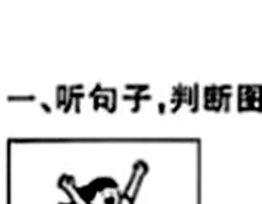 | 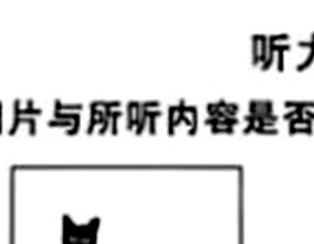 | 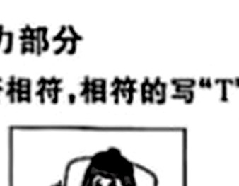 | 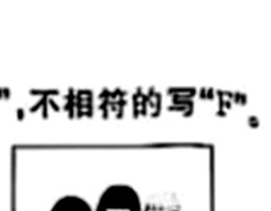
1. ( ) | 2. ( ) | 3. ( ) | 4. ( )
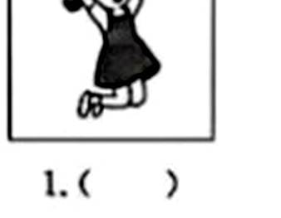 | 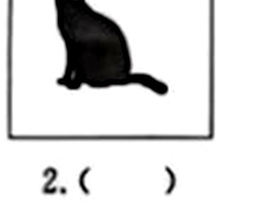 | 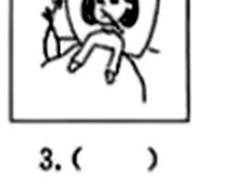 | 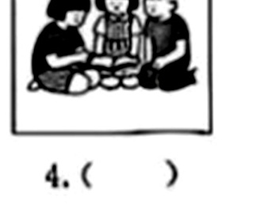
5. ( ) | 6. ( ) | 7. ( ) | 8. ( )

二、听对话，根据听到的顺序，用字母 A—E 给下列图片排序。
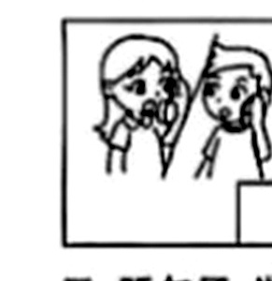 | 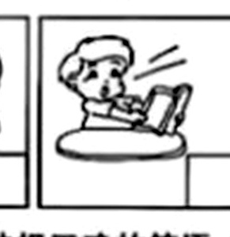 | 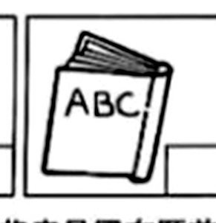 | 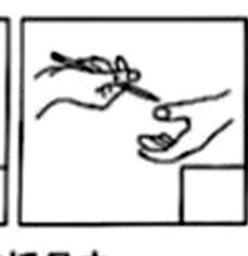 | 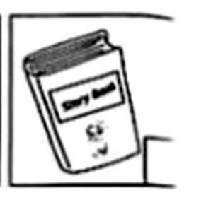
A. ( ) | B. ( ) | C. ( ) | D. ( ) | E. ( )

三、听句子，选择正确的答语，将序号写在题前括号内。
( ) 1.
A. Sure.
B. Please be polite.
( ) 2.
A. I don't like it.
B. I am happy.
( ) 3.
A. I can go to the park.
B. My toy car is broken.
( ) 4.
A. He is tall with short hair.
B. He is angry.
( ) 5.
A. Of course. Let's do it together.
B. You can remember the first word.
英语 · 四上 · 第四单元 第 1 页（共 4 页）

四、听对话，判断句子正误，正确的写“T”，错误的写“F”。
( ) 1. Linda is happy today.
( ) 2. Linda doesn't remember a poem.
( ) 3. Mike needs to use Linda's pencil.
( ) 4. They draw a picture to understand the maths problem.
( ) 5. Mike is a polite boy.
五、听短文，选择正确答案，将序号写在题前括号内。
( ) 1. Where are the children?
A. At home.
B. In a park.
C. At school.
( ) 2. How do the children feel?
A. They are excited.
B. They are happy.
C. They are sad.
( ) 3. Who is Miss Green?
A. An English teacher.
B. A Chinese teacher.
C. A music teacher.
( ) 4. Why is Amy surprised?
A. She gets a gift.
B. She gets 100 in exam.
C. She gets a cake.
( ) 5. Where is Mike's English book?
A. It's in his desk.
B. It's under the chair.
C. It's in his bag.
笔试部分
六、读单词，选出不同类的一项，将序号写在题前括号内。
( ) 1. A. worried B. happy C. feeling D. angry
( ) 2. A. story B. English C. Chinese D. maths
( ) 3. A. stand B. sweep C. water D. open
( ) 4. A. polite B. help C. draw D. remember
( ) 5. A. try B. wait C. door D. use
七、看图读短语，选择与图片相符的短语，将序号写在括号内。
A. talk to a friend
B. a bad cold
C. listen to music
D. tidy up the table
E. open the window
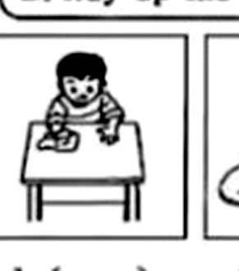 | 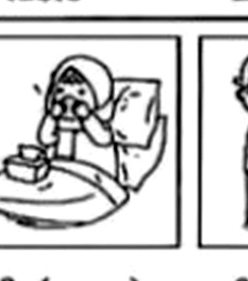 | 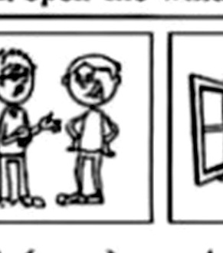 | 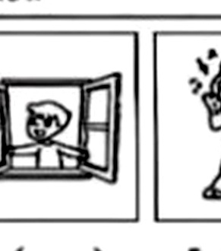 | 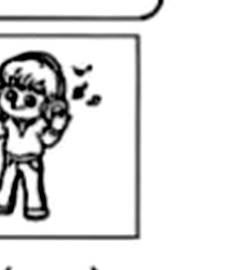
1. ( ) | 2. ( ) | 3. ( ) | 4. ( ) | 5. ( )

英语 · 四上 · 第四单元 第 2 页（共 4 页）

八、读句子，选择正确的答语，将序号写在题前括号内。
A. You should have a good rest.
B. We play football together.
C. Sure. Here you are.
D. It's OK. I can fix it.
E. I can't find my Chinese book.
( ) 1. You look worried. What's the matter?
( ) 2. I have a stomachache.
( ) 3. May I have a cupcake?
( ) 4. What do you do with your friend?
( ) 5. I'm sorry I broke your toy.
九、Max 一家在参观博物馆，他们在说些什么？读对话，从方框中选择合适的句子补全对话，将序号写在横线上。
A. May I use your notebook?
B. What's the matter?
C. What is this?
D. You can draw it down on your notebook.
E. Thanks a lot!
Max: Dad, 1. ________
Dad: It's a rock (岩石).
Max: It looks beautiful! I want to remember it.
Dad: 2. ________
Max: Oh, no!
Mum: 3. ________
Max: I can't find my notebook.
Sister: Don't worry. I have my notebook.
Max: 4. ________
Sister: Sure. Here you are.
Max: 5. ________ I can remember this rock when I go back home!
十、看图读故事，根据故事内容，用数字 1—6 给下列图片排序。
It was sports day. Wilma was in the long jump. She came first. She was happy. Wilf and Chip were in a race. They came second. They were excited. Dad was in the egg and spoon race. He came third. Dad was surprised. Mum was in a race. But Mum came last. She was unhappy. Kids have a surprise for Mum. Mum is happy now.
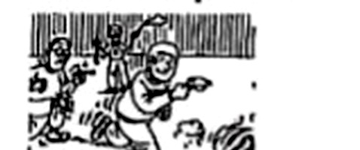 | 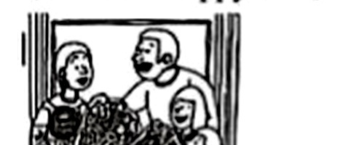 | 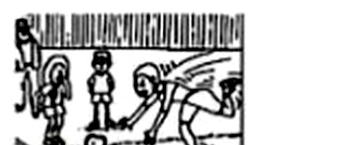
1. ( ) | 2. ( ) | 3. ( )
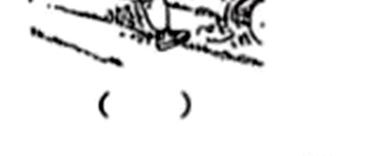 | 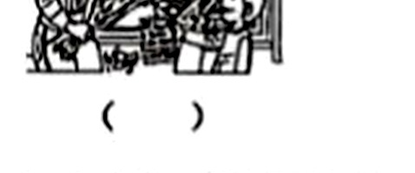 | 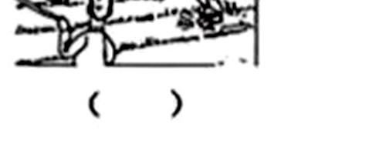
4. ( ) | 5. ( ) | 6. ( )

英语 · 四上 · 第四单元 第 3 页（共 4 页）

十一、以下是 Happy Park 的游园须知。阅读须知内容，完成任务。
Welcome to Happy Park
Open Time: 8:30–18:30 (Tue.–Sun.)
Ticket Price: Adult (成人) ¥20 Kid ¥10
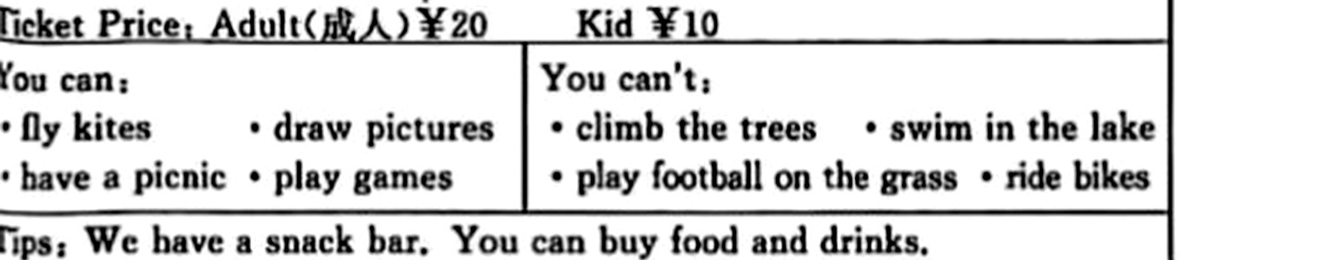
You can:
· fly kites · draw pictures · have a picnic · play games
You can't:
· climb the trees · swim in the lake · play football on the grass · ride bikes
Tips: We have a snack bar. You can buy food and drinks.
任务一：根据须知内容，选择正确答案，将序号写在题前括号内。
( ) 1. When does the park open?
A. On Saturday.
B. On Monday.
C. At 7:00.
( ) 2. Mike is 9 years old. He wants to go to Happy Park with his father. They need to pay (支付)
A. 20 yuan
B. 10 yuan
C. 30 yuan
( ) 3. What can we do in the park?
A. We can swim.
B. We can draw flowers.
C. We can ride a bike.
( ) 4. What can we buy in the park?
A. Kites.
B. Some pictures.
C. Some water.
( ) 5. Which is right?
A. We can go to the park at weekends.
B. We can't play games.
C. We can play football on the grass.
任务二：如果你在 Happy Park 看到了这样的事情，你会说些什么？请你写一写。
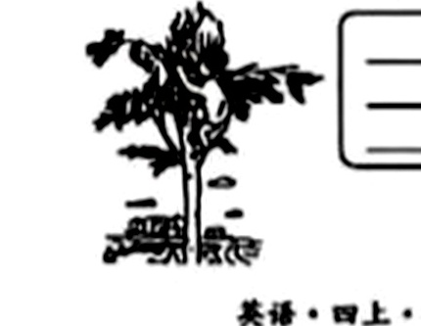
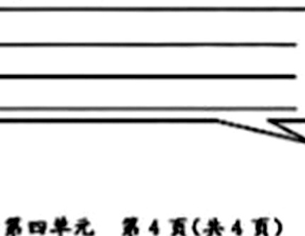
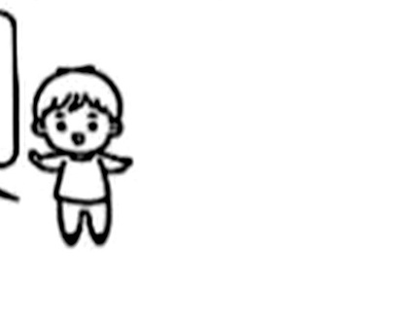
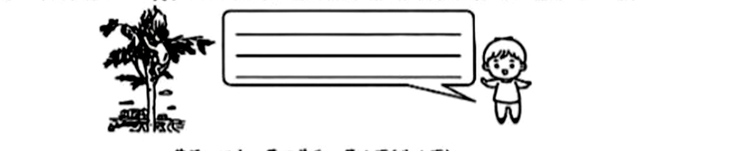
1. _________________________________________________________________
2. _________________________________________________________________
3. _________________________________________________________________
英语 · 四上 · 第四单元 第 4 页（共 4 页）

