英语 · 四上 · 第三单元练习
小学________ 四年级____班 姓名____________ 成绩________
听力部分
一、听句子，选择正确的图片，在方框里画“√”。
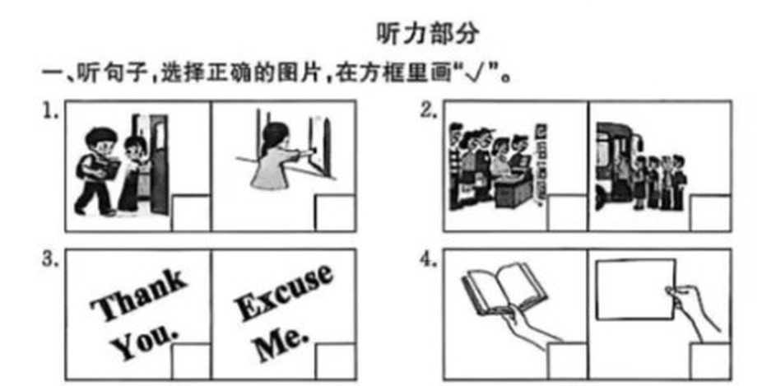
（上图为原卷附图；共 6 小题，在对应方框内画 √）
二、听对话，根据听到的顺序，用数字 1—5 给下列图片排序。
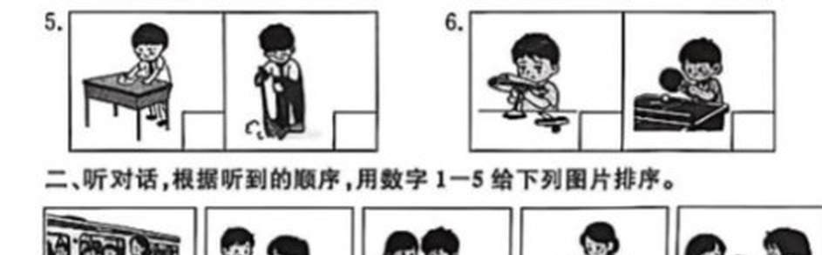
三、听句子，选择正确的答语，将序号写在题前括号内。
( ) 1.
A. You're welcome.
B. It's OK.
( ) 2.
A. No, I don't.
B. Sure, no problem.
( ) 3.
A. Don't worry. You can use mine.
B. I can fix it.
( ) 4.
A. Not at all.
B. It's OK.
( ) 5.
A. Come in, please.
B. No, you can't.
英语 · 四上 · 第三单元 第 1 页（共 4 页）

四、Henry 和同学们在班里做值日，他们是怎么分工的呢？听短文，将人物与其所负责的内容连线。
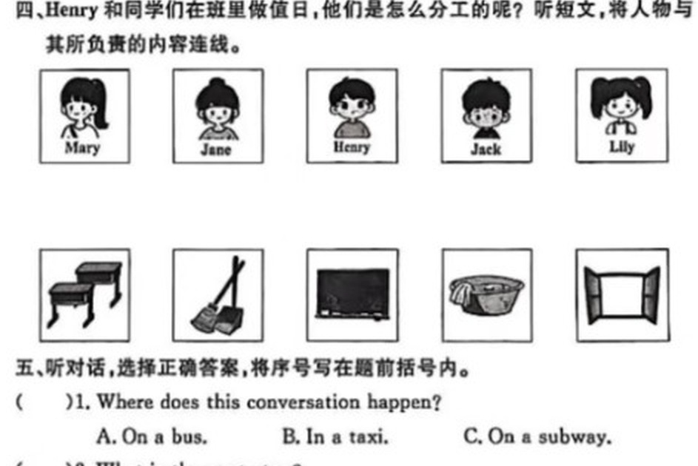
人物：Mary / Jane / Henry / Jack / Lily
五、听对话，选择正确答案，将序号写在题前括号内。
( ) 1. Where does this conversation happen?
A. On a bus.
B. In a taxi.
C. On a subway.
( ) 2. What is the next stop?
A. Beijing Railway Station.
B. Beijing Airport.
C. Dongzhimen Station.
( ) 3. Where does the woman want to go?
A. Beijing Railway Station.
B. Dongzhimen Station.
C. Not mentioned.
( ) 4. Which line should the woman take at Dongzhimen Station?
A. Line 1.
B. Line 2.
C. Line 8.
笔试部分
六、读单词，选出不同类的一项，将序号写在题前括号内。
( ) 1. A. garden B. push C. stand D. open
( ) 2. A. polite B. nice C. line D. clean
( ) 3. A. problem B. way C. floor D. find
( ) 4. A. pass B. use C. bus D. borrow
( ) 5. A. excuse B. hungry C. sweep D. wait
英语 · 四上 · 第三单元 第 2 页（共 4 页）

七、读句子，选择与句子描述相符的词，将序号写在题前括号内。
A. sweep
B. favour
C. line
D. a minute
E. problem
( ) 1. Do something good to help others.
( ) 2. Sixty seconds.
( ) 3. Something is hard to do.
( ) 4. To clean the dust from the floor.
( ) 5. A row of people.
八、读对话，从方框中选择合适的句子补全对话，将序号写在横线上。
A. Can I also get a banana cake?
B. What can I do for you?
C. Here you are.
D. You are welcome.
E. Here's the money. Thank you.
Baker: Hi, 1. ________
Amy: Excuse me, can I have two chocolate cakes?
Baker: Sure, anything else?
Amy: 2. ________
Baker: Certainly. 3. ________
Amy: How much are they?
Baker: They're 30 yuan.
Amy: 4. ________
Baker: 5. ________ Would you like a bag?
Amy: Yes, please.
九、看图读句子，选择与情景相符的句子，将序号写在题前括号内。
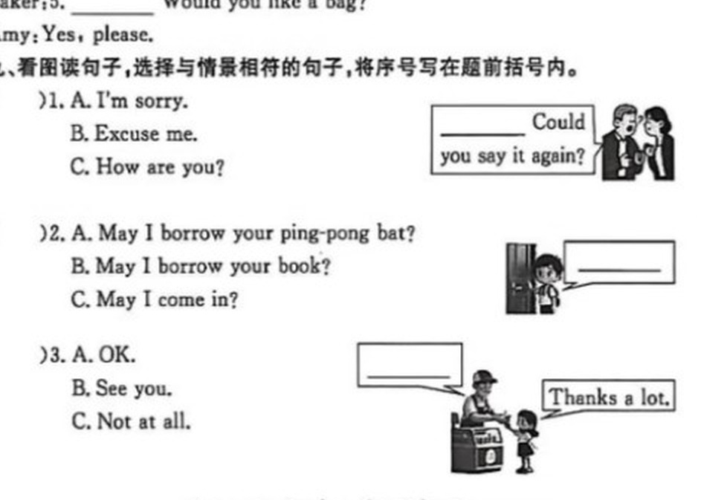
( ) 1.
A. I'm sorry.
B. Excuse me. Could you say it again?
C. How are you?
( ) 2.
A. May I borrow your ping-pong bat?
B. May I borrow your book?
C. May I come in?
( ) 3.
A. OK.
B. See you.
C. Not at all.
( ) 4.
A. Could you please pass me the juice?
B. Have some juice, please.
C. Give me some water.
英语 · 四上 · 第三单元 第 3 页（共 4 页）

十、以下是 George Middle School 的规则。阅读短文，完成任务。
The following rules are from George Middle School.
Please wear school uniforms every day at school. And don't be late for class.
Please walk on the right in the hallways (走廊). And don't run with your friends.
Please keep the desks clean in the classroom. And don't chat or sleep in class.
Please keep the books clean in the school library. And don't take them out.
No eating or drinking in the computer lab. Turn off the computers before you leave.
任务一：根据短文内容，判断句子正误，正确的写“T”，错误的写“F”。
( ) 1. There are four places mentioned (提到) in the rules.
( ) 2. The students can wear whatever they like at school.
( ) 3. The students can take the book out from the school library.
( ) 4. The students cannot eat or drink in the computer lab.
任务二：根据短文内容，填写表格。
Place | Do | Don't
In the hallways | 1. ______________ | 2. ______________
In the classroom | 3. ______________ | 4. ______________
In the school library | 5. ______________ | 6. ______________
In the computer lab | 7. ______________ | No eating or drinking
英语 · 四上 · 第三单元 第 4 页（共 4 页）

