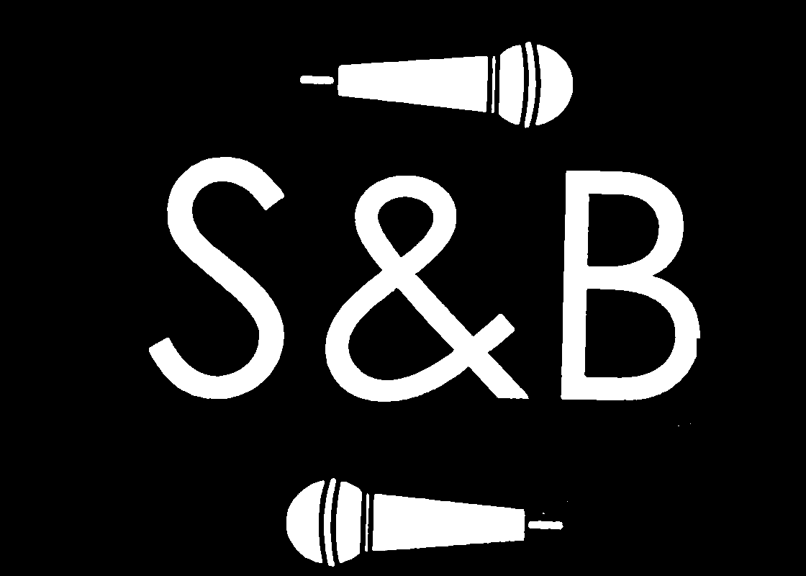

Sarah and the Buds Visual Identity Guide
Logo Typography Color Photography Promotion
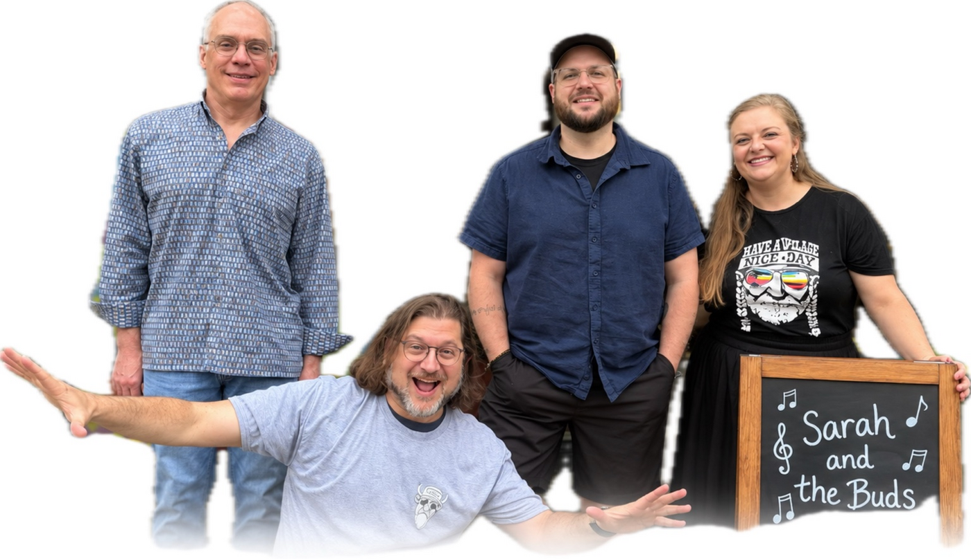
Version 1.0 | September 2026

Purpose and Brand Structure
This guide gives Sarah & the Buds one consistent visual system for show graphics, social posts, flyers, signs, booking materials, and merchandise. The business card establishes the identity: a simple S&B mark, music icons, black and warm white, rounded modern type, and an easygoing personality.

Brand Character
- Warm, welcoming, and genuinely personal
- Playful without looking childish
- Local, familiar, and unpretentious
- Musically confident without feeling overly polished or corporate
- Simple enough to recognize quickly on a phone or across a room

Naming System
Use | Official name | Where it appears
Full band | Sarah & the Buds | Four-piece shows, venue listings, posters, and full-band posts
Duo | Sarah & Bud | Acoustic duo bookings and duo-specific promotion
Shared mark | S&B | Avatar, card front, merchandise, and compact spaces

Always use the ampersand. In normal title case, write Sarah & the Buds with a lowercase “the.” In an all-uppercase lockup, use SARAH & THE BUDS. The S&B mark may represent either act, but the appropriate full name must appear elsewhere on the piece.

Logo System
The S&B lettering is the logo itself. It should be used as artwork rather than retyped. This protects the proportions and character of the mark even when different software or fonts are used.
Current S&B mark reproduced directly from the business card artwork

Full Band Lockup
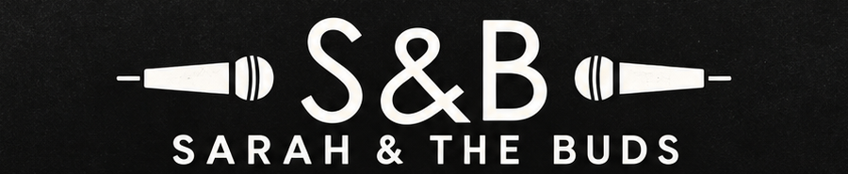
Working full-band lockup for Sarah & the Buds

Approved Arrangements
- Primary mark: S&B with one microphone above and one below, following the card.
- Horizontal lockup: microphones facing inward toward S&B, with SARAH & THE BUDS beneath.
- Compact mark: S&B alone when the complete name is visible nearby.
- One-color use: warm white on black or black on warm white.

Clear Space and Minimum Size
Leave clear space around the logo equal to at least the height of the ampersand. Do not use the complete lockup smaller than 180 pixels wide on screen or 1.5 inches wide in print. At smaller sizes, use the S&B mark without the microphones.

Do Not
- Stretch, rotate, outline, shadow, or distort the logo.
- Retype S&B in a decorative font and present it as the logo.
- Place the white mark over a busy or light part of a photograph.
- Add music notes, badges, stage lights, or other decoration around the mark.
- Change the logo color for individual venues or events.

Typography
Avenir Next is the official working typeface for Sarah & the Buds. Its rounded, geometric shapes closely match the lettering on the current card and give the brand a friendly, modern voice. The S&B logo remains artwork and is never recreated with Avenir Next or another font.
Role | Typeface and weight | Treatment
Major headline | Avenir Next Heavy | Uppercase; large; tight but comfortable spacing
Dates and key facts | Avenir Next Demi Bold | Uppercase; high contrast; easy to scan
Act name | Avenir Next Medium | Uppercase; generous letter spacing
Body and captions | Avenir Next Regular | Sentence case; open line spacing
Free digital substitute | Montserrat | Use equivalent weights when Avenir Next is unavailable
Office fallback | Arial | Use only when neither preferred family is available

UPCOMING SHOWS
SARAH & THE BUDS
OCTOBER 23 | SHAKER VILLAGE | 4:30-6:30 PM

Type Rules
- Use no more than one type family plus the S&B logo artwork in a design.
- Keep show information readable without zooming on a phone.
- Use an en dash for time ranges when supported: 1-3 PM may be typed as 1–3 PM in final artwork.
- Keep AM and PM uppercase and include a space before them.
- Avoid script, Western, condensed novelty, grunge, and distressed typefaces.
The document preview uses a portable sans serif. Production artwork should use Avenir Next or Montserrat as specified above.

Color Palette
The identity is intentionally monochrome. Black and warm white should carry nearly every branded piece. Full-color photography can appear inside this framework without changing the brand colors.
Color | Hex | RGB | Primary use
Stage Black | #111111 | 17, 17, 17 | Primary backgrounds
Warm White | #F5F2EA | 245, 242, 234 | Logo, headlines, and icons
Soft Charcoal | #2A2A2A | 42, 42, 42 | Secondary backgrounds
Paper Gray | #D8D5CE | 216, 213, 206 | Dividers and secondary details
Pure White | #FFFFFF | 255, 255, 255 | Small type requiring maximum contrast

Color Rules
- Default to warm white artwork and type on Stage Black.
- Use black artwork on Warm White when a light background is required.
- Use full-color photos as the main source of color.
- Mute or convert a photo to black and white when its colors compete with the event information.
- Do not introduce gold, yellow, navy, neon, or venue colors as permanent brand colors.

Photography and Graphic Elements
The people are the personality of the brand. Use current photographs of the actual performers and preserve natural faces, expressions, clothing, and proportions.
Preferred photography is current, recognizable, relaxed, and warm

Photography Rules
- Choose natural smiles, playful interaction, and clear faces.
- Keep every member of the advertised lineup visible.
- Preserve natural skin tones and recognizable expressions.
- Use simple backgrounds or clean group cutouts that fade gently into black.
- Never place important text over a face, hand, or instrument.
- Avoid artificial face changes, heavy filters, stock musicians, and excessive smoothing.

Supporting Graphics
Approved supporting elements are the simple microphone, a simple acoustic-guitar silhouette, thin divider lines, rounded corners, and a restrained matte or paper texture. Use one strong music symbol at a time. Avoid decorative music-note sprays, stage-light effects, barrels, saloon imagery, banners, ribbons, and heavy artificial aging.

Show Graphics
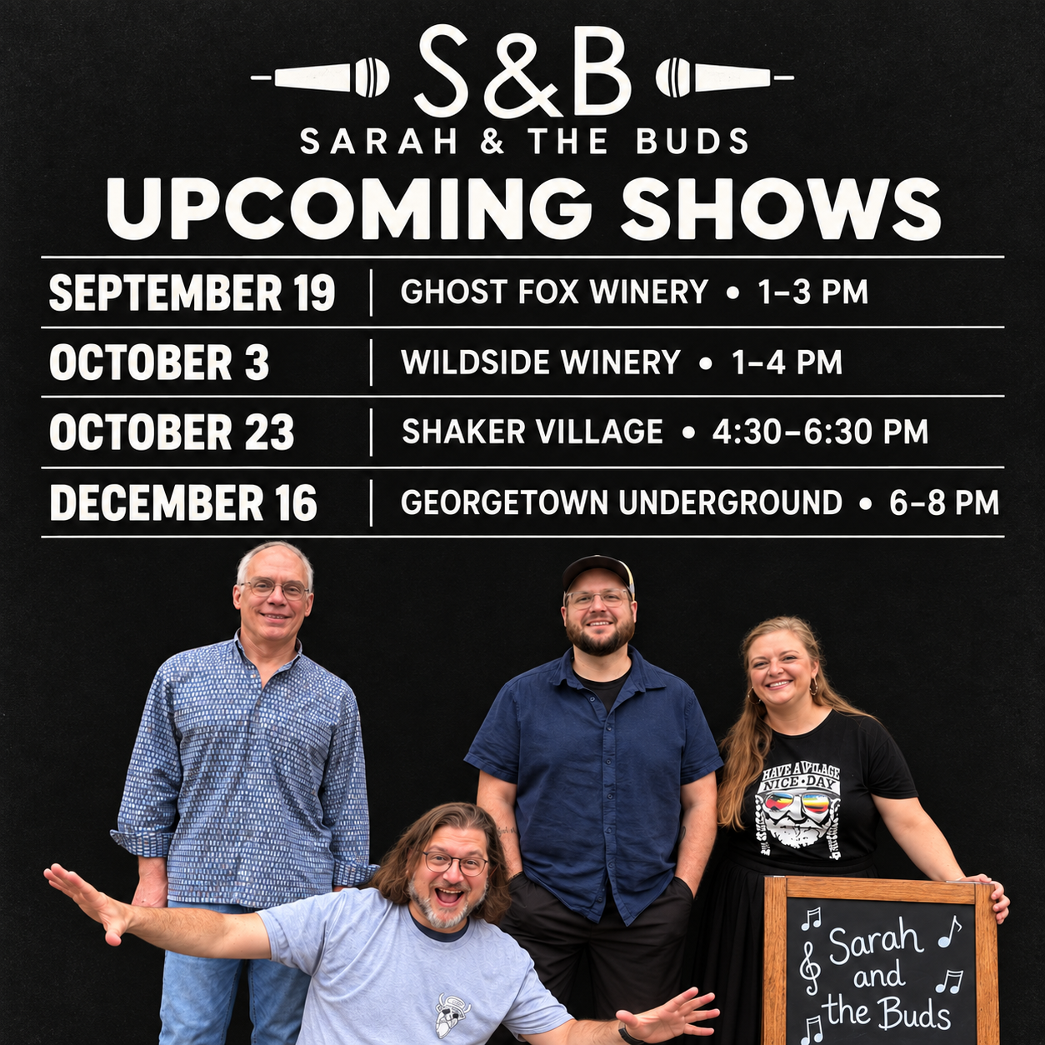 | Recommended square layout  - S&B microphone mark  - Full act name  - Large UPCOMING SHOWS headline  - Clearly separated event rows  - Current group photo along the lower portion  Standard size  1080 x 1080 pixels  Event format  MONTH DAY  VENUE • TIME  Other useful sizes  1080 x 1350 portrait post  1920 x 1080 event screen

Information Priority
A viewer should recognize who is playing, that the piece announces upcoming shows, and the date, venue, and time within two seconds. Decoration is always secondary to those facts.

Mobile Check
- Preview the final graphic at phone-feed size before publishing.
- Do not shrink venue or time information to fit decoration.
- Break a long venue name onto a second line if necessary.
- Check every date, location, and time against the booking information.

Voice and Contact Information
Write like a friendly invitation from the band, not an advertisement written by a promoter. Keep posts direct, grateful, lighthearted, and clear about the practical details.

Example Show Post
We have a few good afternoons and evenings of music coming up. Come hear Sarah & the Buds, bring a friend, and settle in for songs we love playing together. The dates and details are below. We hope to see you there.

Official Contact Block
Channel | Standard listing
Booking phone | (859) 519-0840
Booking email | booksarahandbud@gmail.com
Facebook | facebook.com/sarahandbud
YouTube | youtube.com/@sarahandbud
Instagram | @sarah.and.bud

Use the booking email first, followed by one primary social channel. Include the full contact block only on booking pieces or profile pages. Show graphics should prioritize the performance information.

Production Checklist
- Use the correct act name for the lineup: Sarah & the Buds or Sarah & Bud.
- Use approved S&B artwork without distortion.
- Keep the piece primarily black and warm white.
- Use Avenir Next, Montserrat, or the approved fallback consistently.
- Check every date, venue, and time.
- Show only the performers appearing at that event.
- Keep faces recognizable and unobstructed.
- Remove any decorative element that competes with the event details.
- Confirm the design remains readable at phone size.
- Verify contact and social information before publishing.

Core Asset Set
Maintain the S&B mark, full-band lockup, duo lockup, white-on-transparent and black-on-transparent logo files, square profile image, show templates, and the current approved group photo in one shared folder. Preferred logo formats are SVG and PDF for print, plus transparent PNG for everyday digital use.

