System Context and Analysis
Context diagram, components, interfaces, key data flows, security and capability gaps
Document ID | VA-SYS-01 | Version / Date | 1.0 / 09 Nov 2026
Prepared by | Sai Balaji Budumuru, Business Analyst | Status | Issued for review
Case-study context: VizagAlert is a self-directed Business Analysis portfolio project for Visakhapatnam’s civic services. Items marked [A] are proposed assumptions, and items marked Proposed extend the working prototype; both need validation with the departments before any live use.

1. System context
VizagAlert has three portals on one platform: the Citizen portal, the Official portal and the Admin (Command Centre) portal. Citizen and official flows are isolated at the interface level. The platform relies on Firebase for sign-in, data and photo storage, on Twilio for WhatsApp, and on the browser for camera and location.
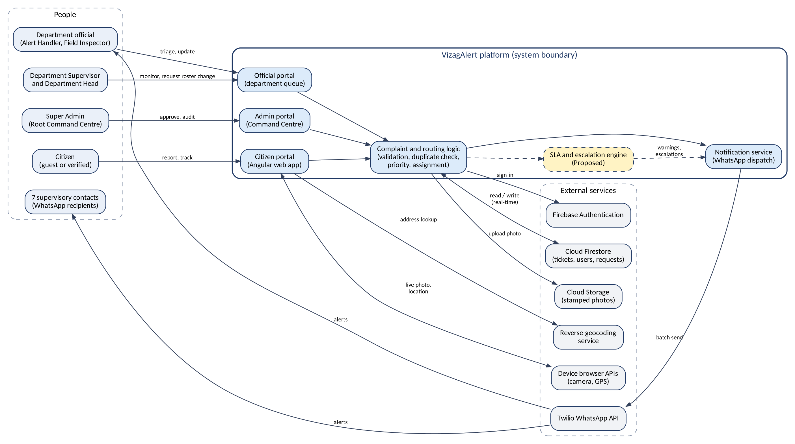
Figure 1. System context diagram (dashed yellow = proposed component)

2. Components
Component | Responsibility | State
Citizen portal (Angular) | Department cards, GPS gate, live camera, canvas stamping, description, guest and verified flows, personal dashboard | Existing
Official portal | Department login, queue with real-time updates, status changes, roster requests | Existing
Admin portal (Command Centre) | Employee directory, designations, approval of requests, audit view | Existing
Complaint and routing logic | Validation, ID creation, duplicate check, priority, SLA due times, assignment, reassignment | Existing (core) / Proposed (duplicates, priority, SLA, reassignment)
Notification service | Builds WhatsApp batch for the department number and 7 contacts; retry and delivery receipts | Existing (send) / Proposed (retry, receipts)
SLA and escalation engine | Five-minute scheduler, warnings, breach alerts L1 to L3, audit of each alert | Proposed
Audit service | Append-only log of every ticket and admin action | Proposed (admin trail exists)

3. External interfaces
Interface | Direction | Data | Failure handling
Firebase Authentication | Platform ↔ service | Credentials, ID tokens, role claims | Login blocked; clear message; no fallback to guest for officials
Cloud Firestore | Platform ↔ service | Tickets, users, requests; real-time listeners | Client retries; writes idempotent by request key
Cloud Storage | Platform → service | Stamped photo | Ticket not created unless upload succeeds
Twilio WhatsApp API | Platform → service → people | Template message with ticket ID, department, category, priority, map link | Retry at 1, 3, 10 minutes; failure logged and flagged; in-app alert always raised
Reverse-geocoding service | Platform → service | Latitude, longitude → street address | Falls back to coordinates; ticket flagged for review
Browser camera and GPS | Device → platform | Live image, coordinates | Permission denied or no fix blocks capture

4. Key data flows

4.1 Complaint submission
- Citizen selects department and category; browser returns GPS coordinates; platform checks they are inside the boundary.
- Camera opens with the emergency number pinned; citizen captures a live photo and enters a description.
- Client burns UTC time and reverse-geocoded address into the image and requests an upload URL.
- Platform validates file signature and size, stores the photo, runs the duplicate check, and creates the ticket with ID, priority and due times.
- Notification service sends the WhatsApp batch; Firestore listeners push the ticket to open department dashboards.

4.2 Status update
- Official changes status; platform checks role, department, transition and mandatory fields (reason code, remark).
- Ticket, SLA clock and audit entry are written together; the citizen dashboard updates through the live listener.

4.3 SLA scan
- Every 5 minutes the engine loads open tickets, computes time used net of Hold, and compares it with the escalation ladder.
- For each new threshold crossed it writes an escalation event, sends the alert, and records the alert in the audit log. A missed run is caught up on the next run.

5. Use cases by actor
Actor | Use cases
Guest | Submit complaint (UC-01)
Verified Citizen | Register (UC-02); log in (UC-03); submit complaint (UC-01); view dashboard and status (UC-04); rate and reopen (UC-05)
Alert Handler / Inspector | Log in (UC-06); view department queue (UC-07); acknowledge and set Active (UC-08); assign inspector (UC-09); hold and resolve (UC-10); request reassignment (UC-11); request roster change (UC-12)
Department Supervisor | All official use cases; respond to escalation (UC-13); view department SLA report (UC-14)
Super Admin | Log in (UC-15); manage directory and designations (UC-16); decide roster and reassignment requests (UC-17); review audit trail (UC-18); view all-department SLA report (UC-14)
System (timer) | Run SLA scan and escalate (UC-19)

6. Security model
Control | Design
Authentication | Firebase Authentication for all roles. Officials sign in through a separate portal with department, Employee ID and password. Super Admin has a Root Admin ID and password; no passwordless path.
Authorisation | Role claims plus Firestore Security Rules: department-scoped reads for officials, own-ticket reads for citizens, no client write to audit entries.
Evidence integrity | Live-camera capture only, GPS before camera, stamp burned into pixels, file-signature and size check.
Privacy | Government ID stored as a salted hash only. Photos may show people; retention to be set with legal advice (OQ-05).
Abuse control | Rate limit of 5 guest complaints per device per hour [A]; lockout after 5 failed official logins.
Audit | Append-only; no role can edit or delete entries.

7. Capability gap: prototype to target
Area | Prototype today | Target (this document set) | Gap
Routing | Citizen picks department | Category sets priority and SLA; duplicate linking | Category model, duplicate rule
Assignment | Department queue | Named inspector with assignment record | Assignment entity and screen
Time control | None | SLA clocks, Hold pause, due times | SLA policy and engine
Escalation | Fixed WhatsApp to 7 contacts at creation | Three-level ladder on breach | Scheduler, rules, alerts
Reassignment | Not supported | Request and Super Admin approval | Request entity, workflow
Citizen loop | Live status for verified citizens | Rating and 7-day reopen | Feedback entity
Audit | Super Admin audit trail | Complete append-only log with old and new values | Wider event capture
Reporting | None | SLA compliance and backlog | Report queries

