Entity Relationship Model and Data Dictionary
Citizen, complaint, department, assignment, SLA and audit log, with supporting entities
Document ID | VA-ERD-01 | Version / Date | 1.0 / 09 Nov 2026
Prepared by | Sai Balaji Budumuru, Business Analyst | Status | Issued for review
Case-study context: VizagAlert is a self-directed Business Analysis portfolio project for Visakhapatnam’s civic services. Items marked [A] are proposed assumptions, and items marked Proposed extend the working prototype; both need validation with the departments before any live use.

1. Logical model
The model is logical. The prototype stores data in Firestore collections (tickets, users, adminRequest); each entity below maps to a collection, and foreign keys become document references. Guests have no CITIZEN row: their complaints carry reporter type GUEST and no citizen ID.
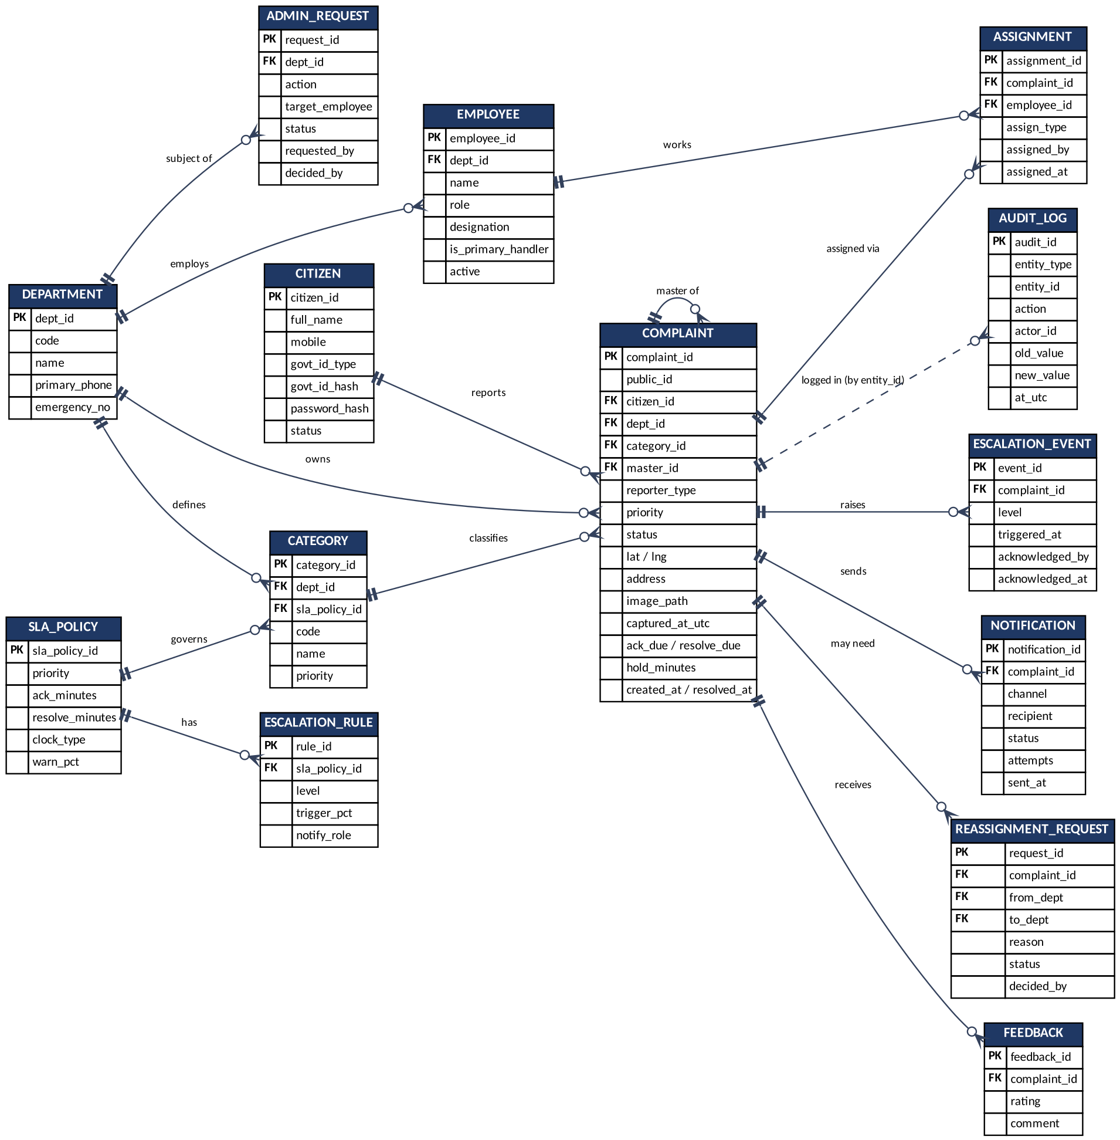
Figure 1. Entity relationship diagram (crow’s foot: one to many)

2. Relationships
Parent | Child | Cardinality | Meaning
CITIZEN | COMPLAINT | 1 : 0..N | A verified citizen reports many complaints; guest complaints have none
DEPARTMENT | COMPLAINT | 1 : 0..N | A department owns many tickets (changes on approved reassignment)
DEPARTMENT | EMPLOYEE | 1 : 0..N | Roster of the department
DEPARTMENT | CATEGORY | 1 : 1..N | Categories belong to one department
SLA_POLICY | CATEGORY | 1 : 1..N | Each category follows one SLA policy
SLA_POLICY | ESCALATION_RULE | 1 : 3..N | Ladder steps per policy
CATEGORY | COMPLAINT | 1 : 0..N | Classification of the ticket
COMPLAINT | COMPLAINT | 1 : 0..N | Master ticket and linked duplicates
COMPLAINT | ASSIGNMENT | 1 : 0..N | Handler and inspector history
EMPLOYEE | ASSIGNMENT | 1 : 0..N | Work given to an employee
COMPLAINT | ESCALATION_EVENT / NOTIFICATION / REASSIGNMENT_REQUEST / FEEDBACK | 1 : 0..N | Events and records of the ticket
DEPARTMENT | ADMIN_REQUEST | 1 : 0..N | Roster change requests
Any entity | AUDIT_LOG | 1 : 0..N | Soft link by entity type and ID; every change is logged

3. Data dictionary

CITIZEN: Registered citizen (guests have no row)
Attribute | Type / key | Description
citizen_id | PK | Unique ID
full_name | text | Name as entered
mobile | text | Contact number
govt_id_type | enum | AADHAAR, VOTER_ID, DL
govt_id_hash | text | Salted hash; raw ID never stored
password_hash | text | Managed by auth provider
status | enum | ACTIVE, LOCKED

DEPARTMENT: One of the six departments
Attribute | Type / key | Description
dept_id | PK | Unique ID
code | text | GVMC, WTR, ELE, TRF, FIR, HSN
name | text | Display name
primary_phone | text | WhatsApp number for alerts
emergency_no | text | Number pinned on camera screen

EMPLOYEE: Official or administrator
Attribute | Type / key | Description
employee_id | PK | Employee or Root Admin ID
dept_id | FK | Null for Super Admin
name | text
role | enum | HANDLER, INSPECTOR, SUPERVISOR, HEAD, SUPER_ADMIN
designation | text | For example Alert Handler
is_primary_handler | bool | One per department
active | bool

CATEGORY: Complaint category
Attribute | Type / key | Description
category_id | PK
dept_id | FK | Owning department
sla_policy_id | FK | SLA that applies
code | text | For example WTR-03
name | text
priority | enum | P1 to P4

SLA_POLICY: Targets per priority
Attribute | Type / key | Description
sla_policy_id | PK
priority | enum | P1 to P4
ack_minutes | int | Acknowledgement target
resolve_minutes | int | Resolution target
clock_type | enum | 24X7, WORKING_HOURS
warn_pct | int | Early-warning threshold

ESCALATION_RULE: Ladder step
Attribute | Type / key | Description
rule_id | PK
sla_policy_id | FK
level | int | 1, 2, 3
trigger_pct | int | Percent of resolve target
notify_role | enum | SUPERVISOR, HEAD, SUPER_ADMIN

COMPLAINT: The ticket
Attribute | Type / key | Description
complaint_id | PK
public_id | text | VZG-NNNN style ID
citizen_id | FK | Null for guest
dept_id | FK
category_id | FK
master_id | FK | Self-reference for linked duplicates
reporter_type | enum | GUEST, VERIFIED
priority | enum | P1 to P4
status | enum | REQUEST, ACTIVE, HOLD, RESOLVED, REOPENED, LINKED
lat / lng | decimal | Capture coordinates
address | text | Reverse-geocoded
image_path | text | Stamped photo in storage
captured_at_utc | datetime | Stamp time
ack_due / resolve_due | datetime | Recalculated on Hold or priority change
hold_minutes | int | Total time paused
created_at / resolved_at | datetime

ASSIGNMENT: Who was given the ticket
Attribute | Type / key | Description
assignment_id | PK
complaint_id | FK
employee_id | FK
assign_type | enum | HANDLER, INSPECTOR
assigned_by | FK | Employee
assigned_at | datetime

ESCALATION_EVENT: Alert raised on breach
Attribute | Type / key | Description
event_id | PK
complaint_id | FK
level | int | 0 warning, 1, 2, 3
triggered_at | datetime
acknowledged_by | FK | Employee
acknowledged_at | datetime

NOTIFICATION: Message log
Attribute | Type / key | Description
notification_id | PK
complaint_id | FK
channel | enum | WHATSAPP, DASHBOARD
recipient | text | Number or role
status | enum | QUEUED, SENT, DELIVERED, FAILED
attempts | int | Up to 4
sent_at | datetime

REASSIGNMENT_REQUEST: Request to move a ticket
Attribute | Type / key | Description
request_id | PK
complaint_id | FK
from_dept | FK
to_dept | FK
reason | text
status | enum | PENDING, APPROVED, REJECTED
decided_by | FK | Super Admin

ADMIN_REQUEST: Roster change request (adminRequest)
Attribute | Type / key | Description
request_id | PK
dept_id | FK
action | enum | ADD_MEMBER, DELETE_MEMBER
target_employee | text
status | enum | PENDING, APPROVED, REJECTED
requested_by | FK
decided_by | FK

FEEDBACK: Citizen rating
Attribute | Type / key | Description
feedback_id | PK
complaint_id | FK
rating | int | 1 to 5
comment | text | Optional

AUDIT_LOG: Append-only history
Attribute | Type / key | Description
audit_id | PK
entity_type | text | COMPLAINT, EMPLOYEE, REQUEST …
entity_id | text | Soft reference
action | text | STATUS_CHANGE, ASSIGN, ESCALATE …
actor_id | text | Who acted; SYSTEM for the engine
old_value | json
new_value | json
at_utc | datetime

4. Controlled values
List | Values
Status | REQUEST, ACTIVE, HOLD, RESOLVED, REOPENED, LINKED
Priority | P1 Critical, P2 High, P3 Medium, P4 Low
Hold reason | PERMIT_PENDING, MATERIAL_AWAITED, OTHER_DEPARTMENT, ACCESS_ISSUE, WEATHER_SAFETY
Breach reason | RESOURCE_SHORTAGE, PERMIT, ACCESS, WEATHER, WRONG_CATEGORY, OTHER
Reporter type | GUEST, VERIFIED

5. Data handling notes
- Government ID: salted hash only; never logged or displayed (BR-29).
- AUDIT_LOG is write-once. Security Rules deny update and delete for every role.
- Retention of photos, notifications and audit entries is an open question (OQ-05); 5 years is the working assumption [A].

