As-Is Business Process: Manual Complaint Handling
How a civic complaint is typically handled today, before VizagAlert
Document ID | VA-BPM-01 | Version / Date | 1.0 / 09 Nov 2026
Prepared by | Sai Balaji Budumuru, Business Analyst | Status | Issued for review
Case-study context: VizagAlert is a self-directed Business Analysis portfolio project for Visakhapatnam’s civic services. Items marked [A] are proposed assumptions, and items marked Proposed extend the working prototype; both need validation with the departments before any live use.

Basis. This model is reconstructed from common municipal practice and the problem the project set out to solve. It has not been validated by walk-through with department staff; the step durations are therefore left for the pilot to measure. Validating it with the Alert Handlers and Supervisors is the first action in the engagement plan (VA-STK-01).

1. Process scope
Item | Description
Trigger | A citizen notices a civic problem (pothole, leak, fallen wire, blocked drain, garbage and similar).
Participants | Citizen, helpline or counter clerk, department supervisor, field staff.
End state | Entry closed in the register, usually without a clear message to the citizen.
Channels today | Telephone helpline, walk-in counter, letters, and messages sent to officers the citizen already knows.

2. As-Is BPMN diagram
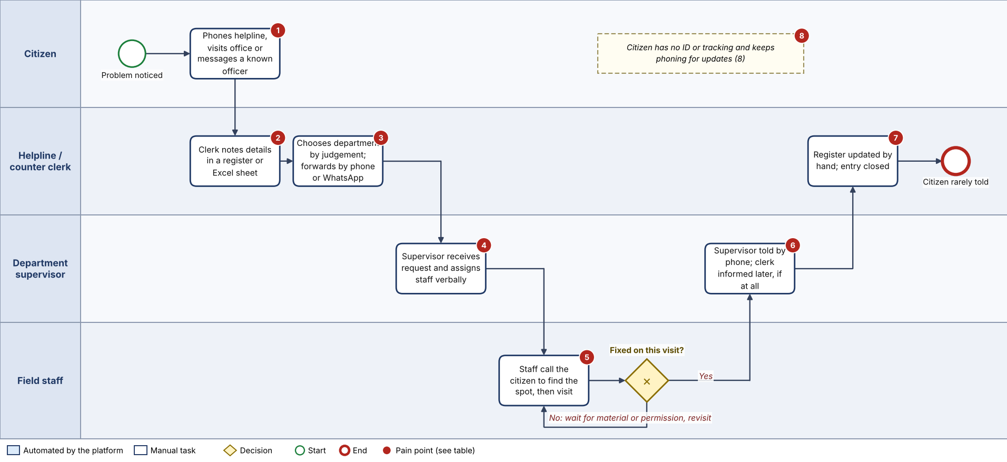
Figure 1. As-Is manual complaint handling (BPMN 2.0; source file VA-BPM-01_As-Is.bpmn)

3. Step description
Step | Actor | What happens | Medium | Pain point
1 | Citizen | Reports by phone, counter visit or message to a known officer, describing the place in words. | Voice, paper, chat | PP-1
2 | Clerk | Writes the details into a register or spreadsheet. No unique ID is given; location is not verified. | Register / Excel | PP-2
3 | Clerk | Decides which department owns the problem and forwards it. | Phone, letter, WhatsApp | PP-3
4 | Supervisor | Receives the request and assigns a crew by word of mouth. | Verbal | PP-4
5 | Field staff | Phone the citizen for the exact spot, visit the site, fix or note what is missing. | Phone, site visit | PP-5
6 | Supervisor | Is told the outcome by phone; tells the clerk later, if at all. | Phone | PP-6
7 | Clerk | Updates the register by hand and closes the entry. | Register | PP-7
8 | Citizen | Has no ticket to quote, so keeps calling to ask for progress. | Phone | PP-8

4. Pain points and root causes
ID | Pain point | Root cause | Business effect | Addressed by (To-Be)
PP-1 | Many channels, no common entry point | No single intake | Complaints get lost or reported twice | One portal, guest or verified access (FR-01 to FR-04)
PP-2 | No ID, no evidence, no verified location | Verbal description; paper register | Disputes; crews waste time finding the site | Live photo with GPS, time and address burned in (FR-06 to FR-08); ID on submit (FR-10)
PP-3 | Wrong department chosen by judgement | No category list or routing rule | Days lost before the right desk sees it | Category-led routing and controlled reassignment (FR-05, FR-23)
PP-4 | Verbal assignment, no owner on record | No assignment record | No accountability for who was sent | Assignment record with assigner and time (FR-19)
PP-5 | Site found through phone calls | Location not captured at source | Slow response, repeat visits | GPS coordinates and map link on the ticket (FR-06)
PP-6 | Outcome reaches supervisors late | No status update mechanism | No view of work in progress | Status workflow with live dashboards (FR-16, FR-17)
PP-7 | Closure is a hand entry; no breach record | No SLA, no timestamps | Delays invisible; no audit | SLA clock, breach reason and audit log (FR-13, FR-24, FR-30)
PP-8 | Citizen cannot track; chases by phone | No ticket or status view | Rising call load; low trust | Complaint ID, live status and feedback (FR-03, FR-21, FR-22)

5. Baseline measures to collect in the pilot
- Time from report to department receipt, and share of complaints sent to the wrong department.
- Time from receipt to site visit, and to closure, by category.
- Share of complaints with no recorded outcome, and number of citizen follow-up calls per complaint.

