To-Be Business Process: Automated Complaint Routing
Submission, routing, resolution and SLA escalation in VizagAlert
Document ID | VA-BPM-02 | Version / Date | 1.0 / 09 Nov 2026
Prepared by | Sai Balaji Budumuru, Business Analyst | Status | Issued for review
Case-study context: VizagAlert is a self-directed Business Analysis portfolio project for Visakhapatnam’s civic services. Items marked [A] are proposed assumptions, and items marked Proposed extend the working prototype; both need validation with the departments before any live use.

The To-Be process is shown as three linked diagrams so each stays readable: A covers submission and automated routing, B covers triage, resolution and reassignment, and C covers SLA monitoring and escalation. Light-blue tasks are performed by the platform with no human step.

1. Design principles
- Capture evidence at the source and never trust a later description of the place.
- Let the platform do routing, priority, duplicate checks, clocks and alerts, so officials spend time on the work itself.
- Every step that changes a ticket is recorded; nobody can change history.
- Escalate automatically on time, not on someone remembering.

2. Diagram A: Submit and route
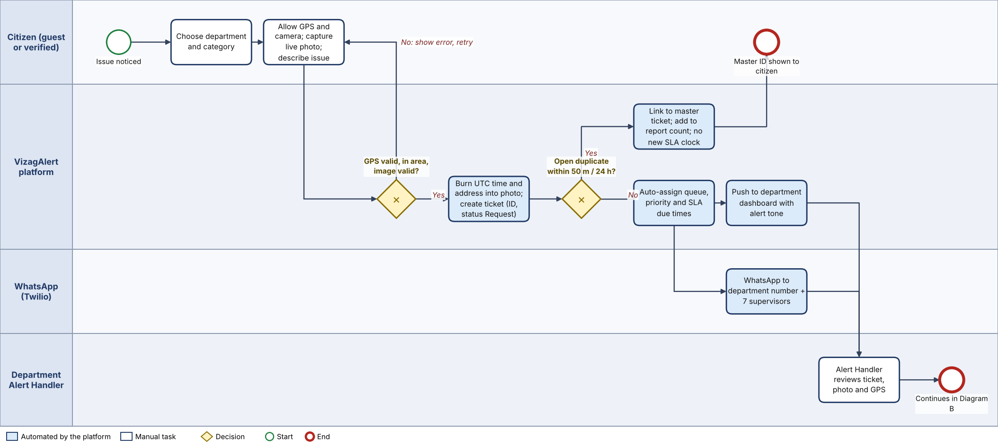
Figure 1. To-Be A, submission and automated routing (source: VA-BPM-02_To-Be-A.bpmn)
Ref | Step | Actor | Description | Requirements
A1 | Choose department and category | Citizen | Selects one of six department cards, then a category that belongs to it. | FR-04, FR-05
A2 | Allow GPS and camera; capture photo | Citizen | Location is checked before the camera opens. Photo comes from the live camera only; emergency number pinned on screen. | FR-06, FR-07, FR-09
A3 | Validate | Platform | Checks coordinates, boundary, file signature and size. Failure returns the citizen to A2 with an error. | FR-06, FR-07
A4 | Stamp and create ticket | Platform | Burns UTC time and address into the photo, uploads it, creates the ticket (status Request) and Complaint ID. | FR-08, FR-10
A5 | Duplicate check | Platform | Open ticket, same department and category, within 50 m and 24 h? If yes the report is linked and the citizen sees the master ID. | FR-11
A6 | Assign queue, priority, SLA | Platform | Sets department queue, priority from category, acknowledgement and resolution due times. | FR-12, FR-13, FR-14
A7 | Notify | Platform, WhatsApp | Pushes to open dashboards with a tone, and sends WhatsApp to the department number and seven supervisory contacts. | FR-15, FR-16
A8 | Review ticket | Alert Handler | Opens ticket with photo, GPS and time; continues in Diagram B. | FR-14

3. Diagram B: Triage, resolution and reassignment
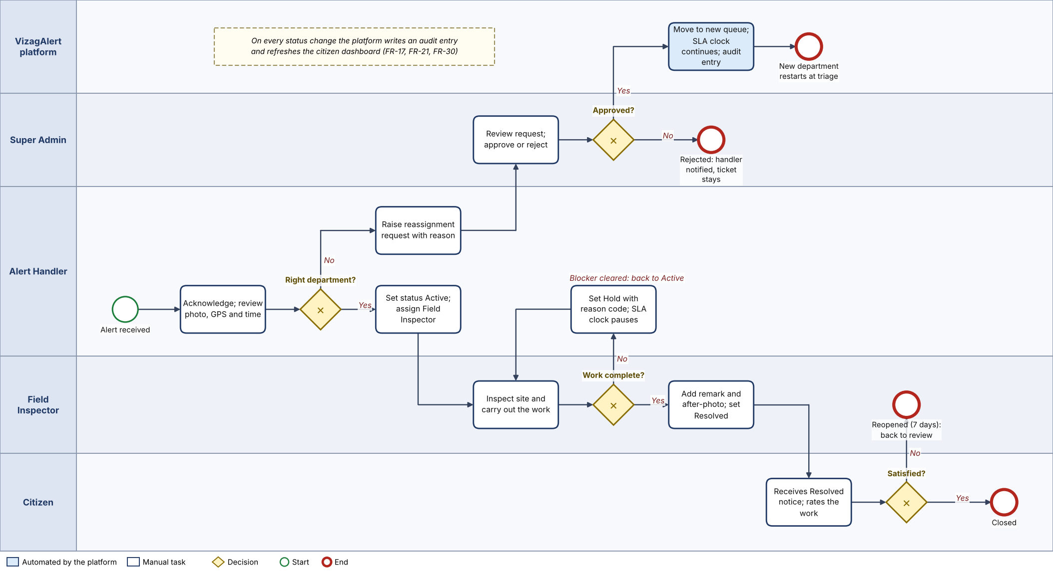
Figure 2. To-Be B, triage and resolution (source: VA-BPM-02_To-Be-B.bpmn)
Ref | Step | Actor | Description | Requirements
B1 | Acknowledge and review | Alert Handler | Reads photo, GPS and time; stops the acknowledgement clock. | FR-14, FR-17
B2 | Right department? | Alert Handler | If not, raises a reassignment request with a reason. Otherwise continues. | FR-23
B3 | Decide request | Super Admin | Approves or rejects. Approval moves the ticket to the new queue with the original SLA clock and writes an audit entry. A ticket may be reassigned at most twice. | FR-23, BR-11 to BR-13
B4 | Set Active; assign inspector | Alert Handler | Status becomes Active; inspector chosen from the department roster. | FR-17, FR-19
B5 | Inspect and work | Field Inspector | Visits the site and does the work. | FR-17
B6 | Work complete? | Field Inspector | If blocked, the ticket goes on Hold with a reason code and remark; the SLA clock pauses until the blocker clears. P1 tickets cannot be held. | FR-18
B7 | Resolve | Inspector / Handler | Adds a remark and optional after-photo and sets Resolved. An overdue ticket needs a breach reason. | FR-20, BR-22
B8 | Notify and rate | Citizen | Verified citizens see the change live and may rate the work. | FR-21, FR-22
B9 | Satisfied? | Verified Citizen | If not, can reopen within 7 days; the ticket returns to Alert Handler review. | FR-22

4. Diagram C: SLA monitoring and escalation
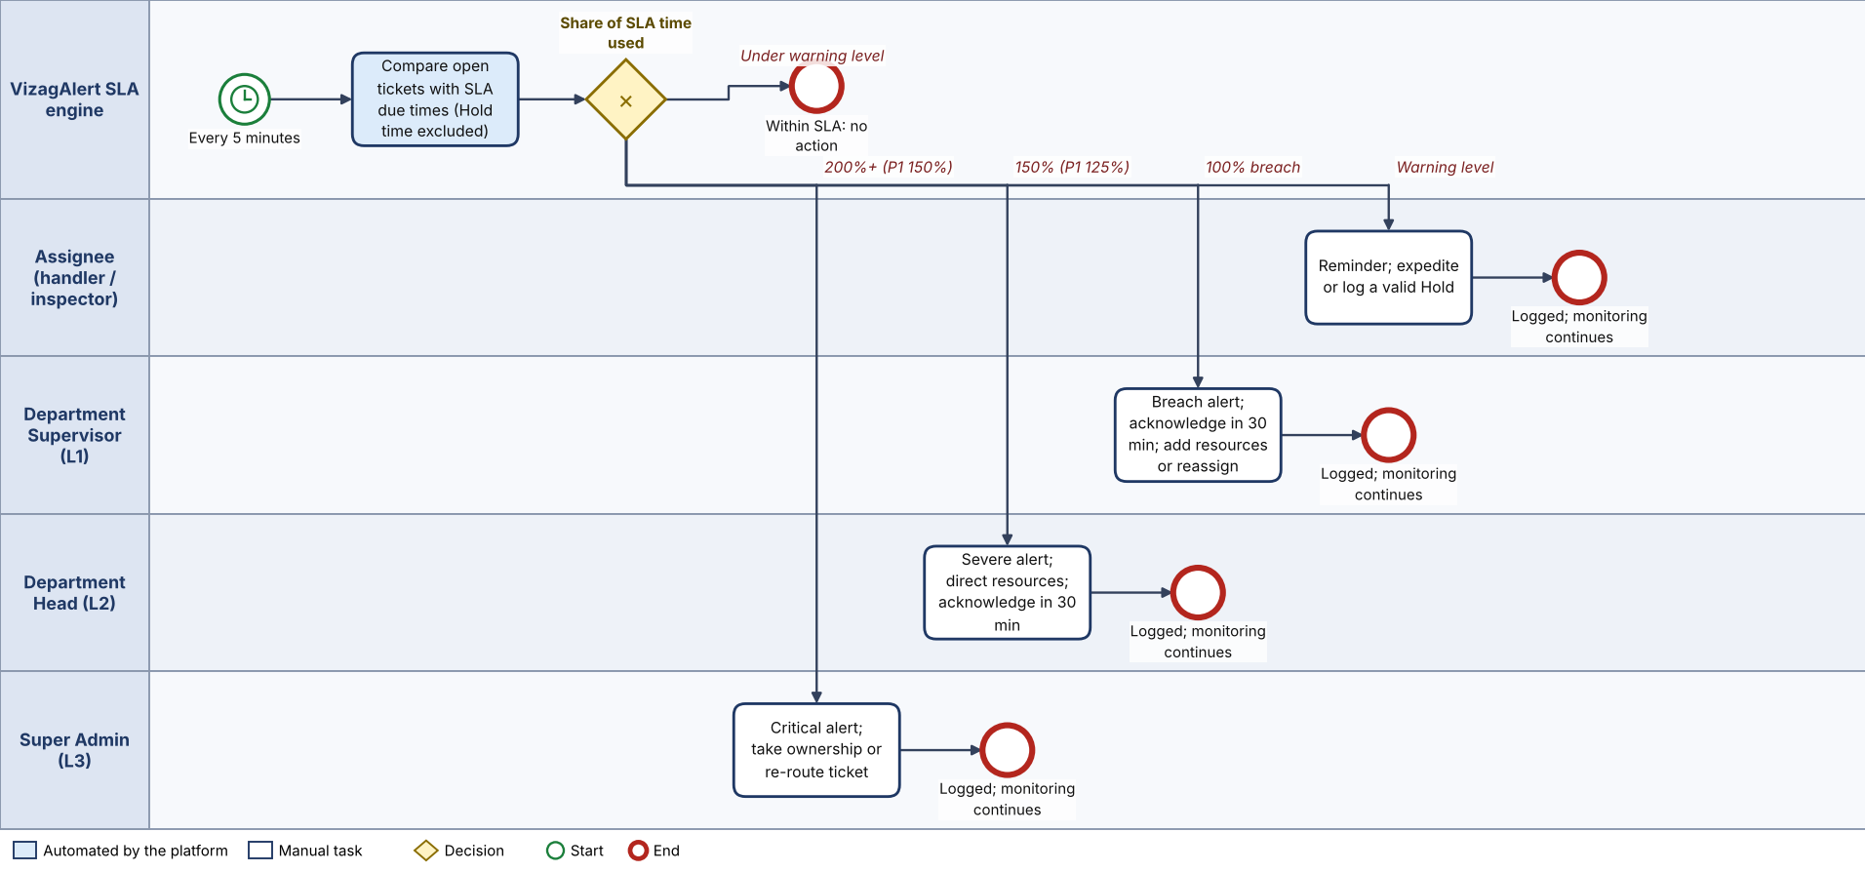
Figure 3. To-Be C, SLA monitoring and escalation (source: VA-BPM-02_To-Be-C.bpmn)
Ref | Step | Actor | Description | Requirements
C1 | Scheduled check | Platform | Every 5 minutes compares each open ticket with its due times, excluding time on Hold. | FR-24
C2 | Warning | Assignee | At the early-warning point the assignee and Alert Handler get a reminder. | FR-24
C3 | L1 breach | Supervisor | At 100% of target the Department Supervisor is alerted and must acknowledge within 30 minutes (10 for P1). | FR-25
C4 | L2 severe breach | Department Head | At 150% (P1: 125%) the Department Head is alerted. | FR-25
C5 | L3 critical breach | Super Admin | At 200% (P1: 150%) the Super Admin and the seven supervisory contacts are alerted; the Super Admin may take ownership or re-route. | FR-25

Exact thresholds by priority are in VA-SLA-01.

5. How the To-Be answers the pain points
As-Is pain point | To-Be change | Expected result
PP-1, PP-8 Scattered channels, no tracking | One portal; Complaint ID; live status | Fewer follow-up calls; every complaint on record
PP-2, PP-5 No evidence, location by phone | GPS gate and stamped live photo | Crews go straight to the site; evidence stands up
PP-3 Misrouting | Category-led routing; approved reassignment | Right desk within a minute; fewer bounced tickets
PP-4, PP-6 Verbal assignment and updates | Assignment record; status workflow; dashboards | Clear owner and live picture
PP-7 No clock, no audit | SLA clock, escalation ladder, append-only audit | Delays surface automatically and can be proved

