**Motivation**

The Lancet reports that uncontrolled hypertension would avert 10 million cardiovascular events worldwide over 10 years (Angell, Sonia Y, et al., 2015). Unfortunately, the measurement of blood pressure is not as straightforward as one might expect due to inherent issues related to human error, calibration issues and patient physiology. New techniques and technologies such as at home blood pressure monitoring have emerged to meet these challenges (Whelton, Paul K., et al., 2017). However, many of them are largely tailored towards privileged groups, ignoring the observation that those living in poor, rural communities have some of the highest risk of hypertension (Harris, J. K., Beatty, 2016). Thus, it appears that there is motivation to investigate how technologies might be used in a more equitable way to assist in hypertension control. Some research has been done on this front such as simplistic hypertension detection system (Golino, Hudson Fernandes, et al., 2014).

**Purpose**

Thus, the primary goal of this study is to investigate how machine learning might be used in a scalable manner to assist in measuring blood pressure. To do this, the study investigates if machine learning can improve upon traditional modeling techniques enough to provide baseline estimates for individuals in the US, using limited predictors. Subsequently, the best performing model can be used in a system that uses predictions to assess whether an observed blood pressure is anomalous in a variety of health settings.

**Methods**

Data for this study comes from National Health and Nutrition Examination Survey, an ongoing cohort study (CDC, 2019). Machine Learning methods are compared on their joint performance in predicting both systolic and diastolic blood pressure. The acceptable distance of an observed blood pressure to the predicted is determined if it has less than a 5% chance of being an observable blood pressure.

**Results**

Ultimately, Random forest offers considerably improvement over traditional methods. Figure 1 shows that the fit produces by random forest has an R-Square of 88% and 93% for systolic and diastolic blood pressure, respectively. This fitted distributions was used to select a cutoff value for blood pressures that may be a result of instrument miscalibration.

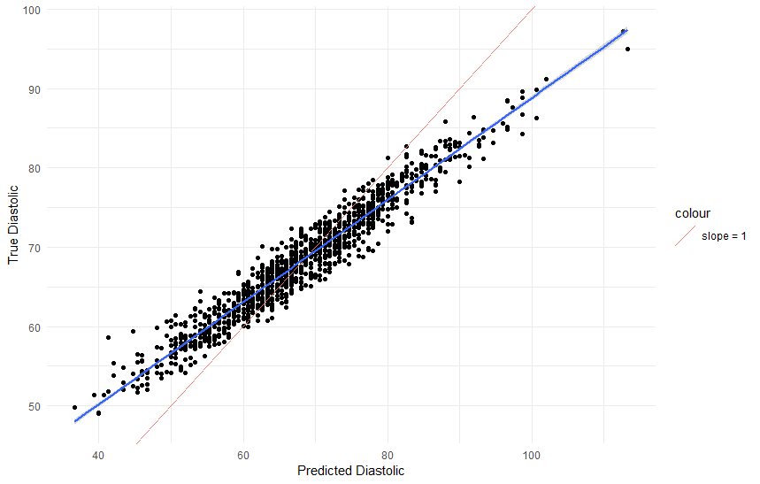**Figure 1: True Blood Pressure compered to Random Forest Prediction**

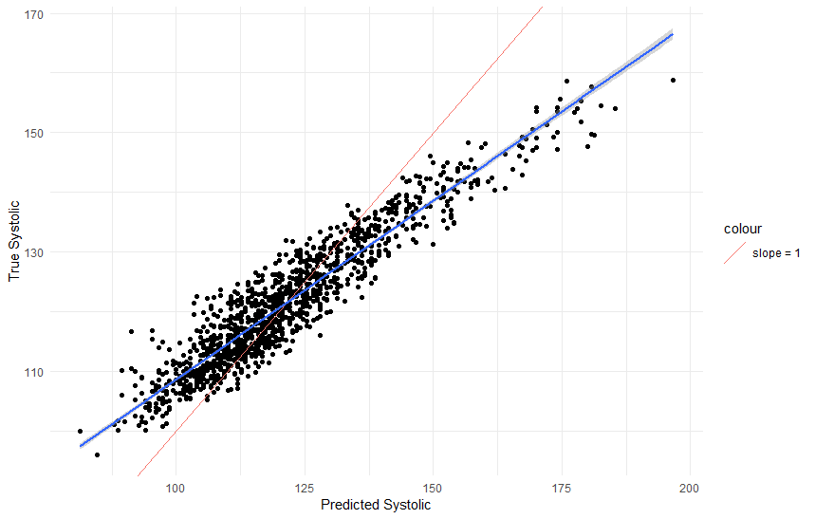

**Discussion**

While it may be the case that the prescribed system proves ineffective in practice, this demonstrates a proof of concept for how technology might be applied in a way that address serious issues in health such as hypertension control that does not exclusively cater to an affluent audience.

**Work cited**

1. Angell, S. Y., De Cock, K. M., & Frieden, T. R. (2015). A public health approach to global management of hypertension. *The Lancet*, *385*(9970), 825-827.
2. Whelton, P. K., Carey, R. M., Aronow, W. S., Casey, D. E., Collins, K. J., Himmelfarb, C. D., ... & MacLaughlin, E. J. (2018). 2017 ACC/AHA/AAPA/ABC/ACPM/AGS/APhA/ASH/ASPC/NMA/PCNA guideline for the prevention, detection, evaluation, and management of high blood pressure in adults: a report of the American College of Cardiology/American Heart Association Task Force on Clinical Practice Guidelines. *Journal of the American College of Cardiology*, *71*(19), e127-e248.
3. Harris, J. K., Beatty, K., Leider, J. P., Knudson, A., Anderson, B. L., & Meit, M. (2016). The double disparity facing rural local health departments. *Annual review of public health*, *37*, 167-184.
4. Golino, H. F., Amaral, L. S. D. B., Duarte, S. F. P., Gomes, C. M. A., Soares, T. D. J., Reis, L. A. D., & Santos, J. (2014). Predicting increased blood pressure using machine learning. Journal of obesity, 2014.
5. Centers for Disease Control and Prevention (CDC). (2019). National Health and Nutrition Examination Survey Questionnaire (NHANES). U.S. Department of Health and Human Services, Centers for Disease Control and Prevention. <https://wwwn.cdc.gov/nchs/nhanes/Default.aspx>.