For Windows 10/11
When you plug the usb to serial cable with pl2303 to your computer os Windows10/11, You’ll see below in your Device Manager,
Follow below Step to solve this problem

Step1, Install PL2303_Prolific.EXE First
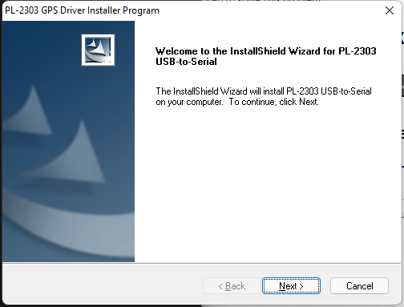

Step2, Update driver from Device Manager Manually
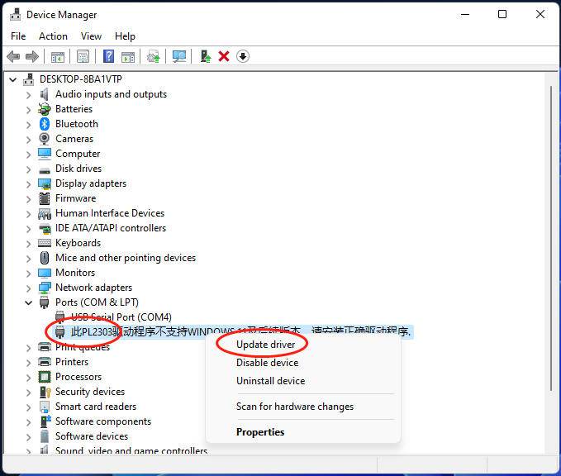

Step3,Choose Browse My Computer for drivers
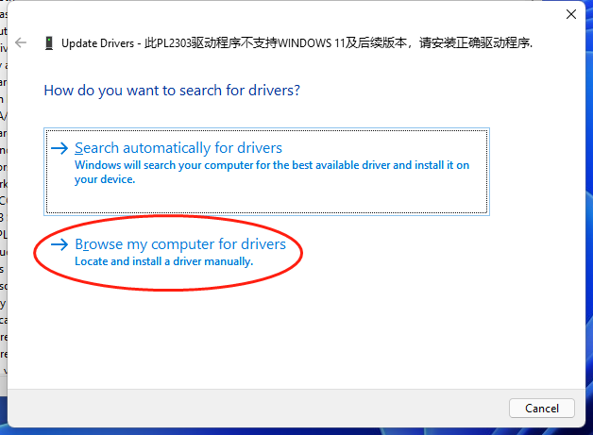

Step4, Choos Pick from a list
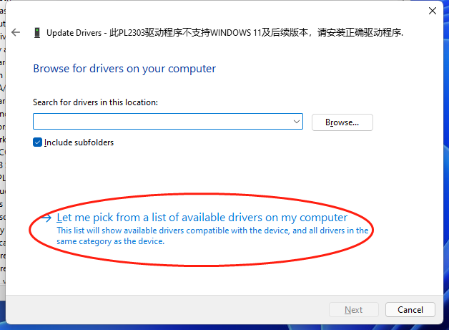

Step5,Choose older Version 3.3.2.105[10/27/2008]
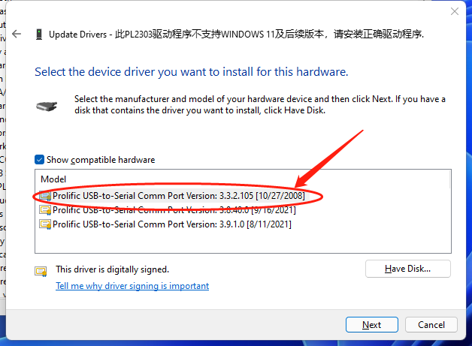

Step6,Become Prolific USB-to-Serial Comm Port
