# PROGRAM PRODUCTIVITY AND EFFICIENCY

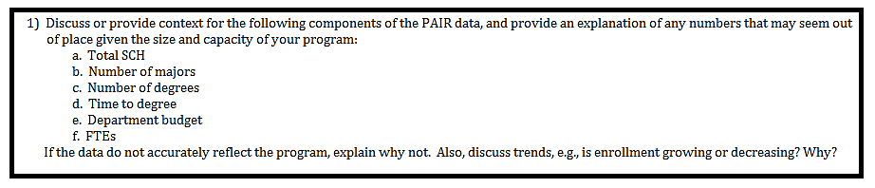

The department steadily has about 10 MS math students and graduates on average 2 students. Thus, the Major/Degree ration is 5. There is an error in the PAIR data. DMS graduated two MS students in 2011 (Jason Baggett and Odile Bastille) not one. Therefore the ratio is indeed 5 not 5.6. It takes some students more than two years to graduate (e.g. for those who are not supported by the department) and some students switch to MS in statistics. Only about two 2 students a year drop out due to either personal reasons and/or poor performance. Thus our graduation rate is above 50% which is a very healthy number as we are also able to maintain high standards and rigorous requirements. The department could sustain much larger graduate program but the number of TA positions is limited and other sources to support math grad students year around (i.e. RAs) is not in general available in math.

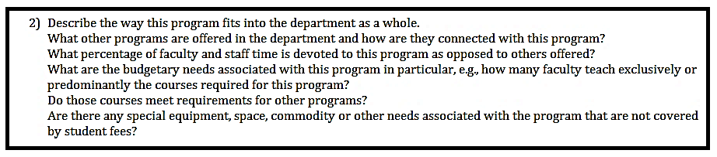

This program is deeply integrated into our department. Any academically strong department (please see more about this below) of math should have a strong graduate program. In fact, funding agencies like NSF explicitly require addressing broader impacts which explicitly assume working with students and/or postdocs. Our department is unable to offer postdoc fellowships and consistently support strong undergraduate research and thus maintaining its graduate program is crucially important to securing external funding in the extremely comparative market.

**What other programs are offered in the department and how are they connected with this program?**

Besides MS math DMS has PhD math, MS stat and BS/BA in math and stat.

**What percentage of faculty and staff time is devoted to this program?**

Our department teaches about four graduate courses a semester. Each PhD faculty member on average teaches about one graduate and one undergraduate course each semester.

**What are the budgetary needs associated with this program in particular, e.g., how many faculty teach exclusively or predominately the courses required for this program?**

All PhD level faculty members teach graduate courses and no faculty member would teach exclusively (or predominantly) graduate courses.

**Do those courses meet requirements for other programs?**

At least four regularly run courses do and attract students from other departments including Optimization, Math Modeling, Numerical Linear Algebra, and Math Physics.

**Are there any special equipment, space, commodity or other needs associated with the program that are not covered by student fees?**

No. Besides office space and computers nothing else is needed.



With some deficiencies (e.g. shortage of office space) the program has sufficient resources and meets its objectives.

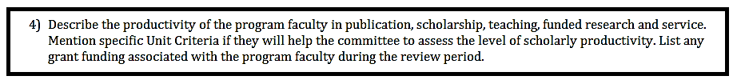

**Research papers**

Research faculty members with appointments in DMS have been extremely productive: over the 5 years of this review, a total of 122 papers have been published, along with 158 research presentations. Without even accounting for partial appointments in DMS, this works out to be almost two papers published per faculty member per year. DMS research faculty is exceedingly productive, particularly when measured using the publication norms in the Mathematical Sciences. Unit Criteria assumes one paper per person.

**Grant funding**

We next report the numbers, that is, how DMS research faculty measure up in terms of grant productivity:

Over the review period, research faculty in DMS applied for 41 grants of various types, ranging from small travel grants of a few thousand dollars to massive grants from the NSF, NASA, and NIH for hundreds of thousands of dollars. Remarkably, when restricting to grants over $100,000, we see that six faculty members have repeatedly been (and still are) funded by NSF, NASA, and NIH during the last five years.

Moreover, 6/11 ≈ 55% of the faculty were supported by large federally funded research grants. This should be considered in light of the fact that nationally less than 35% of mathematicians are supported by federal grants.

Funded grants for math faculty:

1. Allman: Mathematical and computational analysis for species tree inference (**NIH** R01GM117590; $1,543,627; 08/01/15 - 07/31/19). PIs John Rhodes and Elizabeth Allman. **NSF** "Enhancing Phylogenetic Methods and Theory via Algebraic Perspectives" 2007-2012 with co-PI J. Rhodes ($486,450); **NSF** "Participant Support: 2011 Mittag-Leffler Institute" ($48,515); Erskine Fellowship, University of Canterbury 2013; NIMBioS short-term visitor grant AIM SQuaRE grant (2011-2013); NIMBioS working group grant; GCAT Workshop on synthetic biology; Mittag Leffler Institute Research Fellowship; University of Tasmania Visiting ; Scholar SAMSI Research Fellow.
2. Avdonin: **NSF** grant 2014--2017, “Control and Inverse Problems for Differential Equations on Graphs” ($147,000); Australian Research Council grant “Interrogation and Estimation of Differential Equation Networks” (with W. Moran and M. Morelande) 2013—2015; **NSF** grant 2007--2011, “Boundary Inverse Problems in Glaciology” with M. Truffer and D. Maxwell ($385,000).
3. Berman: Simons Foundation Collaboration Grant for Mathematicians 7/1/2011 – 8/31/2016 ($35,000).
4. Bueler: Ed Bueler (PI), Mark Fahnestock (Co-I), Andy Aschwanden (Co-I), and Constantine Khroulev (senior personnel), Understanding measured variability in the Greenland ice sheet using the Parallel Ice Sheet Model (PISM), **NASA** Modeling Analysis and Prediction, NNX13AM16G, funding period June 2013--June 2017 ($737,000); Ed Bueler (PI), Regine Hock (Co-I), David Maxwell (Co-I), and Martin Truffer (Co-I), A high resolution Parallel Ice Sheet Model including fast, sliding flow: advanced development and application, **NASA** Modeling Analysis and Prediction, 2009—2013 ($994,000).
5. Gimbel: Czech National Science Foundation Scholarship; Charles University Research Fellowship.
6. Maxwell: **NSF** FRG: Collaborative Research: Analysis of the Einstein Constraint Equations, 2013-2014, ($150,000); Ed Bueler (PI), Regine Hock (Co-I), David Maxwell (Co-I), and Martin Truffer (Co-I), A high resolution Parallel Ice Sheet Model including fast, sliding flow: advanced development and application, NASA Modeling Analysis and Prediction, 2009--2013. ($994,000); NSF grant 2007--2011, “Boundary Inverse Problems in Glaciology” S. Avdonin with M. Truffer and D. Maxwell ($385,000).
7. Rhodes: Mathematical and computational analysis for species tree inference (**NIH** R01GM117590; $1,543,627; 08/01/15 - 07/31/19). PIs John Rhodes and Elizabeth Allman. **NSF** Grant #0714830: Enhancing Phylogenetic Methods and Theory via Algebraic Perspectives, Division of Mathematical Sciences, Program in Mathematical Biology; with co-PI Elizabeth Allman 2007-12 (partially in this period, but awarded earlier) ($486,450); AIM SQuaRE grant (2011-2013); Mittag Leffler Institute Research Fellowship and other fellowships; NIMBioS short-term visitor grant; Erskine Fellowship, University of Canterbury 2009; University of Tasmania Visiting Scholar.
8. Rybkin: **NSF** DMS-1411560, Integrable PDEs and Hankel operators, 09/01/14-08/30/17 ($213,000); **NSF** REU supplement; 05/01/15-08/30/17 ($42,000); **NSF** DMS 1009673, Inverse Scattering Transform and non-decaying solutions of completely integrable nonlinear PDE’s, 07/01/10-06/30/14 ($200,000); **NSF** DMS 1126006, REU supplement; 06/10/11-06/30/14 ($36,126); **NSF** DMS 0907801, REU supplement, 06/10/09-08/31/10 ($45,000); **NSF** DMS 0707476, Titchmarsh-Weyl m-function and integrable nonlinear PDE’s; 09/01/07-08/31/10 ($115,000).
9. Williams: Fields Institute Travel Grant.

**Teaching:**

As described in detail above, DMS contributes to teaching at all levels; it provides an important part of the baccalaureate core, it provides quantitative training for engineers and other technical disciplines, it provides quality graduate education.

Research faculty typically teach 2 courses each semester.

**Service:**

Members of DMS contribute to service in all its forms: department, university, professional, and public service. In addition to many departmental committees, DMS frequently has representatives serving on college-wide and university-wide committees. During the time of review, this included Faculty Senate, Program Review, University- wide Promotion and Tenure, Curriculum Review (both college- and university--‐wide), General Education Revitalization, Curricular Affairs, Unit Criteria and Faculty Affairs. There are several university-wide committees that have required DMS participation, including Core Review (which was chaired by the DMS representative for several years during the period under review) and Student Academic Development and Achievement.

Members of DMS have also served on various ad-hoc committees, such as the *Educate*

Subcommittee of the Strategic Planning Committee at UAF, the UAF Life Sciences Informatics Advising committee, and the system-wide General Education Learning Objectives committee.

In addition, DMS faculty served on the Joint Health Care Committee and on the Honors Faculty Advisory committee, and one DMS faculty member served as the Chief Negotiator for the current Collective Bargaining Agreement.

DMS faculty members regularly serve as judges at local science fairs, and one person recently was the plenary speaker for the New Mexico High School State Mathematics contest.

Research faculty are also highly involved with service to the discipline. Members of DMS regularly serve as peer reviewers for professional journals, and some faculty are associate editors and editors of peer-reviewed mathematics journals. They also write reviews of conferences and published papers. We note in closing that, after analyzing student success rates in lower-division MATH and DEVM courses, DMS initiated a Subcommittee on Math Placement which suggested using a new mechanism (the ALEKS placement test) for placing students into their MATH and DEVM (and STAT 200) courses in fall 2014. Roll-out of this new placement scheme involved faculty and staff across all areas of the university.

# NEED FOR PROGRAM



Mathematical and Statistical training are an integral part of UAF’s mission and fit well into UAF’s core themes. Thinking at a very high level, part of the university’s responsibility is to provide for adequate quantitative training of its citizens; to prepare Al Mathematical and Statistical training are an integral part of UAF’s mission and fit well into UAF’s core themes. Thinking at a very high level, part of the university’s responsibility is to provide for adequate quantitative training of its citizens; to prepare Alaska’s future workforce and to advance the boundaries of mathematical knowledge.

Specifically, the Mission Statement of the University of Alaska Fairbanks says that the university “…advances and disseminates knowledge through teaching, research and public service…”. The DMS directly contributes to this clause of the Mission Statement, by providing quality teaching to a majority of students in the university (through the required core mathematics requirement or through program requirements such as the calculus sequence), by frequently publishing articles on new research in mathematics and statistics in respected, peer-reviewed journals, and by contributing to the discipline and the general public as referees, members of editorial boards, local science fair judges, statistical consultants, organizers of math contests, as well as serving on local boards and being involved in the local community in ways less directly-connected to mathematics and statistics.

The MS in mathematics directly contribute to all of UAF’s Core Themes, namely **Educate**, **Discover**, **Connect, Prepare**, and **Engage.**

**Educate:** Courses used to fulfill requirements for the Math MS and some courses (Optimization, Math Modeling, Numerical Linear Algebra, and Math Physics) are used to fulfill requirements by some other units. Moreover, all other courses taught by PhD faculty and are used to fulfill requirements for the BS and BA in many other disciplines and are taken by students across the UAF campuses. Within the program, we provide a high-quality degree in mathematics, with various tracks to appeal to many different students, including those interested in pure mathematics and graduate school, those interested in a career in secondary teaching of mathematics, and those interested in working in the public sector or in industry.

**Discover:** The department has researchers who are highly productive, in a variety of mathematical and statistical disciplines. Departmental researchers frequently present at national and international conferences and are involved in collaborations

around the world. They also mentor students, both at the undergraduate and graduate levels, to discover their own paths to mathematical research.

**Prepare:** Courses that satisfy requirements for the Math MS are used to prepare students to continue on PhD programs, teach math at the college level, and to work in a variety of industries. All undergraduate courses math faculty teach also satisfy requirements for the BS and BA degrees in many other programs at all levels of the university, including serving as a significant mathematical core for many of Alaska’s budding engineers. The program also contributes to preparing future teachers of Alaska; many students go on to gain secondary certification in mathematics via the post-baccalaureate certification program. We anticipate that in the future, more students will pursue certification through the new BA in Secondary Education with an emphasis in mathematics.

**Connect:** Through eLearning and the offering of MATH and STAT courses at rural campuses, DMS connects students all over Alaska with undergraduate mathematics and statistics instruction and training.

**Engage:** Undergraduate math courses PhD faculty offer are taken by students of all age demographics in Alaska (advanced high school students, home-schooled students, college students, vocational students, returning non-traditional students, retired citizens, military personnel, etc.) and the courses offered through the B.A. and B.S. degree programs appeal to (and therefore engage) Alaskans in lifelong learning. In addition, as many job qualifications now require significant quantitative training (statistics, engineering), the role of DMS in offering its undergraduate courses is a boost to the economic development of Alaska.



**Quantitative fields at UAF**

DMS is in an implicit partnership with a huge number of majors and disciplines, which rely on the program to provide a solid mathematical background to students in quantitative fields. As discussed above, physics and all the engineering degrees require four math courses, and some of them (electrical engineering, petroleum engineering, computer engineering, computer science and some physics concentrations) require 5 or even 6 math courses.

**Parallel Ice Sheet Model Project**

The Parallel Ice Sheet Model (PISM; [www.pism-docs.org](http://www.pism-docs.org/)) is an open-source scientific software project based on a partnership of UAF with several other institutions.  The PI of this project is Bueler (DMS), Maxwell (DMS) was a recent Co-I, and four M.S. Mathematics students from DMS have worked on PISM-related projects and theses.

While UAF researchers account for about 85% of the code base of PISM, the most important PISM co-developer is the Potsdam Institute for Climate Impact Research (PIK), Potsdam, Germany, whose researchers account for key physics developments which form about 10% of the code base.  PIK-based lead authors have published 13 peer-reviewed articles using PISM since 2011, including three in Nature, all based on close collaboration and consultation with UAF researchers; for comparison there are 6 PISM-based publications with a UAF-based lead author since 2007.

In addition to PIK, the UAF PISM group has active collaboration with researchers at the following institutions

*  Danish Meteorology Institute, Copenhagen, Denmark

*  Centre for Ice and Climate, U. Copenhagen, Denmark

*  Max Planck Institute for Meteorology, Hamburg, Germany

*  Institute for Marine and Atmospheric Research, Utrecht, Netherlands

*  Victoria University, Wellington, New Zealand

*  Stockholm University, Stockholm, Sweden

*  NASA Goddard Institute of Space Studies, USA

which use PISM.  Collectively these additional collaborations have yielded 14 more peer-reviewed publications since 2011.  Clearly, these collaborations imply a high degree of international visibility for UAF-based ice sheet modeling, as an area of research in glaciology, climate science, and mathematical modeling.

The PISM project also represents a strong intra-UA partnership between DMS, GI, and ARSC.  Each of the four NASA grants supporting PISM, totaling $2.4M for the 2001-2017 period, have at least one DMS and at least one GI investigator, and each is based on resources from ARSC (i.e. computer resources, postdoc support, REU support, and consultation).

**Research Experience for Undergraduates**

For the review period (2010-2015), Prof. Alexei Rybkin has raised over $150,000 (mostly through REU supplements, with some contributions from GI and URSA) to support REU activity of 23 undergraduate students. The students participated in 9 distinct projects on math modeling (7 on nonlinear water wave phenomena and 2 on some other applied math topics). This activity has resulted in 3 published research paper, 1 submitted, and 1 in preparation, 18 talks (in colloquium series, domestic and international professional meetings). Besides Dr. Rybkin, Dmitry Nicolsky of GI was actively involved in 5 projects, and Efim Pelinovsky of Institute of Applied Physics, Russia (world-renowned authority on tsunami waves and a major international award recipient) was actively involved in 2 projects (none of which had monetary compensation).

**Joint MATH-CS Graph Theory Research Group**

Members of the DMS and the Computer Science department meet weekly to discuss research problems in graph theory. During the period under review, this collaboration has resulted in 2 papers, which are currently in review.

**Partnerships with Biology and Wildlife**

Faculty members Rhodes and Allman collaborate with faculty in Biology & Wildlife to help increase the quantitative knowledge of students and faculty in biology.  They both have “Research Faculty” appointments with IAB, and have served as informal and formal advisors on biology Ph.D. committees. They have also developed an interdisciplinary undergraduate course MATH/BIOL 393 in synthetic biology, and a graduate course in "Theory of Phylogenetics" that attracts students and faculty in biology and fisheries in addition to those in mathematics and statistics. The last time the “Theory of Phylogenetics” course was offered, students and faculty from UAA and UAS enrolled remotely.



No, only DMS at UAF offers a MS in Mathematics. UAA and UAS have BS/BA in mathematics.

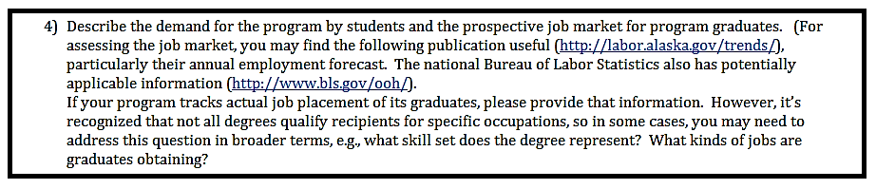

Our graduates are successful at continuing on PhD programs and finding professional jobs.

In the past five years, 10 students graduated from the program with a MS in Mathematics. Of those, five are currently enrolled in PhD programs, one is a full time and one is a part-time instructor in our department, one works as a software engineer and one as a bioinformatics programmer.

(I DON’T HAVE INFOR FOR KRIS KILPATRIC)

# MISSION FULFILLMENT



ATTACHMENTS:

1. PAIR data
2. Budget summary (DO WE NEED IT?)
3. SLOA plan BS Mathematics (DO WE HAVE IT?)