CPE301 – SPRING 2019

Design Assignment 1B

Student Name: John Patrick Buen

Student #: 2000900752

Student Email: buenj1@unlv.nevada.edu

Primary Github address: https://github.com/buenj1/submission_da.git

Directory:

Submit the following for all Labs:

1. In the document, for each task submit the modified or included code (only) with highlights and justifications of the modifications. Also, include the comments.
2. Use the previously create a Github repository with a random name (no CPE/301, Lastname, Firstname). Place all labs under the root folder ESD301/DA, sub-folder named LABXX, with one document and one video link file for each lab, place modified asm/c files named as LabXX-TYY.asm/c.
3. If multiple asm/c files or other libraries are used, create a folder LabXX-TYY and place these files inside the folder.
4. The folder should have a) Word document (see template), b) source code file(s) and other include files, c) text file with youtube video links (see template).

1. **COMPONENTS LIST AND CONNECTION BLOCK DIAGRAM w/ PINS**

Not required for this assignment

1. **INITIAL/MODIFIED/DEVELOPED CODE OF TASK 1/A**

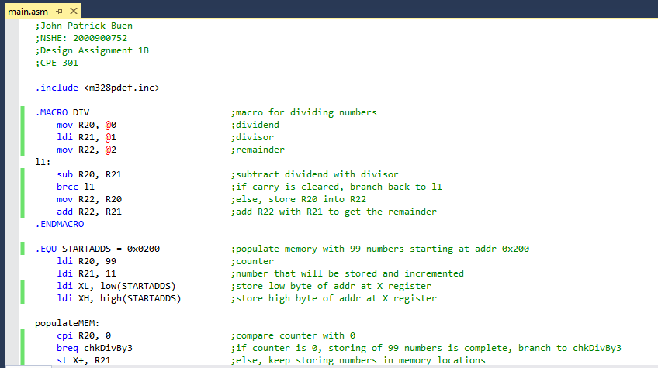

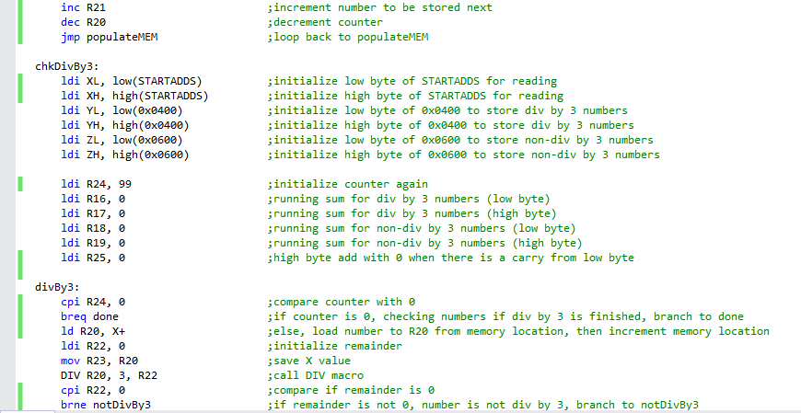

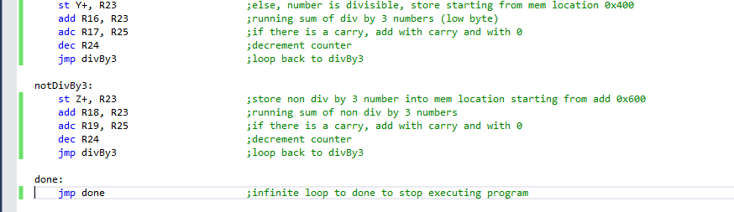

1. **DEVELOPED MODIFIED CODE OF TASK 2/A from TASK 1/A**
2. **SCHEMATICS**

Not required for this assignment

1. **SCREENSHOTS OF EACH TASK OUTPUT (ATMEL STUDIO OUTPUT)**

**Before execution**/population of 99 numbers starting at addr 0x200 (with initialized values):

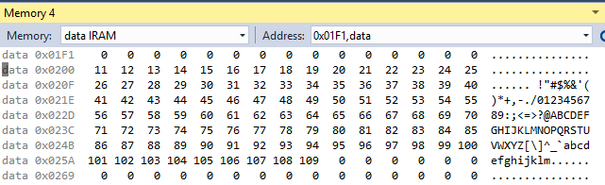

**After execution**/checked if number is div by 3 with running sum of numbers:

Mem location starting at 0x400 (div by 3 numbers)

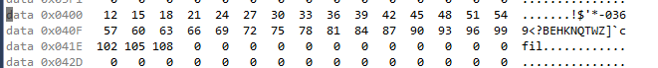

Mem location starting at 0x600 (non div by 3 numbers)

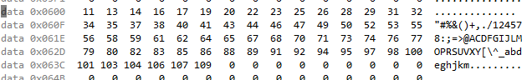

Sum of div and non div by 3 numbers

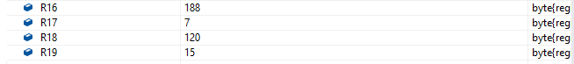

Execution Time @ 16MHz:

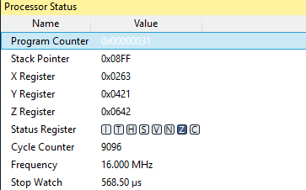

1. **SCREENSHOT OF EACH DEMO (BOARD SETUP)**

Not required for this assignment

1. **VIDEO LINKS OF EACH DEMO**

Not required for this assignment

1. **GITHUB LINK OF THIS DA**

https://github.com/buenj1/submission_da.git

**Student Academic Misconduct Policy**

<http://studentconduct.unlv.edu/misconduct/policy.html>

“This assignment submission is my own, original work”.

JOHN PATRICK BUEN