CPE301 – SPRING 2019

Design Assignment 3B

Student Name: John Patrick Buen

Student #: 2000900752

Student Email: buenj1@unlv.nevada.edu

Primary Github address: https://github.com/buenj1/submission_da.git

Directory:

Submit the following for all Labs:

1. In the document, for each task submit the modified or included code (only) with highlights and justifications of the modifications. Also, include the comments.
2. Use the previously create a Github repository with a random name (no CPE/301, Lastname, Firstname). Place all labs under the root folder ESD301/DA, sub-folder named LABXX, with one document and one video link file for each lab, place modified asm/c files named as LabXX-TYY.asm/c.
3. If multiple asm/c files or other libraries are used, create a folder LabXX-TYY and place these files inside the folder.
4. The folder should have a) Word document (see template), b) source code file(s) and other include files, c) text file with youtube video links (see template).

1. **COMPONENTS LIST AND CONNECTION BLOCK DIAGRAM w/ PINS**

Components: atmega328p Xplained Mini board, FTDI chip, male-female jumpers, micro USB, mini USB, LM35

Block Diagram:

ATMEGA328P block diagram:

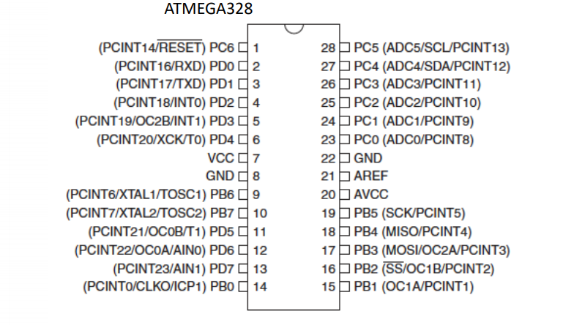

1. **INITIAL/MODIFIED/DEVELOPED CODE OF TASK 1**

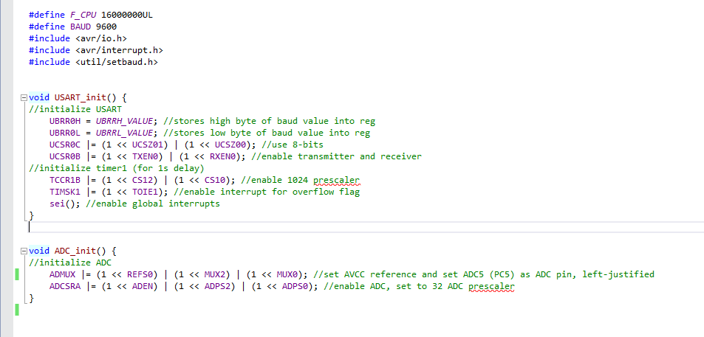

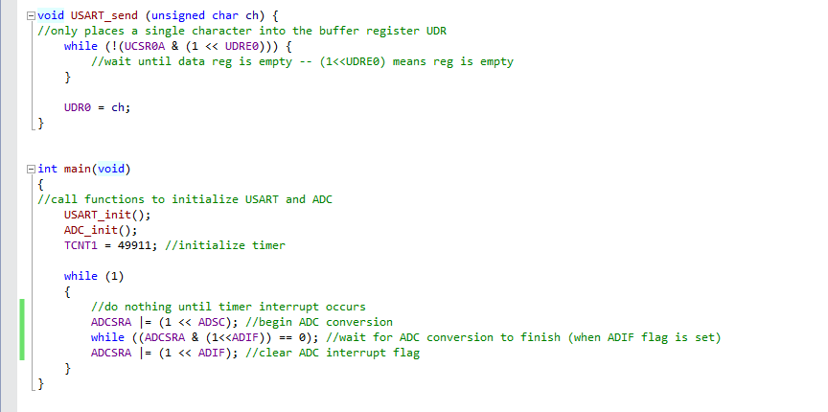

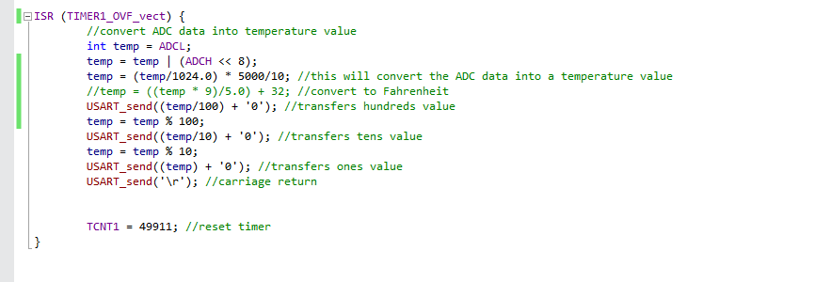

1. **SCHEMATICS**

FTDI Chip:

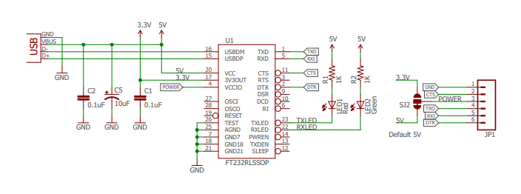

LM35:

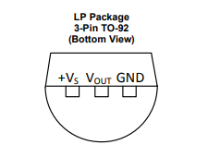

1. **SCREENSHOTS OF EACH TASK OUTPUT (ATMEL STUDIO OUTPUT)**

Using LM35

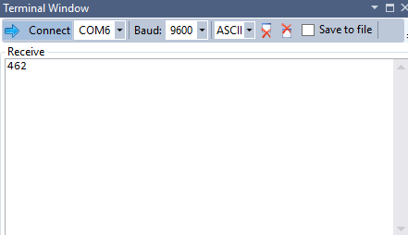

1. **SCREENSHOT OF EACH DEMO (BOARD SETUP)**

Setup:

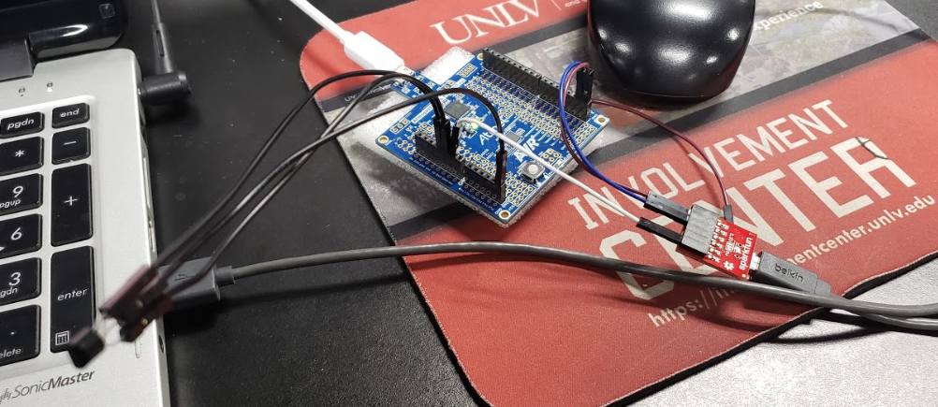

1. **VIDEO LINKS OF EACH DEMO**

None for this assignment

1. **GITHUB LINK OF THIS DA**

https://github.com/buenj1/submission_da.git

**Student Academic Misconduct Policy**

<http://studentconduct.unlv.edu/misconduct/policy.html>

“This assignment submission is my own, original work”.

JOHN PATRICK BUEN