CPE301 – SPRING 2019

MIDTERM 1

Student Name: John Patrick Buen

Student #: 2000900752

Student Email: buenj1@unlv.nevada.edu

Primary Github address: <https://github.com/buenj1/submission_da>

Directory:

Submit the following for all Labs:

1. In the document, for each task submit the modified or included code (only) with highlights and justifications of the modifications. Also, include the comments.
2. Use the previously create a Github repository with a random name (no CPE/301, Lastname, Firstname). Place all labs under the root folder ESD301/Midterm, sub-folder named LABXX, with one document and one video link file for each lab, place modified asm/c files named as LabXX-TYY.asm/c.
3. If multiple asm/c files or other libraries are used, create a folder LabXX-TYY and place these files inside the folder.
4. The folder should have a) Word document (see template), b) source code file(s) and other include files, c) text file with youtube video links (see template).

1. **COMPONENTS LIST AND CONNECTION BLOCK DIAGRAM w/ PINS**

Components: **atmega328p xplained mini board, ESP01 Module (ESP8266), ESP01 Programmer/Adapter (red), LM34**

Block Diagram:

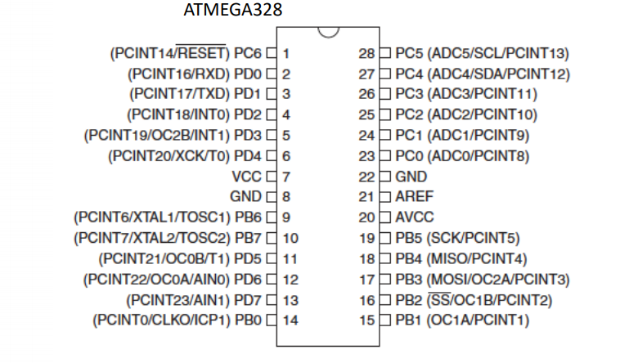

*Pins used*: PD0-PD1 -> RX and TX slots, PC0 -> ADC0 slot, 3.3V and GND

1. **INITIAL/MODIFIED/DEVELOPED CODE OF TASK**

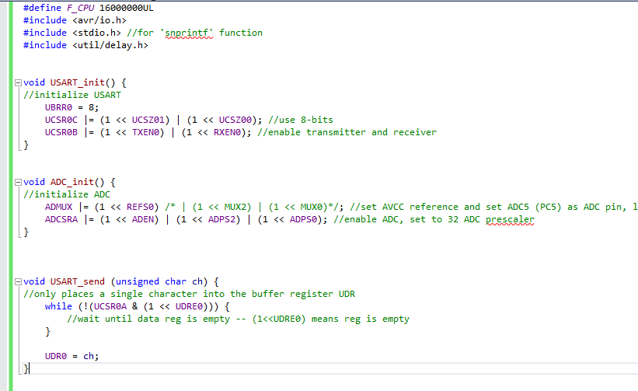

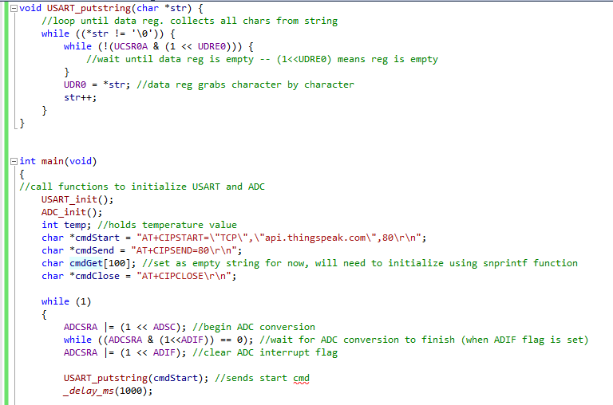

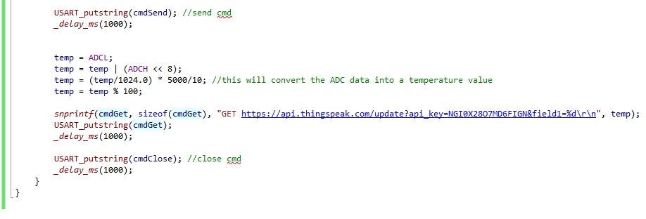

1. **SCHEMATICS**

ESP01 Module Schematic:

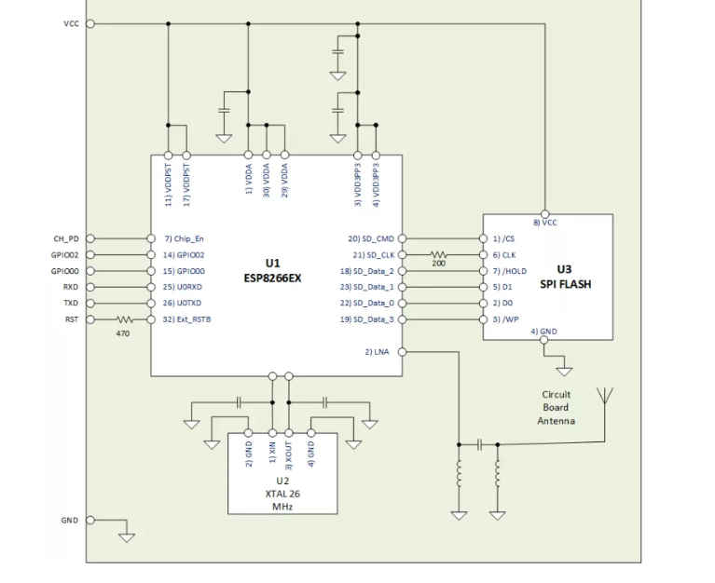

Pin outs for ESP01:

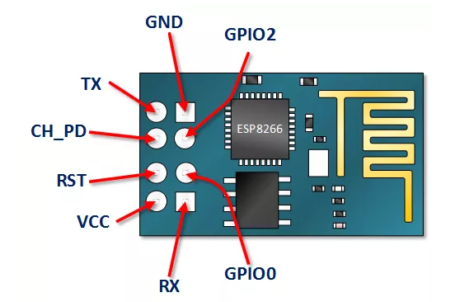

1. **SCREENSHOTS OF EACH TASK OUTPUT (ATMEL STUDIO OUTPUT)**

Temperature graph from Thingspeak:

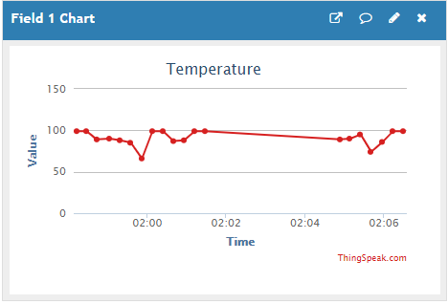

Data Visualizer Terminal:

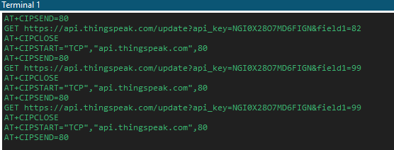

1. **SCREENSHOT OF EACH DEMO (BOARD SETUP)**

Setup for flashing firmware onto ESP01 module using USB to ESP01 Adapter

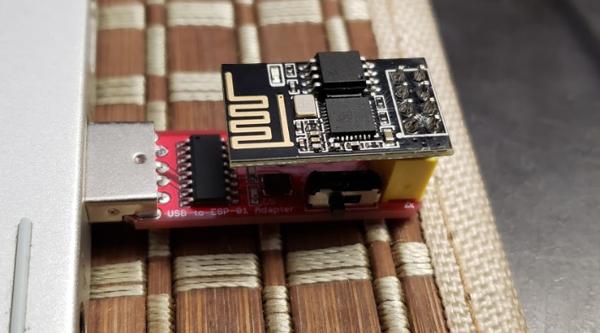

Setup for connecting xplained mini with the ESP01 Module and the LM34 temperature sensor

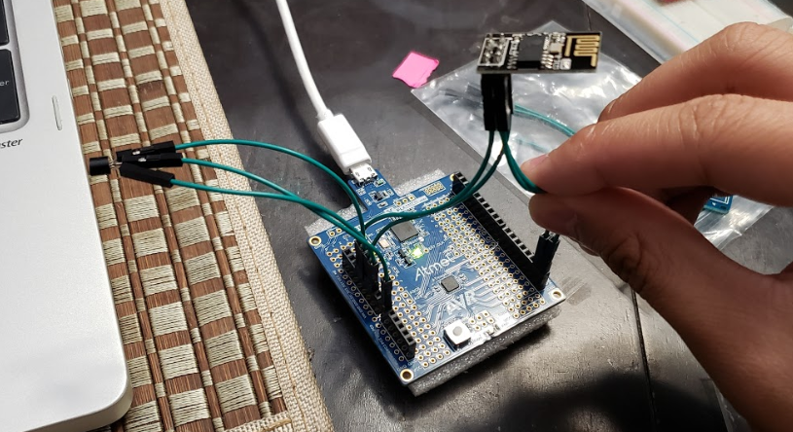

1. **GITHUB LINK OF THIS MIDTERM**

<https://github.com/buenj1/submission_da>

**Student Academic Misconduct Policy**

<http://studentconduct.unlv.edu/misconduct/policy.html>

“This assignment submission is my own, original work”.

John Patrick Buen