**Date Submitted: 12/4/19**

Youtube Links:

Task 3 - https://www.youtube.com/watch?v=3Q-srxBYgbQ

Task 4 - https://www.youtube.com/watch?v=6095Jg_yvqM

Task 5 - https://www.youtube.com/watch?v=HHGP1VU0s3I

Schematics/Images

Map of Assigned Pins from SCS

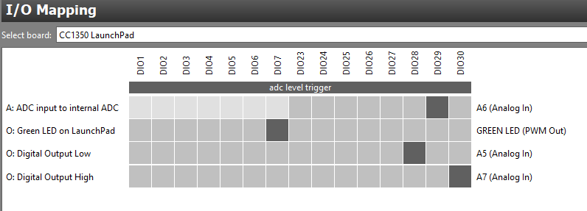

Task 3 – Graph of adcValue above/below the threshold

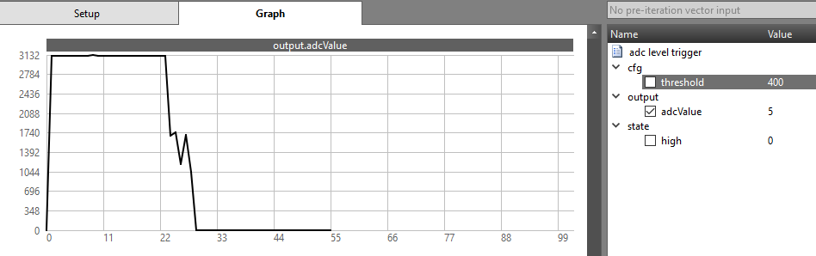

Task 5 – Packets received from transmitter to receiver

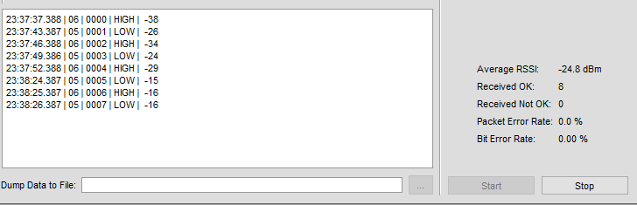

Code(s):

**Empty.c:**

/*

* Copyright (c) 2015-2019, Texas Instruments Incorporated

* All rights reserved.

*

* Redistribution and use in source and binary forms, with or without

* modification, are permitted provided that the following conditions

* are met:

*

* * Redistributions of source code must retain the above copyright

* notice, this list of conditions and the following disclaimer.

*

* * Redistributions in binary form must reproduce the above copyright

* notice, this list of conditions and the following disclaimer in the

* documentation and/or other materials provided with the distribution.

*

* * Neither the name of Texas Instruments Incorporated nor the names of

* its contributors may be used to endorse or promote products derived

* from this software without specific prior written permission.

*

* THIS SOFTWARE IS PROVIDED BY THE COPYRIGHT HOLDERS AND CONTRIBUTORS "AS IS"

* AND ANY EXPRESS OR IMPLIED WARRANTIES, INCLUDING, BUT NOT LIMITED TO,

* THE IMPLIED WARRANTIES OF MERCHANTABILITY AND FITNESS FOR A PARTICULAR

* PURPOSE ARE DISCLAIMED. IN NO EVENT SHALL THE COPYRIGHT OWNER OR

* CONTRIBUTORS BE LIABLE FOR ANY DIRECT, INDIRECT, INCIDENTAL, SPECIAL,

* EXEMPLARY, OR CONSEQUENTIAL DAMAGES (INCLUDING, BUT NOT LIMITED TO,

* PROCUREMENT OF SUBSTITUTE GOODS OR SERVICES; LOSS OF USE, DATA, OR PROFITS;

* OR BUSINESS INTERRUPTION) HOWEVER CAUSED AND ON ANY THEORY OF LIABILITY,

* WHETHER IN CONTRACT, STRICT LIABILITY, OR TORT (INCLUDING NEGLIGENCE OR

* OTHERWISE) ARISING IN ANY WAY OUT OF THE USE OF THIS SOFTWARE,

* EVEN IF ADVISED OF THE POSSIBILITY OF SUCH DAMAGE.

*/

/*

* ======== empty.c ========

*/

/*Include Semaphores*/

**#include** <ti/sysbios/knl/Semaphore.h>

**#include** <ti/sysbios/BIOS.h>

// Main loop Semaphore

Semaphore_Struct semMainLoop;

Semaphore_Handle hSemMainLoop;

/*scif header and macro*/

**#include** "scif.h"

**#define** BV(x) (1 << (x))

/* For usleep() */

**#include** <unistd.h>

**#include** <stdint.h>

**#include** <stddef.h>

/* Driver Header files */

**#include** <ti/drivers/GPIO.h>

// #include <ti/drivers/I2C.h>

// #include <ti/drivers/SPI.h>

// #include <ti/drivers/UART.h>

// #include <ti/drivers/Watchdog.h>

/* Board Header file */

**#include** "Board.h"

/*SC Task Alert Handling*/

**void** **processTaskAlert**(**void**) {

// Clear the ALERT interrupt source

scifClearAlertIntSource();

//Do SC Task processing here

// Fetch 'state.high' variable from SC

uint8_t high = scifTaskData.adcLevelTrigger.state.high;

// Set Red LED state equal to the state.high variable

**GPIO_write**(Board_GPIO_RLED, high);

//Acknowledge the ALERT event

scifAckAlertEvents();

}

/*SC callback functions*/

**void** **scCtrlReadyCallback**(**void**) {

} // scCtrlReadyCallback

**void** **scTaskAlertCallback**(**void**) {

//Post to main loop semaphore

Semaphore_post(hSemMainLoop);

} // scTaskAlertCallback

/*

* ======== mainThread ========

*/

**void** \***tirtosScThread**(**void** *arg0)

{

// Semaphore initialization

Semaphore_Params semParams;

Semaphore_Params_init(&semParams);

Semaphore_construct(&semMainLoop, 0, &semParams);

hSemMainLoop = Semaphore_handle(&semMainLoop);

/* 1 second delay */

//uint32_t time = 1;

/* Call driver init functions */

**GPIO_init**();

// I2C_init();

// SPI_init();

// UART_init();

// Watchdog_init();

/* Configure the LED pin */

**GPIO_setConfig**(Board_GPIO_LED0, GPIO_CFG_OUT_STD | GPIO_CFG_OUT_LOW);

/* Turn on user LED */

**GPIO_write**(Board_GPIO_LED0, Board_GPIO_LED_ON);

/*SC Driver Initialization*/

// Initialize the Sensor Controller

scifOsalInit(); //init OSAL of the scif framework

scifOsalRegisterCtrlReadyCallback(scCtrlReadyCallback); //init CTRL ready callback

scifOsalRegisterTaskAlertCallback(scTaskAlertCallback); //init Task Alert callback

scifInit(&scifDriverSetup); //init SC task driver

// Set the Sensor Controller task tick interval to 1 second

uint32_t rtc_Hz = 1; // 1Hz RTC

scifStartRtcTicksNow(0x00010000 / rtc_Hz);

//bits 31:16 represent the seconds, bits 15:0 represent 1/65536 of a second

// Configure Sensor Controller tasks

scifTaskData.adcLevelTrigger.cfg.threshold = 600; //set threshold value

//Start Sensor Controller task

scifStartTasksNbl(BV(SCIF_ADC_LEVEL_TRIGGER_TASK_ID)); //execute task

**while** (1) {

// Wait on sem indefinitely

Semaphore_pend(hSemMainLoop, BIOS_WAIT_FOREVER);

// Call process function

processTaskAlert();

}

}

**------------------------------------------------------------------------------------**

**rfPacketTx.c:**

/*

* Copyright (c) 2019, Texas Instruments Incorporated

* All rights reserved.

*

* Redistribution and use in source and binary forms, with or without

* modification, are permitted provided that the following conditions

* are met:

*

* * Redistributions of source code must retain the above copyright

* notice, this list of conditions and the following disclaimer.

*

* * Redistributions in binary form must reproduce the above copyright

* notice, this list of conditions and the following disclaimer in the

* documentation and/or other materials provided with the distribution.

*

* * Neither the name of Texas Instruments Incorporated nor the names of

* its contributors may be used to endorse or promote products derived

* from this software without specific prior written permission.

*

* THIS SOFTWARE IS PROVIDED BY THE COPYRIGHT HOLDERS AND CONTRIBUTORS "AS IS"

* AND ANY EXPRESS OR IMPLIED WARRANTIES, INCLUDING, BUT NOT LIMITED TO,

* THE IMPLIED WARRANTIES OF MERCHANTABILITY AND FITNESS FOR A PARTICULAR

* PURPOSE ARE DISCLAIMED. IN NO EVENT SHALL THE COPYRIGHT OWNER OR

* CONTRIBUTORS BE LIABLE FOR ANY DIRECT, INDIRECT, INCIDENTAL, SPECIAL,

* EXEMPLARY, OR CONSEQUENTIAL DAMAGES (INCLUDING, BUT NOT LIMITED TO,

* PROCUREMENT OF SUBSTITUTE GOODS OR SERVICES; LOSS OF USE, DATA, OR PROFITS;

* OR BUSINESS INTERRUPTION) HOWEVER CAUSED AND ON ANY THEORY OF LIABILITY,

* WHETHER IN CONTRACT, STRICT LIABILITY, OR TORT (INCLUDING NEGLIGENCE OR

* OTHERWISE) ARISING IN ANY WAY OUT OF THE USE OF THIS SOFTWARE,

* EVEN IF ADVISED OF THE POSSIBILITY OF SUCH DAMAGE.

*/

/***** Includes *****/

/*String and Semaphore Libraries*/

**#include** <string.h> // strlen() and memcpy()

**#include** <ti/sysbios/knl/Semaphore.h>

**#include** <ti/sysbios/BIOS.h>

**#include** "scif.h"

**#define** BV(x) (1 << (x))

// Semaphore variables - struct and handle

Semaphore_Struct semMainLoop;

Semaphore_Handle hSemMainLoop;

/* Standard C Libraries */

**#include** <stdlib.h>

**#include** <unistd.h>

/* TI Drivers */

**#include** <ti/drivers/rf/RF.h>

**#include** <ti/drivers/PIN.h>

**#include** <ti/drivers/pin/PINCC26XX.h>

**#include** <ti/drivers/GPIO.h>

/* Driverlib Header files */

**#include** DeviceFamily_constructPath(driverlib/rf_prop_mailbox.h)

/* Board Header files */

**#include** "Board.h"

**#include** "smartrf_settings/smartrf_settings.h"

/***** Defines *****/

/* Do power measurement */

//#define POWER_MEASUREMENT

/* Packet TX Configuration */

**#define** PAYLOAD_LENGTH 30

**#ifdef** POWER_MEASUREMENT

**#define** PACKET_INTERVAL 5 /* For power measurement set packet interval to 5s */

**#else**

**#define** PACKET_INTERVAL 500000 /* Set packet interval to 500000us or 500ms */

**#endif**

/***** Prototypes *****/

/***** Variable declarations *****/

**static** RF_Object rfObject;

**static** RF_Handle rfHandle;

/* Pin driver handle */

**static** PIN_Handle ledPinHandle;

**static** PIN_State ledPinState;

**static** uint8_t packet[PAYLOAD_LENGTH];

**static** uint16_t seqNumber;

/*

* Application LED pin configuration table:

* - All LEDs board LEDs are off.

*/

//Board_LED1 is controlled by SC

PIN_Config pinTable[] =

{

Board_PIN_LED0 | PIN_GPIO_OUTPUT_EN | PIN_GPIO_LOW | PIN_PUSHPULL | PIN_DRVSTR_MAX,

**#ifdef** POWER_MEASUREMENT

**#if** defined(Board_CC1350_LAUNCHXL)

Board_DIO30_SWPWR | PIN_GPIO_OUTPUT_EN | PIN_GPIO_HIGH | PIN_PUSHPULL | PIN_DRVSTR_MAX,

**#endif**

**#endif**

PIN_TERMINATE

};

/***** Function definitions *****/

/*SC Callbacks*/

**void** **scCtrlReadyCallback**(**void**) {

// Do nothing

} // scCtrlReadyCallback

**void** **scTaskAlertCallback**(**void**) {

// Signal main loop

Semaphore_post(hSemMainLoop);

} // scTaskAlertCallback

**void** \***txTaskFunction**(**void** *arg0)

{

RF_Params rfParams;

**RF_Params_init**(&rfParams);

/* Open LED pins */

ledPinHandle = **PIN_open**(&ledPinState, pinTable);

**if** (ledPinHandle == NULL)

{

**while**(1);

}

**#ifdef** POWER_MEASUREMENT

**#if** defined(Board_CC1350_LAUNCHXL)

/* Route out PA active pin to Board_DIO30_SWPWR */

PINCC26XX_setMux(ledPinHandle, Board_DIO30_SWPWR, PINCC26XX_MUX_RFC_GPO1);

**#endif**

**#endif**

RF_cmdPropTx.pktLen = PAYLOAD_LENGTH;

RF_cmdPropTx.pPkt = packet;

RF_cmdPropTx.startTrigger.triggerType = TRIG_NOW;

/* Request access to the radio */

**#if** defined(DeviceFamily_CC26X0R2)

rfHandle = RF_open(&rfObject, &RF_prop, (RF_RadioSetup*)&RF_cmdPropRadioSetup, &rfParams);

**#else**

rfHandle = **RF_open**(&rfObject, &RF_prop, (RF_RadioSetup*)&RF_cmdPropRadioDivSetup, &rfParams);

**#endif**// DeviceFamily_CC26X0R2

/* Set the frequency */

**RF_postCmd**(rfHandle, (RF_Op*)&RF_cmdFs, *RF_PriorityNormal*, NULL, 0);

// Main Loop Semaphore initialization

Semaphore_Params semParams;

Semaphore_Params_init(&semParams);

semParams.mode = Semaphore_Mode_BINARY;

Semaphore_construct(&semMainLoop, 0, &semParams);

hSemMainLoop = Semaphore_handle(&semMainLoop);

**GPIO_init**();

// Initialize the Sensor Controller

scifOsalInit();

scifOsalRegisterCtrlReadyCallback(scCtrlReadyCallback);

scifOsalRegisterTaskAlertCallback(scTaskAlertCallback);

scifInit(&scifDriverSetup);

// Set the Sensor Controller task tick interval to 1 second

uint32_t rtc_Hz = 1; // 1Hz RTC

scifStartRtcTicksNow(0x00010000 / rtc_Hz);

// Configure Sensor Controller tasks

scifTaskData.adcLevelTrigger.cfg.threshold = 600;

// Start Sensor Controller task

scifStartTasksNbl(BV(SCIF_ADC_LEVEL_TRIGGER_TASK_ID));

// Main loop

**while**(1) {

// Wait for signal

Semaphore_pend(hSemMainLoop, BIOS_WAIT_FOREVER);

// Clear the ALERT interrupt source

scifClearAlertIntSource();

// Get 'state.high', and set highStr to appropriate string

uint16_t high = scifTaskData.adcLevelTrigger.state.high;

**const** **char** *highStr = (high != 0) ? "HIGH" : "LOW";

uint16_t highStrLen = **strlen**(highStr);

// Populate packet, and set pktlen

packet[0] = (uint8_t)(seqNumber >> 8);

packet[1] = (uint8_t)(seqNumber++);

**memcpy**(packet + 2, highStr, highStrLen);

RF_cmdPropTx.pktLen = 2 + highStrLen;

// Send packet Tx

**RF_runCmd**(rfHandle, (RF_Op*)&RF_cmdPropTx, *RF_PriorityNormal*, NULL, 0);

// Toggle pin

**PIN_setOutputValue**(ledPinHandle, Board_PIN_LED0, high);

// Acknowledge the ALERT event

scifAckAlertEvents();

}

}

**------------------------------------------------------------------------------------**