CPE 403 ADV EMB SYS DES F 2019

TITLE: TI-RTOS Assignment

GOAL: The goal of this assignment is to create 3 tasks: 1. ADC task, 2. UART task, and 3. a switch read task. Each task will be executed in order every 30 ms.

* A HWI timer runs every 1 ms. The timer is incremented every 1 ms and will then be reset back to 0 once it reaches 30 ms (or the 30th instance).
* At every **10th instance**, the ADC values are updated and read (ADC task).
* At every **20th instance**, the current ADC value read from the previous task is displayed onto the terminal (UART task)
* At every **30th instance**, the state of a switch is read (either SW1 or SW2):
  + if the switch **was pressed**, update and set a new pulse width value (duty cycle).
  + if the switch **was not pressed**, do not update/change the pulse width value (duty cycle).

DELIVERABLES:

Tasks (all are completed):

* *ADC Task* – read the value of the ADC coming from the output of the potentiometer.
* *UART Task* – display the recently obtained ADC value onto a local terminal
* *Switch Read Task* – read the state of a switch. If the switch was pressed, update the duty cycle of the PWM signal. Else, do not update the duty cycle of the PWM.

COMPONENTS:

* TIVAC TM4C (TI-RTOS)
* Potentiometer: used to read the ADC values from
* Breadboard and jumper wires

SCHEMATICS and PICTURES:

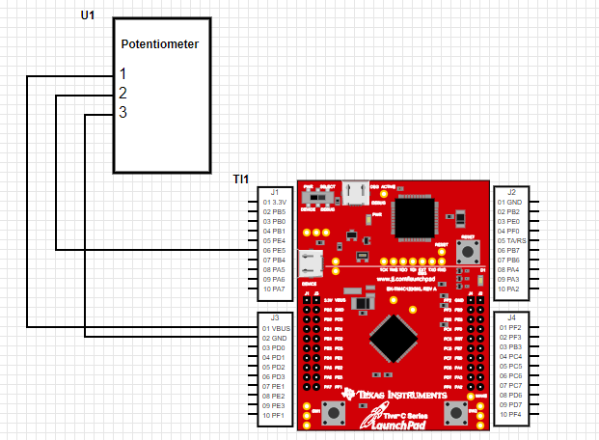Schematic Overview:

Samples of ADC Values (read from potentiometer):

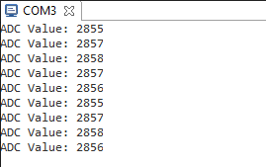

Sampled PWM Signal Showing the Pulse Width and Duty Cycle:

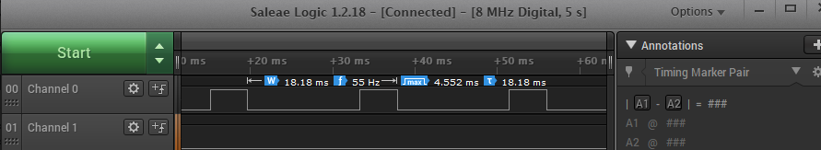

Execution Graph (showing the HWI timer and the switch read task, note: timer executes every 1 ms):

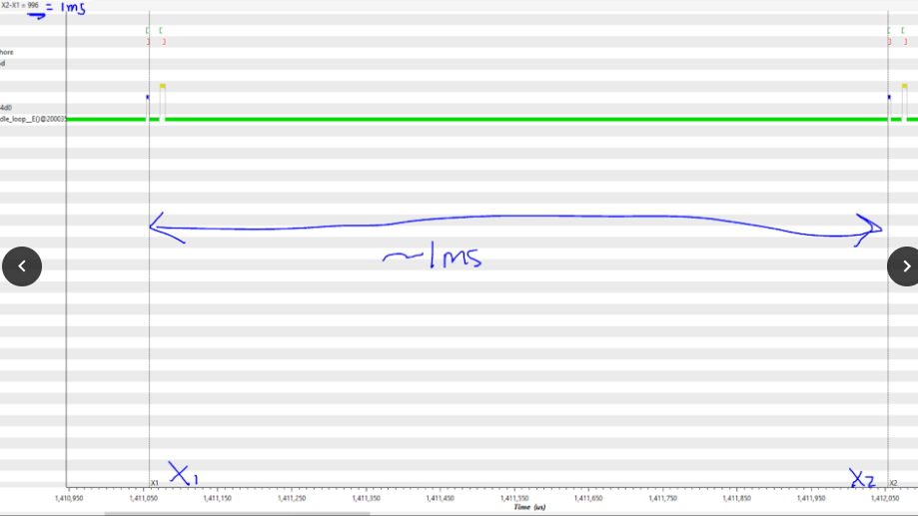

Graph is showing it in microseconds. The value above (~996us is around 1ms)

IIMPLEMENTATION:

CODE:

/*

* Copyright (c) 2015, Texas Instruments Incorporated

* All rights reserved.

*

* Redistribution and use in source and binary forms, with or without

* modification, are permitted provided that the following conditions

* are met:

// *

// * * Redistributions of source code must retain the above copyright

// * notice, this list of conditions and the following disclaimer.

// *

// * * Redistributions in binary form must reproduce the above copyright

// * notice, this list of conditions and the following disclaimer in the

// * documentation and/or other materials provided with the distribution.

// *

// * * Neither the name of Texas Instruments Incorporated nor the names of

// * its contributors may be used to endorse or promote products derived

// * from this software without specific prior written permission.

// *

// * THIS SOFTWARE IS PROVIDED BY THE COPYRIGHT HOLDERS AND CONTRIBUTORS "AS IS"

// * AND ANY EXPRESS OR IMPLIED WARRANTIES, INCLUDING, BUT NOT LIMITED TO,

// * THE IMPLIED WARRANTIES OF MERCHANTABILITY AND FITNESS FOR A PARTICULAR

// * PURPOSE ARE DISCLAIMED. IN NO EVENT SHALL THE COPYRIGHT OWNER OR

// * CONTRIBUTORS BE LIABLE FOR ANY DIRECT, INDIRECT, INCIDENTAL, SPECIAL,

// * EXEMPLARY, OR CONSEQUENTIAL DAMAGES (INCLUDING, BUT NOT LIMITED TO,

// * PROCUREMENT OF SUBSTITUTE GOODS OR SERVICES; LOSS OF USE, DATA, OR PROFITS;

// * OR BUSINESS INTERRUPTION) HOWEVER CAUSED AND ON ANY THEORY OF LIABILITY,

// * WHETHER IN CONTRACT, STRICT LIABILITY, OR TORT (INCLUDING NEGLIGENCE OR

// * OTHERWISE) ARISING IN ANY WAY OUT OF THE USE OF THIS SOFTWARE,

// * EVEN IF ADVISED OF THE POSSIBILITY OF SUCH DAMAGE.

// */

//

//----------------------------------------

// BIOS header files

//----------------------------------------

#include <xdc/std.h> //mandatory - have to include first, for BIOS types

#include <ti/sysbios/BIOS.h> //mandatory - if you call APIs like BIOS_start()

#include <xdc/runtime/Log.h> //needed for any Log_info() call

#include <xdc/cfg/global.h> //header file for statically defined objects/handles

//------------------------------------------

// TivaWare Header Files

//------------------------------------------

#include <stdint.h>

#include <stdbool.h>

#include "inc/hw_types.h"

#include "inc/hw_memmap.h"

#include "driverlib/sysctl.h"

#include "driverlib/gpio.h"

#include "inc/hw_ints.h"

#include "driverlib/interrupt.h"

#include "driverlib/timer.h"

#include "driverlib/adc.h"

#include "utils/uartstdio.h"

#include "driverlib/uart.h"

#include "driverlib/pin_map.h"

#include "driverlib/pwm.h"

//----------------------------------------

// Function Prototypes

//----------------------------------------

void hardware_init(void);

void HWI_Timer(void);

void adcTaskFxn(void);

void swReadTaskFxn(void);

void uartTaskFxn(void);

void InitConsole(void);

//---------------------------------------

// Define stmts and Global Variables

//---------------------------------------

#define PWM_FREQUENCY 55 // PWM frequency set to 55Hz

volatile int16_t counter;

uint32_t ui32ADC0Value[4];

uint32_t ui32ADCAvg;

uint32_t ui32Adjust;

volatile uint32_t ui32Load;

volatile uint32_t ui32PWMClock;

/*main function*/

int main(void)

{

hardware_init(); // call function to initialize the hardware

/* Start BIOS */

BIOS_start();

}

void InitConsole(void){

//Enable GPIO port A for UART pins

SysCtlPeripheralEnable(SYSCTL_PERIPH_GPIOA);

//Configure UART pins for Rx and Tx

GPIOPinConfigure(GPIO_PA0_U0RX);

GPIOPinConfigure(GPIO_PA1_U0TX);

//Enable UART0.

SysCtlPeripheralEnable(SYSCTL_PERIPH_UART0);

//Use the internal 16MHz oscillator

UARTClockSourceSet(UART0_BASE, UART_CLOCK_PIOSC);

//Select the alternate (UART) function for these pins

GPIOPinTypeUART(GPIO_PORTA_BASE, GPIO_PIN_0 | GPIO_PIN_1);

//Initialize the UART

UARTStdioConfig(0, 115200, 16000000);

}

//---------------------------------------------------------------------------

// hardware_init()

//

// inits GPIO pins for toggling the LED

//---------------------------------------------------------------------------

void hardware_init(void)

{

uint32_t ui32Period;

counter = 0; // initialize counter to 0

//Set CPU Clock to 40MHz. 400MHz PLL/2 = 200 DIV 5 = 40MHz

SysCtlClockSet(SYSCTL_SYSDIV_5|SYSCTL_USE_PLL|SYSCTL_XTAL_16MHZ|SYSCTL_OSC_MAIN);

SysCtlPWMClockSet(SYSCTL_PWMDIV_64);

SysCtlPeripheralEnable(SYSCTL_PERIPH_PWM1);

SysCtlPeripheralEnable(SYSCTL_PERIPH_GPIOD);

// ADD Tiva-C GPIO setup - enables port, sets pins 1-3 (RGB) pins for output

SysCtlPeripheralEnable(SYSCTL_PERIPH_GPIOF);

SysCtlPeripheralEnable(SYSCTL_PERIPH_GPIOE); // enable analog input 3 (PE0)

GPIOPinTypeGPIOOutput(GPIO_PORTF_BASE, GPIO_PIN_1|GPIO_PIN_2|GPIO_PIN_3);

GPIOPinTypeGPIOInput(GPIO_PORTF_BASE, GPIO_PIN_0|GPIO_PIN_4);

GPIOPinTypeADC(GPIO_PORTE_BASE, GPIO_PIN_0); // use PE0 (AIN3 - channel 3) for potentiometer

GPIOPadConfigSet(GPIO_PORTF_BASE, GPIO_PIN_0|GPIO_PIN_4, GPIO_STRENGTH_2MA, GPIO_PIN_TYPE_STD_WPU);

//initialize PWM

ui32PWMClock = SysCtlClockGet() / 64;

ui32Load = (ui32PWMClock / PWM_FREQUENCY) - 1;

GPIOPinTypePWM(GPIO_PORTD_BASE, GPIO_PIN_0); //PD0 PWM pin

GPIOPinConfigure(GPIO_PD0_M1PWM0);

PWMGenConfigure(PWM1_BASE, PWM_GEN_0, PWM_GEN_MODE_DOWN);

PWMGenPeriodSet(PWM1_BASE, PWM_GEN_0, ui32Load);

PWMOutputState(PWM1_BASE, PWM_OUT_0_BIT, true);

PWMGenEnable(PWM1_BASE, PWM_GEN_0);

//initialize ADC

SysCtlPeripheralEnable(SYSCTL_PERIPH_ADC0);

ADCHardwareOversampleConfigure(ADC0_BASE, 64);

ADCSequenceConfigure(ADC0_BASE, 1, ADC_TRIGGER_PROCESSOR, 0);

// using channel 3 for the ADC samples

ADCSequenceStepConfigure(ADC0_BASE, 1, 0, ADC_CTL_CH3);

ADCSequenceStepConfigure(ADC0_BASE, 1, 1, ADC_CTL_CH3);

ADCSequenceStepConfigure(ADC0_BASE, 1, 2, ADC_CTL_CH3);

ADCSequenceStepConfigure(ADC0_BASE, 1, 3, ADC_CTL_CH3 | ADC_CTL_IE | ADC_CTL_END);

ADCSequenceEnable(ADC0_BASE, 1);

// Initialize Timer 2 for the HWI

SysCtlPeripheralEnable(SYSCTL_PERIPH_TIMER2);

TimerConfigure(TIMER2_BASE, TIMER_CFG_PERIODIC);

ui32Period = (SysCtlClockGet() / 500); // period is around 1ms

TimerLoadSet(TIMER2_BASE, TIMER_A, ui32Period);

TimerIntEnable(TIMER2_BASE, TIMER_TIMA_TIMEOUT);

TimerEnable(TIMER2_BASE, TIMER_A);

// call function to initialize UART

InitConsole();

}

void adcTaskFxn(void){

// read ADC value, store into variable,

// set the pulse width according to the ADC value

while(1){

ADCIntClear(ADC0_BASE, 1);

ADCProcessorTrigger(ADC0_BASE, 1);

while (!ADCIntStatus(ADC0_BASE, 1, false)) {}

ADCSequenceDataGet(ADC0_BASE, 1, ui32ADC0Value);

ui32ADCAvg = (ui32ADC0Value[0] + ui32ADC0Value[1] + ui32ADC0Value[2] + ui32ADC0Value[3] + 2)/4;

ui32Adjust = ui32ADCAvg; // store ADC avg value into the ui32Adjust variable

Semaphore_pend (sem_ADC, BIOS_WAIT_FOREVER);

}

}

void uartTaskFxn(void){

// display the current ADC value on terminal

while(1){

UARTprintf("ADC Value: %d\n", ui32Adjust);

Semaphore_pend (sem_UART, BIOS_WAIT_FOREVER);

}

}

void swReadTaskFxn(void){

// when the switch is pressed, the duty cycle of the PWM

// changes according to the ADC value

while(1){

// if switch 1 is pressed down...

if(GPIOPinRead(GPIO_PORTF_BASE, GPIO_PIN_4)==0x00)

{

// set and adjust the width of the PWM using the ui32Adjust value

PWMPulseWidthSet(PWM1_BASE, PWM_OUT_0, ui32Adjust);

}

Semaphore_pend (sem_swRead, BIOS_WAIT_FOREVER);

}

}

void HWI_Timer(void){

// HWI executes every 1ms

// at every 10th instance, ADC task is executed

// at every 20th instance, UART task is executed

// at every 30th instance, swRead task is executed and reset the counter

TimerIntClear(TIMER2_BASE, TIMER_TIMA_TIMEOUT); // clear Timer interrupt

counter++; // increment counter every time HWI occurs

// every time the pulse is high, turn on LED, else, turn off LED

// the duration of the time that is high depends on the pulse width value

// that was set in the sw read function

if(GPIOPinRead(GPIO_PORTD_BASE, GPIO_PIN_0))

{

GPIOPinWrite(GPIO_PORTF_BASE, GPIO_PIN_1|GPIO_PIN_2|GPIO_PIN_3, 4);

}

else

{

GPIOPinWrite(GPIO_PORTF_BASE, GPIO_PIN_2, 0);

}

// execute ADC

if (counter == 10){

Semaphore_post (sem_ADC);

}

// execute UART and display current ADC value

else if (counter == 20){

Semaphore_post (sem_UART);

}

// execute sw Read task and read if the switch is pressed or not

// if pressed, change the pwm pulse width according to the ADC value

else if (counter == 30){

Semaphore_post (sem_swRead);

counter = 0; // reset counter

}

}