|  |  |  |  |
| --- | --- | --- | --- |
| № | ti, с | ti −⟨t⟩N, с | (ti −⟨t⟩N)2, с2 |
|  | 8.01 |  |  |
|  | 8.03 |  |  |
|  | 8.02 |  |  |
|  | 7.90 |  |  |
|  | 8.01 |  |  |
|  | 7.96 |  |  |
|  | 8.00 |  |  |
|  | 8.01 |  |  |
|  | 7.96 |  |  |
|  | 8.00 |  |  |
|  | 8.02 |  |  |
|  | 8.01 |  |  |
|  | 7.89 |  |  |
|  | 7.92 |  |  |
|  | 7.99 |  |  |
|  | 7.95 |  |  |
|  | 7.91 |  |  |
|  | 7.96 |  |  |
|  | 8.05 |  |  |
|  | 8.01 |  |  |
|  | 8.03 |  |  |
|  | 7.98 |  |  |
|  | 8.1 |  |  |
|  | 8.05 |  |  |
|  | 7.95 |  |  |
|  | 8.00 |  |  |
|  | 7.97 |  |  |
|  | 7.99 |  |  |
|  | 8.08 |  |  |
|  | 8.06 |  |  |
|  | 7.97 |  |  |
|  | 7.97 |  |  |
|  | 7.93 |  |  |
|  | 8.00 |  |  |
|  | 7.97 |  |  |
|  | 7.95 |  |  |
|  | 7.99 |  |  |
|  | 7.94 |  |  |
|  | 7.98 |  |  |
|  | 8.04 |  |  |
|  | 7.96 |  |  |
|  | 8.05 |  |  |
|  | 7.94 |  |  |
|  | 7.99 |  |  |
|  | 7.98 |  |  |
|  | 8.00 |  |  |
|  | 7.97 |  |  |
|  | 7.90 |  |  |
|  | 8.02 |  |  |
|  | 8.04 |  |  |
|  | выборочное значение среднего = 7.99 | -0.09 | выборочное среднеквадратичное отклонение = 0.05  максимальное значение плотности распределения = 7.98 |

|  |  |  |  |  |
| --- | --- | --- | --- | --- |
| Границы интервалов, c | Дельта N | (Дельта N) / (N *(Дельта t)), c^(-1) | 𝑡, c | 𝜌, c ^(-1) |
| 7.89 | 4 | 4/1,5=2, 2/3 | 7,905 | 2.22 |
| 7.92 |
| 7.92 | 6 | 6/1,5=4 | 7.935 | 4.84 |
| 7.95 |
| 7.95 | 10 | 10/1,5=6, 2/3 | 7.965 | 7.37 |
| 7.98 |
| 7.98 | 16 | 16/1,5=10, 2/3 | 7.995 | 7.82 |
| 8.01 |
| 8.01 | 7 | 7/1,5=4, 2/3 | 8.025 | 5.79 |
| 8.04 |
| 8.04 | 4 | 4/1,5=2, 2/3 | 8.055 | 2.99 |
| 8.07 |
| 8.07 | 3 | 3/1,5=2 | 8.085 | 1.08 |
| 8.10 |

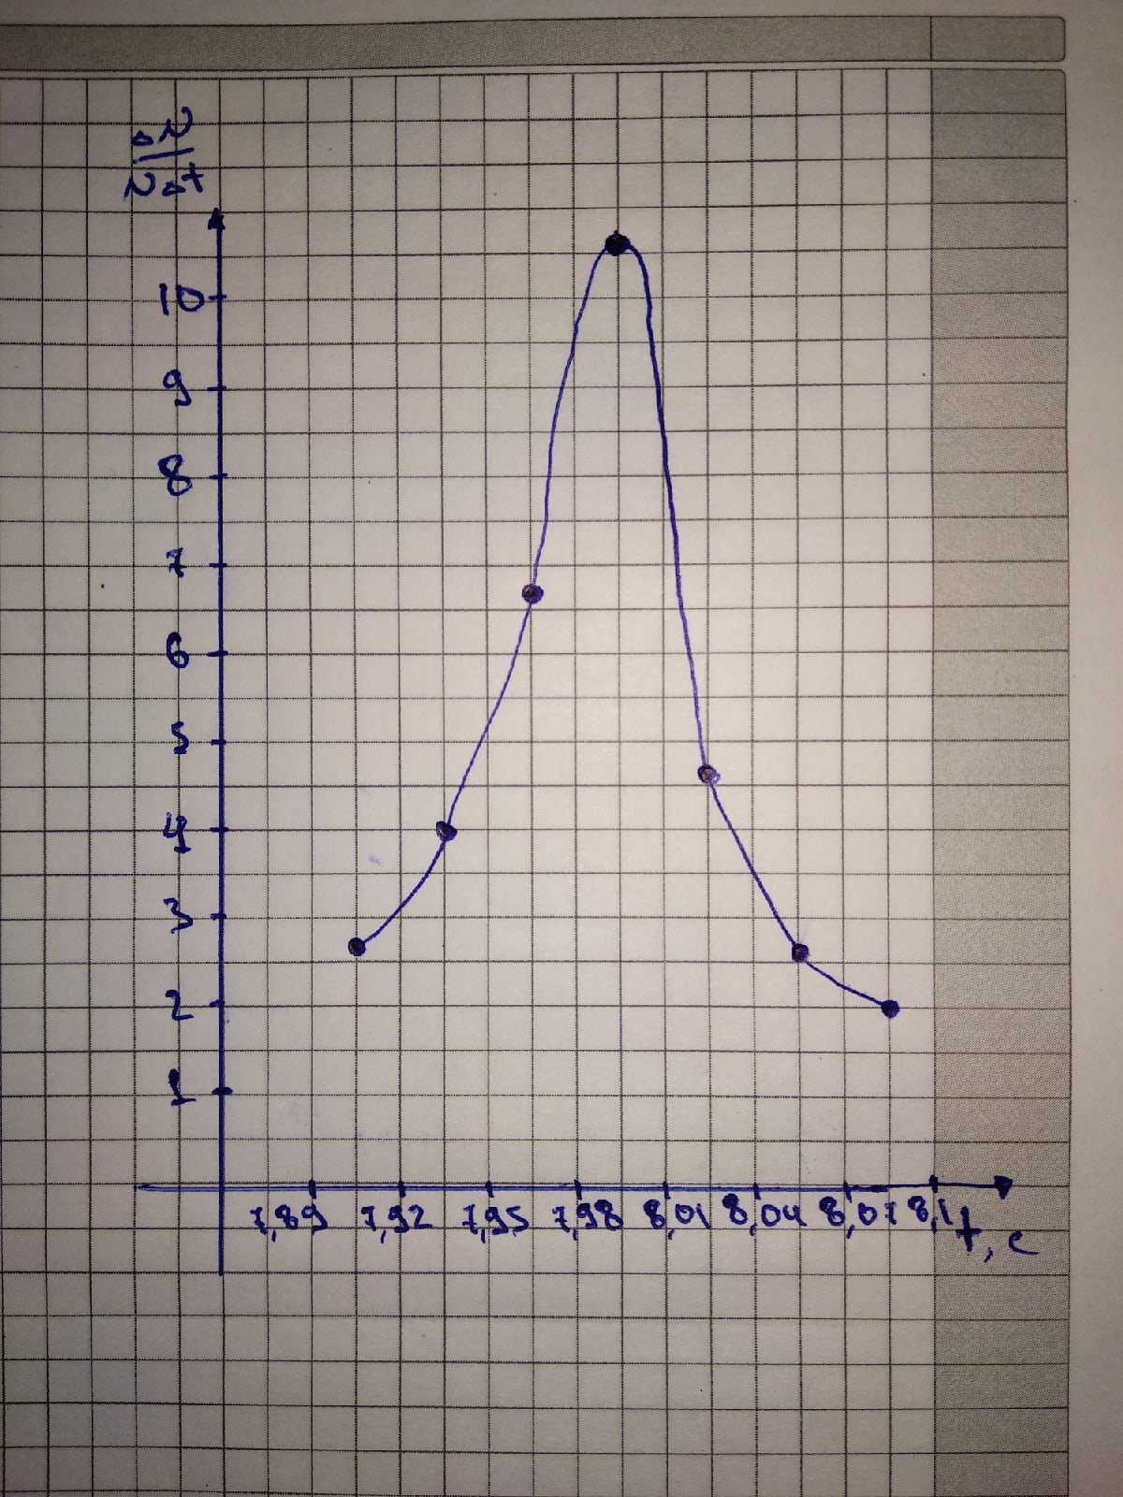

|  |  |  |  |  |  |
| --- | --- | --- | --- | --- | --- |
|  | от | до | Дельта N | Дельта N / N | P |
| (T)N ± σN | 7.94 | 8.04 | 38 | 38/50 | 0,76 |
| (T)N ± 2σN | 7.89 | 8.09 | 49 | 49/50 | 0,98 |
| (T)N ± 3σN | 7.84 | 8.14 | 50 | 50/50 | 1 |

t =2.01*0.95=1.91