Ryan Coughlin

CS-583

Prof. Price

3/31/2022

Deepest Dungeon Game Design Document (GDD)

***‘Escape the deep dungeon and reach the light of day’***  – Ryan Coughlin

This page: Table of Contents and Team Member Listing

|  |  |  |
| --- | --- | --- |
| Table of Contents  [1 Game Overview](https://n-xovwktmtjsnaxyc2mwes2xu7pohqedmdm6zjw5q-2lu-script.googleusercontent.com/userCodeAppPanel)  [2 High Concept](https://n-xovwktmtjsnaxyc2mwes2xu7pohqedmdm6zjw5q-2lu-script.googleusercontent.com/userCodeAppPanel) / Genre  [3 Unique Selling Points](https://n-xovwktmtjsnaxyc2mwes2xu7pohqedmdm6zjw5q-2lu-script.googleusercontent.com/userCodeAppPanel)  [4 Platform Minimum Requirements](https://n-xovwktmtjsnaxyc2mwes2xu7pohqedmdm6zjw5q-2lu-script.googleusercontent.com/userCodeAppPanel)  [5 Competitors / Similar Titles](https://n-xovwktmtjsnaxyc2mwes2xu7pohqedmdm6zjw5q-2lu-script.googleusercontent.com/userCodeAppPanel)  [6 Synopsis](https://n-xovwktmtjsnaxyc2mwes2xu7pohqedmdm6zjw5q-2lu-script.googleusercontent.com/userCodeAppPanel)  [7 Game Objectives](https://n-xovwktmtjsnaxyc2mwes2xu7pohqedmdm6zjw5q-2lu-script.googleusercontent.com/userCodeAppPanel)  [8 Game Rules](https://n-xovwktmtjsnaxyc2mwes2xu7pohqedmdm6zjw5q-2lu-script.googleusercontent.com/userCodeAppPanel)  [9 Game Structure](https://n-xovwktmtjsnaxyc2mwes2xu7pohqedmdm6zjw5q-2lu-script.googleusercontent.com/userCodeAppPanel)  [10 Game Play](https://n-xovwktmtjsnaxyc2mwes2xu7pohqedmdm6zjw5q-2lu-script.googleusercontent.com/userCodeAppPanel)  [10.1 Game Controls](https://n-xovwktmtjsnaxyc2mwes2xu7pohqedmdm6zjw5q-2lu-script.googleusercontent.com/userCodeAppPanel)  [10.2 Game Camera](https://n-xovwktmtjsnaxyc2mwes2xu7pohqedmdm6zjw5q-2lu-script.googleusercontent.com/userCodeAppPanel)  [10.2.1 HUD](https://n-xovwktmtjsnaxyc2mwes2xu7pohqedmdm6zjw5q-2lu-script.googleusercontent.com/userCodeAppPanel)  [10.2.2 Maps](https://n-xovwktmtjsnaxyc2mwes2xu7pohqedmdm6zjw5q-2lu-script.googleusercontent.com/userCodeAppPanel)  [11 Players](https://n-xovwktmtjsnaxyc2mwes2xu7pohqedmdm6zjw5q-2lu-script.googleusercontent.com/userCodeAppPanel)  [11.1 Characters](https://n-xovwktmtjsnaxyc2mwes2xu7pohqedmdm6zjw5q-2lu-script.googleusercontent.com/userCodeAppPanel)  [11.2 Metrics](https://n-xovwktmtjsnaxyc2mwes2xu7pohqedmdm6zjw5q-2lu-script.googleusercontent.com/userCodeAppPanel)  [11.3 States](https://n-xovwktmtjsnaxyc2mwes2xu7pohqedmdm6zjw5q-2lu-script.googleusercontent.com/userCodeAppPanel)  [11.4 Weapons](https://n-xovwktmtjsnaxyc2mwes2xu7pohqedmdm6zjw5q-2lu-script.googleusercontent.com/userCodeAppPanel)  [12 Player Line-up](https://n-xovwktmtjsnaxyc2mwes2xu7pohqedmdm6zjw5q-2lu-script.googleusercontent.com/userCodeAppPanel)  [13 NPC](https://n-xovwktmtjsnaxyc2mwes2xu7pohqedmdm6zjw5q-2lu-script.googleusercontent.com/userCodeAppPanel)  [13.1 Enemies](https://n-xovwktmtjsnaxyc2mwes2xu7pohqedmdm6zjw5q-2lu-script.googleusercontent.com/userCodeAppPanel)  [13.1.1 Enemy States](https://n-xovwktmtjsnaxyc2mwes2xu7pohqedmdm6zjw5q-2lu-script.googleusercontent.com/userCodeAppPanel)  [13.1.2 Enemy Spawn Points](https://n-xovwktmtjsnaxyc2mwes2xu7pohqedmdm6zjw5q-2lu-script.googleusercontent.com/userCodeAppPanel)  [13.2 Allies / Companions](https://n-xovwktmtjsnaxyc2mwes2xu7pohqedmdm6zjw5q-2lu-script.googleusercontent.com/userCodeAppPanel)  [13.2.1 Ally States](https://n-xovwktmtjsnaxyc2mwes2xu7pohqedmdm6zjw5q-2lu-script.googleusercontent.com/userCodeAppPanel)  [13.2.2 Ally Spawn Points](https://n-xovwktmtjsnaxyc2mwes2xu7pohqedmdm6zjw5q-2lu-script.googleusercontent.com/userCodeAppPanel)  [14 Art](https://n-xovwktmtjsnaxyc2mwes2xu7pohqedmdm6zjw5q-2lu-script.googleusercontent.com/userCodeAppPanel)  [14.1 Setting](https://n-xovwktmtjsnaxyc2mwes2xu7pohqedmdm6zjw5q-2lu-script.googleusercontent.com/userCodeAppPanel)  [14.2 Level Design](https://n-xovwktmtjsnaxyc2mwes2xu7pohqedmdm6zjw5q-2lu-script.googleusercontent.com/userCodeAppPanel)  [14.3 Audio](https://n-xovwktmtjsnaxyc2mwes2xu7pohqedmdm6zjw5q-2lu-script.googleusercontent.com/userCodeAppPanel)  [15 Procedurally Generated Content](https://n-xovwktmtjsnaxyc2mwes2xu7pohqedmdm6zjw5q-2lu-script.googleusercontent.com/userCodeAppPanel)  [15.1 Environment](https://n-xovwktmtjsnaxyc2mwes2xu7pohqedmdm6zjw5q-2lu-script.googleusercontent.com/userCodeAppPanel)  [15.2 Levels](https://n-xovwktmtjsnaxyc2mwes2xu7pohqedmdm6zjw5q-2lu-script.googleusercontent.com/userCodeAppPanel)  [15.3 Artificial Intelligence NPC](https://n-xovwktmtjsnaxyc2mwes2xu7pohqedmdm6zjw5q-2lu-script.googleusercontent.com/userCodeAppPanel)  [15.4 Visual Arts](https://n-xovwktmtjsnaxyc2mwes2xu7pohqedmdm6zjw5q-2lu-script.googleusercontent.com/userCodeAppPanel)  [15.5 Audio](https://n-xovwktmtjsnaxyc2mwes2xu7pohqedmdm6zjw5q-2lu-script.googleusercontent.com/userCodeAppPanel)  [15.6 Minimum Viable Product (MPV)](https://n-xovwktmtjsnaxyc2mwes2xu7pohqedmdm6zjw5q-2lu-script.googleusercontent.com/userCodeAppPanel)  [16 Wish List](https://n-xovwktmtjsnaxyc2mwes2xu7pohqedmdm6zjw5q-2lu-script.googleusercontent.com/userCodeAppPanel)  17 Bibliography   |  | | --- | |  | | Game Development Team Members    PRODUCER  Ryan Coughlin  PRODUCTION MANAGER  Ryan Coughlin    PRODUCTION COORDINATOR  Ryan Coughlin  GAME DESIGNERS  Ryan Coughlin  SYSTEMS/IT COORDINATOR  Ryan Coughlin  PROGRAMMERS  Ryan Coughlin  TECHNICAL ARTISTS  Ryan Coughlin  AUDIO ENGINEERS  Ryan Coughlin  UX TESTERS  Ryan Coughlin |

|  |
| --- |
|  |

# 1 Game Overview

Title: Deepest Dungeon

Platform: PC Standalone

Genre: Vertical Platformer

Rating: (10+) ESRB

Target: Casual gamer (aging from 12 - 30)

Fantasy Fans

Release date: May 2022

Publisher: Peanut Box Inc.

Description:

Deepest Dungeon is a dungeon platformer where you wake up at the bottom of a deep dungeon and must jump your way to the top by using platforms. While platforming, the player must avoid environmental dangers like dart traps, and hostile dungeon inhabitants like skeletons.

# 2 High Concept / Genre

Normally, adventures start a dungeon from the entrance and go deeper. This time the player start at the end of the dungeon and must get back to the surface. The player will go through increasingly harder dungeon rooms. Difficulty will increase by fighting harder enemies and more environmental hazards such as dart traps and boulders

# 3 Unique Selling Points

Animated sprites

Realistic Physics

Unique level design

# 4 Platform Minimum Requirements

Platform: PC

OS: Windows

Graphics cards: DX9 (shader model 2.0) capabilities; generally

everything made since 2004 should work

# 5 Competitors / Similar Titles

Donkey Kong

# 6 Synopsis

You are a medieval character who wakes up with a bump on your head and in a dark stone room. You pick up the only weapon in the room and begin climbing to find a way out.

# 7 Game Objectives

Clear enemies in each dungeon room and platform to the top. Exit through the door to start the next room. Each room has a unique level design (platform/tap locations, trap types, enemy types/locations)

# 8 Game Rules

The game levels are closed dungeon room environments where the player must make it to the exit by dodging traps and defeating skeletons. The player can attack the skeletons with their dagger. There are coins in hard-to-reach places in each room and skeletons drop a single coin. Coins act as the player’s score. After clearing all 5 rooms the player wins.

# 9 Game Structure

Character creation

Enter Dungeon room

Clear room obstacles



Escape to surface

Exit room via door

X5

# 10 Game Play

## 10.1 Game Controls

W,A,S,D to move.

* A,D to move left and right
* W to jump
* S to drop down platform

Shift to sprint.

Left click to attack with dagger.

Press n key to skip level.

## 10.2 Game Camera

The game camera follows the player, with the player always at the center of the screen.

### 10.2.1 HUD

### 10.2.2 Maps

# 11 Players

## 11.1 Characters

There is one human player character, but the character name and color can be customized

## 11.2 Metrics

Health: 100

Attack Damage: 10,20,30 on 1st 2nd and 3rd swing

## 11.3 States

* Idle
  + the player is not moving
  + animation has player slowly bending the knees
* Walking
  + The player is moving normal speed
  + Walking animation plays
* Sprinting
  + The player is moving fast speed
  + Walking animation plays faster and player hunches forward
* Swinging
  + Swing down
    - Player clicks once
    - Player swings dagger down
  + Swing up
    - Player lands 1st hit and clicks again
    - Player swings dagger up
  + Stab forward
    - Player lands 2nd hit and clicks again
    - Player stabs forward

## 11.4 Weapons

Player has 1 weapon. Dagger.

Player can also use environment to damage enemies (Boulder, bombs).

# 12 Player Line-up

There is only 1 player character available

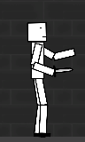

# 13 NPC

## 13.1 Enemies

Skeleton

* Health: 100
* Base damage: 10 (x1 easy, x1.5 normal, x2 hard)
* Swings arms at player, applying slight knockback

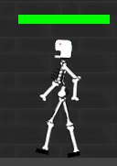

### 13.1.1 Enemy States

### 13.1.2 Enemy Spawn Points

## 13.2 Allies / Companions

None

### 13.2.1 Ally States

None

### 13.2.2 Ally Spawn Points

None

# 14 Art

## 14.1 Setting

The game takes place in a fantasy dungeon. The player must always go up to an exit door to get closer to the surface.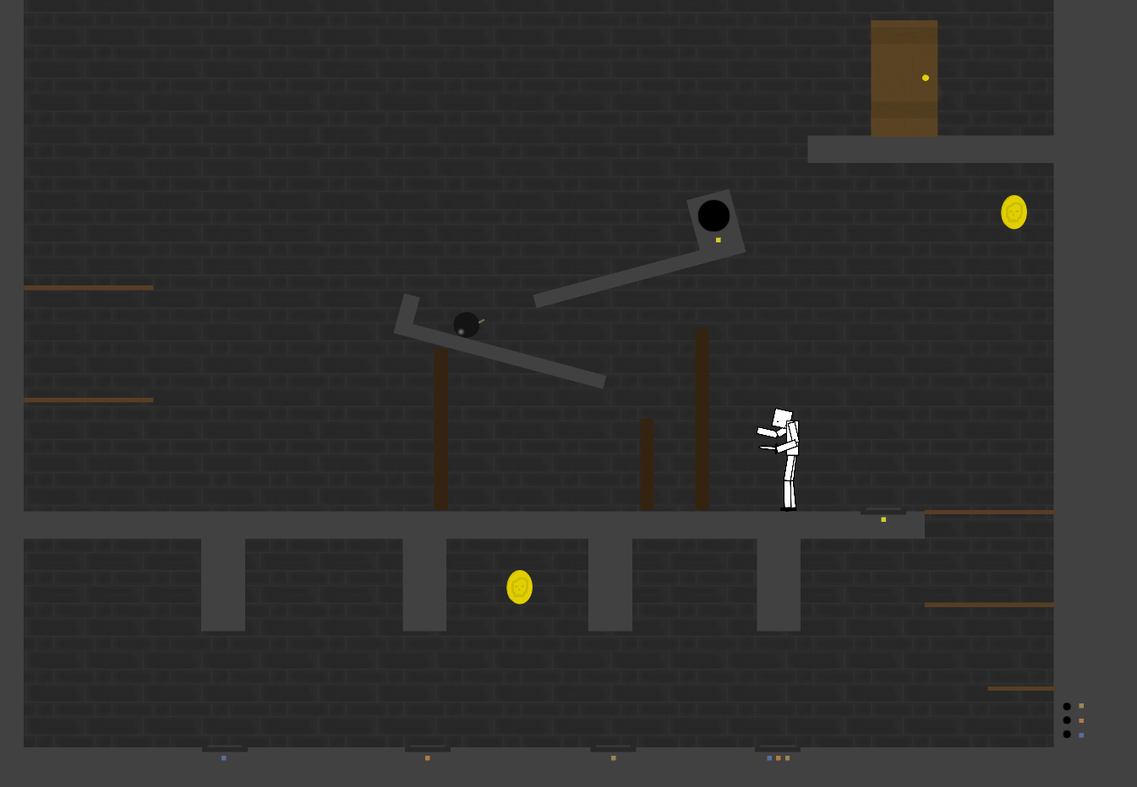

## Level Design

Each room has obstacles in the form of:

* platform parkour

* skeletons

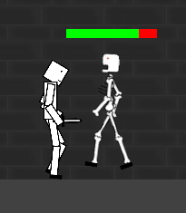

* and traps

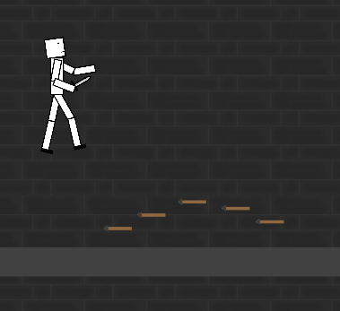

## 14.3 Audio

# 15 Procedurally Generated Content

None

## 15.1 Environment

## 15.2 Levels

## 15.3 Artificial Intelligence NPC

## 15.4 Visual Arts

## 15.5 Audio

## 15.6 Minimum Viable Product (MPV)

# 16 Wish List

* Add more enemy types. This could create variety with different approaches to attacking different enemy types.
* Add player upgrades. Coins could be spent for upgrades, or better weapons/loot could be picked up along the way.

## 17 Bibliography

Tutorial Videos:

How to rig a 2D Sprite: https://www.youtube.com/watch?v=eXIuizGzY2A

How to make a health bar: https://www.youtube.com/watch?v=v1UGTTeQzbo

Sounds (all from OpenGameArt.org):

Skeleton sounds: by ArcadeParty @ https://opengameart.org/content/zombie-skeleton-monster-voice-effects

Potion, coin, door, and dagger swing sounds: by artisticdude @ https://opengameart.org/content/rpg-sound-pack

Explosion sounds: by Unamed @ https://opengameart.org/content/9-explosion-sounds

Dart shoot sound: by dorkster @ https://opengameart.org/content/bow-arrow-shot

Dart wobble sound: by qubodup @ https://opengameart.org/content/wood-wobbling-rattling

Victory Music: by el-corleo @ https://opengameart.org/content/victory-song

Dungeon Music: by Fantasy Musica @ https://opengameart.org/content/dungeon-01

Sprites Created using Krita and Adobe Photoshop

Game title font: Breathe Fire III by Chequered Ink @ https://www.fontspace.com/category/rpg

Inspired by:

Grey Menu Button Design inspired by Minesweeper Tiles.

Mele combo attack mechanic inspried by Pirates of the Carribean Online.

Darts, bomb, and boulder trap mechanic inspired by Terraria.

Pressure plate mechanic inspured by Terraria/Minecraft.

2D sprites designed using Krita and Adobe Photoshop