RAND AI IMPLEMENTATION GUIDE
How Rand AI Uses Entropy
A visual guide to the prediction strategy
Entropy asks a simple question: are six lottery numbers spread around 1–49 in a balanced way, or crowded into one part of the range?
Written for high-school readers
Based on the current Rand AI source implementation · July 2026

1. The big idea
In information science, entropy measures how evenly something is distributed. Rand AI applies that idea to the spaces between six lottery numbers.
Pizza-slice analogy: Imagine the numbers 1 through 49 arranged in a circle. The six chosen numbers cut that circle into six slices. Similar slice sizes mean high entropy. One huge slice and several tiny slices mean low entropy.

The strategy is interested in draw shape, not in whether a number is “good” or “bad” by itself.
- High entropy: the six circular gaps are similar in size.
- Low entropy: some gaps are tiny while another gap is very large.
- The result is normalized to a percentage from 0% to 100%.
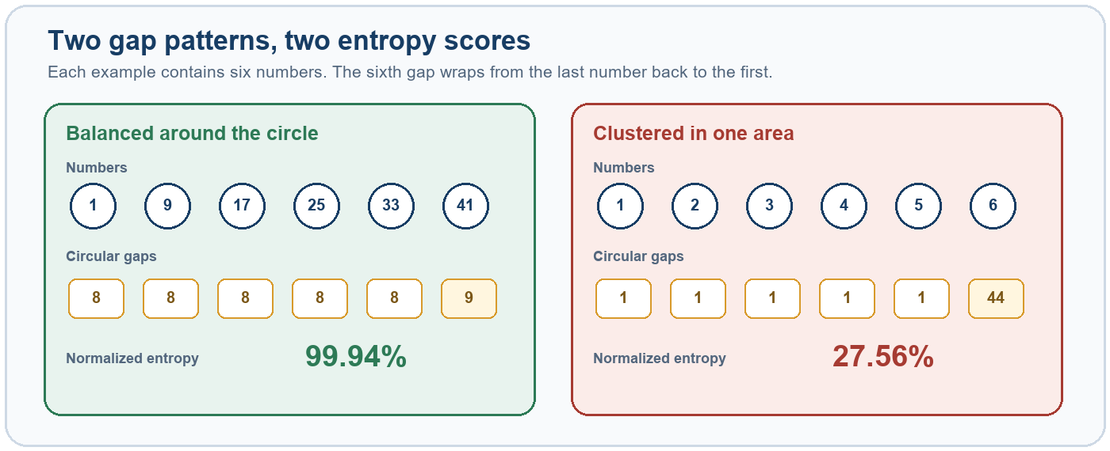
Figure 1. A balanced set divides the 1–49 circle into similar pieces; a clustered set leaves one very large wrap-around gap.
Important: Entropy does not prove that a combination is more likely to win. It is a descriptive pattern used to rank candidates from historical data.

2. How one draw becomes an entropy percentage
Rand AI performs the following steps for every completed draw.
- Sort the six numbers. For example: 4, 7, 15, 26, 37, 49.
- Measure five forward gaps. Subtract each number from the next one: 3, 8, 11, 11, and 12.
- Add the circular gap. Wrap from 49 back to 4: (49 + 4) - 49 = 4. The six gaps always add to 49.
- Convert gaps to shares. Divide every gap by 49. A gap of 8 becomes 8/49, or about 0.163.
- Calculate Shannon entropy. Use each share in the standard entropy formula, then add the six contributions.
- Normalize the answer. Divide by log2(6), the maximum possible entropy for six parts, and multiply by 100.
Formula used in the code: H = -sum(p_i x log2(p_i)); Entropy percent = H / log2(6) x 100

Why divide by log2(6)?
There are six gaps. Entropy is greatest when all six shares are equal. Dividing by that theoretical maximum changes the result into an easy 0–100 scale.
Example draw | Six circular gaps | Entropy | Meaning
1, 9, 17, 25, 33, 41 | 8, 8, 8, 8, 8, 9 | 99.94% | Almost perfectly balanced
4, 7, 15, 26, 37, 49 | 3, 8, 11, 11, 12, 4 | 94.14% | Fairly balanced
1, 2, 3, 4, 5, 6 | 1, 1, 1, 1, 1, 44 | 27.56% | Strongly clustered

Technical note: the implementation uses differences between selected numbers. The circular total is 49. This is slightly different from a “space” definition that counts only unselected numbers between two selected values.

3. What Rand AI remembers from history
After calculating a draw’s entropy, Rand AI gives that same entropy percentage to every number that appeared in the draw. It updates the history before creating the prediction for the next draw.
Example: If draw 100 contains number 17 and has 94% entropy, number 17 receives 94 points in its entropy history for that appearance.

Two history records are kept for each number
Record | What is stored | Why it matters
Entropy total | The sum of entropy percentages from every draw containing that number. | Dividing by appearances gives the number’s average draw entropy.
High-entropy hits | How many appearances occurred in draws with entropy at least 92%. | Dividing by appearances gives the high-entropy share.

The code also tracks appearances and the current gap: how many draws have passed since a number last appeared.

The three-part candidate score
Part | Weight | Question answered
Average entropy | 55% | When this number appeared, how balanced were its draws on average?
High-entropy share | 30% | How often did it appear in draws scoring at least 92%?
Current gap | 15% | How overdue is it now? Full gap credit is reached at 28 draws.

Raw score: 0.55 x average entropy + 0.30 x high-entropy share in percent + 0.15 x overdue score

4 | Worked candidate example
Suppose number 17 has appeared 100 times in the history used by the prediction engine.
Input | Value | Contribution
Average entropy | 88% | 88 x 0.55 = 48.4
High-entropy share | 25% | 25 x 0.30 = 7.5
Current gap | 14 draws | (14 / 28 x 100) x 0.15 = 7.5
Raw total | — | 48.4 + 7.5 + 7.5 = 63.4

The overdue part is capped. A current gap of 28 or more receives 100% of the available gap component, which is 15 points.
If a number has never appeared: Rand AI starts its average entropy at 50%, its high-entropy share at 0%, and still allows the current-gap component to contribute.

From raw scores to a Top-6 prediction
- Score all 49 numbers. Every candidate receives the same three-part calculation.
- Rescale to 0–1. The lowest raw score becomes 0 and the highest becomes 1. Values between them are scaled proportionally.
- Sort from highest to lowest. If scores tie, the number with the larger current gap goes first. If that also ties, the lower number goes first.
- Take the first six. Those numbers are displayed as the Entropy strategy’s Top-6 prediction.
Edge case: If every raw score is identical, the rescaling function assigns 0 to all candidates; gap and number order then break the ranking ties.

5 | Where users see the result
The strategy is registered as Entropy and described in the application as “Structural gap-entropy history with overdue adjustment.”
- Predictions ranks all 49 numbers and marks the six highest candidates.
- Each candidate can show its average entropy and high-entropy share.
- Strategy Effectiveness compares completed Top-6 results with a random benchmark.
- Entropy can also act as one expert inside Rand AI’s combined strategies.

Three entropy readings that should not be confused
Location | What it measures
Entropy prediction strategy | Historical circular-gap shape for draws containing each candidate, plus a current-gap adjustment. This guide focuses on this implementation.
Possible Draw entropy status | The circular-gap entropy of the six numbers currently selected in a plan. It labels the set as Clustered, Balanced, or Correlated.
Randomness diagnostics | How evenly all 49 numbers have appeared in the entire dataset. This uses frequency entropy, not the six-gap candidate score.

What the strategy can and cannot say
- It can summarize whether past draws containing a number tended to have balanced spacing.
- It can combine that pattern with a small overdue-number adjustment.
- It cannot change the lottery’s rules or make independent random events predictable.
- A high score is a ranking signal, not a winning probability.
- The 92% threshold, 28-draw cap, and 55/30/15 weights are design choices and should be tested rather than treated as natural laws.
Responsible interpretation: Use entropy as one transparent feature among several. Judge it with walk-forward results, compare it with random selections, and avoid claiming certainty from a pattern score.

6. Quick reference
Item | Implementation value
Lottery range | 1 through 49
Numbers per draw | 6
Gap type | Six forward differences, including one circular wrap-around gap
Entropy formula | Shannon entropy, base 2
Normalization | Divide by log2(6), then multiply by 100
High-entropy threshold | 92%
Score weights | 55% average entropy; 30% high-entropy share; 15% current gap
Gap cap | Full overdue credit at 28 draws
Final score scale | Min-max scaled across all 49 candidates to 0–1
Tie-breakers | Larger current gap, then lower number
Output | A ranking of 49 numbers and a Top-6 selection

Plain-language glossary
Candidate: one of the numbers 1–49 being ranked.
Circular gap: the forward distance between neighboring selected numbers, including the wrap from the largest number back to the smallest.
Entropy: a score for how evenly the six gaps share the full circle.
High-entropy draw: a draw whose normalized entropy is at least 92%.
Current gap: the number of draws since a candidate last appeared.
Min-max scaling: changing a set of scores so the smallest is 0 and the largest is 1.

7. Implementation map
The main logic is in src/rand_ai/strategy_prediction.py:
- _gap_entropy_percent — calculates normalized circular-gap entropy.
- _StrategyState.remember — records entropy history for drawn numbers.
- _StrategyState._entropy_scores — builds the 55/30/15 raw score.
- _scale_scores and _ranking_from_scores — normalize and order candidates.
- build_prediction_suites — updates history and produces each next-draw prediction.
One-sentence summary: Rand AI’s Entropy strategy favors numbers that have often appeared in evenly spaced draws, especially when those numbers are currently overdue.

