Group 5 Project Report – Sprint 1

Backlog:(10 marks)
-prioritized user stories
-one picture per stand up meeting

Task Board:(10 marks)
-user stories/task
-one picture per meeting

User Story Cards (10 marks)
-Two photos of each card

Burn Down Chart(5 marks)

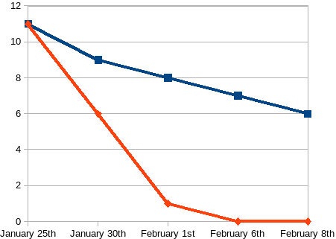

Retrospective summary (10 marks)
-list of items to improve
-members who volunteered for those tasks

Starfish Diagram (5marks)
-To upload the photo for it

Zip file containing the program(10 marks)
-Attached already
Spreadsheet of Attendance (5marks)
-Attached already

List of tasks that each person did in the sprint (5 marks)
-Work not in a traditional sprint(IE preparing materials, organizing photos)

