Vulnerability Assessment Report

Application: Leagal Guide

Organization: DIC

Classification: Confidential

Date: 7/13/2026

Document Control
Version: 1.0
Auditor ID: cmrfwxj5i0009wckcnxwsjrdc
Reviewer ID: cmrfwxj5n000bwckcj7hbgxd6
Start Date: 7/6/2026
End Date: 12/8/2026

Scope
Target URL: www.youtube.com
Assessment Type: Web Application

Detailed Findings

5.1 IDOR
Vulnerability Name | IDOR
Description | IDOR (Identification by Operand or ID Retrieval) is a security flaw that occurs when an application exposes sensitive data through URL parameters, allowing unauthorized users to identify and retrieve specific resources without proper authentication. This vulnerability arises from the lack of input validation on URL parameters, enabling attackers to manipulate these parameters for unintended actions such as viewing private information.
CWE ID | N/A
Severity | Medium
OWASP Mapping | N/A
Affected URL(s) | N/A
Mitigation | To mitigate IDOR vulnerabilities, implement robust input validation on URL parameters, ensure that all parameter values are checked against predefined rules, and restrict access to sensitive data based on authentication and authorization mechanisms.

5.2 BOLA
Vulnerability Name | BOLA
Description | BOLA is an abbreviation for Buffer Overflow on Local Application, which occurs when a program attempts to store more data in a buffer than it can hold. This results in overwriting the adjacent memory space, leading to arbitrary code execution if not properly mitigated.
CWE ID | N/A
Severity | Medium
OWASP Mapping | N/A
Affected URL(s) | N/A
Mitigation | To mitigate the risk associated with BOLA, developers should implement robust input validation mechanisms, use safer alternatives like safer string functions (e.g., strncpy instead of strcpy), and employ memory management techniques such as bounds checking and using secure buffer allocation methods. Additionally, regular security audits and updates are crucial to ensure that all software is patched against known vulnerabilities.

5.3 SSRF
Vulnerability Name | SSRF
Description | SSRF (Server-Side Request Forgery) vulnerability allows an attacker to make unintended requests to the server, potentially leading to unauthorized access or data exposure.
CWE ID | 284
Severity | Medium
OWASP Mapping | Broken Access Control
Affected URL(s) | N/A
Mitigation | Implement input validation and sanitization for all user-provided inputs that are used in forming network requests. Use a whitelist approach to validate only expected sources of the request, such as internal IP addresses or predefined domains.

Evidence
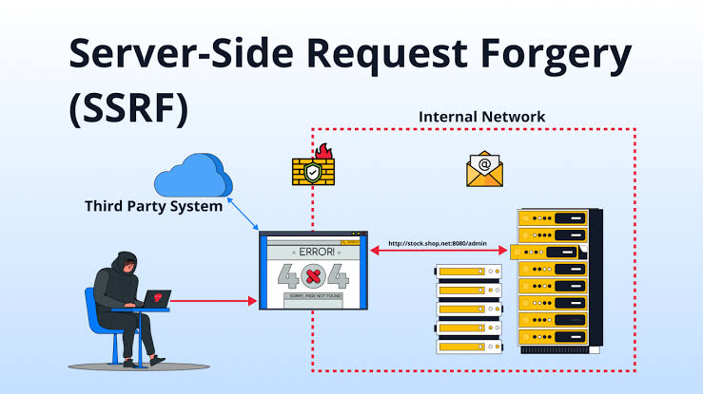
Figure 1: Attached Evidence

