**iOS内购，支付成功后，拿收据去apple服务器验证的返回示例**

**json字符串：**

|  |
| --- |
| JSON  {  "receipt":{"receipt_type":"ProductionSandbox", "adam_id":0, "app_item_id":0, "bundle_id":"com.xihe.refuel", "application_version":"1", "download_id":0, "version_external_identifier":0, "receipt_creation_date":"2021-02-03 01:37:54 Etc/GMT", "receipt_creation_date_ms":"1612316274000", "receipt_creation_date_pst":"2021-02-02 17:37:54 America/Los_Angeles", "request_date":"2021-02-03 01:38:03 Etc/GMT", "request_date_ms":"1612316283021", "request_date_pst":"2021-02-02 17:38:03 America/Los_Angeles", "original_purchase_date":"2013-08-01 07:00:00 Etc/GMT", "original_purchase_date_ms":"1375340400000", "original_purchase_date_pst":"2013-08-01 00:00:00 America/Los_Angeles", "original_application_version":"1.0",  "in_app":[  {"quantity":"1", "product_id":"test_iap_01", "transaction_id":"1000000773036354", "original_transaction_id":"1000000773036354", "purchase_date":"2021-02-03 01:37:54 Etc/GMT", "purchase_date_ms":"1612316274000", "purchase_date_pst":"2021-02-02 17:37:54 America/Los_Angeles", "original_purchase_date":"2021-02-03 01:37:54 Etc/GMT", "original_purchase_date_ms":"1612316274000", "original_purchase_date_pst":"2021-02-02 17:37:54 America/Los_Angeles", "is_trial_period":"false"}]}, "environment":"Sandbox", "status":0} |

**预览：**

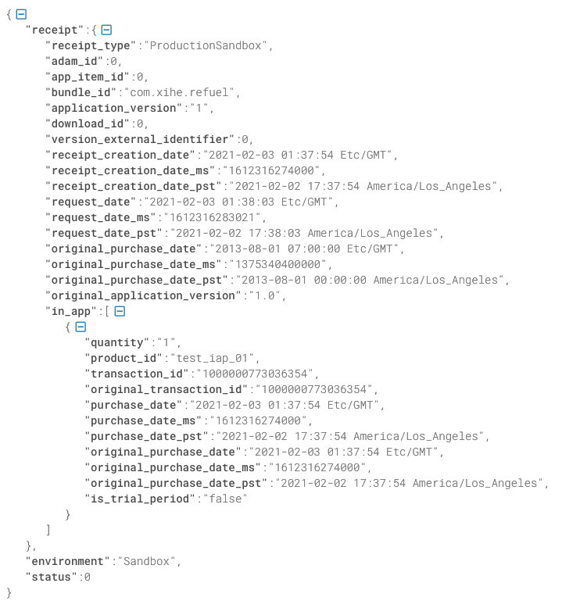

**Obcj字典类型的打印信息：**

|  |
| --- |
| JSON  {  environment = Sandbox;  receipt = {  "adam_id" = 0;  "app_item_id" = 0;  "application_version" = 1;  "bundle_id" = "com.xihe.refuel";  "download_id" = 0;  "in_app" = (  {  "is_trial_period" = false;  "original_purchase_date" = "2021-02-03 01:04:22 Etc/GMT";  "original_purchase_date_ms" = 1612314262000;  "original_purchase_date_pst" = "2021-02-02 17:04:22 America/Los_Angeles";  "original_transaction_id" = 1000000773030851;  "product_id" = "test_iap_01";  "purchase_date" = "2021-02-03 01:04:22 Etc/GMT";  "purchase_date_ms" = 1612314262000;  "purchase_date_pst" = "2021-02-02 17:04:22 America/Los_Angeles";  quantity = 1;  "transaction_id" = 1000000773030851;  }  );  "original_application_version" = "1.0";  "original_purchase_date" = "2013-08-01 07:00:00 Etc/GMT";  "original_purchase_date_ms" = 1375340400000;  "original_purchase_date_pst" = "2013-08-01 00:00:00 America/Los_Angeles";  "receipt_creation_date" = "2021-02-03 01:04:22 Etc/GMT";  "receipt_creation_date_ms" = 1612314262000;  "receipt_creation_date_pst" = "2021-02-02 17:04:22 America/Los_Angeles";  "receipt_type" = ProductionSandbox;  "request_date" = "2021-02-03 01:04:26 Etc/GMT";  "request_date_ms" = 1612314266783;  "request_date_pst" = "2021-02-02 17:04:26 America/Los_Angeles";  "version_external_identifier" = 0;  };  status = 0;  } |

**拿沙盒数据，去正式环境验证，返回的数据：**

|  |
| --- |
| JSON  {  status = 21007;  } |