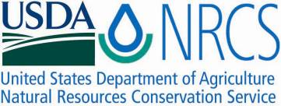

Plant Fact Sheet

TEXAS INDIAN MALLOW

*Abutilon fruticosum* Guill. & Perr*.*

Plant Symbol = ABFR3

Contributed by: USDA – NRCS James E. ”Bud” Smith Plant Materials Center, Knox City, Texas

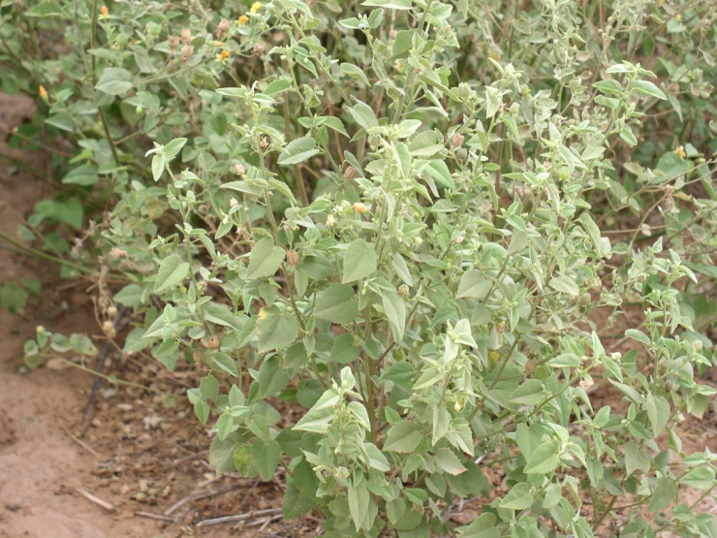

Photo Courtesy: USDA NRCS James E. “Bud” Smith Plant Materials Center

Alternate Names

Pelotazo, sweet Indian mallow, Indian mallow

**Uses**

Texas Indian mallow a native perennial subshrub forb grows in dry areas on cliffs, slopes, limestone outcrops, prairies and in open woods and chaparral. Plants are browsed by deer, sheep and goats and are quickly eliminated from grazed rangelands. Seeds are eaten by bobwhite quail and mourning doves, and the plants provide cover for wildlife. It has potential to enhance water quality and improve range condition with proper management. Indian mallow is drought-tolerant and suitable for xeriscaping. The conspicuous flower attracts birds, butterflies and larval plant food for several species of skipper butterflies.

**Status**

Please consult the PLANTS Web site and your State Department of Natural Resources for this plant’s current status (e.g. threatened or endangered species, state noxious status, and wetland indicator values).

**Description and Adaptation**

Mallow Family (Malvaceae). Texas Indian mallow an upright warm-season, hairy perennial subshrub forb reaches .3 to 1.8 meters (1 to 6 feet) , more commonly .6 to .9 meters (2 to 3 feet high), the stem unbranched to much branched. Leaves 10 centimeters (4 inches) long, alternate, short-stalked; blade thickish, gray in color with fine, star-shaped hairs, heart-shaped at base, sharply pointed at tip, the margins irregularly toothed. Upper leaves much smaller. Flowersare conspicuous at1.9 to 2.54 centimeters (¾ to 1 inch) across; 5 petals, pale orange-yellow; stamens numerous; blooms from June to October; 5 to 9 hairy carpels, two or more seeds in each carpel. Found in dry, mostly calcareous soils of prairies, chaparral and in open woodlands, and on rocky cliffs and slopes from Arkansas, Oklahoma to Texas.

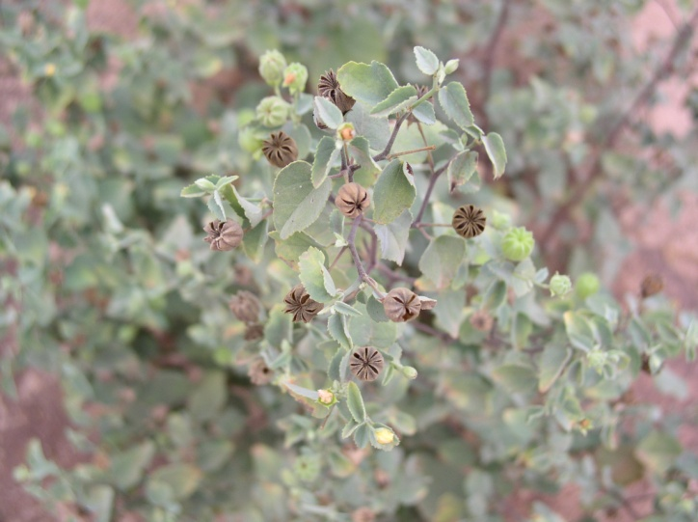

Photo Courtesy: USDA NRCS James E. “Bud” Smith Plant Materials Center

**Establishment**

Texas Indian mallow should be seeded early in the spring, either by broadcasting or with a grass drill equipped with a small seed box. For best result seeds no deeper than ¼ to ½ inch on a firm well prepared seedbed using some type of carrier, such as sand, to enhance seed distribution. Texas Indian mallow could be a valuable component if included in a grass/forb mix for pasture and rangeland.

Seed production of Texas Indian mallow is achieved at the NRCS James E. “Bud” Smith Plant Materials Center in Knox City, Texas by seeding at a rate of 2.0 Pure Live Seed (PLS) pound per acre. The Plant Materials Center seeds in the spring after the last frost with a two row cotton planter equipped with a Planet Jr. planter attachment.

**Management**

Texas Indian mallow will require grazing management to maintain plant vigor and persistence. Plants have reported to prefer full or part sun exposure and not full shade. If used for landscaping remove the previous years’ growth prior to spring growth.

**Pests and Potential Problems**

During evaluation and subsequent seed production at the James E. “Bud“ Smith Plant Materials Center near Knox City, Texas, no serious pests or diseases were observed.

**Environmental Concerns**

Texas Indian mallow does not pose any known negative concerns to the environment.

**Seeds and Plant Production**

Seed can be harvested with a standard combine and run through a hammer mill then cleaned with a fanning mill. Seed of Texas Indian mallow is small with 136,900 seeds per pound.

**Cultivars, Improved, and Selected Materials (and area of origin)**

There are currently no cultivars of Texas Indian mallow in seed commercial industry.

**Prepared By and Species Coordinator:**

*Rudy G. Esquivel*

USDA – NRCS

James E. “Bud” Smith Plant Materials Center

Knox City, Texas

**Citiation:**

Esquivel, R. 2008. Plant Fact Sheet for Texas Indian mallow (*Abutilon fruticosum.* USDA-Natural Resources Conservation Service, James E. “Bud” Smith Plant Materials Center, Knox City, Texas 79529.

Published: February 2008

Edited: 14Jan08 rtc; 06Jun11bc

For more information about this and other plants, please contact your local NRCS field office or Conservation District <<http://www.nrcs.usda.gov/>>, and visit the PLANTS Web site <[http://plants.usda.gov](http://plants.usda.gov/)> or the Plant Materials Program Web site <<http://plant-materials.nrcs.usda.gov>>

**USDA IS AN EQUAL OPPORTUNITY PROVIDER AND EMPLOYER**