|  |
| --- |
| wild onion |
| *Allium hyalinum* Kellogg |
| Plant Symbol = ALHY |

*Contributed by: USDS NRCS National Plant Data Center*

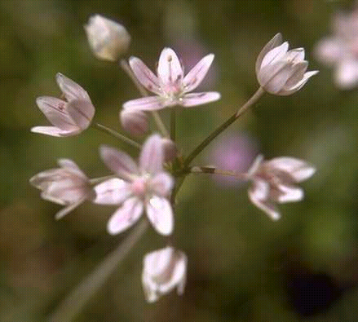

Gladys L. Smith

© California Academy of Sciences

@ CalPhotos

#### Alternate Names

Many species of *Allium* are known by the common name “wild onion.”

#### Uses

*Ethnobotanic*: The young foliage of *Allium* species is delicious and can be used in the place of chives. This onion was a food of the Tabatulabal and probably many other tribes as well. Sometimes the bulb was eaten raw. Today, individuals of many tribes still gather different species of wild onions.

#### Status

Please consult the PLANTS Web site and your State Department of Natural Resources for this plant’s current status and wetland indicator values.

#### Description

*General*: Lily Family (Liliaceae). This herbaceous perennial plant has herbage with the characteristic taste and smell of onions. The scape is 15-45 cm high and the leaves are 2-3 and linear. Reproduction is from wrinkled, black seeds contained in a capsule or by ovoid to spherical bulbs. The bulb-coats are brown or gray, thin, with horizontal undulate reticulation in vertical rows. Five to 25 pale pink to white flowers are in an umbel subtended by 2 or 3 thin whitish or scarious bracts.

#### Distribution

For current distribution, please consult the Plant Profile page for this species on the PLANTS Web site. This plant is found from 50 to 1500 m in moist areas in grassy slopes and mosses on rocks in the Sierra Nevada and San Joaquin Valley.

#### Establishment

Dig up the bulbs of plants that are in bloom or seed or purchase the bulbs and plant them in the ground in autumn. The bulbs should be planted 1 to 3 inches deep in a well-drained soil in full sun or partial shade. *Allium* species do especially well in raised beds for drainage. Water them after planting and then let the rains come. Weed around the plants. Most animals don’t eat wild onions. This species of wild onion can be invasive.

If establishing the plant by seed, plant the seeds in the fall in pots in partial shade. Scatter the seeds on top of a well-drained soil. Sprinkle a thin layer of dirt over the top and place quarter-inch gravel over the soil. Water the pots and keep them slightly moist. Stop watering when the leaves shrivel in the early summer. Plant the plants out in the garden or wildlands after two years in the summer or fall. Let the rains do the watering.

#### Management

Separate the plants every several years and replant.

#### Cultivars, Improved and Selected Materials (and area of origin)

ALHY is available from native plant nurseries within its range.

#### References

Chesnut, V.K. 1902. *Plants used by the Indians of Mendocino County, California*. Contributions from the U.S. National Herbarium Vol. VII. Reprinted by the Mendocino County Historical Society in 1974.

Davies, D. 1992. *Alliums: The ornamental onions*. Timber Press, Inc., Portland, Oregon.

Hickman, J.C. (ed.). 1993. *Allium*. pp. 1172-1179 IN: *The Jepson Manual: Higher Plants of California*. University of California Press, Berkeley, California.

Mathew, B. 1997. *Growing bulbs: The complete practical guide*. Timber Press, Inc., Portland, Oregon.

USDA, NRCS 1999. *The PLANTS database*. National Plant Data Center, Baton Rouge, Louisiana. <http://plants.usda.gov>. Version: 990405.

Voegelin, E.W. 1938. *Tubatulabal ethnography*. Anthropological Records Vol 2:(1):1-84.

#### Prepared By & Species Coordinators

*M. Kat Anderson*

USDA NRCS National Plant Data Center

c/o Plant Science Department, University of California, Davis, California

*Wayne Roderick*

Former Director of the East Bay Regional Parks Botanic Garden, Berkeley, California

Edited: 29jan03 jsp; 09jun03 ahv; 30may06jsp

For more information about this and other plants, please contact your local NRCS field office or Conservation District, and visit the PLANTS Web site<<http://plants.usda.gov>> or the Plant Materials Program Web site <<http://Plant-Materials.nrcs.usda.gov>>

*The U.S. Department of Agriculture (USDA) prohibits discrimination in all its programs and activities on the basis of race, color, national origin, sex, religion, age, disability, political beliefs, sexual orientation, and marital or family status. (Not all prohibited bases apply to all programs.) Persons with disabilities who require alternative means for communication of program information (Braille, large print, audiotape, etc.) should contact USDA's* [*TARGET Center*](http://www.usda.gov/oo/target.htm) *at 202-720-2600 (voice and TDD).*

*To file a complaint of discrimination write USDA, Director, Office of Civil Rights, Room 326-W, Whitten Building, 14th and Independence Avenue, SW, Washington, DC 20250-9410 or call 202-720-5964 (voice or TDD). USDA is an equal opportunity provider and employer.*

*Read about* [*Civil Rights at the Natural Resources Convervation Service*](http://www.nrcs.usda.gov/about/civilrights/)*.*