|  |  |
| --- | --- |
| **Natural Resources Conservation Service** | Plant Guide |

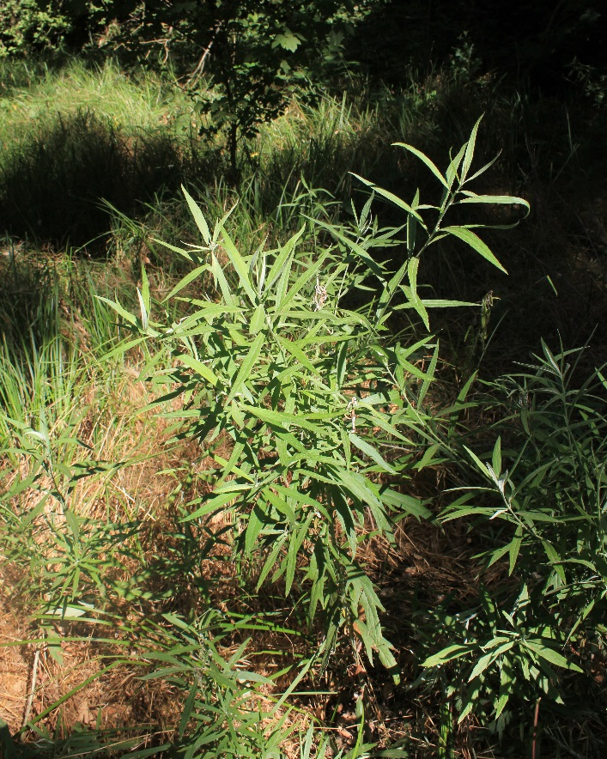**DOUGLAS’ SAGEWORT**

**Artemisia douglasiana Bess.**

Plant Symbol = ARDO3

*Common Names:* mugwort, western mugwort, California mugwort,

Douglas’ mugwort

*Scientific Names: Artemisia campestris* L. var. *douglasiana* (Besser) B. Boivin, *Artemisia vulgaris* L. subsp. *heterophylla* (Nutt.) H.M. Hall & Clem., *Artemisia vulgaris* L. var. *douglasiana* (Besser) H. St. John.

### Description

*General*: Douglas’ sagewort is an aromatic perennial forb in the sunflower family (Asteraceae) that is native to the western United States. It is rhizomatous and has many slender, 3-5 ft. tall stems. The leaf blades are 3-6 in. long, and can be as wide as 2 in. across. In color, they are green to grey-green, silvery-white underneath, In shape, they are narrowly elliptic to widely oblanceolate with 3-5 lateral lobes (Shultz, 2006,2014). The upper-surface is sparsely hairy, while the lower surface is densely hairy. The grey flowering heads are leafy-bracted panicles with short matted hairs. The disciform heads are 0.1 – 0.2 in. diameter, inconspicuous in clusters, with pistilate flowers (5-9) and disk flowers (6-25). Bloom is from mid-spring through late fall. The fruits 0.05 x 0.1in.) are grey brown.

Douglas’ sagewort (Mugwort) growing at the Lockeford PMC. Photo by Michal Tutka, Lockeford PMC June 2015.

*Distribution*: Douglas’ sagewort is native to western North America from Washington and Idaho, through Oregon, in Nevada, through California and the Baja Peninsular of Mexico. It is found along the Pacific coast and in riparian corridors from sea level to 7,200 feet in elevation (USDA). For current distribution, please consult the Plant Profile page for this species on the PLANTS Web site.

*Habitat*: Douglas’ sagewort is found primarily in drainages and riparian corridors (Shultz 2006). It grows well in dry or moist shaded sites and is tolerant or a range of soil types. It may be found in meadows at higher elevations.

### Adaptation

Douglas’ sagewort grows on a variety of soil types in riparian habitats. It dies back over the winter and also with summer drought, the rhizomes spout with moisture and warmer temperatures in the spring.

### Uses

*Wildlife:* Ecological benefits of Douglas’ sagewort to wildlife include seed forage, perching spots, and vegetative cover for birds, as well as nesting material for bees once the plant has senesced.

**Warning**

**Douglas’ sagewort extracts have been shown to be cytotoxic to human cells (Giordano et al., 1990). Pregnant women should not ingest mugwort, as it is an abortifacient. Douglas’ sagewort contains the monoterpene thujone, a neurotoxin which in high doses causes convulsions, seizures, and even death. Because thujone is extracted by alcohols, it is strongly advised not to make mugwort tinctures (Somaweera at al. 2013). Aqueous solutions of thujone are in minute concentrations and so are probably safe for use (Adams and Garcia, 2006).**

### The grey flowering heads are leafy-bracted panicles with short matted hairs. The disciform heads are 2-4 mm in diameter, inconspicuous in clusters, with pistilate flowers (5-9) and disk flowers (6-25). Hand holding single leaf long and narrow with lobed margin, green in color.Ethnobotany

*Medicinal*: Douglas’ sagewort is highly esteemed by many

California tribes for its many medicinal applications. The Miwok use the leaves to prepare a tea that is sipped to reduce swelling in any part of the body, and use it to relive prostate problems. (McCarthy et al 2012). Leaves are rubbed on the forehead to relieve headaches (Personal observation and Train et al, 1957). It is commonly used as a remedy for poison oak rash (Duncan, 1961; McCarthy et al., 2012; Timbrook, 1990; 2007). In Argentina, the chewed leaves are used to treat peptic ulcers and external sores and studies have been conducted on other medicinal uses (Giordano et al., 1990).

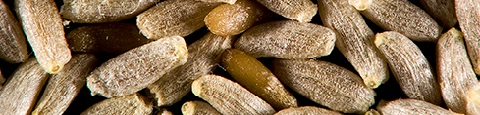Reports in the literature from the Costanoans, Pomo, and Maidu document its use as an analgesic to treat colds, fevers, and respiratory problems such as bronchitis and asthma (Bocek, 1982; Chestnut, 1902: Duncan, 1961); and for headaches and earaches (Barrett and Gifford, 1933; Bocek, 1982). Douglas’ sagewort was also used as a compress for wounds, to treat sores and peptic ulcers (Heinrich et al., 1998, Timbrook, 2007) and urinary problems (Bocek, 1982). It was used regularly for women’s health issues, such as treating premenstrual syndrome and dysmenorrhea (Adams and Garcia, 2006), to improve circulation after childbirth (Chestnut, 1902) and to terminate difficult pregnancies (Somaweera et al., 2013). Tongva girls bathed in tea in preparation for puberty (Incayawar, 2010).

|  |  |
| --- | --- |
| *Left:* | Inflorescence of Douglas’ sagewort, ©Avis Boutell |
| *Right:* | Lower leaves and those of younger plants tend to be toothed or lobed. Photo by Tutka.CAPMC |
| *Bottom:* | Fruit, 1.4x2.0 mm in size, ©John Macdonald |

*Ceremonial*: Douglas’ sagewort (mugwort) is revered by indigenous tribes in California. It is used during ceremonies and for other purposes, such as to ward off spirits and ghosts, especially after the death of a family member and for repatriation ceremonies (Duncan, 1961; MacCarthy, 2012). It is often placed in several locations in the home for protection (McCarthy et al., 2012). The Paiute people used Douglas’ sagewort ceremoniously as a wash when coming out of ritual dances (Reid et al., 2009). Mourning Miwok would plug their nostrils with its leaves, using the aroma to clear their heads (Barrett and Gifford, 1933).

*Other uses:*  Douglas’ sagewort has insect repellant properties. Leaves were placed in baskets and food storage containers to keep pests away. (Reid et al., 2009.). A Chumash myth indicates that leaves were used to line babies cradles (Timbrook, 2007). Leaves would be burned to stave off mosquitos (Bocek, 1982; Duncan, 1961). The Costanoans burned its branches to smoke bees from nests (Bocek, 1982).

### Status

This plant may become weedy or invasive in some regions or habitats and may displace desirable vegetation if not properly managed. It is not considered a weed in natural areas, but can occasionally become weedy in such areas as drainage ditches and low places in pastures (DiTomaso and Healy, (2007).

Please consult the PLANTS Web site (<http://plants.usda.gov/>) and your state’s Department of Natural Resources for this plant’s current status (e.g., threatened or endangered species, state noxious status, and wetland indicator values).

### Planting Guidelines

Douglas’ sagewort seeds germinate at relatively cool temperatures to coincide with fall precipitation. Direct seeding can be done throughout the late fall and winter on prepared sites at a seeding rate of 2.2 lb/acre drilled at a depth of ¼ inch, or 3 lb/acre broadcast. At Elkhorn Slough on the central California Coast field plantings were generally most successful in the early spring (ESNERR, 2001). If seeding must be done later in the spring, stratification may be of benefit (Deitschman, 1974). Establishment from transplants is also successful as one- and 2-year-old seedlings can be field-planted early in the spring, as fall transplanting is generally not successful (Deitschman 1974). Irrigation will assist with establishment for the first year or two depending upon the location. It would be essential for drier sites. Douglas’ sagewort can also be effectively propagated from rhizomes, using a protocol developed for *Artemisia vulgaris*, which showed that ~75% of 2-cm long rhizome sections produced roots and shoots (Klingeman et al. 2004). Once established, Douglas’ sagewort spreads easily from rhizomes and because of this, a few established plants can effectively populate a suitable site.

### Control

Please contact your local agricultural extension specialist or county weed specialist to learn what works best in your area and how to use it safely. Always read label and safety instructions for each control method. Trade names and control measures appear in this document only to provide specific information. USDA NRCS does not guarantee or warranty the products and control methods named, and other products may be equally effective.

### Seeds and Plant Production

*Collection and storage:* Determination of fruit ripeness can be difficult because of the small fruit size. Douglas’ sagewort is ready to harvest when fruits can be easily removed from the heads by shaking and are too hard to be easily crushed with a thumbnail. Because the fruit matures so late in the season, it often has to be harvested quickly after maturity to avoid losses and storm damage. The heads are clipped, placed in paper bags to dry, then rubbed over screens to remove the chaff and stored in a dry cooler (ESNERR, 2001). For propagation, fruits are sown into plug trays filled with potting mix then lightly covered with more potting mix. The trays are misted with an automatic irrigation system. Fifteen days after germination, seedlings are transplanted into larger containers, then moved into a lath house, keeping them moist. Transplant survival averages 85% and one or two year old plants can be used for planting out (Young 2001).

### 

### Cultivars, Improved, and Selected Materials (and area of origin)

Cultivars should be selected based on the local climate, resistance to local pests, and intended use. Consult with your local land grant university, local extension or local USDA NRCS office for recommendations on adapted cultivars for use in your area**.**

**Literature Cited**

Adams, J.D. Jr. and C. Garcia. 2006. Women’s health among the Chumash. Evidence-Based Complementary and Alternative

Medicine. 3:125-31.

Barrett, S.A. and E.W. Gifford. 1933. Miwok material culture. Bulletin of the Public Museum of the City of Milwaukee.

2:117-376.

Bocek, B. 1982. Ethnobotany of the Costanoan Indians, California, based on collections by John P. Harrington. Economic

Botany. 38:240-55.

Boutell, A. 2009. Asteraceae – *Artemesia douglasiana* (mugwort) <https://www.flickr.com/photos/aboutell/3811470163/>

(accessed on 16 July 2015).

Chestnut, V.K. 1902. Plants used by the Indians of Mendocino County, California. US National Herbarium Contributions.

7:295-408.

Deitschman, G. H. 1974. *Artemisia* L. Sagebrush. Pp. 235-237 211 *in* Seeds of Woody Plants in the United States. Forest

Service, USDA, Washington, DC.

DiTomaso, J.M. and E.A. Healy. 2007. Weeds of California and other Western States. University of California, Oakland Agriculture and Natural Resources Pub. 3488.

Duncan, J.W. 1961. Maidu Ethnobotany. Thesis, San Francisco State College, San Francisco, California.

ESNERR 2001. Native Species Planting Guide for the Elkhorn Slough National Estuarine Research Reserve.

[www.elkhornslough.org/habitat-restoration/native_plants.pdf](http://www.elkhornslough.org/habitat-restoration/native_plants.pdf) (accessed 8 June 2016).

Giordano, O., Guerreiro E, Pestchanker M, Guzmán J, Pastor D & Guardia T. 1990. The gastric cytoprotective effect of

several sesquiterpene lactones. Journal of Natural Products. 53:803-809.

Heinrich, M, Robles, M., West, J.E., Ortiz de Montellano, B.R., and Rodríguez, E. 1998. Ethnopharmacology of Mexican

Asteraceae (Compositae). Annual Review of Pharmacology and Toxicology. 38:539-565.

Incayawar, M. 2010. Kwiash. http://www.runajambi.net/tongva/mugwort.html (accessed 10 July 2015)

Klingeman, W.E., Robinson, D.K., McDaniel, G.L. 2004. Mugwort (*Artemisia vulgaris*) rhizome regeneration in pine bark,

soil and sand substrates. Hortscience 39:746-746.

Macdonald, J. 2007. *Artemisia douglasiana* [Photograph].

http://www.hazmac.biz/070312/070312ArtemisiaDouglasiana.html (accessed 16 July 2015).

McCarthy, H., A. Barajas, D. Berg, R. Cox, V. Day-Burciaga, J. Dick, R. Fuller, D. Hendricks, R. Hendricks, S. Hendricks, J. Lavell, D. Lingo, G. Mangoang, P. Montgomery and V. Stone. 2012. Field Guide to Plants Important to the Central Sierra Me-Wuk Indians: With Traditional Uses. Ed T. Norton. Tuolumne Band of Me-Wuk Indians of the Tuolumne Rancheria of California

Reid, S., Wishingrad, V. and McCabe, S. 2009. Native American Uses of California Plants - Ethnobotany

http://arboretum.ucsc.edu/pdfs/ethnobotany-webversion.pdf (accessed 13 July 2015

Shultz, L.M. 2006. *Artemisia douglasiana*. Flora of North America Vol, 19, 20 and 21, p. 524. [Online]. url: (accessed 10

August 2015).

Shultz, L.M. 2014. *Artemisia douglasiana*, in Jepson Flora Project (eds.) Jepson eFlora.

http://ucjeps.berkeley.edu/cgibin/get_IJM.pl?tid=1187 (accessed 13 July 2015).

Somaweera, H., Lai, G.C, Blackeye, R., Littlejohn, B., Aguirre, R.M., LaPena, V., Pasqua, A., Hintz, M.M. 2013. Ethanolic

extracts of California mugwort (*Artemisia douglasiana* Besser) are cytotoxic against normal and cancerous human

cells. Journal of herbal medicine. 3:47-51.

Timbrook, J. 1990. Ethnobotany of Chumash Indians, California, based on collections by John P. Harrington. Economic

Botany. 44:236-253.

Timbrook, J. 2007. Chumash ethnobotany: plant knowledge among the Chumash people of southern California. Heyday

Books, Berkley, CA. Pp 37-39.

Train, P., J.R. Henrichs and W.A. Archer, revised 1957, Medicinal Uses of Plants by Indian Tribes of Nevada, Washington DC. U.S. Department of Agriculture, page 39

United States Department of Agriculture NRCS. PLANTS National Database Reports, Plant Profile: *Artemisia douglasiana*

Besser. http://plants.usda.gov/core/profile?symbol=ARDO3 (accessed 13 July 2015).

Young, B. 2001. Propagation protocol for production of container *Artemisia douglasiana* Bess. San Francisco, California. In:

Native Plant Network. http://www.nativeplantnetwork.org (accessed 10 July 2015).

### 

### Citation

Tutka, M. 2015. Plant Guide for California mugwort (*Artemisia douglasiana)*. USDA-Natural Resources Conservation Service, Plant Materials Center, Lockeford, CA.

Published: August, 2016

Edited:

For more information about this and other plants, please contact your local NRCS field office or Conservation District at <http://www.nrcs.usda.gov/> and visit the PLANTS Web site at <http://plants.usda.gov/> or the   
Plant Materials Program Web site:

<http://plant-materials.nrcs.usda.gov>.

PLANTS is not responsible for the content or availability of other Web sites.

The U.S. Department of Agriculture (USDA) prohibits discrimination against its customers, employees, and applicants for employment on the bases of race, color, national origin, age, disability, sex, gender identity, religion, reprisal, and where applicable, political beliefs, marital status, familial or parental status, sexual orientation, or all or part of an individual's income is derived from any public assistance program, or protected genetic information in employment or in any program or activity conducted or funded by the Department. (Not all prohibited bases will apply to all programs and/or employment activities.)

If you wish to file an employment complaint, you must contact your agency's [EEO Counselor](http://www.ascr.usda.gov/doc/EEO_Counselor_List.pdf) (PDF) within 45 days of the date of the alleged discriminatory act, event, or in the case of a personnel action. Additional information can be found online at <http://www.ascr.usda.gov/complaint_filing_file.html>.

If you wish to file a Civil Rights program complaint of discrimination, complete the [USDA Program Discrimination Complaint Form](http://www.ocio.usda.gov/sites/default/files/docs/2012/Complain_combined_6_8_12.pdf) (PDF), found online at <http://www.ascr.usda.gov/complaint_filing_cust.html>, or at any USDA office, or call (866) 632-9992 to request the form. You may also write a letter containing all of the information requested in the form. Send your completed complaint form or letter to us by mail at U.S. Department of Agriculture, Director, Office of Adjudication, 1400 Independence Avenue, S.W., Washington, D.C. 20250-9410, by fax (202) 690-7442 or email at [program.intake@usda.gov](mailto:program.intake@usda.gov).

Individuals who are deaf, hard of hearing or have speech disabilities and you wish to file either an EEO or program complaint please contact USDA through the Federal Relay Service at (800) 877-8339 or (800) 845-6136 (in Spanish).

Persons with disabilities who wish to file a program complaint, please see information above on how to contact us by mail directly or by email. If you require alternative means of communication for program information (e.g., Braille, large print, audiotape, etc.) please contact USDA's TARGET Center at (202) 720-2600 (voice and TDD).

For any other information dealing with Supplemental Nutrition Assistance Program (SNAP) issues, persons should either contact the USDA SNAP Hotline Number at (800) 221-5689, which is also in Spanish or call the [State Information/Hotline Numbers](http://www.fns.usda.gov/snap/contact_info/hotlines.htm).

For any other information not pertaining to civil rights, please refer to the listing of the [USDA Agencies and Offices](http://www.usda.gov/wps/portal/usda/usdahome?navtype=MA&navid=AGENCIES_OFFICES_C) for specific agency information.

***Helping People Help the Land***

**USDA IS AN EQUAL OPPORTUNITY PROVIDER AND EMPLOYER**