|  |
| --- |
| saguaro cactus |
| *Carnegiea gigantea* (Engelm.) Britt. & Rose |
| Plant Symbol = CAGI7 |

Contributed By: USDA NRCS National Plant Data Center

#### Alternative Names

giant cactus

#### Uses

*Ethnobotanic*: The fruits and the seeds of the saguaro were extensively utilized for food by the Papago, Akimel and Tohono O'odham (also known as Pima), and Seri of Arizona and Mexico. In fact, families established camps in specific cactus areas and in both the Papago and Pima calendars, the saguaro harvest marked the beginning of the new year. The fruits were harvested with a special pole, often made of saguaro ribs with a small crosspiece. Some families still harvest the fruits today. A gruel was traditionally made from the saguaro fruits and used as a medicine by the Pima to make a mother's milk flow after childbirth. The seeds were roasted and ground on a metate and made into a mush. Other parts of the saguaro also were useful. The dead saguaro ribs were used by the Pima as splints to bind injured limbs and as cross pieces in the manufacture of

babies' cradles. The Seri in Mexico used a piece of the saguaro rib to make the mainshaft or handle of a compound drill stick used in fire making. The ribs also were used as walking canes and in the making of wattle and daub house walls.

*Wildlife*: The white-wing dove feeds on saguaro seeds during the fruiting season. Gila woodpeckers and gilded flickers make holes in the trunks and use them as nests. After these are abandoned, they are inhabited by elf owls and starlings.

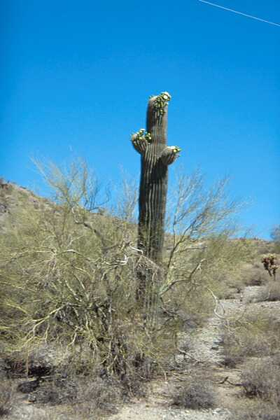

Plant Herbarium

© Arizona State University

@ Arizona Trees and Shrubs

#### Status

Please consult the PLANTS Web site and your State Department of Natural Resources for this plant’s current status and wetland indicator values.

#### Description

*General*: Cactus Family (Cactaceae). This cactus has an erect, branched stem 3-16 m tall and 30-75 cm in diameter. The arms sometimes number as many as 50. The ribs are prominent and number from 12 to 30. Gray spines densely cover the stem. The funnelform-campanulate flowers are 8.5-12.5 cm and the outer parts are green with lighter borders and the inner parts are petal-like and white. The nocturnal flowers appear singly at the uppermost areoles and they smell like ripe melons. When open, each flower is filled with many white stamens. The fruit is scaly, 25-45 mm in diameter and obovoid with a dark red interior and black seeds that are about 0.75 in diameter.

#### Distribution

For current distribution, please consult the Plant Profile page for this species on the PLANTS Web site. This cactus is found on gravelly slopes, rocky ridges and outwash fans below 1500 m in the Lower Sonoran Zone, from northern Arizona and along the Colorado River in Riverside and Imperial Counties, California, to northern Sonora, Mexico.

#### Establishment

Saguaro cacti need well-drained soil and full sunlight for optimal development. They also cannot withstand prolonged temperatures below freezing. Since saguaros grow so slowly, it is best to obtain nursery-grown plants. Plant saguaros in the ground in October, being sure that the area selected is sheltered from full sun with a shade cloth or by other means through the first summer. Plants should be planted away from compacted areas that receive foot travel or heavy equipment. Young plants can be watered once a month during extended drought, but established plants can survive solely upon natural rainfall.

#### Cultivars, Improved and Selected Materials (and area of origin)

CAGI7 is somewhat available through native plant nurseries and seed companies within its range. Contact your local Natural Resources Conservation Service (formerly Soil Conservation Service) office for more information. Look in the phone book under ”United States Government”. The Natural Resources Conservation Service will be listed under the subheading “Department of Agriculture.”

#### References

Anderson, E.F. 1993. Cactaceae. Pp. 450-458 IN: *The Jepson manual higher plants of California*. J.C. Hickman (ed). University of California Press, Berkeley, California.

Arizona State University Plant Herbarium 2000. *Arizona trees and shrubs*. Version: 000228. <http://ls.la.asu.edu/herbarium/treeshrub/pages/plants/cargig.html>. ASU Life Sciences, Tucson, Arizona.

Castetter, E.F. & W.H. Bell 1942. *Pima and Papago Indian agriculture*. University of New Mexico Press, Albuquerque, New Mexico.

Curtin, L.S.M. 1984. *By the prophet of the earth ethnobotany of the Pima*. University of Arizona Press, Tucson, Arizona.

Felger, R.S. & M.B. Moser 1985. *People of the desert and sea ethnobotany of the Seri Indians*. University of Arizona Press, Tucson, Arizona.

Kearney, T.H. & R.H. Peebles 1960. *Arizona flora*. University of California Press, Berkeley, California.

Mielke, J. 1993. *Native plants of southwestern landscapes*. University of Texas Press, Austin, Texas

Rea, A.M. 1997. *At the desert's green edge an ethnobotany of the Gila River Pima*. University of Arizona Press, Tucson, Arizona.

Shreve, F. & I.L. Wiggins 1964. *Vegetation and flora of the Sonoran Desert*. Stanford University Press, Palo Alto, California.

USDA, NRCS 2000. *The PLANTS database*. Version: 000229. <http://plants.usda.gov> National Plant Data Center, Baton Rouge, Louisiana.

#### Prepared By and Species Coordinator

*M. Kat Anderson*

USDA, NRCS, National Plant Data Center

c/o Department of Environmental Horticulture, University of California, Davis, California

Edited: 05dec00 jsp; 29apr03 ahv; 31may06 jsp

For more information about this and other plants, please contact your local NRCS field office or Conservation District, and visit the PLANTS Web site<<http://plants.usda.gov>> or the Plant Materials Program Web site <<http://Plant-Materials.nrcs.usda.gov>>

*The U.S. Department of Agriculture (USDA) prohibits discrimination in all its programs and activities on the basis of race, color, national origin, sex, religion, age, disability, political beliefs, sexual orientation, and marital or family status. (Not all prohibited bases apply to all programs.) Persons with disabilities who require alternative means for communication of program information (Braille, large print, audiotape, etc.) should contact USDA's* [*TARGET Center*](http://www.usda.gov/oo/target.htm) *at 202-720-2600 (voice and TDD).*

*To file a complaint of discrimination write USDA, Director, Office of Civil Rights, Room 326-W, Whitten Building, 14th and Independence Avenue, SW, Washington, DC 20250-9410 or call 202-720-5964 (voice or TDD). USDA is an equal opportunity provider and employer.*

*Read about* [*Civil Rights at the Natural Resources Convervation Service*](http://www.nrcs.usda.gov/about/civilrights/)*.*