|  |
| --- |
| flannelbush |
| *Fremontodendron californicum* (Torr.) Coville |
| Plant Symbol = FRCA6 |

# *Contributed By: USDA NRCS National Plant Data Center & East Bay Regional Parks Botanic Garden*

#### Alternate Names

FremontiaUses

*Ethnobotanic*: The bark is cut at one end of the branches and peeled off in long strips. These are washed and rubbed between the hands. Three strands are rolled together on the upper thigh to make cordage a type of string or rope that was made into a pack strap and tumpline by the Kawaiisu. The wood was also sometimes substituted for willow in the making of Kawaiisu baby cradles. The inner bark was soaked in water and the infusion drank as a physic by the Kawaiisu. Many other California tribes utilized the bark for cordage including the Owens Valley Paiute, Sierra Miwok, Western Mono, and Tubatulabal. The Sierra Miwok made a hoop of the bark wrapped with buckskin for the hoop and pole game. The Tubatulabal used rope made of flannelbush to lash bundles of tules together for a raft, to tie up crooks on pinyon staves, to bundle firewood into a load, and for two ends of a pack strap. The Western Mono used the young split branches to tie together their looped stirring sticks and to assemble different types of cone-shaped storage bins for acorns and manzanita berries.

#### Status

Please consult the PLANTS Web site and your State Department of Natural Resources for this plant’s current status, such as, state noxious status, and wetland indicator values.

#### Description

*General*: Sterculia Family (Sterculiaceae). Named after the explorer John C. Fremont, this shrub or small tree reaches 3-8 m in height. The twigs have dense stellate hairs. The shrub has ovate, soft to leathery leaves with 3 main lobes with hairs on the upper and lower surfaces. The spectacular solitary flowers are 35-60 mm wide with no petals and subtended by 3 showy yellow, sepal-like bracts. The ovoid fruit is chambered.

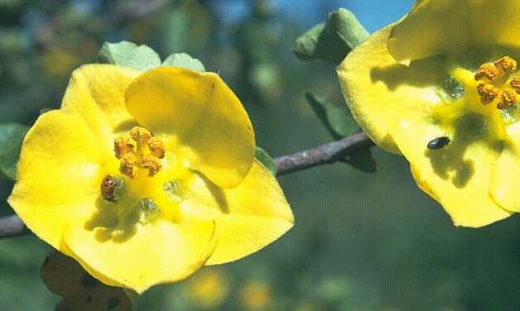

Alfred Brousseau

© Brother Eric Vogel, St. Mary's College

@ CalPhotos

#### Distribution

For current distribution, please consult the Plant Profile page for this species on the PLANTS Web site. The shrub is found from 400-2200 m in chaparral, oak woodland, and pine forests in the California Floristic Province, Arizona, and down to Baja California.

#### Establishment

The plants grow in extremely rocky areas and are often found in crevices of rocks. In southern California, these plants are found in areas containing very gritty soil and low rainfall. Buy small seedlings and plant them in the fall in a pile of roadfill with no clay (mostly gravel and rock and very little soil). Plant the seedlings in mounds in full sun. Plant in shallow holes and make sure that no soil covers the top of the ball of soil that contains the seedlings. Cover the soil with gravel and rock, then water. Keep the mound moist until new growth is several inches long (not over 4 inches), then stop watering. Water at the edge of the mound making sure that the water doesn't get within fifteen inches of the trunk of the plant. Leave the shrub alone from then on and use no fertilizer.

#### Management

You can prune this shrub at any time of the year. Tribes in the Sierra Nevada burned individual shrubs or areas where the shrubs grew in the fall or winter to induce rapid elongation of young epicormic branches which were harvested and split for cordage.

#### Cultivars, Improved and Selected Materials (and area of origin)

Contact your local Natural Resources Conservation Service (formerly Soil Conservation Service) office for more information. Look in the phone book under ”United States Government.” The Natural Resources Conservation Service will be listed under the subheading “Department of Agriculture.”

#### References

Barrett, S.A. & E.W. Gifford 1933. *Miwok material culture*. Bulletin of the Public Museum of the City of Milwaukee 2(4):117-376.

Steward, J.H. 1933. *Ethnography of the Owens Valley Paiute*. University of California Publications in American Archaeology and Ethnology 33(5):423-438.

USDA, NRCS 1999. *The PLANTS database*. National Plant Data Center, Baton Rouge, Louisiana. <http://plants.usda.gov>. Version: 990412.

Voegelin, E.W. 1938. *Tubatulabal ethnography*. Anthropological Records 2(1):1-84.

Whetstone, R.D. & T.A. Atkinson 1993. *Sterculiaceae*. Pages 1077-1078 IN: *The Jepson manual: Higher plants of California*. J.C. Hickman (ed.). University of California Press, Berkeley, California.

Zigmond, M.L. 1981. *Kawaiisu ethnobotany*. University of Utah Press. Salt Lake City, Utah.

#### Prepared By & Species Coordinator

*M. Kat Anderson*

USDA, NRCS, National Plant Data Center

c/o Environmental Horticulture Department, University of California, Davis, California

*Wayne Roderick*

Former Director of the East Bay Regional Parks Botanic Garden, Berkeley, California

Edited: 05dec00 jsp; 19may03 ahv; 07jun06 jsp

For more information about this and other plants, please contact your local NRCS field office or Conservation District, and visit the PLANTS Web site<<http://plants.usda.gov>> or the Plant Materials Program Web site <<http://Plant-Materials.nrcs.usda.gov>>

*The U.S. Department of Agriculture (USDA) prohibits discrimination in all its programs and activities on the basis of race, color, national origin, sex, religion, age, disability, political beliefs, sexual orientation, and marital or family status. (Not all prohibited bases apply to all programs.) Persons with disabilities who require alternative means for communication of program information (Braille, large print, audiotape, etc.) should contact USDA's* [*TARGET Center*](http://www.usda.gov/oo/target.htm) *at 202-720-2600 (voice and TDD).*

*To file a complaint of discrimination write USDA, Director, Office of Civil Rights, Room 326-W, Whitten Building, 14th and Independence Avenue, SW, Washington, DC 20250-9410 or call 202-720-5964 (voice or TDD). USDA is an equal opportunity provider and employer.*

*Read about* [*Civil Rights at the Natural Resources Convervation Service*](http://www.nrcs.usda.gov/about/civilrights/)*.*