|  |
| --- |
| roundhead lespedeza |
| *Lespedeza capitata* Michx. |
| Plant Symbol = LECA8 |

*Contributed By: USDA NRCS National Plant Data Center*

### Alternate Names

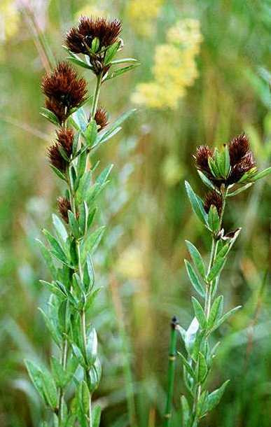

© Kenneth Sytsma

University of Wisconsin

@ Atlas of Florida Vascular Plants

roundheaded bush clover, bushclover

**Uses**

*Ethnobotanic*: The Omaha and Ponca used the stems for a moxa to treat cases of neuralgia and rheumatism. The Comanche boiled the leaves for a beverage tea. The Meskwaki used the root as an antidote for poison. The Iroquois used the whole plant of *Lespedeza* (unidentified to species level) in combination with *Euonymus obovata* for stricture caused by something wrong with the blood.

*Wildlife*: Roundhead lespedeza seeds are an

important food source for the bobwhite quail.

### Status

Please consult the PLANTS web site and your State Department of Natural Resources for this plant’s current status, such as, state noxious status and wetland indicator values.

### Description

*General:* Bean Family (Fabaceae). This herbaceous, native, perennial has erect stems that are 6-15 dm, and simple and branched above. The petioles are 2-5 mm, shorter than the stalk of the terminal leaflet. The plant has numerous small trifoliolate leaves. The leaflets are 4.5 x 1.8 cm, variable in shape and pubescence. The flowers are ochroleucous and are arranged in spikes or heads. The calyx lobes are all separate and the wings exceed the keel. Each flower is subtended at the base by small bractlets. The fruits are indehiscent, and 1-seeded.

*Distribution*: For current distribution, please consult the Plant Profile page for this species on the PLANTS Web site. This plant is found in dry, open woods, sand dunes, and prairies. It ranges from Maine and southern Quebec to Minnesota and South Dakota, south to Georgia, west Florida, and Texas.

**Establishment**

*Propagation by seeds*:Clean the seed and scarify each seed coat with sandpaper. If you are storing the seeds before planting, put them in cold storage. Plant the seeds in a bedding mix with a light layer of vermiculite on top. Sow the seeds in flats and water them, keeping them moist. Do not over water them. The seeds will germinate in approximately two weeks. After two more weeks, the seedlings will be ready to transplant into plugs. These plants can be transplanted once again in several weeks to larger pots. In the middle of May, after the danger of frost has past, the plugs can be directly transplanted into a well-drained soil in full sunlight and watered. Make sure the plants are moist for several weeks until established.

**Cultivars, Improved and Selected Materials (and area of origin)**

LECA8 is available through selected native plant nurseries within its range. Please check the Vendor Database, expected to be on-line through the PLANTS Web site in 2001 by clicking on Plant Materials.

**References**

Carlson, G.G., & V.H. Jones 1940. *Some notes on uses of plants by the Comanche Indians*. Papers of the Michigan Academy of Science, Arts and Letters 25:517-542.

Gilmore, M.R. 1977.  *Uses of plants by the Indians of the Missouri River region.* University of Nebraska Press, Lincoln, Nebraska.

Gleason, H.A. & A. Cronquist 1991. *Manual of vascular plants of northeastern United States and adjacent Canada.* Second Edition. The New York Botanical Garden, Bronx, New York.

Herrick, J.W. 1995.  *Iroquois medical botany*. Syracuse University Press, Syracuse, New York.

Moerman, D.E. 1998.  *Native American ethnobotany.* Timber Press, Portland, Oregon.

Smith, H.H. 1928*. Ethnobotany of the Meskwaki*. Bulletin of the Public Museum of the City of Milwaukee 4:2(175-326).

USDA, NRCS 2000. *The PLANTS database*. Version: 000503. <http://plants.usda.gov>. National Plant Data Center, Baton Rouge, Louisiana.

Wunderlin, R.P., B.F. Hansen, & E.L. Bridges 2000. *Atlas of Florida vascular plants*. Version: 000503. <http://cyber.acomp.usf.edu/~isb/projects/atlas/atlas.html>. University of South Florida, Institute for Systematic Botany, Tampa, Florida.

**Prepared By & Species Coordinator**

*M. Kat Anderson*, USDA NRCS National Plant Data Center, c/o Department of Plant Science, University of California, Davis, California

Edited 05dec00 jsp; 21may03 ahv; 24may06jsp

For more information about this and other plants, please contact your local NRCS field office or Conservation District, and visit the PLANTS Web site<<http://plants.usda.gov>> or the Plant Materials Program Web site <<http://Plant-Materials.nrcs.usda.gov>>

*The U.S. Department of Agriculture (USDA) prohibits discrimination in all its programs and activities on the basis of race, color, national origin, sex, religion, age, disability, political beliefs, sexual orientation, and marital or family status. (Not all prohibited bases apply to all programs.) Persons with disabilities who require alternative means for communication of program information (Braille, large print, audiotape, etc.) should contact USDA's* [*TARGET Center*](http://www.usda.gov/oo/target.htm) *at 202-720-2600 (voice and TDD).*

*To file a complaint of discrimination write USDA, Director, Office of Civil Rights, Room 326-W, Whitten Building, 14th and Independence Avenue, SW, Washington, DC 20250-9410 or call 202-720-5964 (voice or TDD). USDA is an equal opportunity provider and employer.*

*Read about* [*Civil Rights at the Natural Resources Convervation Service*](http://www.nrcs.usda.gov/about/civilrights/)*.*