|  |
| --- |
| nootka lupine |
| *Lupinus nootkatensis* Donn ex Sims |
| Plant Symbol = LUNO |

Contributed by: USDA NRCS National Plant Data Center

# Alternative Name

blue lupine

# Uses

*Ethnobotanic*: The roots of Nootka lupine were roasted or pit cooked by the Nuxalk and Kwakwaka’wakw (Pojar & Mackinnon 1994). The seeds were used as protein rich vegetable or savory dish in any of the ways that cooked beans are used, they were also roasted or ground into a powder.

*Wildlife*: Grizzly bears relish the roots of Nootka lupine and make large feeding excavations on north coastal estuarine marshes where both lupines and bears thrive (Pojar & Mackinnon 1994).

# Status

# Please consult the Plants Web site and your State Department of Natural Resources for this plant’s current status, such as, state noxious status and wetland indicator values.

# Description

*General*: Bean family (Fabaceae). Nootka lupine is a native perennial that dies back annually to a thick rhizome (Pojar & Mackinnon 1994). The leaves are palmately compound and up to six centimeters long. The flowers are blue (sometimes tinged pink or white), pea-like, to two centimeters long; in dense clusters as much as thirty centimeters long (Ibid). They are hermaphrodite (have both female and male organs) and are pollinated by bees.

*Distribution*: Known from Alaska in the U.S., but circumboreal. For current distribution, please consult the Plant profile page for this species on the PLANTS Web site.

# Adaptation

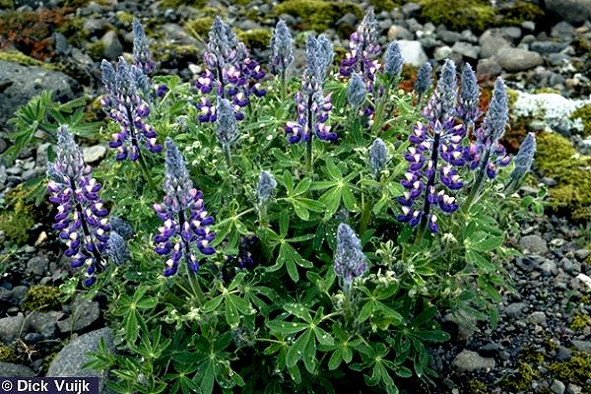

© Dick Vuijk

Flora of Iceland

Nootka lupine is commonly found in gravel bars, meadows, tidal marshes and open slopes. This plant requires well-drained soil and prefers sandy, loamy and clay soils. It grows best in a sunny position and cannot tolerate shade.

# Establishment

*Propagation by Seed*: Nootka lupine seeds should be pre-soaked for twenty-four hours, to break down the tough seed coats, and then sow in the early spring in a greenhouse. The seedlings should be thinned out as soon as the first true leaf appears (Heuser 1997). Division should be done in the spring, just before new growth commences (Ibid).

# Management

Lupines are most valuable because of the masses of nitrogen fixing bacteria, which live in nodules on their roots and convert the free nitrogen of the atmosphere into compounds that are essential to plant and animal growth (Moldenke 1949).

# Cultivars, Improved and Selected Materials (and area of origin)

Not readily available. Contact your local Natural Resources Conservation Service (formerly Soil Conservation Service) office for more information. Look in the phone book under ”United States Government.” The Natural Resources Conservation Service will be listed under the subheading “Department of Agriculture.”

# References

Hedrick, U.P. 1972. *Sturtevant’s edible plants of the world*. Dover Publications, New York, New York.

Huxley, A.1992. *The new RHS dictionary of gardening*. MacMillian Press, New York, New York.

Moerman, D. 1998. *Native American ethnobotany*. Timber Press, Portland, Oregon.

Moldenke, H.N. 1949. *American wildflowers*. D. Van Nostrand Company, Inc., New York, New York.

Pojar, J. & A. MacKinnon 1994. *Plants of the Pacific Northwest Coast: Washington, Oregon, British Columbia, and Alaska*. Lone Pine Publishing, Redmond, Washington.

Turner, N.J. *Food plants of coastal first peoples*. UBC Press, Vancouver, Canada.

# Vuijk, D. 2002. *Lupinus nootkatensis*. IN: Flora of Iceland. Accessed: 10jan02. <http://www1.bos.nl/~dvuijk/plants/data/Lupinus-nootkatensis/y992211.html>

# Prepared By

#### *Jammie Favorite*

formerly USDA, NRCS, National Plant Data Center

# Baton Rouge, Louisiana

# Species Coordinator

*M. Kat Anderson*

USDA, NRCS, National Plant Data Center, c/o Plant Sciences Dept., Davis, California

Edited: 19jun02 jsp; 21may03 ahv; 060802 jsp

For more information about this and other plants, please contact your local NRCS field office or Conservation District, and visit the PLANTS Web site<<http://plants.usda.gov>> or the Plant Materials Program Web site <<http://Plant-Materials.nrcs.usda.gov>>

*The U.S. Department of Agriculture (USDA) prohibits discrimination in all its programs and activities on the basis of race, color, national origin, sex, religion, age, disability, political beliefs, sexual orientation, and marital or family status. (Not all prohibited bases apply to all programs.) Persons with disabilities who require alternative means for communication of program information (Braille, large print, audiotape, etc.) should contact USDA's* [*TARGET Center*](http://www.usda.gov/oo/target.htm) *at 202-720-2600 (voice and TDD).*

*To file a complaint of discrimination write USDA, Director, Office of Civil Rights, Room 326-W, Whitten Building, 14th and Independence Avenue, SW, Washington, DC 20250-9410 or call 202-720-5964 (voice or TDD). USDA is an equal opportunity provider and employer.*

*Read about* [*Civil Rights at the Natural Resources Convervation Service*](http://www.nrcs.usda.gov/about/civilrights/)*.*