

Plant Guide

**Longleaf Pine**

***Pinus palustris* P. Mill**.

Plant Symbol = PIPA

*Contributed by*: USDA NRCS National Plants Data Team, Davis, California and the Mississippi Choctaw Field Office, Choctaw Mississippi

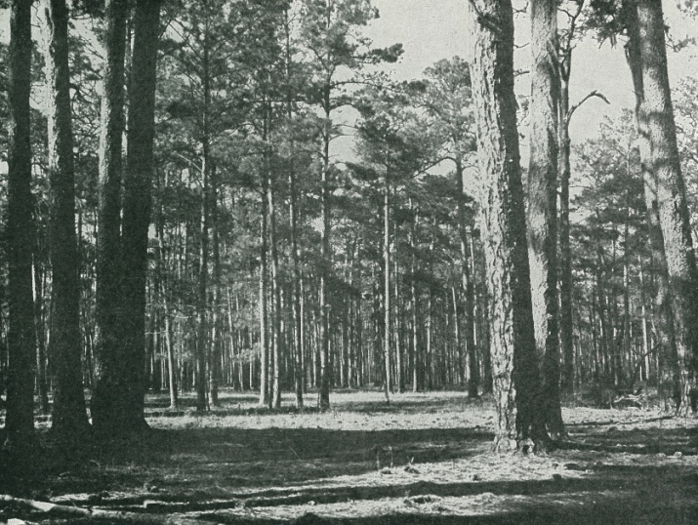

*Figure 1. Old-growth longleaf pine forest, St. Tammany Parish, Louisiana. Courtesy of the Smithsonian Institution, circa 1909.*

### Alternate Names

### Hard, Longstraw, Pitch, Fat, Southern Yellow, Swamp, Yellow or Georgia Pine

**Uses**

*Cultural:* Grooveless stone axes and adzes found in archaeological contexts in the southeastern United States reflect considerable Indian use of wood resources in southeastern forests (Delcourt et al. 1993). One of the most important of these wood resources was the pines. Pines had many uses among southeastern tribes, but often the kind of pine used is not identified. Given that in the past, longleaf pine dominated many landscapes in the Southeast, it is likely that it was utilized for many of the purposes described here. The Choctaw made darts that were used in blowguns from splinters of pine, sharpened at one end (Bushnell 1909). Tribes of the Southeast used pine wood for house frames, canoes, frames for skin boats or rafts, and bows (Swanton 1946). The Creek and Choctaw used pine bark to cover the roofs of their houses (Swanton 1931, 1946; Walker 2004). The Cherokee made

canoes out of logs of large pines and they were hollowed

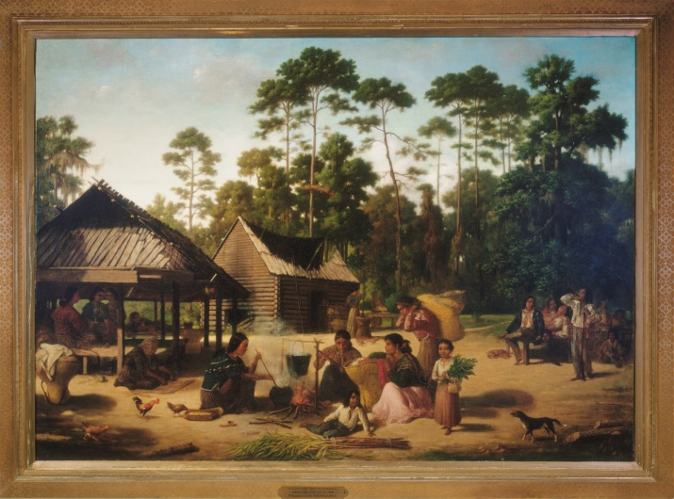

*Figure 2. Choctaw Village near the Tchefuncte River, an oil painting by François Bernard, Bonfouca, St. Tammany Parish. La., 1846. Notice the log cabin and summer arbor. Both are probably made of longleaf pine wood and observe the longleaf pine forest in the background. Courtesy of the Peabody Museum of Archaeology and Ethnology, Harvard University: 41-72-10/27.*

out with fire and scraped and chipped with oyster shells and stone hatchets (Swanton 1946; Catesby 1731-43). Longleaf pine was used for torches for fishing and hunting at night, as fuelwood and tinder for heating and cooking, and village streets were paved with pine bark (Earley 2004). Pines are considered by the Cherokee to have eternal lives, and therefore a home where a death occurred was purified with the smoke from pine branches, burned in a cooking vessel; pine branches were also thrown on the rekindled hearth fire (Mooney 1932). A Cherokee medicine man made a decoction of the tops of pines that was drunk by the patient for removing the pain in the body caused by the intrusion of a foreign object (Mooney 1932).

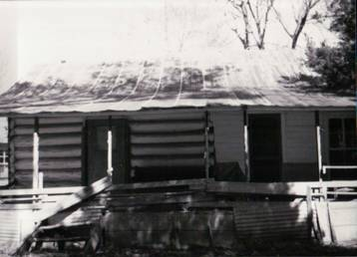

*Figure 3: Longleaf log cabin constructed and used by a member of the Choctaw-Apache Tribe of Ebarb. Photo used by permission by Chief John Procell. Photo comes from their tribal collection.*

The Choctaw-Apache Tribe of Ebarb located in Sabine Parish, Louisiana, utilized the longleaf pine wood for many purposes: as kindling for fires and for constructing log homes, cribs for livestock use, and slat houses (Rogers 2012). The slat homes were constructed of boards hewn from a longleaf pine log (see figures 2 - 4) (Rogers 2012). The Adai Caddo also made log or slat homes (Rogers 2012).

The Alabama Coushatta, Chitimacha, Adai Caddo, Louisiana Coushatta (Koasati), Tunica-Biloxi Tribe of Louisiana, Clifton Choctaw, Four Winds Tribe Louisiana Cherokee Confederacy, Choctaw-Apache Tribe of Ebarb, Seminole, and Houma used and continue to use the distinct long needles of longleaf pine in the making of baskets (figures 5-8) (Gettys 1979; Kniffen et al. 1987; Rogers 2012; S. Turnbaugh and W. Turnbaugh 1986). The needles are gathered in the spring while still on the tree or fall from the ground and dried in a cool place out of direct sunlight (Rogers 2012).

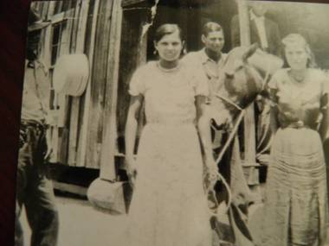

*Figure 4: Slat House construction from longleaf pine. House was the home to the great grandfather of the current Chief of the Choctaw-Apache Tribe of Ebarb - John Procell. The woman in the photo is Chief Procell’s mother. Picture used by permission of John Procell.*

Once dry the sheaths of the needles are clipped or scraped off and discarded and the needles are stored in paper sacks or other breathable containers until needed (Rogers 2012). Before using dried needles, they are soaked in water to regain their flexibility and then used (Rogers 2012). The long pine needles are coiled, and sewn in place with the inner bark of dogwood or slippery elm (Kniffen et al. 1987). The Louisiana Coushatta tribe was among the first practitioners of the coiled pine needle basket technique and they are still known for their skill at making longleaf pine needle baskets and trays.

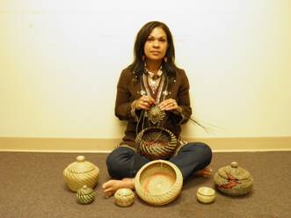

*Figure 5: Becky Thomas, Clifton Choctaw shown weaving a basket; Seated around her on the floor are other baskets that she has created. She is one of the premier basket weavers of the tribe. Photograph by E. John Rogers.*

Both the Louisiana and Texas Coushatta are known for their round and oval baskets, which may be decorated with flowers or pine cones (figure 6). Pine needle trays have also been made since the 1930s.The Coushatta are also known for making pine needle effigy baskets in numerous animal shapes.

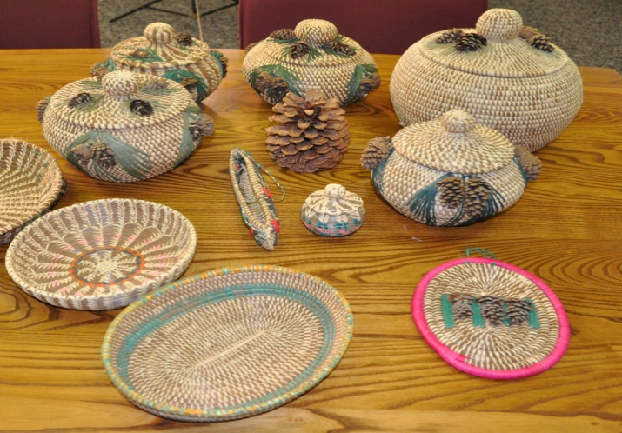

*Figure 6: Longleaf pine trees have been used for generations to craft intricate handmade baskets made by Tribal members and elders of the Alabama-Coushatta Tribe of Texas. Photograph by Beverly Moseley.*

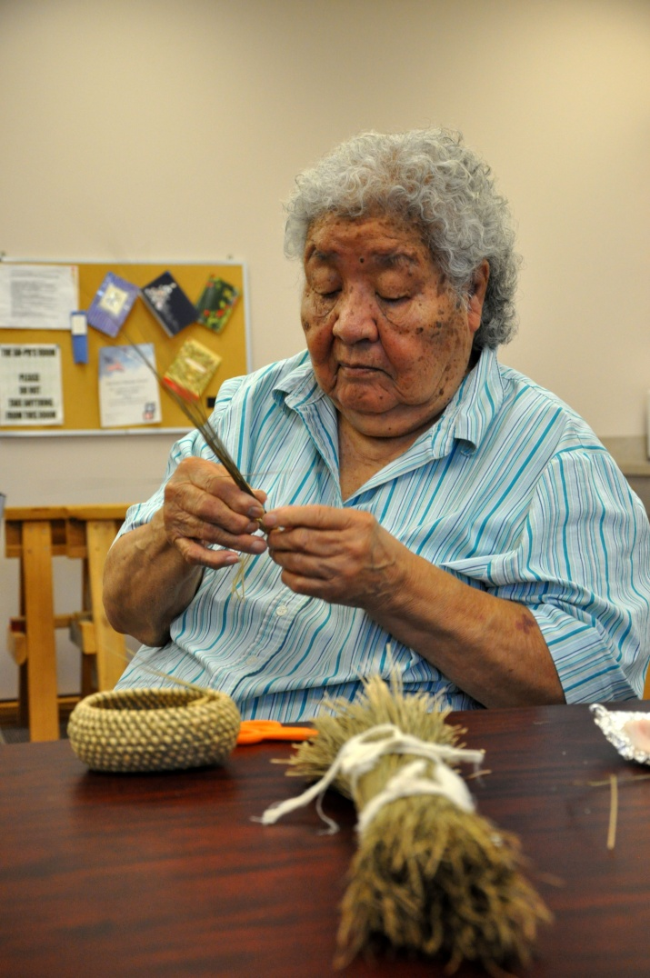

*Figure 7: Doris Battise, is a master basket weaver and a member of the Alabama-Coushatta Tribe of Texas. Photograph is by Beverly Moseley.*

During the 1960’s Coushatta women produced a wide array of animals: bear, crabs, crayfish, frogs, etc. The Louisiana Coushatta have also planted long leaf pine on their land near Elton in the southwestern part of the state, so they can continue to make baskets in the future (Rogers 2012).

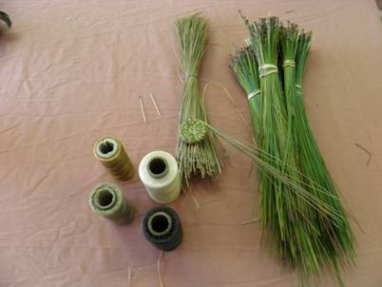

*Figure 8: Materials needed to begin a longleaf needle basket; photograph taken at a longleaf pine needle basket workshop at the Four Winds Cherokee Tribal office. Permission granted by Four Winds Tribe to use and take photograph. Photograph was taken by E. John Rogers.*

It takes large quantities of pine needles to make a basket and today locating enough sources of needles is difficult in Louisiana (Rogers 2012) and many parts of the Southeast.

Non-Indian women in the early to mid-part of the twentieth century made longleaf pine needle baskets for gathering fruits and berries, vegetables and flowers, and also eggs from the barnyard (Tappan 1930). They also made them for decoration and pine needle basketry was taught in local schools (Hammel 1917). The favored time for gathering the needles was autumn (Lang 1926).

Many early non-Indian settlers in the Southeastern United States considered longleaf pine the most valuable of all the kinds of pines (Porcher 1991). They found medicinal value in longleaf pine using turpentine as a stimulant and diuretic, and if taken in large doses, it served as a laxative (Porcher 1991). The turpentine was also used in the making of soap. The buds of the pine or the inner bark was steeped in water and drunk as a cure for colds and coughs (Porcher 1991). As non-Indian settlers moved into the area, they grazed their sheep, hogs, and cattle in the open understories of these pine forests and hogs also consumed the pine nuts (Porcher 1991). By the late 1700’s Europeans and Americans had created an increased demand for naval stores where the wood was employed in the siding of ships, masts, yardarms and for floorboards in buildings (Porcher 1991). The tree took on great economic importance in Western society for saw timber. The second-growth longleaf pine became important for lumber, pulpwood, crossties, boxes, crates, fuelwood, and in producing turpentine and rosin (Mattoon 1922). Two distinct pine products, tar derived by slow-burning pine wood in a kiln, and pitch made from tar boiled in a kettle or cauldron were used to seal naval ships, making them watertight (Earley 2004). At one time, the bulk of the turpentine produced in the United States came from southeastern longleaf pine forests (Mattoon 1922). Forest examiner Wilbur Mattoon commented in 1922 on the extensive destruction of young stands that were worked heavily for these products.

Today young stands of longleaf pine can produce pine straw mulch, a very important regional product obtained from longleaf pine stands beginning at about age 8, peaking at age 18 and sometimes continuing for many more years (Wallace and Ward, 2011; Ward, 2011). Care must be taken if pine straw is to be harvested sustainably and native understory plants conserved (Ward, 2011). Mature longleaf forests produce high quality timber products including utility poles, lumber and pulpwood.

*Wildlife:* Many kinds of animals are associated with the groundcover in longleaf pine forests. In fact, the majority of the biological diversity in longleaf forests is in the understory, not the tree canopies (Simberloff 1993). Wild turkeys (*Meleagris gallapavo*), fox squirrels (*Sciurus niger*), and gopher tortoises (*Gopherus polyphemus*) all use the longleaf pine understory. The gopher tortoise is crucial to longleaf pine communities because at least 332 other animal species use its burrows such as Florida mice *(Podomys floridanus*), indigo snakes (*Drymarchon couperi*), and gopher frogs (*Rana capito*) (Jackson and Milstrey 1989; Franz 1984). The gopher tortoise is a species of special concern—declining through loss of habitat and lack of fire in existing habitats (Barlow 2004). In one study higher densities were found in open areas with herbaceous ground cover and bare soil and much lower in areas of higher shade and shrub cover (Barlow 2004). The red-cockaded woodpecker (*Picoides borealis*) and the Bachman’s sparrow (*Aimophila aestivalis*) are two of many federally listed species that inhabit the endangered longleaf pine-wiregrass ecosystem of the southeastern coastal plain (Noss et al. 1995). With changed fire regimes, other birds that frequent longleaf pine are declining such as the brown-headed nuthatch (*Sitta pusilla*), loggerhead shrike (*Lanius ludovicianus*), and eastern bluebird (*Sialia sialis*) (Cox 1987 cited in Barlow 2004). Longleaf stands are also highly valued for wildlife habitat necessary for bobwhite quail (*Colinus virginianus).*

**Status**

Please consult the PLANTS Web site and your State Department of Natural Resources for this plant’s current status (e.g., threatened or endangered species, state noxious status, and wetland indicator values).

**Description**

*General:* The tree grows up to 120 feet tall (37 meters) tall, with a rounded crown. The orange-brown trunk is straight, up to 30 inches (76 cm) in diameter and it has coarse, rectangular, scaly plates (Harlow and Harrar, 1969). The leaves are 25-40 cm. long and are in threes that are persistent for 2 years (Gleason and Cronquist 1991; Radford et al. 1968). Longleaf pine has a deep taproot and a definite grass stage (Kral 1993). The seed cones are solitary or paired 15 cm. long. A heavy crop of pine cones bearing seed occurs at intervals of about every seven years and the seeds require two years to mature (Mattoon 1922).

*Distribution:* The forest grows from 0-700 m and once occupied a belt extending through the Coastal Plain from extreme southern Virginia to the Everglades in Florida and west into Texas, originally covering about 92 million acres prior to European settlement (Shantz and Zon 1924; Frost 1993). Though confined mostly to the Coastal Plain, longleaf can also be encountered in parts of the Piedmont, as well as the southern foothills of the Appalachian Mountains (Earley 2004). When the Spanish arrived in the early 1500s, longleaf pine was the dominant tree over 60 million acres of the Southeast, and it grew in mixtures with other pines and hardwoods on an additional 30 million acres (Earley 2004). Presently longleaf occupies only 3.4 million acres (America’s Longleaf 2009). Longleaf pine communities have been reduced to about three percent of their original area, due to logging, turpentining, open range grazing by hogs and other livestock, fire suppression, clearing for agriculture, and urban development (Frost 1993). The longleaf pine forests of Texas and Louisiana have declined by eighty-five percent since 1935 (Bridges and Orzell 1989 cited in Noss et. al 1995). Ninety-eight percent of the presettlement longleaf pine forests in the Southeastern Coastal Plain are gone (Noss et al. 1995). Longleaf pine forests of Florida have dwindled by eighty-eight percent (Kautz 1993 cited in Noss et al. 1995). Lawrence S. Earley (2004) estimates that the majority of old-growth longleaf pine forest is gone—with a mere 12,000 acres remaining in scattered stands.

*Habitat:* Longleaf pine grows in pure stands over large areas and has the ability to grow on poor, dry, and poorly drained soils (Mattoon 1922). It is found in dry sandy uplands, sandhills, savannas, wet flatwoods of the coastal plain from Virginia to Texas, as well as montane sites including dry, rocky ridgetop areas in Alabama and Georgia (Estes 2006). The region experiences from 40 to 60 inches of rain a year.

**Adaptation**

Longleaf pine forests are adapted to the disturbances of fire and hurricanes and frequent low intensity burns are important in maintaining variable horizontal structure in this plant community (Landers et al 1995; Estes 2006). Longleaf pine is remarkably resistant to fire. It puts out an extensive root system following seed germination, enabling the seedling to sprout from its root collar if defoliated by fire (Carey 1992; Ware et al. 1993). The terminal bud of the seedling is protected from the heat of grass fires by a rosette of long, green needles and older growth has a thick, fire-resistant bark (Watson 1940; Carey 1992). The large seeds germinate best on bare mineral soil—an effective way to create these conditions is through prescribed burning (Garren 1943 cited in Wagner 2003; Watson 1940).

When the earliest explorers came into the southeastern United States, they commented on the wide spacing of longleaf pine trees. Early ecologists such as B.W. Wells marveled at the size of the old-growth trees, measuring a yard or more in basal diameter (Wells 1932 cited in Earley 2004). Euro-American accounts describe Southeastern Indian burning practices in the longleaf pine forests for many reasons such as to facilitate hunting by opening the woods, encourage forage for wildlife, and control insects (Earley 2004; Lawson 1967).

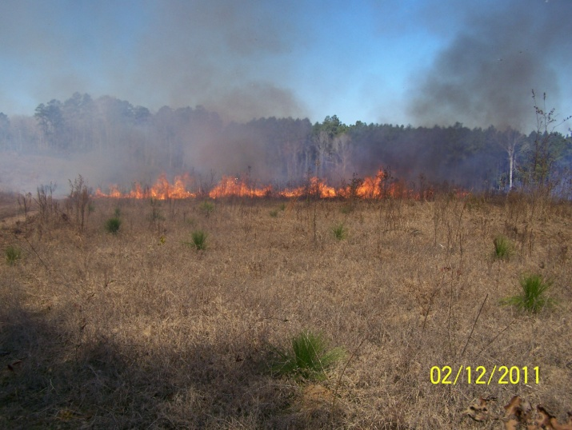

*Figure 9: Silvicultural burning of longleaf in the grass stage. Photograph was taken by E. John Rogers.*

These fires were frequent, every two to four years (Rogers 2012). The time of year for most Indian-set fires was fall to winter (Ware et al. 1993). Together, lightning and Indian-set fires created the open forests that Europeans, such as William Bartram, observed in the Southeast.

Many of the ecosystems where longleaf pine grows, such as the pine flatwood ecosystem, are fire dependent. Pine flatwoods have a fire frequency of every one to eight years (Behm 2003). Numerous studies demonstrate that prescribed burning can help put cutover longleaf lands back into timber production without planting (Bruce and Bickford 1950). Longleaf pine grows best with low-intensity fires spaced one to three years apart (Kalisz et al. 1986; Myers 1985 cited in Wagner 2003). Some research suggests that many longleaf pine sites have been replaced by hardwoods and other species of pines (Boyer 1990; Frost 1993; Myers and Peroni 1983). Many of these vegetation changes are in part a result of shifts in the fire regimes, likely due to a decrease in Indian burning and lightning fire suppression.

**Establishment and Management**

Seeds of longleaf pine are the largest of the southern pines. They do not store well and are best planted in the fall after collection between October and November and test for seed viability prior to planting. Longleaf is mostly regenerated with bare root or container seedlings. Best results are obtained with container seedlings, planted slightly above ground level when soil is moist between November and March. Planting rates vary from 300 to 900 per acre but the most commonly recommended rate is 600-700 per acre (Longleaf Pine Partnership Council 2013). Longleaf is very susceptible to competing vegetation. Competing vegetation must be controlled either chemically or mechanically with seedlings planted in the center of a weed free area with a radius of at least 15 inches (Longleaf Alliance 2009). If there is a history of cultivation sub-soiling will be necessary to break up soil compaction (Longleaf Alliance 2009). Prescribed fire applied at an interval of 1-3 years is necessary to exclude hardwood trees and shrubs and maintain a natural understory of grasses and forbs. An occasional growing season burn (April-June) is necessary to reduce the number and vigor of hardwood sprouts (Jose et. al.2006). If competing vegetation is not controlled, longleaf will remain in the “grass stage” for up to 15 years, rather than the minimum of 2 years (Jose et. al. 2006). Seedlings in the grass stage are capable of re-sprouting if damaged or top-killed (Jose et. al. 2006). Height growth can be rapid once seedlings emerge from the grass stage. Young stands of longleaf tend to quickly develop a range of size classes reducing the risk of stagnation and the need for pre-commercial thinning (Burns 1983).

**Pests and Diseases**

The longleaf pine has two serious enemies—the hog and the brown spot needle disease (*Septoria acicola*) which causes defoliation. Hogs root the seedlings up and can live on the stored food material in the roots. The needle disease is caused by a fungus which is often a very serious enemy of the young seedlings underneath a “rough” of dead grass. Burning the dead grass in winter at intervals of more than one year can control this disease (Chapman 1941; Greene 1931). Longleaf pine is less susceptible to southern pine beetle*, Dendroctonus frontalis*, and pitch canker, *Fusarium moniliforme* var. *subglutinans* than other southern pines.

**Control**

Please contact your local agricultural extension specialist or county weed specialist to learn what works best in your area and how to use it safely. Always read label and safety instructions for each control method. Trade names and control measures appear in this document only to provide specific information. USDA NRCS does not guarantee or warranty the products and control methods named, and other products may be equally effective.

## Cultivars, Improved, and Selected Materials (and area of origin)

This plant is available from native plant nurseries. Select plants from seed collected from healthy vigorous local stands to maintain genetic diversity and integrity of ecotypes.

**References**

America’s Longleaf 2009. Rangewide Conservation Plan for Longleaf Pine. Regional Working Group for America’s Longleaf. 42 pp. <http://www.americaslongleaf.org/>

Barlow, S.E. 2004. Vegetative characteristics of gopher tortoise (*Gopherus polyphemus*) habitat on the Lower Suwannee National Wildlife Refuge: Implications for restoration and management of pine communities. Master's Thesis. University of Florida.

Bartram, W. 1996. William Bartram Travels and Other Writings. Literary Classics of the United States, Inc., New York, N.Y.

Boyer, W.D. 1990. *Pinus palustris* Mill. Longleaf pine. Pages 405-412 In: Silvics of North America Volume 1. Conifers. USDA Forest Service Agriculture Handbook 654.

Bridges, E.L., and S.L. Orzell. 1989. Longleaf pine communities of the west Gulf coastal plain. Natural Areas Journal 9:246-263.

Burns, R. M., ed., 1983. Silvicultural Systems for the Mahor Forest Types of the United States, pp. 153-156. W.D. Boyer and D.W. Peterson. Ag. Handbook 445, USDA-Forest Service, Washington, DC. <http://www.treesearch.fs.fed.us/pubs/32974>

Burns, R.M. and B.H. Honkala, 1990. Silvics of North America: Vol. 1. Agriculture Handbook No. 654. U.S. Department of Agriculture, Forest Service, Washington, DC. <http://www.na.fs.fed.us/spfo/pubs/silvics_manual/table_of_contents.htm>

Bushnell, D.L., Jr. 1909. The Choctaw of Bayou Lacomb, St. Tammany Parish, Louisiana. Bureau of American Ethnology Bulletin, Number 48. Smithsonian Institution, Washington, D.C.

Carey, J.H. 1992. *Pinus palustris* In: Fire Effects Information System, [Online]. U.S. Department of Agriculture, Forest Service, Rocky Mountain Research Station, Fire Sciences Laboratory. Available at : http://www.fs.fed.us/database/feis/

Catesby, M. 1731-1743. The Natural History of Carolina, Florida, and Bahama Islands. 2 Vols. London.

Chapman, H.H. 1941. Controlled burning correspondence. Journal of Forestry 39:888-890.

Cox, J. 1987. The breeding bird survey in Florida: 1969-1983. Fla. Field Nat. 15:29-56.

Delcourt, P.A., H.R. Delcourt. D.F. Morse, and P.A. Morse. 1993. History, evolution, and organization of vegetation and human culture. Pages 47-79 In: Biodiversity of the Southeastern United States Lowland Terrestrial Communities. W.H. Martin, S.G. Boyce, and A.C. Echternacht (eds.). John Wiley & Sons, Inc. New York, N.Y.

Earley, L.S. 2004. Looking for Longleaf: The Fall and Rise of an American Forest. The University of North Carolina Press, Chapel Hill.

Estes, B.L. 2006. Impact of Interacting Disturbances on Longleaf Pine Communities. Ph.D. Dissertation. School of Forestry and Wildlife Sciences. Auburn University. Auburn, Alabama.

Franz, R. 1984. The Florida gopher frog and the Florida pine snake as burrow associates of the gopher tortoise in northern Florida. Pages 16-20 in: The Gopher Tortoise and its Community. D.R. Jackson and R.J. Bryant (eds.). Florida State Museum, University of Florida, Gainesville.

Frost, C.C. 1993. Four centuries of changing landscape patterns in the longleaf pine ecosystem. Pages 17-44 in: Proceedings, 18th Tall Timbers Fire Ecology Conference—The Longleaf Pine Ecosystem: Ecology, Restoration and Management, S.M. Hermann (ed.). Tall Timbers Research Station, Tallahassee, Fla.

Garren, K.H. 1943. Effects of fire on vegetation of the Southeastern United States. Botanical Review 9:617-654.

Gettys, M. 1979. Basketry of the Eastern United States. Self-published.

Gleason, H.A. and A. Cronquist. 1991. Manual of Vascular Plants of Northeastern United States and Adjacent Canada. Second Edition. The New York Botanical Garden, Bronx.

Greene, S.W. 1931. The forest that fire made. American Forests 37:583-84.

Hammel, W.C. 1917. Pine-needle Basketry in Schools. Department of Interior Bureau of Education Bulletin 1917, No. 3. Greensboro, N.C.

Harlow, W.M. and E.S. Harrar 1969. Textbook of Dendrology. McGraw-Hill, Fifth Ed. pp.81-84.

Jackson, D.R., and E.R. Milstrey. 1989. The fauna of gopher tortoise burrows. In Proceedings of the Gopher Tortoise Relocation Symposium. J.E. Diemer D.R. Jackson, J.L. Landers, J.N. Layne, and D.A. Wood (eds.). Florida Game and Fresh Water Fish Commission, Tallahassee.

Jose, S., E.J. Jokela and D.L. Miller, ed., 2006. The Longleaf Pine Ecosystem: Ecology, Silviculture, and Restoration. Springer. 438 pp.

Kalisz, P.J., A.W. Dorian, and E.L. Stone. 1986. Prehistoric land-use and the distribution of longleaf pine on the Ocala National Forest, Florida: an interdisciplinary synthesis. Florida Anthropologist 39(3):183-193.

Kautz, R.S. 1993. Trends in Florida wildlife habitat 1936-87. Florida Scientist 1:7-24.

Kniffen, F.B., H.F. Gregory, and G.A. Stokes. 1987. The Historic Indian Tribes of Louisiana From 1542 to the Present. Louisiana State University Press, Baton Rouge.

Kral, R. 1993. Pinus Linnaeus, Sp. Pages 373-398 in: Flora of North America Vol. 2: Pteridophytes and Gymnosperms. Flora of North America Editorial Committee (ed.). Oxford University Press, Oxford.

Landers, J.L., D.H. Van Lear, and W.D. Boyer. 1995. The longleaf pine forests of the Southeast: requiem or renaissance? Journal of Forestry 93: 39-44.

Lang, E. Mrs. 1926. Basketry Weaving and Design. Charles Scribner’s Sons. New York, N.Y. Longleaf Alliance 2009. Longleaf Academy: Longleaf 101. <http://www.longleafalliance.org/academy/overview> .

Lawson, J. 1967. A New Voyage to Carolina. University of North Carolina Press, Chapel Hill. Reprint. Original published in 1709.

Longleaf Pine Partnership Council 2013, in press. Longleaf Planting Density White Paper. <http://www.americaslongleaf.org/whosinvolved/partnership-council/>

Mattoon, W.R. 1922. Longleaf pine. U.S.D.A. Bulletin 1061.

Minno, M.C. 1995. Definitive destination: Ocala National Forest, Florida. American Butterflies 3(4):4-11.

Mooney, J. 1932. The Swimmer manuscript: Cherokee sacred formulas and medicinal prescriptions. F.M. Olbrechts (ed.) Smithsonian Institution Bureau of American Ethnology Bulletin 99. U.S. Government Printing Office, Washington, D.C.

Myers, R.L. 1985. Fire and the dynamic relationship between Florida sand hill and sand pine scrub vegetation. Bulletin of the Torrey Botanical Club 112(3):241-252.

Myers, R.L. and P.A. Peroni. 1983. Approaches to determining aboriginal fire use and its impact on vegetation. Bulletin of the Ecological Society of America 64(3):217-18.

Noss, R.F., E.T. LaRoe III, and J.M. Scott. 1995. Endangered Ecosystems of the United States: A Preliminary Assessment of Loss and Degradation. Biological Report 28. National Biological Service, U.S. Department of the Interior, Washington, D.C.

Porcher, M.D., F.P. 1991. Resources of the Southern Fields and Forests, Medical, Economical, and Agricultural. Reprinted by Norman Publishing, San Francisco (Originally published in 1863 by Evans & Cogswell, Charleston).

Radford, A.E., H.E. Ahles, and C. R. Bell. 1968. Manual of the Vascular Flora of the Carolinas. The University of North Carolina Press, Chapel Hill.

Rogers, E.J. 2012. Longleaf Pine Tree Usage by American Indian Tribes of Louisiana: Pine Cones, Needles and Logs. USDA Natural Resources Conservation Service Report.

Shantz, H.L. and R. Zon. 1924. Natural vegetation. Atlas of American Agriculture, Pt. 1, Sec. E. U.S. Department of Agriculture, Washington, D.C.

Simberloff, D. 1993. Species-area and fragmentation effects on old-growth forests: prospects for longleaf pine communities. Proceedings of the Tall Timbers Fire Ecology Conference, No. 18, the Longleaf Pine Ecosystem: Ecology, Restoration and Management. S.M. Hermann (ed.). Tall Timbers Research Station, Tallahassee, FL.

Swantion, J.R. 1931. Source material for the social and ceremonial life of the Choctaw Indians. Bureau of American Ethnology Bulletin 103. Smithsonian Institution, Washington, D.C. U.S. Government Printing Office.

__________. 1946. The Indians of the Southeastern United States. Smithsonian Institution Bureau of American Ethnology Bulletin 137. United States Government Printing Office, Washington, D.C.

Tappan, G. 1930. Louisiana Basketry. Extension Circular No. 136. Louisiana State University and Agricultural and Mechanical College. Division of Agricultural Extension, W.B. Mercier, Director.

Turnbaugh, S.P. and W.A. Turnbaugh. 1986. Indian Baskets. Schiffer Publishing Ltd. West Chester, Pennsylvania.

Wagner, G.E. 2003. Eastern woodlands anthropogenic ecology. People and Plants in Ancient Eastern North America. P.E. Minnis (ed.). Smithsonian Books. Washington, D.C.

Walker, W.B. 2004. Creek Confederacy before removal. Pages 373-392 in: Handbook of North American Indians Vol. 14. Southeast. R.D. Fogelson (Vol. ed.). Smithsonian Institution, Washington, D.C.

Wallace, D. and T. Ward 2011. Pine Straw – A Profitable Agroforestry Enterprise. Agroforestry Notes, AF Note-37, USDA National Agroforestry Center, Lincoln, NE. <http://nac.unl.edu/documents/agroforestrynotes/an37ff06.pdf>

Ward, T., 2011. Minimum Impact Pine Straw Raking. Forestry Technical Note. USDA-Natural Resources Conservation Service, E. National Technology Support Center, Greensboro, NC.

Ware, S., C. Frost, and P.D. Doerr. 1993. Southern mixed hardwood forest: the former longleaf pine forest. Pages 447-493 In: Biodiversity of the Southeastern United States Lowland Terrestrial Communities. W.H. Martin, S.G. Boyce, and A.C. Echternacht (eds.). John Wiley & Sons, Inc. New York, N.Y.

Watson, Jr., L. 1940. Controlled burning and the management of longleaf pine. Journal of Forestry 38:44-47.

Wells, B.W. 1932. The Natural Gardens of North Carolina. Reprint 2002. University of North Carolina Press, Chapel Hill.

Prepared By: M. Kat Anderson, Ethnoecologist, USDA NRCS National Plants Team; Tim Oakes USDA NRCS Liaison-Conservation Program Analyst to the Mississippi Band of Choctaw Indians and E. John Rogers, District Conservationist Sabine SWCD, Many, LA.

**Citation**

Anderson, M.K., T. Oakes, and E.J. Rogers 2012. Plant Guide for Longleaf Pine (*Pinus palustris* P. Mill.). USDA-Natural Resources Conservation Service, National Plants Team. Davis, CA 95616.

**Acknowledgements**

The authors would like to thank Mark Garland, Ramona Garner, Garry Stephens and Thomas Ward for editing of this Plant Guide and to Beverly Moseley for her photo contributions. Appreciation is expressed to the Shields Library at UC Davis for use of its vast library collections and interlibrary loan services to find limited and obscure library materials in book, report, and microfilm form from many institutions across the country.

Published: May 30, 2013

Edited: June 7, 2013

For more information about this and other plants, please contact your local NRCS field office or Conservation District at <http://www.nrcs.usda.gov/> and visit the PLANTS Web site at <http://plants.usda.gov/> or the Plant Materials Program Web site <http://plant-materials.nrcs.usda.gov>.

PLANTS is not responsible for the content or availability of other Web sites.

**USDA IS AN EQUAL OPPORTUNITY PROVIDER AND EMPLOYER**