|  |
| --- |
| frosted mint |
| *Poliomintha incana* (Torr.) Gray |
| Plant Symbol = POIN3 |

Contributed by: USDA NRCS National Plant Data Center

##### Alternate Names

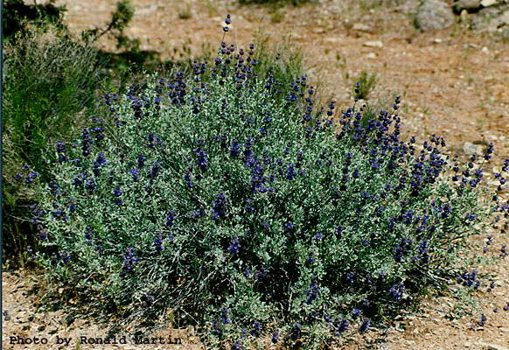

© Ronald Martin

Intermountain Wildflowers

Southern Utah University

Rosemary mint, purple sage

##### Uses

*Ethnobotanic*: Comanche medicine women chewed the leaves of frosted mint to sweeten the taste of other drugs. The Hopi and Tewa used frosted mint to treat rheumatism and ear trouble. They also used the flowers for flavoring in food preparation.

##### Status

Please consult the PLANTS Web site and your State Department of Natural Resources for this plant’s current status (e.g. threatened or endangered species, state noxious status, and wetland indicator values).

##### Description

General: Mint Family (Labiatae). Frosted mint is a shrub that reaches 5 dm in height and is very branched. The branches are straight, slender, and erect. The branches have a silvery color and a dense covering of small hairs. The leaves are attached directly to the branches without a supporting stalk. The leaves are long and narrow with almost parallel sides (1-3 cm long). The leaves are veinless and covered with white, soft, wooly hairs. The flowers grow in groups of 1 to 3 and are located below their axils. The flowers are 6 to 7 mm long. The calyx has 15 simple veins, is oblong shaped, and covered with white, soft, shaggy hairs. The calyx has conspicuous awl-shaped teeth. The corollas are 1 to 1.4 cm long and have a lavender color with purple dots on the lower lip. The tube of the corolla has long, soft, straight hairs in the form of a ring.

*Distribution*: For current distribution, please consult the Plant Profile page for this species on the PLANTS Web site.

*Habitat*: Frosted mint is found on eroded slopes and in sandy soils.

##### Pests and Potential Problems

Grown in its native habitat and using local seed stock, frosted mint should not be prone to debilitating pests.

##### Cultivars, Improved, and Selected Materials (and area of origin)

These materials are readily available from commercial plant sources. Contact your local Natural Resources Conservation Service (formerly Soil Conservation Service) office for more information. Look in the phone book under ”United States Government.” The Natural Resources Conservation Service will be listed under the subheading “Department of Agriculture.”

##### References

Colton, H.S. 1974. *Hopi history and ethnobotany*. IN D.A. Horr (ed). *Hopi Indians*. Garland Press, New York, New York. 424 pp.

Correl, D.S. & M.C. Johnston 1970. *Manual of the vascular plants of Texas*. Texas Research Foundation, Renner, Texas. 1881 pp.

Great Plains Flora Association 1986. *Flora of the Great Plains*. University Press of Kansas, Lawrence, Kansas. 1392 pp.

Jones, D.E. 1968. *Comanche plant medicine*. Papers in Anthropology 9:1-13.

Martin, R.E. et al. 2002. *Intermountain wildflowers*. Southern Utah University, Cedar City, Utah. <http://www.suu.edu/faculty/martin/utahwildflowers.htm>. Accessed: 30May2002.

Moerman, D.E. 1998. *Native American ethnobotany*. Timber Press, Portland, Oregon. 927 pp.

Moerman, D.E. 1999*. Native American ethnobotany database: Foods, drugs, dyes and fibers of native North American peoples*. The University of Michigan-Dearborn. <http://www.umd.umich.edu/cgi-bin/herb>.

Whiting, A.F. 1939. *Ethnobotany of the Hopi*. Museum of Northern Arizona Bulletin #15. 120 pp.

##### Prepared By:

##### *Matthew D. Hurteau*

##### Formerly USDA, NRCS, National Plant Data Center, c/o Environmental Horticulture Department, University of California, Davis, California

##### Species Coordinator:

##### *M. Kat Anderson*

##### USDA, NRCS, National Plant Data Center, c/o Plant Sciences Department, University of California, Davis, California

##### Edited: 30May2002 jsp ; 29may03 ahv; 060808 jsp

For more information about this and other plants, please contact your local NRCS field office or Conservation District, and visit the PLANTS Web site<<http://plants.usda.gov>> or the Plant Materials Program Web site <<http://Plant-Materials.nrcs.usda.gov>>

*The U.S. Department of Agriculture (USDA) prohibits discrimination in all its programs and activities on the basis of race, color, national origin, sex, religion, age, disability, political beliefs, sexual orientation, and marital or family status. (Not all prohibited bases apply to all programs.) Persons with disabilities who require alternative means for communication of program information (Braille, large print, audiotape, etc.) should contact USDA's* [*TARGET Center*](http://www.usda.gov/oo/target.htm) *at 202-720-2600 (voice and TDD).*

*To file a complaint of discrimination write USDA, Director, Office of Civil Rights, Room 326-W, Whitten Building, 14th and Independence Avenue, SW, Washington, DC 20250-9410 or call 202-720-5964 (voice or TDD). USDA is an equal opportunity provider and employer.*

*Read about* [*Civil Rights at the Natural Resources Convervation Service*](http://www.nrcs.usda.gov/about/civilrights/)*.*