|  |
| --- |
| interior live oak |
| *Quercus wislizeni* A. DC. |
| Plant Symbol = QUWI2 |

Contributed by: USDA NRCS National Plant Data Center

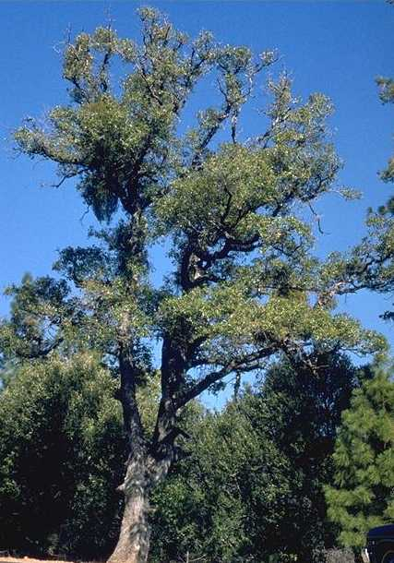

Brother Alfred Brousseau

© Brother Eric Vogel, St. Mary’s College

@ CalPhotos

#### Alternate Names

*Quercus parvula*, *Quercus shrevei*; dwarf interior live oak, scrub interior live oak, Highland live oak Sierra live oak; this species is recognized as having two varieties: Qu*ercus wislizeni* var. *frutescens* and *Quercus* *wislizeni* var. *wislizeni*

#### Uses

*Wildlife Use*: Interior live oak provides important food and cover for a wide variety of birds and mammals: black-tailed jackrabbit, Audubon cottontail, brush rabbit, Beechy ground squirrel, Sonoma chipmunk, beaver, porcupine, and elk. It is important for winter browse by Columbian black-tailed deer. Acorns are a valuable food source for deer and other wild ungulates, birds, and small mammals in the fall.

*Ethnobotanic*: After leaching away the bitter tannins, Native Americans used the acorns of many oaks (*Quercus* spp.) for cooking oils, soups, stews, or breads after leaching away the tannins. Interior live oak also has a high value for fuel wood and is also used for landscaping.

#### Status

Please consult the PLANTS Web site and your State Department of Natural Resources for this plant’s current status, such as, state noxious status and wetland indicator values.

#### Description

Interior live oak is a slow-growing, variable evergreen, which grows as a large shrub or small tree. Plants may reach 30 to 75 feet in height or assume a shrub-like growth form with heights of only 8 to 10 feet. Leaves, which persist for 2 years, are mostly oblong-to-elliptic or lanceolate, and spiny-toothed to entire. Both leaf surfaces are shiny green but the upper surface is darker. Interior live oak is monoecious. Male flowers are borne in catkins 1 to 3 inches in length, whereas female flowers grow in clusters of two to four in the upper leaf axils.

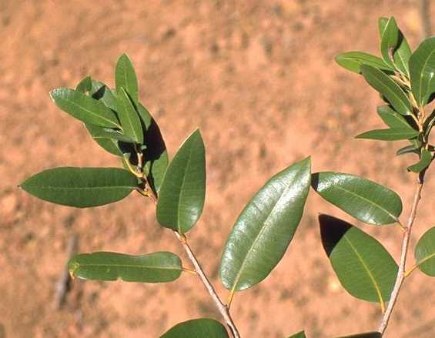

Brother Alfred Brousseau

© Brother Eric Vogel, St. Mary’s College

@ CalPhotos

*Distribution*: For current distribution, please consult the Plant Profile page for this species on the PLANTS Web site. This plant is native to California and Mexico. Interior live oak occurs from northern California in Siskiyou and Shasta counties, south along the foothills of the Sierra Nevada and inner Coast Ranges, plus the Channel Islands. Adapted to the following zones in California: Douglas-fir, Ponderosa pine, lodgepole pine, redwood, western hardwoods, and chaparral - mountain shrub.

#### Establishment

*Adaptation*: This species is generally found on soils with a pH range between 5.6 and 7.5, with depths of 20 to 40 inches. Interior live oak grows particularly well on dry, shallow, well-drained loams, clay loams, gravelly loams, or gravel. Interior live oak is tolerant of shade, particularly when young. Interior live oak appears to be well-adapted to persist with or without fire. For more information, consult the FEIS database.

*Propagation/Regeneration*: Interior live oak regenerates vegetatively after disturbance and also reproduces through seed. Cleaned acorns average approximately 125 per pound (275/kg). Annual seed production appears to be somewhat variable, although each interior live oak tree generally produces good seed crops at 5- to 7-year intervals. Acorns generally ripen after mid-August. Research indicates that the acorns of interior live oak can germinate without exposure to low temperatures. However, exposure to temperatures of 32 to 41° F can effectively stratify seed and enhance germination.

#### Management

Interior live oak sprouts vigorously after fire or mechanical disturbance.

#### Cultivars, Improved and Selected Materials (and area of origin)

Available from nurseries specializing in native plants within California. Contact your local Natural Resources Conservation Service (formerly Soil Conservation Service) office for more information. Look in the phone book under ”United States Government.” The Natural Resources Conservation Service will be listed under the subheading “Department of Agriculture.”

#### References

Barrett, S.W. 1980. *Indians and fire*. Western Wildlands 6(3):17-21.

Bartolome, J.W. 1987. *California annual grassland and oak savannah*. Rangelands. 9(3):122-125.

Block, W.M. & M.L. Morrison 1990. *Wildlife diversity of the Central Sierra foothills*. California Agriculture 44(2):19-22.

Brophy, W. 1973. *Evolution and ecology in Quercus: A study of hybridization and introgression between Quercus agrifolia Nee. and Q. wislizenii A. DC*. Thesis. California State University, Hayward, California. 97 p.

Griffin, J.R. 1977. *Oak woodland*. pp. 383-415. IN: Barbour, M.G. & J. Major, eds. *Terrestrial vegetation of California*. John Wiley and Sons, New York, New York.

Myatt, R.G. 1980*. Canyon live oak vegetation in the Sierra Nevada*. pp. 86-91. IN: Plumb, T.R. technical coordinator. *Proceedings of the symposium on the ecology, management and utilization of California oaks*. 1979 June 26-28; Claremont, California. Gen. Tech. Rep. PSW-44. USDA, Forest Service, Pacific Southwest Forest and Range Experiment Station, Berkeley, California.

Plumb, T.R. & A.P. Gomez 1983. *Five southern California oaks: Identification and postfire management*. Gen. Tech. Rep. PSW-71. USDA, Forest Service, Pacific Southwest Forest and Range Experiment Station, Berkeley, California. 56 p.

USDA, Forest Service 1990. *Fire effects information system*. Version: 990928. <http://www.fs.fed.us/database/feis/>. Prescribed Fire and Fire Effects Research Work Unit, Rocky Mountain Research Station, Missoula, Montana.

USDA, NRCS 1999. *The PLANTS database*. Version: 990928. <http://plants.usda.gov>. National Plant Data Center, Baton Rouge, Louisiana.

Van Dersal, W.R. 1938. *Native woody plants of the United States, their erosion-control and wildlife values*. USDA, Washington, D.C. 362 p.

#### Prepared By:

### *J. S. Peterson*, USDA, NRCS, National Plant Data Center, Baton Rouge, Louisiana

#### Species Coordinator:

## *M. Kat Anderson*

USDA, NRCS, National Plant Data Center, c/o Environmental Horticulture Dept., Davis, California

Edited: 19jun02 jsp; 29may03 ahv; 060809 jsp

For more information about this and other plants, please contact your local NRCS field office or Conservation District, and visit the PLANTS Web site<<http://plants.usda.gov>> or the Plant Materials Program Web site <<http://Plant-Materials.nrcs.usda.gov>>

*The U.S. Department of Agriculture (USDA) prohibits discrimination in all its programs and activities on the basis of race, color, national origin, sex, religion, age, disability, political beliefs, sexual orientation, and marital or family status. (Not all prohibited bases apply to all programs.) Persons with disabilities who require alternative means for communication of program information (Braille, large print, audiotape, etc.) should contact USDA's* [*TARGET Center*](http://www.usda.gov/oo/target.htm) *at 202-720-2600 (voice and TDD).*

*To file a complaint of discrimination write USDA, Director, Office of Civil Rights, Room 326-W, Whitten Building, 14th and Independence Avenue, SW, Washington, DC 20250-9410 or call 202-720-5964 (voice or TDD). USDA is an equal opportunity provider and employer.*

*Read about* [*Civil Rights at the Natural Resources Convervation Service*](http://www.nrcs.usda.gov/about/civilrights/)*.*