|  |
| --- |
| sitka willow |
| *Salix sitchensis* Sanson ex Bong. |
| Plant Symbol = SASI2 |

Contributed by: USDA NRCS National Plant Data Center

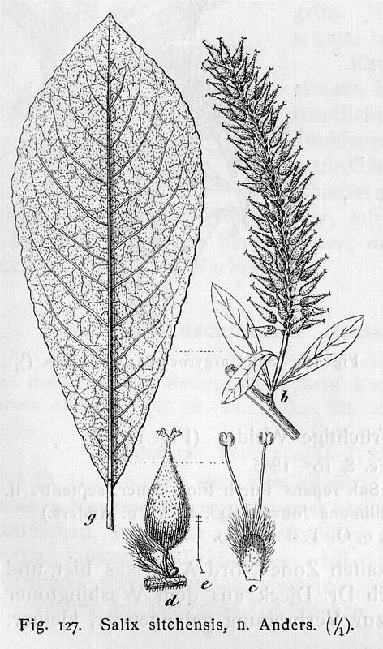

Handbuch der Laubholzkunde (1889)

© Kurt Stubel’s Online Library

# Alternative Names

satin willow, silky willow

# Uses

*Ethnobotanic*: The inner bark was dried, grounded into a powder and then added to cereal for use in making bread. Willow branches and bark was used for making ropes for nets, tying, and bending. The Straits Salish used the bark to make a gray dye for mountain goat wool (Pojar & MacKinnon 1994). The Haida used the spring catkins or pussy willows of this species as decoration (Ibid.). The Indians used the wood and twigs in drying fish, stretching skins, and basket making (Viereck & Little 1972).

*Medicinal*: Willows are the source of the natural precursor to aspirin, salicylic acid, found in leaves and bark (Pojar & MacKinnon 1994). The bark can be pounded and applied to wounds as a healing agent (Moerman 1998). An infusion of the stems has been used in the treatment of stomach complaints (Ibid.).

*Conservation*: Sitka willow is used in forested riparian buffers to help reduce stream bank erosion, protect aquatic environments, enhance wildlife, and increase biodiversity.

# Status

# Please consult the Plants Web site and your State Department of Natural Resources for this plant’s current status, such as, state noxious status and wetland indicator values.

# Description

*General*: Willow Family (Salicaceae). *Salix sitchensis* is a large shrub or small tree, six to twenty-five feet high. The leaves are alternate, oblonceolate or narrowly ovate, two to five inches long, and usually sharp-pointed. The flowers appear before or with the leaves, on short leafy shoots, males are five centimeters long, and the females are eight centimeters long (Pojar & MacKinnon 1994). The bark is smooth, slightly furrowed, and scaly.

# *Distribution*: *Salix sitchensis* is native to stream banks from southern Alaska to southwestern Oregon (Viereck & Little 1972). For current distribution, please consult the Plant profile page for this species on the PLANTS Web site.

# Adaptation

Sitka willow is found on or near lake shores, wetland margins, forest edges, wet openings, and clearings at low to middle elevations. This species prefers damp, heavy soil but will succeed in most soils. It grows best in sunny locations but will tolerate some shade.

# Establishment

*Propagation by Seed*: Seeds must be surface sown as soon as they are ripe in late spring. Seeds are viable for only a few days and the maximum storage period is four to six weeks with germination rates dropping off fast after ten days at room temperature (Dirr & Heuser 1987). Willow seeds have no dormancy and germinate within twelve to twenty-four hours after falling on moist ground (Ibid.). Seedbeds must be kept moist until seedlings are well established.

*Propagation by cuttings*: Sitka willow can be propagated through hardwood cuttings that can be collected and prepared for insertion when they are well ripened, from November to March. Cuttings seven to ten inches long and a half to one inch thick are initially stuck in the ground at close spacing and lifted after one year (Dirr & Heuser 1987). Willow cuttings have a rooting percentage of ninety to one- hundred percent without the use of rooting hormones (Ibid.).

# Cultivars, Improved and Selected Materials (and area of origin)

Somewhat available in native plant nurseries within its area of distribution. Contact your local Natural Resources Conservation Service (formerly Soil Conservation Service) office for more information. Look in the phone book under ”United States Government.” The Natural Resources Conservation Service will be listed under the subheading “Department of Agriculture.”

# References

Britton, N.L. 1908. *North American trees*. Henry Holt & Company, New York, New York.

Dippel, L. 1889. *Handbuch der laubholzkunde*. From Kurt Stuber’s Online Library, Max-Planck-Institut fur Zuchtungsforschung, Koln, Germany.

Accessed: 11jan02. <http://caliban.mpiz-koeln.mpg.de/~stueber/dippel/band2/127.html>

Dirr, M.A. & M.W. Heuser 1987. *The reference manual of woody plant propagation*. Varsity Press, Athens, Georgia.

Farrar, J.L. 1995. *Trees of the northern United States and Canada*. Iowa State University Press, Ames, Iowa.

Lauriault, J. 1989. *Identification guide to the trees of Canada*. Fitzhenry & Whiteside, Ontario, Canada.

MacKinnon, A., J. Pojar, & R. Coupe´ 1992. *Plants of the northern British Columbia*. Lone Pine Publishing, Canada.

McMinn, H.E. & E. Maino 1963. *An illustrated manual of pacific coast trees*. University of California Press, Berkeley, California.

Moerman, D. 1998. *Native American ethnobotany*. Timber Press, Oregon.

Nelson, R.A. 1992. *Handbook of rocky mountain plants*. Roberts Rinehart Publishers, Niwot, Colorado.

Pojar, J & A. MacKinnon 1994. *Plants of the pacific northwest coast: Washington, Oregon, British Columbia, and Alaska*. Lone Pine Publishing, Redmond, Washington.

Preston, R.J., Jr., 1989. *North American trees*. 4th ed. Iowa State University Press, Ames, Iowa.

Rehder, A. 1990. *Manual of cultivated trees and shrubs: hardy in North America*. 2nd ed. Dioscorides Press, Portland, Oregon.

Sargent, C.S. 1961. *Manual of the trees of North America*. Vol. 1. Dover Publications, Inc., New York, New York.

Viereck, L.A. & E.L. Little, Jr. 1972. A*laska trees and shrubs*. United States Department of Agriculture, Agriculture Handbook No. 410, Washington, D.C.

# Prepared By:

## *Lincoln M. Moore*

USDA, NRCS, National Plant Data Center, Baton Rouge, Louisiana

# Species Coordinator

## *M. Kat Anderson*

USDA, NRCS, National Plant Data Center, c/o Plant Sciences Dept., Davis, California

Edited: 19jun02 jsp; 03jun03 ahv; 060816 jsp

For more information about this and other plants, please contact your local NRCS field office or Conservation District, and visit the PLANTS Web site<<http://plants.usda.gov>> or the Plant Materials Program Web site <<http://Plant-Materials.nrcs.usda.gov>>

*The U.S. Department of Agriculture (USDA) prohibits discrimination in all its programs and activities on the basis of race, color, national origin, sex, religion, age, disability, political beliefs, sexual orientation, and marital or family status. (Not all prohibited bases apply to all programs.) Persons with disabilities who require alternative means for communication of program information (Braille, large print, audiotape, etc.) should contact USDA's* [*TARGET Center*](http://www.usda.gov/oo/target.htm) *at 202-720-2600 (voice and TDD).*

*To file a complaint of discrimination write USDA, Director, Office of Civil Rights, Room 326-W, Whitten Building, 14th and Independence Avenue, SW, Washington, DC 20250-9410 or call 202-720-5964 (voice or TDD). USDA is an equal opportunity provider and employer.*

*Read about* [*Civil Rights at the Natural Resources Convervation Service*](http://www.nrcs.usda.gov/about/civilrights/)*.*