|  |
| --- |
| vinegarweed |
| *Trichostema lanceolatum* Benth. |
| Plant Symbol = TRLA4 |

Contributed by: USDA NRCS National Plant Data Center

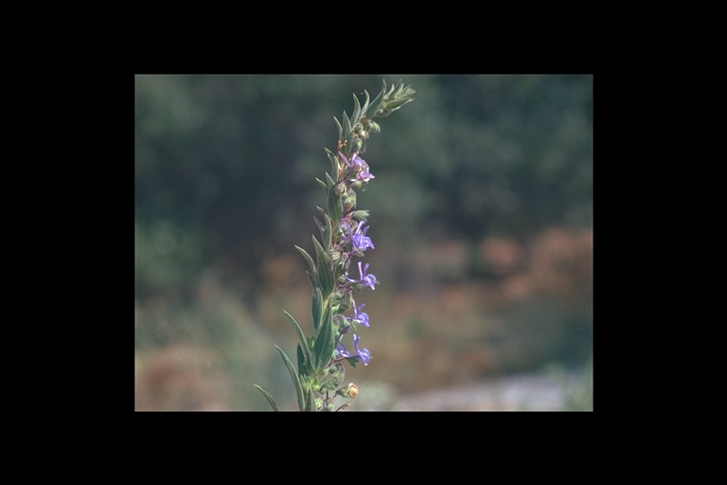

©William R. Hewlett

California Academy of Sciences

@ Calflora

# Alternate Names

Blue-curls, camphor weed, romero, yerba del aigre, stink weed, turpentine weed, wild rosemary

# Uses

*Ethnobotanic*: Vinegarweed is a medicinal herb that was highly valued by the Salinan, Ohlone, Miwok, and many other California Indian tribes who continue to use it today. In the past, the herb was so important that the Salinan used vinegarweed as “money” in trade with the Yokuts and other California tribes (Heinsen 1972).

The strongly aromatic leaves and flowers were used fresh or dried to make infusions of varying strengths to treat a myriad of maladies. A decoction or tea made from the leaves and flowers was taken to treat colds, stomachaches, headaches, ague, bladder problems, and malaria. Vinegarweed tea was gargled to treat inflammation of the throat. The steam from hot infusions was sniffed into the nasal passages to treat colds, coughs, headaches, and nose bleeds. Sitting over a steaming decoction of the leaves treated uterine trouble.

The raw or boiled leaves were crushed into a poultice to treat wounds. Ground leaves were rubbed on the face and chest of persons with colds or any place on the skin where there was pain (Bocek 1984). Leaf decoctions were applied to infected sores, smallpox lesions, and other skin eruptions. Vinegarweed was steeped in water and used as a bath to prevent smallpox and ague. Chewed leaves were stuffed in or around an aching tooth.

The Kawaiisu tribe made a nonmedicinal drink from the leaves (Zigmond 1981). The aromatic leaves and stems were crushed and placed in bedding to repel fleas.

The Salinan was among those California tribes that used vinegarweed to aid in catching fish. The fisherman would strategically build dams in rivers and streams to trap the fish within small ponds. Then, mashed or powdered plants were thrown into the water with the fish. After the plants were added, the fish would become sluggish and easier to catch in the fishermen’s nets or sieves made of willow. Numerous reasons have been offered for this reaction including that the fish were either poisoned (Moerman 1998), their gills clogged (Murphey 1959), or that the plants affected the oxygen in the water (Heinzen 1972).

*Wildlife:* Vinegarweed is an important bee plant (Jepson 1911).

# Status

Please consult the PLANTS Web site and your State Department of Natural Resources for this plant’s current status (e.g. threatened or endangered species, state noxious status, and wetland indicator values).

# Description

General: Mint family (Lamiaceae). Vinegarweed is an annual forb or herb native to California and Oregon. Vinegarweed is named for its pungent medicinal odor that can be detected over long distances.

The plants range from 1 to 10 dm with branches arising from the base. The thin, lance-shaped leaves are 2 to 7 cm long. The leaves are dotted with glands that produce the strong somewhat sour odor. The pale blue to lavender flowers grow from the leaf axils along one side of the top of the unbranched stems. The flowers are slender tubes, 5 to 10 mm long, with five lobes and long arched stamens (13 to 20 mm) that protrude out of the flower. The seeds are four tiny nutlets that are joined at the base. The seeds germinate with the rains, but begin to grow in earnest only after the rainy season has ended. The plants bloom from late June or July until November.

*Distribution*: Vinegarweed occurs from northern Oregon to the northern Baja along the Pacific Coast Ranges. It grows in dry, open fields and roadsides below 1000 meters. For current distribution, please consult the Plant Profile page for this species on the PLANTS Web site.

*Habitat*: Vinegarweed is found in dry, open areas and disturbed habitats. Vinegarweed is an early seral component of coastal sage scrub, chaparral, and oak woodland communities.

# Adaptation

Vinegarweed is xerophytic and adapted to the dry, rainless summers of California’s Mediterranean climate.

# Establishment

The seeds ripen in the late fall and collected seeds can be planted immediately or stored. Be sure to thoroughly dry the seeds before storing. Placing them in a sunny well-ventilated place can dry the seeds. To store, place the seeds into an airtight container and store them in a cool, dark place.

Sow the seeds in the late fall or early spring. Prepare a seedbed that receives full sun and in an area that is well drained. Broadcast the seeds and lightly rake them into the soil. Tamp the soil snuggly over the seeds. If planting the seeds in the spring, gently sprinkle the sown bed with water and keep it lightly moist until the seedlings are established. Once established, vinegarweed is very drought resistant and will not tolerate frequent watering.

# Cultivars, Improved, and Selected Materials (and area of origin)

The Salinan and other California tribes used the closely related perennial shrub, *Trichostema lanatum* (wooly blue curls or California rosemary) for many of the same purposes as vinegarweed. *T. lanatum* resembles rosemary (*Rosmarinus* spp.) and is a lovely addition to the garden. There are two cultivars of *T. lanatum* (“Lion Den” and Salmon Creek”) that have been developed by the UC Santa Cruz Arboretum (Rogers 2001). Both cultivars are from cuttings taken in the Santa Lucia Mountains.

Contact your local Natural Resources Conservation Service (formerly Soil Conservation Service) office for more information. Look in the phone book under ”United States Government.” The Natural Resources Conservation Service will be listed under the subheading “Department of Agriculture.”

# References

##### Barrett, S.A. & E.W. Gifford 1933. *Miwok material culture: Indian life of the Yosemite region.* Bulletin of Milwaukee Public Museum Vol. 2, No. 4. Yosemite Association, Yosemite National Park, California. 388 pp.

##### Bocek, B.R. 1984. *Ethnobotany of Costanoan Indians, California, based on collections by John P. Harrington.* Economic Botany, Vol. 38, No. 2. Pp. 240-255.

##### Heinsen, V. 1972. *Mission San Antonio de Padua* *Herbs: Medicinal herbs of early days*. Third edition. Lockwood, California. 142pp.

Heizer, R.F. & A.B. Elsasser 1980. *The natural world of the California Indians*. University of California Press, Berkeley & Los Angeles, California. 271 pp.

##### Hewlett, W.R. 1999. *Trichostema lanceolatum*. California Academy of Sciences. Digital Library Project, University of California, Berkeley. [Online]. Available: http://www.calflora.org. Accessed [15 December 2001].

Jepson, W. L. 1911. *A flora of western middle California*. Second Edition. Cunningham, Curtiss & Welch, San Francisco, Califorina. 515 pp.

Lewis, H. 1993. *Trichostema, Blue Curls.* In: J.D. Hickman, Editor. *The Jepson manual: Higher plants of California.* University of California Press, Berkeley, California. Pp. 732-733.

Moerman, D.E. 1998. *Native American ethnobotany*. Timber Press, Portland, Oregon. 927 pp.

Moerman, D.E. 1999. *Native American Ethnobotany Database: Foods, drugs, dyes and fibers of native North American Peoples. The University of Michigan-Dearborn.* [Online]. Available:

<http://www.umd.umich.edu/cgi-bin/herb>

##### [6January2002].

Munz, P.A. & D.D. Keck 1963. *A California flora.* University of California Press, Berkeley & Los Angeles, California. 1681 pp.

Murphey, E.V.A. 1959. *Indian uses of native plants.* Mendocino County Historical Society, Fort Bragg, California. 81 pp.

Rogers, D. 2001. *Romero or wooly blue curls.* The Double Cone Quarterly. Vol. IV, No. 2 [Online]. Available: <http://www.ventanawild.org/news/ss01/romero.html> [15December2001].

Wallace, W.J. 1978. *Southern ValleyYokuts* in *Handbook of North American Indians, Vol. 8, California*, R.F. Heizer, Ed. Smithsonian Institution, Washington, D.C. Pp448-461.

Zigmond, M.L. 1981. *Kawaiisu ethnobotany.* University of Utah Press, Salt Lake City, Utah. 102 pp.

# Prepared By:

Diana L. Immel

Formerly USDA, NRCS, National Plant Data Center, c/o Environmental Horticulture Department, University of California, Davis, California

# Species Coordinator:

##### *M. Kat Anderson*

USDA, NRCS, National Plant Data Center, c/o

##### Plant Sciences Department, University of California, Davis, California

##### Edited: 29jan03 jsp; 04jun03 ahv; 060818 jsp

For more information about this and other plants, please contact your local NRCS field office or Conservation District, and visit the PLANTS Web site<<http://plants.usda.gov>> or the Plant Materials Program Web site <<http://Plant-Materials.nrcs.usda.gov>>

*The U.S. Department of Agriculture (USDA) prohibits discrimination in all its programs and activities on the basis of race, color, national origin, sex, religion, age, disability, political beliefs, sexual orientation, and marital or family status. (Not all prohibited bases apply to all programs.) Persons with disabilities who require alternative means for communication of program information (Braille, large print, audiotape, etc.) should contact USDA's* [*TARGET Center*](http://www.usda.gov/oo/target.htm) *at 202-720-2600 (voice and TDD).*

*To file a complaint of discrimination write USDA, Director, Office of Civil Rights, Room 326-W, Whitten Building, 14th and Independence Avenue, SW, Washington, DC 20250-9410 or call 202-720-5964 (voice or TDD). USDA is an equal opportunity provider and employer.*

*Read about* [*Civil Rights at the Natural Resources Convervation Service*](http://www.nrcs.usda.gov/about/civilrights/)*.*