

Plant Guide

# SMALL CRANBERRY

## Vaccinium oxycoccos L.

Plant Symbol = VAOX

*Contributed by*: USDA NRCS National Plant Data Team, Greensboro, NC

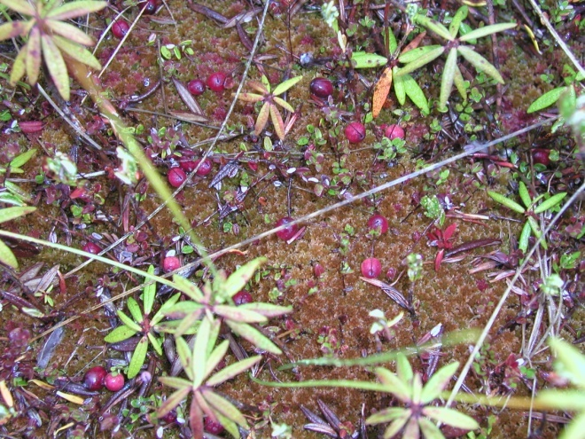

Small cranberries growing in a bog on the western Olympic Peninsula, Washington. Photograph by Jacilee Wray, 2006.

### Alternate Names

Bog cranberry, swamp cranberry, wild cranberry

### Uses

Said to have a superior flavor to the cultivated cranberry (*Vaccinium macrocarpon*) (Shepard 1855; Eastwood 1856), large quantities of the tart berries were gathered in the fall by tribes of the Great Lakes region such as the Menomini and Potawatomi (Smith 1923; Smith 1933), tribes of the Northeast such as the Iroquois and Lenape (Stout 1914; Waugh 1916), the Inuit of Alaska (Trehane 2004), the Chinook of Oregon, and the Makah, Klallam, Hoh, Quileute, Quinault, and Chemakum of western Washington (Gunther 1973; Hedrick 1972; Eells 1996; Archibald 1999). The First Nations of Canada, such as the Haida, Kwakwaka'wakw, and other cultural groups also relished the berries (Turner 2004; U'mista Cultural Society et al. 1998). Because the berries last through the winter and preserve well under the snow, they could also be gathered in spring as was done by the Dena'ina of south-central Alaska and the Woods Cree of Canada (Kari 1987; Leighton 1985). Even though they are small, the importance of these berries to many indigenous cultures should not be underestimated. The fact that the month of September is connected with "the season for cranberries" in the Makah lunar calendar underscores the importance of these fruits in their food economy (Waterman 1920).

Small cranberries were gathered wild in England and Scotland and made into tarts, marmalade, jelly, jam, and added to puddings and pies (Eastwood 1856). Many colonists were already familiar with this fruit in Great Britain before finding it in North America. The small cranberry helped stock the larder of English and American ships, fed trappers in remote regions, and pleased the palates of Meriwether Lewis and William Clark in their explorations across the United States (Lewis and Clark 1965). The Chinook, for example, traded dried cranberries with the English vessel Ruby in 1795 and at Thanksgiving in 1805 Lewis and Clark dined on venison, ducks, geese, and small cranberry sauce from fruit brought by Chinook women (McDonald 1966; Lewis and Clark 1965). Because the small cranberry can grow in association with large cranberry (*Vaccinium macrocarpon*) in the Great Lakes region, northeastern USA and southeastern Canada (Boniello 1993; Roger Latham pers. comm. 2009) it is possible that the Pilgrims of Plymouth were introduced to both edible species by the Wampanoag.

The berries are still gathered today in the United States, Canada, and Europe (Himelrick 2005). The Makah, Quinault, and Quileute of the Olympic Peninsula still gather them every fall and non-Indians from early settler families still gather them (Anderson 2009). Small cranberries are an important source of phenolic compounds, especially anthocyanins, that show high anti-oxidant potential (Kahkonen et al. 2001; Kahkonen et al. 1999). They are an excellent source of flavonols, having higher concentrations than apples (Himelrick 2005).

There were many indigenous ways to prepare and eat cranberries. Berries could be eaten fresh, boiled, baked in a pit, dried or stored for future use, and in later times they were canned and used for making jams, jellies, and pies (Gill 1984; Olson 1936). In western Washington, the berries were usually stored in boxes or baskets until soft and brown (Gunther 1973). For example, among the Quileute on the Olympic Peninsula cranberries either sat in storage until they became soft, or they were crushed and eaten with grease (Powell and Morganroth 1998). The Potawatomi and the Menomini of Wisconsin sweetened the berries with maple sugar (Smith 1933; Smith 1923). The Menomini dried them in the sun for winter use and ate dried cranberries and dried sweet corn together, sweetened with maple sugar (Smith 1923). In the Northeastern United States, pemmican was made by pounding cranberries into a mixture of dried, smoked game meat, animal fat, and seeds (Kavasch 1995). The Canadian Chippewa combined dried berries with moose fat or deer tallow (Buttree 1932). The Kwakwaka'wakw of western British Columbia ate the berries fresh to quench thirst or dried them into cakes. Their favorite way to prepare them was to boil them and serve them with grease (U'mista Cultural Society et al. 1998) from eulachon (*Thaleichthys pacificus*), a small West-coast fish. Early non-Indian settlers, having learned of their edibility from the Indians, made cranberry sauces, bubbling tarts, and nogs from cranberries. The Indians of western Washington also used the fruit as a paint (Eells 1996).

*Wildlife:* The berries are eaten by many kinds of animals such as Roosevelt elk, black bears, black-tailed deer, foxes, squirrels, chipmunks, rabbits, and hares (Anderson 2009; Jacquemart 1997; Matthews 1992). Birds such as wild geese, Hudsonian godwits, sharp-tailed grouse, and ring-necked pheasants also eat small cranberries (Matthews 1992; Haskin 1934). The small cranberry is a larval food plant for the listed Makah copper butterfly in western Washington (Pyle and Pyle 2001). Many birds use small cranberry ecosystems for foraging and/or nesting including the rock ptarmigan, willow ptarmigan, common loon, double-crested cormorant, great blue heron, Canada goose, killdeer, American wigeon, and many others (Jacquemart 1997; Czech and Parsons 2002).

### Status

Please consult the PLANTS Web site and your State Department of Natural Resources for this plant’s current status (e.g., threatened or endangered species, state noxious status, and wetland indicator values).

### Description

*General*: A member of the heath family (Ericaceae), small cranberry is a trailing, vine-like shrub with delicate stems that often creep over *Sphagnum* moss. The plant has alternate small evergreen leaves with rolled edges that are dark green above, pale beneath, and pointed at the tip. The pale rose flowers have petals that are bent backwards. The one to four flowers appear between May and August and look like small shooting stars. They form a terminal cluster and spring from the tips of stems (Gleason and Cronquist 1991; Pettinger and Costanzo 2002). The red, sometimes off-white berry is small (3/8 inch wide), round, and slightly acid, ripening between August and October (Jacquemart 1997; Clark 1998; Piper and Beattie 1915; Pojar and MacKinnon 1994; Pettinger and Costanzo 2002). The plant is similar in appearance to the cultivated cranberry (Gleason and Cronquist 1991).

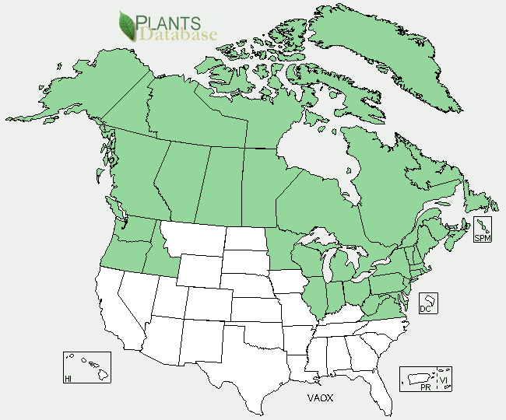Small cranberry distribution from USDA-NRCS PLANTS Database.

The small cranberry occurs throughout Alaska and across Canada to Labrador, Greenland, and Newfoundland, south through the New England states, the northern portions of the Great Lake States, and western Washington and Oregon. It also occurs in northern Europe and Asia (Matthews 1992; Gleason and Cronquist 1991). For current distribution, please consult the Plant Profile page for this species on the PLANTS Web site.

*Habitat*: The small cranberry is found in wetlands: bogs, swamps, and muskegs and along the marshy shores of ponds and lakes. Many of these wetlands were created by the melting of glaciers 10,000 to 18,000 year ago (Jones 1936). This species often occurs where there is no perched water table caused by a hardpan. The typical habitat of this species is *Sphagnum* peat and sometimes sand or hardpan. This vine is occasionally found in tidal wetlands along both the western and eastern shores of North America (Tiner 2009; Gunther 1973). Since the small cranberry is shade intolerant, relic stands occur in bogs that have developed a conifer overstory (Conway 1949; Matthews 1992). It is found in small swamps in pine barrens in New Jersey, Pennsylvania, New York and New England.

**Adaptation**

Small cranberry is one of the first colonizers of burned bogs and increases in abundance with repeated fires if the fires are not too severe (Flinn and Wein 1977; Vogl 1964; Matthews 1992). It also regenerates vegetatively by re-growing from rhizomes and by layering (Flinn and Wein 1988; Matthews 1992).

### Establishment

Small cranberry can be propagated by seeds or by cuttings or by severing sectors of rooted runners (Trehane 2004). Cuttings should be taken during the dormant season, and treated with rooting hormone (Leopold 2005). It needs a sunny location in the garden with wet to moist, acidic and often peaty soils (Pettinger and Costanzo 2002).

### Management

Early non-Indian descriptions of the small cranberry paint a picture of abundance. Albert Reagan reported in 1928 for the Bois Fort Ojibwa of Minnesota that: "Cranberries [both *Vaccinium macrocarpon* and *V. oxycoccos*] are very plentiful in the swampy regions and are quite an article of food. Many bushels of them are sold by the Indians each year (Reagan 1928). Part of the coast of Lake Superior was described as "flaming red with [*Vaccinium oxycoccos*] berries" in 1855 (Eastwood 1856). James Swan recorded in his diary on October 23, 1859 about the northwest coast of Washington that "Mr. Webster shipped on board of the Hartford 23 barrels of cranberries [*Vaccinium oxycoccos*] " (Swan 1859-1866). These barrels were obtained from the Makah.

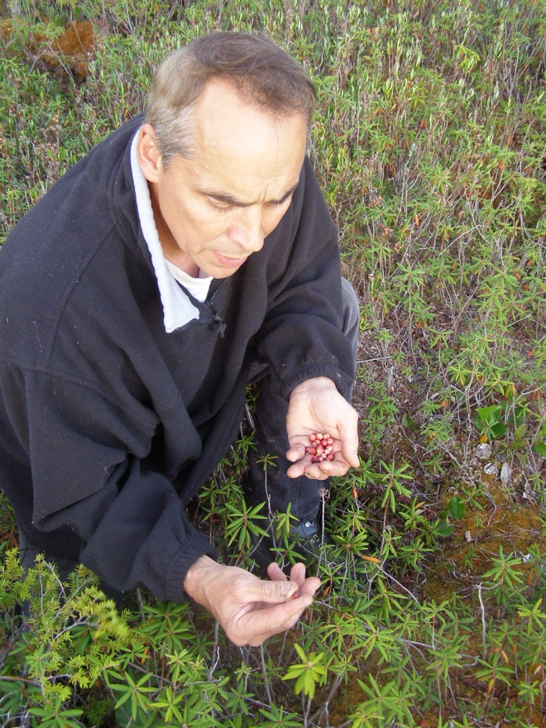

Gary Ray, Makah, picking bog cranberries on Ts'oo-yuhs Prairie on the Makah Reservation in late September 2009. Photograph by M. Kat Anderson, 2009.

Reports of such large quantities suggest the possibility of Indian stewardship to increase fruit yields. Lightning is rare within the Pacific northwestern distribution of small cranberries (Agee 1993; Kay 2007; Vitt et al. 1990), and tribes maintained them by burning (Anderson 2009; Latham 2008). The primary role of fire was to keep open habitats for the small cranberries and other useful plants. Burning arrested the processes of succession that would otherwise have allowed the forest to advance, which would have reduced sunlight to the fruit-bearing plants, increased competition for nutrients, and made the plants more difficult to get to and harvest. Gregory Colfax, Makah, explains this function of burning in relation to small cranberries: “My dad [Lloyd Colfax] mentioned that the [Ts’oo-yuhs] prairie was burned yearly or whenever it was necessary. When the cranberry bogs would get so overgrown then the folks knew that it was time to do it. And so it was generally in autumn I think when it happened—just at the time when you had your long spells of light summer weather in September and October. And it was the perfect time to do it because you match it to the wind and you match it to upcoming rains” (pers. comm.).

Indian burning of bogs also had a directly beneficial effect on individual cranberry plants, maintaining vigor and stimulating the production of berries. Without pruning or burning, the vines produce many runners, and produce less and less fruit. Traditionally tribes in western Washington, such as the Quinault and the Makah, burned off bogs periodically not only to keep them open by eliminating encroaching shrubs and trees but also to stimulate the plants to produce more fruit (Anderson 2009). This probably would have a similar effect to the pruning of the cultivated cranberry practiced by growers today. They prune heavily vined cranberries for two reasons: 1) severing most of the runners removes apical dominance in many of the vines, promoting new uprights to produce fruit in the second year after pruning; and 2) removing top growth allows more sunlight to reach the vines, encouraging increased flower bud initiation (Eck 1990). Paul Eck (1990) instructs cranberry growers to burn or mow overgrown bogs during the dormant season to bring them back into productive bearing.

Today conifers and hardwoods are advancing into bogs (Rigg 1922; Reichle and Doyle 1965; Tiner 1991) where the small cranberries grow and this is partly due to the cessation of Indian-set fires that kept them open (Latham 2008; Anderson 2009) and to the later stages of forest regrowth after clearcutting.

### Cultivars, Improved, and Selected Materials (and area of origin)

This plant is available from native plant nurseries.

### References

Agee, J.K. 1993. Fire Ecology of Pacific Northwest

Forests*.* Washington, D.C., Island Press.

­­Anderson, M.K. 2009. The Ozette Prairies of

Olympic National Park: their former indigenous uses and management. Final report to Olympic National Park, Port Angeles, Washington.

Archibald, L. 1999. There Was a Day: Stories of the

Pioneers. Printed by Olympic Graphic Arts, Inc., Forks, WA.

Boniello, R. 1993. A comparison of some habitat

requirements of *Vaccinium macrocarpon* and *Vaccinium oxycoccos*. Unpublished report in the Research Collections of the Biological Station, University of Michigan.

Buttree, J.M. 1932. Foods of the Omaha and

Chippewa. The Totem Board 11(11):443-454. The Woodcraft League of America, Inc. Santa Fe. University of New Mexico Press, Albuquerque.

Clark, L.J. 1998.Wild Flowers of the Pacific

Northwest. J. Trelawny (ed.). Third Edition. Madeira Park, BC: Harbour Publishing.

Conway, V.M. 1949. The bogs of central Minnesota.

Ecological Monographs 19(2):173-206.

Czech, H.A. and K.C. Parsons. 2002. Agricultural

wetlands and waterbirds: a review. Waterbirds: The International Journal of Waterbird Biology 25(2):56-65.

Eastwood, B. 1856. The Cranberry and Its Culture: A

Complete Manual for the Cultivation of the Cranberry, with a Description of the Best Varieties. C.M. Saxton & Co. New York.

Eck, P. 1990. The American Cranberry. Rutgers

University Press, New Brunswick, N.J.

Eells, Rev. M. 1996. The Twana, Chemakum, and

Klallam Indians of Washington Territory. Ye Galleon Press, Fairfield, WA. Originally published by the Smithsonian Institution in 1889.

Flinn, M.A. and R.W. Wein. 1977. Depth of

underground plant organs and theoretical survival during fire. Canadian Journal of Botany 55:2550-2554.

Gill, S. 1984. Ethnobotany of the Makah People,

Olympic Peninsula, Washington. Makah Language Program, Neah Bay, Washington and Marion Ownbey Herbarium Wasington State University, Pullman, WA.

Gleason, H.A. and A. Cronquist. 1991. Manual of

Vascular Plants of Northeastern United States and Adjacent Canada. The New York Botanical Garden. Bronx, N.Y.

Gunther, E.. 1973. Ethnobotany of Western

Washington: The Knowledge and Use of Indigenous Plants by Native Americans. Seattle: University of Washington Press.

Haskin, L.L. 1934. Wild Flowers of the Pacific

Coast. Metropolitan Press, Publishers. Portland, Oregon.

Hedrick, U.P. (ed.). 1972. Sturtevant's Edible Plants

of the World. Dover Publications, Inc. New York, N.Y.

Himelrick, D.G. 2005. Wild berries in Finland. Small

Fruits Review 1(3):83-94.

Jacquemart, A. 1997. *Vaccinium oxycoccos* L.

(*Oxycoccus palustris* Pers.) and *Vaccinium Microcarpum* (Turez. Ex Rupr.) Schmalh. (*Oxycoccus microcarpus* Turez. Ex Rupr.)

Jones, G.N. 1936. A Botanical Survey of the

Olympic Peninsula, Washington. University of Washington Publications in Biology, Vol. 5. Seattle, Washington: University of Washington

Kahkonen, M.P., A.I. Hopia, and M. Heinonen. 2001.

Berry phenolics and their antioxidant activity. J. Agric. Food Chem. 49(8):4076-4082.

Kahkonen, M.P., A.I. Hopia, H.J. Vuorela, J.P.

Rauha, K. Pihlaja, T. Kujala, and M. Heinonen. 1999. Antioxidant activity of plant extracts containing phenolic compounds. J. Agric. Food Chem. 47:3954-3962.

Kari, P.R. 1987. Tanaina Plantlore Dena'ina K'et'una:

An Ethnobotany of the Dena'ina Indians of Southcentral Alaska. National Park Service Alaska Region, Anchorage. Second Edition.

Kavasch, E.B. 1995. Enduring Harvests: Native

American Foods and Festivals for Every Season. The Globe Pequot Press, Old Saybrook, Connecticut.

Kay, C.E. 2007. Are lightning fires unnatural? A

comparison of aboriginal and lightning ignition rates in the United States. Pages 16-28 In: Proceedings of the 23rd Tall Timbers Fire Ecology Conference: Fire In Grassland and Shrubland Ecosystems. R.E. Masters and K.E.M. Galley (eds.). Tall Timbers Research Station, Tallahassee, FL.

Latham, R. 2008. Information sources for

reconstructing the vegetation of Philadelphia, lower Bucks, and Delaware Counties, Pennsylvania, around the time of European settlement. Unpublished report to the Pennsylvania Natural Heritage Program, Western Pennsylvania Conservancy, Middletown, PA.

Leighton, A.L. 1985. Wild plant use by the Woods

Cree (Nihithawak) of East-Central Saskatchewan. National Museum of Man Mercury Series. Canadian Ethnology Service Paper No. 101. A Diamond Jenness Memorial Volume.

Leopold, D.J. 2005. Native Plants of the Northeast: A

Guide for Gardening and Conservation. Timber Press, Portland, OR.

Lewis, M. and W. Clark. 1965. The History of the

Lewis and Clark Expedition. E. Coues (ed.). Vols. I-- III. Dover Publications, Inc. N.Y., N.Y. Reissue of the four-volume edition published by Francis P. Harper in 1893.

Matthews, R.F. 1992. *Vaccinium oxycoccos*. In: Fire

Effects Information System, [Online]. U.S. Department of Agriculture, Forest Service, Rocky Mountain Research Station, Fire Sciences Laboratory (Producer). http://www.fs.fed.us/database/feis.

McDonald, L. 1966.Coast Country: A History of

Southwest Washington. Portland: Binfords & Mort, Publishers.

Olson, R.L. 1936. The Quinault Indians. University

of Washington Press, Seattle.

Pettinger, A. and B. Costanzo. 2002. Native Plants in

the Coastal Garden: A Guide for Gardeners in the Pacific Northwest. Timber Press. Portland, OR.

Piper, C.V. and R.K. Beattie. 1915. Flora of the

Northwest Coast. Press of the New Era Printing Co., Lancaster, PA.

Powell, J. and C. Morganroth III. 1998. Quileute Use

of Trees & Plants: A Quileute Ethnobotany. Prepared for Quileute Natural Resources, LaPush, Washington.

Pyle, R.M. and T.L. Pyle. 2001. Final Report: Oregon

Silverspot Survey, Ozette Prairies, Olympic National Park Second Summer's Work.

Pojar, J. and A. MacKinnon (eds.) 1994. Plants of

the Pacific Northwest Coast: Washington, Oregon, British Columbia & Alaska. Lone Pine Publishing, Vancouver, British Columbia.

Reagan, A.B. 1928. Plants used by the Bois Fort

Chippewa (Ojibwa) Indians of Minnesota. The Wisconsin Archeologist 7(4): 230-248.

Reichle, D.E. and W.T. Doyle. 1965. Bryophyte

succession in a northern Illinois bog. The Bryologist 68(4)463-470.

Rigg, G.B. 1922. A bog forest. Ecology 3(3):207-

213.

Shepard, F. 1855. Letter to B. Eastwood, in Eastwood

(1856), The Cranberry and its Culture: A Complete Manual for the Cultivation of the Cranberry, with a Description of the Best Varieties. C.M. Saxton & Co. New York.

Smith, H.H. 1923. Ethnobotany of the Menomini

Indians. Bulletin of the Public Museum of the City of Milwaukee 4:1(1-174).

_________. 1933. Ethnobotany of the Forest

Potawatomi Indians. Bulletin of the Public Museum of the City of Milwaukee 7:1(1-230).

Stout, A.B. 1914. Vegetable foods of the American

Indian. Journal of the New York Botanical Garden 15(171):50-60.

Swan, J.G. 1859-1866. James Gilchrist Swan Papers.

Daily Journals. Accession No. 1703-001. Special Collections, University of Washington Libraries, Seattle, Washington.

Tiner, R.W. 1991. The concept of a hydrophyte for

wetland identification. BioScience 41(4):236-247.

_________. 2009. Field Guide to Tidal Wetland

Plants of the Northeastern United States and Neighboring Canada: Vegetation of Beaches, Tidal Flats, Rocky Shores, Marshes, Swamps, and Coastal Ponds. University of Massachusetts Press, Amherst.

Trehane, J. 2004. Blueberries, Cranberries and Other

Vacciniums. Timber Press, Portland.

Turner, N. J. 2004. Plants of Haida Gwaii. Sononis

Press, Winlaw, B.C.

U'mista Cultural Society, J. Pasco, and B.D.

Compton. 1998. The Living World: Plants and Animals of the Kwakwaka'wakw. L. Hunt (ed.). U'mista Cultural Centre, Alert Bay, British Columbia.

Vitt, D.H., D.G. Horton, N.G. Slack, N. Malmer.

1990. Sphagnum-dominated peatlands of the hyperoceanic British Columbia coast: patterns in surface water chemistry and vegetation. Canadian Journal of Forestry Research 20:696-711.

Vogl, R.J. 1964. The effects of fire on a muskeg in

northern Wisconsin. Journal of Wildlife Management 28(2):317-329.

Waterman, T.T. 1920. Puget Sound Geography. Vol.

I Files 1-8. Vol. II Files 9-14 and Vol. III Files 15-25. Copy from microfilm [1864 Wash,. Ethnol.] at University of California Archives, Museum of Anthropology Archives, Berkeley.

Waugh, F.W. 1916. Iroquois foods and food

preparation. Canada Department of Mines Geological Survey Memoir 86. Ottawa, Government Printing Bureau.

**Prepared By**: *M. Kat Anderson,* USDA NRCS National Plant Data Team, Greensboro, NC

### Citation

Anderson, M., 2011. Plant Guide for small cranberry (*Vaccinium oxycoccos)*. USDA-Natural Resources Conservation Service, National Plant Data Center. Greensboro, NC 27401.

**Acknowledgements**

The author would like to thank Doug Goldman and Roger Latham for editing this Plant Guide and providing citations.

Published

Edited: 15Feb2011jw

For more information about this and other plants, please contact your local NRCS field office or Conservation District at <http://www.nrcs.usda.gov/> and visit the PLANTS Web site at <http://plants.usda.gov/> or the Plant Materials Program Web site <http://plant-materials.nrcs.usda.gov>.

PLANTS is not responsible for the content or availability of other Web sites.

**USDA IS AN EQUAL OPPORTUNITY PROVIDER AND EMPLOYER**