|  |
| --- |
| fan palm |
| *Washingtonia filifera* (L. Linden) H. Wendl. |
| Plant Symbol = WAFI |

Contributed by: USDA NRCS National Plant Data Center

###### Alternative Names

California fan palm

###### Use

*Ethnobotanic*: Palm oases were important habitation sites for the Cahuilla and other tribes. The fan palm provided abundant fruit that was relished by the Cahuilla. It was eaten fresh or dried in the sun and then stored in ollas for future consumption. The seeds and flour were pounded into a meal, mixed with other flours and water to a mush. A beverage was made by soaking the fruit in water. Additionally, the leaves were used for clothing, sandals, thatching, and basketry materials, the fruit stalks for fire drills, and leafstalks for household utensils. The Cahuilla, Diegueno, and Luiseno of southern California used the leaves for matting, stuffing and in rough ropemaking.

*Wildlife*: Hooded orioles nest in the tree canopies, constructing their nests of palm frond fragments. The paper wasp often builds its nest on the underside of a palm leaf and the western yellow bat roosts in fan palms. Woodpeckers make their nests in dead palm trees, and their cavities become home to a myriad of

birds in later years including house finches, American kestrels, and owls.

###### Status

Please consult the PLANTS Web site and your State Department of Natural Resources for this plant’s current status, such as, state noxious status and wetland indicator values.

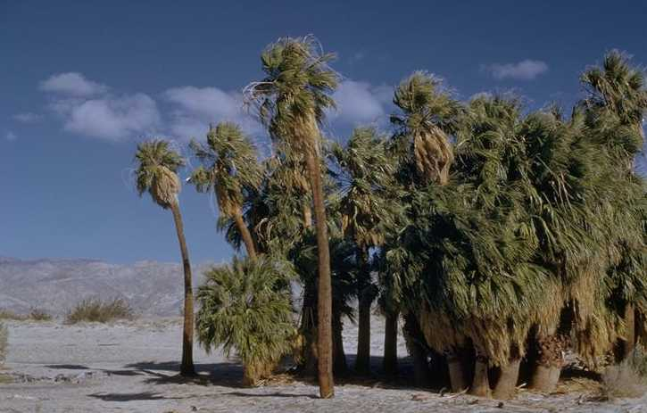

Brother Alfred Brousseau

© Brother Eric Vogel, St. Mary’s College

@ CalPhotos

###### Description

*General*: Palm family (Arecaceae). This tree has a thick, robust trunk and achieves a height up to 20 m. The large tufts of leaves are fan-shaped, fibrous, and gray green, and their spined petioles are 1-2 m. The blades are 1-2 m and are divided nearly to the middle. The many white flowers are small and enclosed by a spathe. The black fruits are oblong or ovate.

###### Distribution

For current distribution, please consult the Plant Profile page for this species on the PLANTS Web site**.**

###### Establishment

*Adaptation*: This plant is found below 1200 m in groves, alkaline spots of seeps, springs, and streams, on the west and north edge of the Colorado Desert, Turtle Mountains, the Sonoran Desert, southeastern Arizona, and northern Baja, California.

*Propagation by seed*: One can improve seed germination by collecting seeds from coyote manure. Apparently germination is very high from seeds which have passed through the animals' digestive systems. Plant the seeds in the spring in large pots, one-quarter inch apart in well-drained, friable soil such as a mixture of sand, loam, and peat moss or vermiculite and peat moss. Be patient, as the seeds take from four to fifteen weeks to germinate. At the first true leaf stage, plant the seedlings into separate one-gallon containers and hold until out-planting. Seedlings should be sheltered from winds and major temperature changes. When planting fan palm in a permanent location, plant seedlings during the fall, in areas exposed to full sunlight. Fall plantings must be watered during the following two summers if rainfall is low.

###### Management

The dead leaves that form a skirt should be removed periodically. Native Americans historically and prehistorically enhanced palm populations through firing palm stands and planting seeds. Palm stands were burned to control infestations of the palm-boring beetle (*Dinapate wrightii*), to improve access to the palms and their fruit by clearing underbrush, and to increase the production and enhance the quality of fruit. Furthermore, these fires encouraged seed production, increasing the density of palms on favorable sites. Native Americans also acted as dispersal agents, carrying seeds of palms, which are small and easy to germinate, from one oasis to the next, extending the palm's range.

###### Cultivars, Improved and Selected Materials (and area of origin)

Seeds and plants of selected *Washingtonia* cultivars are available from many nurseries. It is best to plant species from your local area, adapted to the specific site conditions where the plants are to be grown. Contact your local Natural Resources Conservation Service (formerly Soil Conservation Service) office for more information. Look in the phone book under ”United States Government.” The Natural Resources Conservation Service will be listed under the subheading “Department of Agriculture.”

###### References

Bean L.J. & K.S. Saubel 1972. *Temalpakh: Cahuilla Indian knowledge and usage of plants*. Malki Museum Press, Morongo Indian Reservation, Banning, California.

Cornett, J.W. 1989a. *Desert palm oasis*. Palm Springs Desert Museum. Companion Press, Santa Barbara, California.

Cornett, J.W. 1989b. *The desert fan palm--Not a relict*. Abstract in C.A. Warren and J.S. Schneider (eds.) *Mojave Desert Quaternary Research Center.* Third Annual Symposium Proceedings, San Bernardino County Museum Association.

Cornett, J.W. 1987a. *Indians and the desert fan palm*. Masterkey 12-17.

Cornett, J.W. 1987b. *A giant boring beetle*. Environment Southwest. No. 518:21-25.

Cornett, J.W. 1985. *Reading fan palms*. Natural History 94(10):64-73.

Mathewson, M.S. 1985*. Threads of life: Cordage and other fibers of the California tribes.* Unpublished Senior Thesis. Department of Anthropology, University of California, Santa Cruz, Santa Cruz, California.

McClenaghan, L.R. & A.C. Beauchamp1986. *Low genic differentiation among isolated populations of the California fan palm (Washingtonia filifera*). Evolution 40(2):315-322.

McClintock, E. 1978. *The Washington fan palm*. Fremontia 6:3-5.

McClintock, E. 1993. *Arecaceae.* Page 1105 IN: *The Jepson Manual: Higher plants of California.* J.C. Hickman (ed.). University of California Press, Berkeley, California.

Nabhan, G.P. 1985. *The palm in our hands*. Pages 20-34 IN: *Gathering the Desert*. University of Arizona Press, Tucson, Arizona.

Schmidt, M.G. 1980*. Growing California native plants*. University of California Press, Berkeley, California.

###### Prepared By

# *M. Kat Anderson*

USDA, NRCS, National Plant Data Center

*Wayne Roderick*

Former Director of the East Bay Regional Parks Botanic Garden, Berkeley, California

###### Species Coordinator

# *M. Kat Anderson*

USDA, NRCS, National Plant Data Center

c/o Plant Sciences Department, University of California, Davis, California

Revised: 19jun0200 jsp; 060818 jsp

For more information about this and other plants, please contact your local NRCS field office or Conservation District, and visit the PLANTS Web site<<http://plants.usda.gov>> or the Plant Materials Program Web site <<http://Plant-Materials.nrcs.usda.gov>>

*The U.S. Department of Agriculture (USDA) prohibits discrimination in all its programs and activities on the basis of race, color, national origin, sex, religion, age, disability, political beliefs, sexual orientation, and marital or family status. (Not all prohibited bases apply to all programs.) Persons with disabilities who require alternative means for communication of program information (Braille, large print, audiotape, etc.) should contact USDA's* [*TARGET Center*](http://www.usda.gov/oo/target.htm) *at 202-720-2600 (voice and TDD).*

*To file a complaint of discrimination write USDA, Director, Office of Civil Rights, Room 326-W, Whitten Building, 14th and Independence Avenue, SW, Washington, DC 20250-9410 or call 202-720-5964 (voice or TDD). USDA is an equal opportunity provider and employer.*

*Read about* [*Civil Rights at the Natural Resources Convervation Service*](http://www.nrcs.usda.gov/about/civilrights/)*.*