|  |
| --- |
| koa |
| *Acacia koa* A. Gray |
| Plant Symbol = ACKO |

Contributed by: [Traditional Tree Initiative](http://traditionaltree.org)

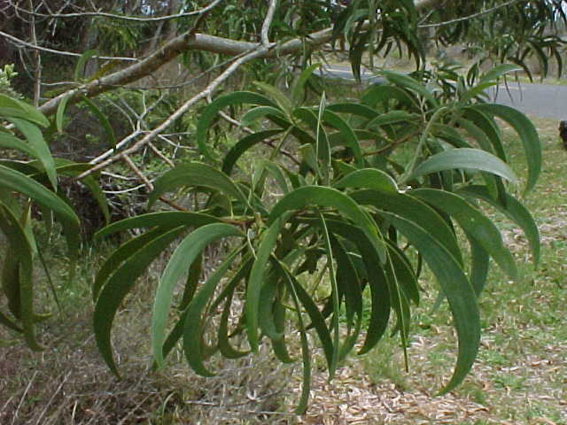

Acacia koa, University of Hawaii

The following information has been abstracted from the full treatment at <http://www.traditionaltree.org>. Please consult the full treatment for more information including genetics, associated species, establishment, plantation design, and agroforestry management.

Alternate Names

None

A closely related species is ACKO2 - *Acacia koaia*: dwarf koa, koaie, koaoha, koai‘e, koaia

Uses

The primary use is for timber, though it creates wildlife habitat, and is an ornamental. Koa trees in natural ecosystems provide habitat for many plants, insects, and birds, some endangered, such as the ‘akiapōlā‘au (*Hemignathus munroi*), a species of honeycreeper. As a nitrogen-fixing species, koa plays an important role in forest fertility. A key traditional use of koa logs by early Hawaiians was to build canoes and make tools. Commercially, koa is the premier native timber of Hawai‘i and is one of the most expensive woods in the world. The leaves and ashes have been used medicinally by Hawaiians. Tannin from the koa bark has been used to make a red dye for traditional bark cloth. The name “koa” also means “warrior” in Hawaiian and is important culturally.

Status

Please consult the PLANTS Web site and your State Department of Natural Resources for this plant’s current status (e.g. threatened or endangered species, state noxious status, and wetland indicator values).

Description and Adaptation

Koa is the largest native Hawaiian tree. It typically attains heights of 15-25 m (50-80 ft) with a canopy spread of 6-12 m (20-40 ft). Found between 100-2300 m (330-7500 ft). The form of trees ranges from an upright single trunk to low and sprawling with multiple trunks. Pale yellow flowers are borne in axillary racemes with spherical heads about 8.5 mm (0.33 in) in diameter. Flowers are produced throughout the year, peaking in mid to late winter. Seeds are contained within a pod (legume) 15-20 cm (6-8 in) long containing 6-12 seeds. There are three varieties of *Acacia koa*. *A*.*koa* var. *koa*, *A*.*koa* var. *latifolia*, and A. *koa* var. *kauaiensis*.

*Distribution*: Endemic to the Hawaiian Islands. Please consult the Plant Profile page for this species on the PLANTS Web site.

Establishment

The only propagation method currently in wide use is from seed. Pods are ready to pick when their color has turned from green to brown or black. Growing koa seedlings is very similar to many other nitrogen-fixing tree species, requiring pre-germination treatment (scarification) to break through the hard, impermeable seed coat, inoculation with appropriate rhizobia bacteria, and special nutrient requirements. Trees should be inoculated in the nursery within 4 weeks of germination.

Koa requires well-drained soils. Koa stands on shallow soils are not as productive as those on deep soils and may be short-lived. Koa is difficult to integrate with annual crops due to koa’s aggressive surface root system that competes with crops, while also susceptible to damage by human, animal, and machine traffic.

Hawai‘i’s highly variable climate means that matching an appropriate seed source to the site conditions is important to foster a viable koa planting. Environmental tolerances of koa vary by population. Such variation is one reason that seedlings used in reforestation should come from seeds collected from sites near or similar to the planting site. Koa trees grow well only in the sun. After an overnight frost, young seedlings may be killed by rapid thawing caused by direct sunlight. The use of sun screens to slow thawing of seedlings is recommended. Young seedlings are intolerant of grass competition.

Management

Overwatering and over-fertilization cause stress which often exhibits itself as yellowing of the leaves. Decreasing irrigation and eliminating nitrogen fertilizer can reverse the problem. Weed whacking the bark at the base of the tree can ruin the tree in a fraction of a second. It’s best to control weeds only by hand cutting and mulching near the tree. Leave a few inches of space against the trunk when mulching to reduce rotting. Root-bound seedlings that have become stunted in their containers will never return to being vigorous, healthy trees and should be discarded.

Without adequate soil contact, newly planted seedlings can be severely set back or die within a few days of planting. When planting seedlings, especially those grown in forestry tubes, the soil should be firmed up against the seedling’s root system. Windy or shady conditions are not conducive to rapid growth. Trees should be protected from wind and given full sun most of the day. When planting dense stands of koa, failure to thin trees will cause growth to stagnate. The planting area must be fenced to exclude any grazing animals and competitive vegetation should be removed around planting holes.

In urban situations, mulching with leafy materials is recommended to suppress weeds, conserve moisture, and protect koa’s surface roots. Pruning is not recommended since cuts provide easy access to fungi and borers.

Pests and Potential Problems

Pests and diseases currently limit koa’s optimal range to elevations above 610 m (2000 ft). The major pests affecting koa are koa wilt, fungi, and twig borers. Twig borers damage branches and may kill young seedlings. Livestock readily consume small seedlings and can quickly cause catastrophic damage to young trees. Seed predators include seed weevils and the koa seed worm. The koa moth may cause defoliation and in some cases may kill trees. Rusts are common on phyllodes, but are usually not serious problems. Banana poka (*Passiflora tarminiana*), a vigorous climbing vine, has overgrown and suppressed stands of koa. Koa is susceptible to root-knot nematodes, especially when grown in grassy areas at low elevations.

**Environmental Concern**

Koa is not generally planted outside its native range. However, as a fast-growing nitrogen-fixing tree, the potential for invasiveness outside Hawai‘i may be high. Alien invasive species can take over koa forests and prevent regeneration.

Full treatment: Elevitch, C.R., K.M. Wilkinson, and J.B Friday. 2006. *Acacia koa* (koa) and *Acacia koaia* (koai‘a), ver. 2.2. In: C.R. Elevitch (ed.). Species Profiles for Pacific Island Agroforestry. Permanent Agriculture Resources (PAR), Hōlualoa, Hawai‘i. <http://www.traditionaltree.org>.

Edited: 090609 jsp

For more information about this and other plants, please contact your local NRCS field office or Conservation District, and visit the PLANTS Web site<<http://plants.usda.gov>> or the Plant Materials Program Web site <<http://Plant-Materials.nrcs.usda.gov>>

*The U.S. Department of Agriculture (USDA) prohibits discrimination in all its programs and activities on the basis of race, color, national origin, age, disability, and where applicable, sex, marital status, familial status, parental status, religion, sexual orientation, genetic information, political beliefs, reprisal, or because all or a part of an individual's income is derived from any public assistance program. (Not all prohibited bases apply to all programs.) Persons with disabilities who require alternative means for communication of program information (Braille, large print, audiotape, etc.) should contact USDA's TARGET Center at (202) 720-2600 (voice and TDD).*

*To file a complaint of discrimination write to USDA, Director, Office of Civil Rights, 1400 Independence Avenue, S.W., Washington, D.C. 20250-9410 or call (800) 795-3272 (voice) or (202) 720-6382 (TDD). USDA is an equal opportunity provider and employer."*

*Read about* [*Civil Rights at the Natural Resources Conservation Service*](http://www.nrcs.usda.gov/about/civilrights/)*.*