|  |
| --- |
| koai‘a |
| *Acacia koaia* W. Hillebrand |
| Plant Symbol = ACKO2 |

Contributed by: [Traditional Tree Initiative](http://traditionaltree.org)

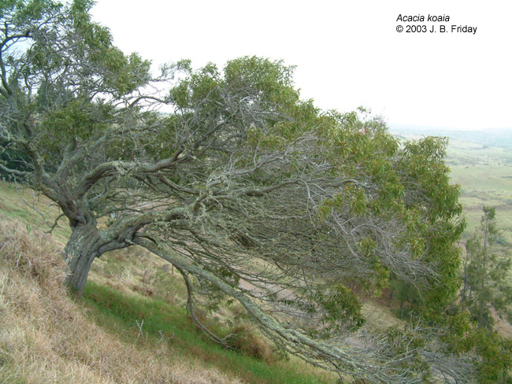

J.B. Friday

The following information has been abstracted from the full treatment at <http://www.traditionaltree.org>. Please consult the full treatment for more information including genetics, associated species, establishment, plantation design, and agroforestry management.

Alternate Names

dwarf koa, koaie, koaoha, koai‘e, koaia

Uses

The wood is much harder than koa and was used by early Hawaiians for tools, fishhooks, spears, and canoe parts. When the trees were readily available, they were used for durable fence posts. Today, the rare wood is used for gun stocks, knife handles, bowls, and artwork. The tree is also grown as an ornamental.

With its short size and domed canopy, koai‘a can be used as a hedge tree, though a uniform hedge can not be expected. Secondly, pruning is not recommended due to the risk of increasing the plant’s susceptibility to insect or disease attack.

Status

Please consult the PLANTS Web site and your State Department of Natural Resources for this plant’s current status (e.g. threatened or endangered species, state noxious status, and wetland indicator values).

Description and Adaptation

Koai‘a is a close relative of koa native to the Hawaiian Islands. These two are so closely related that there is controversy among taxonomists as to whether they are different species.

Koai‘a is much more compact in size than koa, often having a bushy, gnarled, or even horizontal growth habit. Koai‘a grows well in harsher conditions than koa. Koai‘a is a small tree, rarely taller than 5 m (16 ft) with a domed canopy that is usually about as wide as the tree is tall when grown in the open. The phyllodes are generally narrower, shorter, and straighter than those of koa. The inflorescence is similar to koa, but the seedpods are narrower with seeds longitudinally arranged instead of transversely as in koa.

*Distribution*: Please consult the Plant Profile page for this species on the PLANTS Web site.

Establishment

Koai‘a is propagated from seed using methods identical to those used for koa, It is best to use seeds from adjacent populations. Growing koai‘a seedlings is very similar to many other nitrogen-fixing tree species, requiring pre-germination treatment (scarification) to break through the hard, impermeable seed coat, inoculation with appropriate rhizobia bacteria, and special nutrient requirements. Trees should be inoculated in the nursery within 4 weeks of germination.

Management

Full sun is best for rapid growth and plant vigor, though they do well in partial sun. Koai‘a requires freely draining soils.

Pests and Potential Problems

The major pests affecting koai‘a are koa wilt, fungi, and twig borers. Twig borers damage branches and may kill young seedlings. Livestock readily consume small seedlings and can quickly cause catastrophic damage to young trees. Seed predators include seed weevils and the koa seed worm. The koa moth may cause defoliation and in some cases may kill trees. Rusts are common on phyllodes, but are usually not serious problems. Banana poka (*Passiflora tarminiana*), a vigorous climbing vine, has overgrown and suppressed stands of koai‘a. Koai‘a is susceptible to root-knot nematodes, especially when grown in grassy areas at low elevations.

Environmental Concerns

Koai‘a has a strong lateral root system, which is often partially exposed on the surface, especially in rocky soils. Any kind of traffic can injure the roots and stress the plant. It is best to plant the tree in areas with limited or no traffic. Herbicide use under the tree should be avoided. Instead, mulching or living ground cover of herbaceous plants are ideal for use under koai‘a trees.

Full treatment: Elevitch, C.R., K.M. Wilkinson, and J.B Friday. 2006. *Acacia koa* (koa) and *Acacia koaia* (koai‘a), ver. 2.2. In: C.R. Elevitch (ed.). Species Profiles for Pacific Island Agroforestry. Permanent Agriculture Resources (PAR), Hōlualoa, Hawai‘i. <http://www.traditionaltree.org>.

Edited: 090609 jsp

For more information about this and other plants, please contact your local NRCS field office or Conservation District, and visit the PLANTS Web site<<http://plants.usda.gov>> or the Plant Materials Program Web site <<http://Plant-Materials.nrcs.usda.gov>>

*The U.S. Department of Agriculture (USDA) prohibits discrimination in all its programs and activities on the basis of race, color, national origin, age, disability, and where applicable, sex, marital status, familial status, parental status, religion, sexual orientation, genetic information, political beliefs, reprisal, or because all or a part of an individual's income is derived from any public assistance program. (Not all prohibited bases apply to all programs.) Persons with disabilities who require alternative means for communication of program information (Braille, large print, audiotape, etc.) should contact USDA's TARGET Center at (202) 720-2600 (voice and TDD).*

*To file a complaint of discrimination write to USDA, Director, Office of Civil Rights, 1400 Independence Avenue, S.W., Washington, D.C. 20250-9410 or call (800) 795-3272 (voice) or (202) 720-6382 (TDD). USDA is an equal opportunity provider and employer."*

*Read about* [*Civil Rights at the Natural Resources Conservation Service*](http://www.nrcs.usda.gov/about/civilrights/)*.*