|  |
| --- |
| Desert needlegrass |
| *Achnatherum speciosum* (Trin. & Rupr.) Barkworth |
| Plant Symbol = ACSP12 |

*Contributed By: USDA NRCS Great Basin Plant Materials Center*

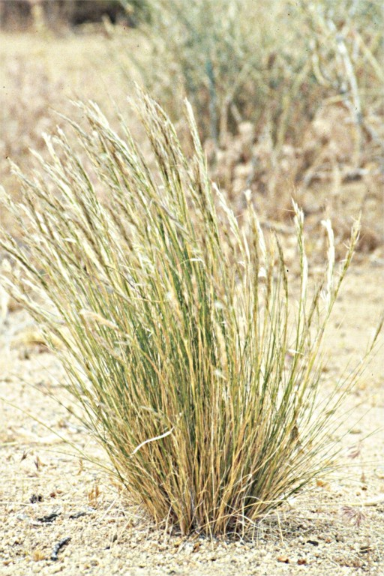

© Dr. D.W. Taylor, Jepson Herbarium

## Alternate Names

desert stipa, *Stipa speciosa*

**Uses**

*Grazing/Rangeland*: Desert needlegrass is palatable to all classes of livestock when young. After desert needlegrass matures, it is moderately grazed by horses and cattle, but is often avoided by other livestock such as sheep.

*Soil Stabilization*: Desert needlegrass can be used for ground cover in arid areas where there is light disturbance. However, it may not persist in areas with a large population of grazing animals due to excessive trampling and overgrazing.

*Wildlife*: Desert needlegrass is palatable to wildlife such as desert bighorn sheep and feral burros, particularly when young.

**Status**

Consult the PLANTS Web site and your State Department of Natural Resources for this plant’s current status (e.g., threatened and endangered species, state noxious status, and wetland indicator values).

**Description**

Grass Family (Poaceae). Desert needlegrass is a native, cool-season, perennial bunch grass that grows from 1 to 2 feet tall (30 to 60 cm). The leaf basal sheath is hairy, the leaf blade is generally rolled, and the ligule is short. The inflorescence is compact, 4 to 6 inches long (10 to 15 cm), and is generally partly enclosed by the uppermost leaf sheath. Seeds have an awn approximately 1.5 inches long (38 mm) that is bent once and is hairy below the bend.

**Adaptation and Distribution**

Desert needlegrass typically grows on coarse soils with little or no profile development, including alluvial fans, dry rocky hills, talus slopes, and in canyons. Desert needlegrass can tolerate low precipitation environments and usually occurs in areas that receive 6 to 20 inches (15 to 50 cm) of annual precipitation.

Desert needlegrass typically grows in Mediterranean climates that have mild winters and warm to hot summers.

Desert needlegrass is found throughout many western states, including New Mexico, Colorado, Arizona, Utah, Nevada, California, and Oregon. For current distribution, consult the Plant Profile page for this species on the PLANTS Web site.

## Establishment

Desert needlegrass can reproduce vegetatively and by seed. Vegetative reproduction occurs through the annual growth of new tillers. Seed production is highly variable depending on rainfall, and little seed is produced when soil moisture is low and temperatures are high.

The long awns of desert needlegrass seed enable self-planting. Cycles of wetting and drying cause the awn to twist and untwist, which drives the seed into the ground.

A study on germination rates for desert needlegrass found that germination was greatest for a treatment temperature of 59 degrees Fahrenheit. The study concluded that after 14 days of incubation at 59 degrees Fahrenheit, germination should be more than 90%.

**Management**

Desert needlegrass tolerates light grazing, but overgrazing may eliminate desert needlegrass from the ecological site. It is best to graze desert needlegrass before seed develops because the seed has a prominent, sharp callus that can injure the eyes and mouths of grazing animals.

## Cultivars, Improved and Selected Materials (and area of origin)

No releases of this species have been completed.

## Prepared By:

## *Steven Perkins*, USDA NRCS Great Basin PMC, Fallon, Nevada

*Dan Ogle*, USDA NRCS, Boise, Idaho

## Species Coordinator:

*Steven Perkins*, USDA NRCS Great Basin Plant Materials Center, Fallon, Nevada

Edited: 30Jan08sp; 30Jan08dgo; 08Feb29 jsp

For more information about this and other plants, please contact your local NRCS field office or Conservation District, and visit the PLANTS Web site<<http://plants.usda.gov>> or the Plant Materials Program Web site <<http://Plant-Materials.nrcs.usda.gov>>

*The U.S. Department of Agriculture (USDA) prohibits discrimination in all its programs and activities on the basis of race, color, national origin, sex, religion, age, disability, political beliefs, sexual orientation, and marital or family status. (Not all prohibited bases apply to all programs.) Persons with disabilities who require alternative means for communication of program information (Braille, large print, audiotape, etc.) should contact USDA's* [*TARGET Center*](http://www.usda.gov/oo/target.htm) *at 202-720-2600 (voice and TDD).*

*To file a complaint of discrimination write USDA, Director, Office of Civil Rights, Room 326-W, Whitten Building, 14th and Independence Avenue, SW, Washington, DC 20250-9410 or call 202-720-5964 (voice or TDD). USDA is an equal opportunity provider and employer.*

*Read about* [*Civil Rights at the Natural Resources Convervation Service*](http://www.nrcs.usda.gov/about/civilrights/)*.*