

Plant Fact Sheet

Maui Chaff flower

*Achyranthes splendens* Mart. Ex Moq.

Plant Symbol = ACSP3

Contributed by: USDA/NRCS Hoolehua Plant Materials Center

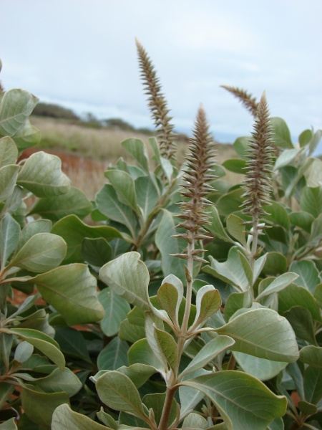

Figure Outplanting of A. splendens var. splendens at Upper Kaulana, Kahoolawe. Kim & Forest Starr, DEC2008

Alternate Names:

Ewa hinahina; round chaff flower; round-leaved chaff flower.

Uses:

Achyranthes splendens has the potential for ecosystem restoration, re-vegetation of degraded habitats, and to increase diversity in dry-land and coastal communities.

Its silvery appearance makes it an excellent selection for xeriscape gardens and other dryland landscaping projects.

Status

Please consult the PLANTS Web site and your State Department of Natural Resources for this plant’s current status (e.g., threatened or endangered species, state noxious status, and wetland indicator values).

*Achyranthes splendens* var. *rotunda* is listed by the U.S. Federal Government as an Endangered Species.

Description and Adaptation

*Achyranthes splendens* is a small shrub 2 to 6 feet in height. The leaves are arranged opposite and are obovate to broadly elliptic or suborbicular in shape, ranging in size from ¾ to 4 ½ inches long and ½ to 2 ½ inches wide. The leaves are also covered with white hairs, especially on the lower surface giving them a silvery appearance. Its flower is a densely-congested spike with a silvery appearance as well and can measure from 1 to 9 ½ inches long.

*Achyranthes splendens* is an endemic shrub. It occurs naturally at low elevations, generally from sea level to 100 feet, in open, dry areas. It is known to survive plantings up to 1000 feet. It is currently known to occur naturally along the western coast of Oahu, on the Kalaupapa peninsula on Molokai, near Manele and Maunalei Gulch on Lanai, in West Maui, and near Kula on East Maui. There are 2 varieties recognized in The Manual of the Flowering Plants of Hawaii (Wagner 1990); *A. splendens* var. *rotundata,* and *A. splendens* var. *splendens*.

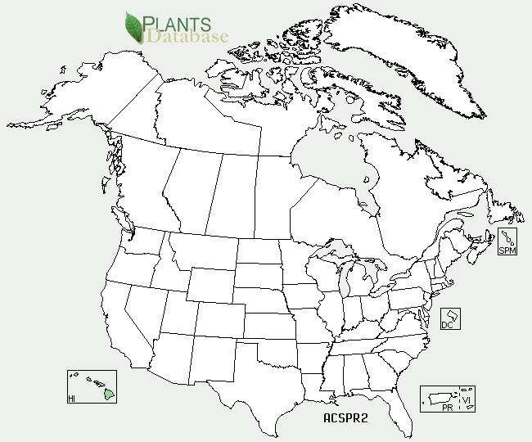

Achyranthes splendens distribution from USDA-NRCS PLANTS Database.

For updated distribution, please consult the Plant Profile page for this species on the PLANTS Web site.

Establishment

*Achyranthes splendens* will propagate easily either by seed or by vegetative cuttings. Dibble tubes and a sterile planting medium with good drainage are recommended to start propagules. Cuttings should be started under 50% shade. Seeds should be started in full sunlight and should germinate within 7-10 days. Out-plant *A. splendens* in areas where it can enjoy full sunlight. *A. splendens* will tolerate low fertility soils, but soil amendments based on soil tests will benefit any planting. When out-planting seedlings, moderate moisture should be provided until plants become established. This could take at least 1-2 months.

Management

*Achyranthes splendens* is well adapted to low rainfall areas and requires very little moisture, if any, once it has become established. *A. splendens* will thrive with no to very little soil amendments. It tolerates pruning and will recover easily from the occasional broken branch. There have been instances at the Hoolehua PMC where the major stem had broken off and the remaining stump had re-grown completely.

Pests and Potential Problems

There are no known pests or potential problems.

Environmental Concerns

*Achyranthes splendens* is primarily threatened by urban development. Other threats include invasive alien plants, wildfires, introduced deer and cattle ranching.

Cultivars, Improved, and Selected Materials (and area of origin)

None.

Prepared By:

David Duvauchelle – Natural Resource Specialist

Citation

Duvauchelle, David P.L., 2010. Plant fact sheet for Maui chaff flower (*Achyranthes splendens)*. USDA-Natural Resources Conservation Service, Hoolehua Plant Materials Center. Hoolehua, Hawaii 96729.

Published*:* October 2010

Edited: [16Sep2010_dd;17Sep2010_jab ]

For more information about this and other plants, please contact your local NRCS field office or Conservation District <<http://www.nrcs.usda.gov/>>, and visit the PLANTS Web site <[http://plants.usda.gov](http://plants.usda.gov/)> or the Plant Materials Program Web site <<http://plant-materials.nrcs.usda.gov>>.

**USDA IS AN EQUAL OPPORTUNITY PROVIDER AND EMPLOYER**