|  |
| --- |
| jointvetch |
| *Aeschynomene americana* L. |
| Plant symbol = AEAM |

Contributed by: USDA Florida Plant Materials Center, Brooksville, Florida

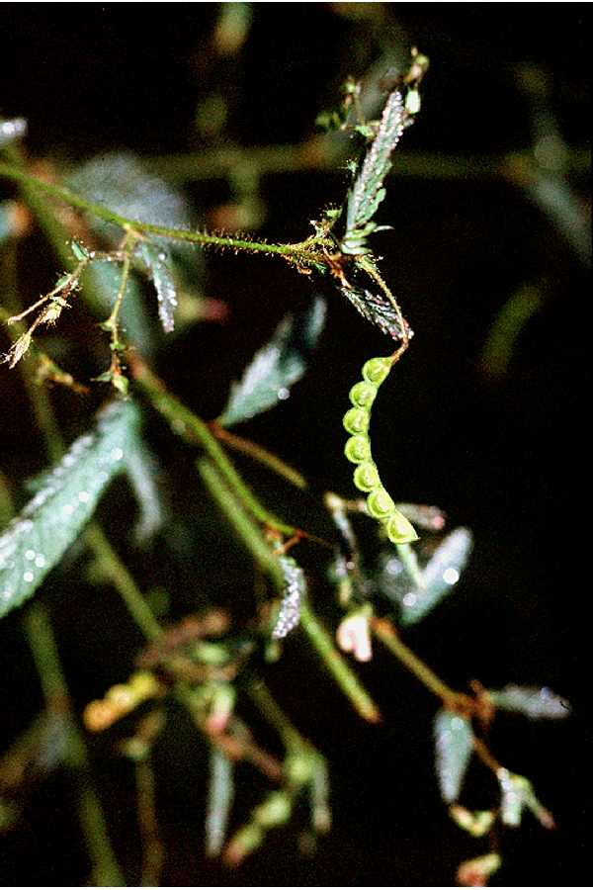

Robert H. Mohlenbrock

USDA SCS 1991 @ PLANTS

Alternate Names

Shyleaf

Uses

Jointvetch is primarily used as an annual grazing crop that can be cut for hay before maturity. Deer graze it and quail, dove, and turkey eat the seed. It can also be used as components of fresh water wetland reclamation seedings.

Status

Please consult the PLANTS Web site and your State Department of Natural Resources for this plant’s current status (e.g. threatened or endangered species, state noxious status, and wetland indicator values).

Description and Adaptation

Legume Family (Fabaceae). Jointvetch is an upright native, annual to short-lived perennial plant that could be classified as a forb or subshrub growing 3 to 6 feet tall. The stems are well-branched and moderately leafy. The leaves are compound, have 25 to 60 leaflets measuring 3 inches long, and are sensitive to light and touch. The flowers are yellow with dark lines and appear as loose clusters.

Establishment

The site should be moderately to poorly drained. If the site floods during the rainy season, the stand should be well established before flooding begins. Taller plants have a moderate tolerance to temporary flooding. During hot weather, seedlings can be damaged within a few days. The soil should be well prepared by plowing, disking, and packing. Excellent volunteer stands may be obtained by disking areas that had successful stands and matured seed the previous year. Apply lime, if necessary, to bring the soil pH into the 5.5 to 6.5 range. Seed between March 1 and June 30, if irrigated, or after June 1st when there is a greater chance of adequate rainfall to allow germination and sustain the seedling. In a prepared seed bed, broadcast 5 pounds per acre de-hulled seed or 10 lbs/acre in the hull. If you are seeding into existing pastures, the seeding rate should be doubled. Cultipack the ground after seeding. Place seed at a ½ to 1 inch seeding depth. All seed should be inoculated with either “cowpea” or special *Aeschynomene* culture.

Management

Maintain a pH of 5.5 to 6.0. Apply fertilizer according to soil test recommendations. Initiate grazing when plants are 18 to 24 inches high and remove cattle when grazed to 2 to 3 inches. To insure a volunteer crop, grazing must cease after October 1st to allow blooming, seed set, and seed maturation. After seed maturation, graze to use forage before November 1st, when forage value decreases. Volunteering following a seed crop can be encouraged and a stand secured by disking or chopping the area in early to mid-spring of succeeding years. Graze the area until volunteer seed germinates to reduce weed competition. Resume grazing when plants are 18 inches high.

Cultivars, Improved, and Selected Materials (and area of origin)

A selection ‘F-149’ has been distributed by the Natural Resources Conservation Service since the 1950’s, though it was never formally released. Little variation occurs in native stands throughout Florida. Researchers at the University of Florida have done extensive work with this species and it is commercially available.

Prepared By:

Florida Plant Materials Center, Brooksville, Florida.

Species Coordinator:

Florida Plant Materials Center, Brooksville, Florida.

Edited: 23March2006 jsp

For more information about this and other plants, please contact your local NRCS field office or Conservation District, and visit the PLANTS Web site<<http://plants.usda.gov>> or the Plant Materials Program Web site <<http://Plant-Materials.nrcs.usda.gov>>

*The U.S. Department of Agriculture (USDA) prohibits discrimination in all its programs and activities on the basis of race, color, national origin, sex, religion, age, disability, political beliefs, sexual orientation, and marital or family status. (Not all prohibited bases apply to all programs.) Persons with disabilities who require alternative means for communication of program information (Braille, large print, audiotape, etc.) should contact USDA's* [*TARGET Center*](http://www.usda.gov/oo/target.htm) *at 202-720-2600 (voice and TDD).*

*To file a complaint of discrimination write USDA, Director, Office of Civil Rights, Room 326-W, Whitten Building, 14th and Independence Avenue, SW, Washington, DC 20250-9410 or call 202-720-5964 (voice or TDD). USDA is an equal opportunity provider and employer.*

*Read about* [*Civil Rights at the Natural Resources Convervation Service*](http://www.nrcs.usda.gov/about/civilrights/)*.*