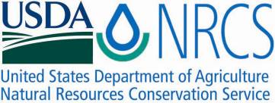

Plant Fact Sheet

# spike bentgrass

## Agrostis exarata Trin.

Plant Symbol = AGEX

Contributed by: USDA NRCS Plant Materials Center, Corvallis, Oregon

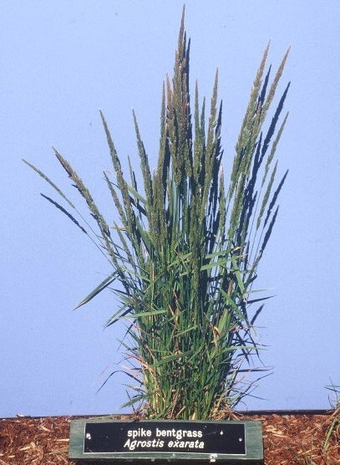

*Dale Darris*

*USDA-NRCS Corvallis PMC*

### Alternative Names

*Alternate Common Names:* spike redtop, western bentgrass

*Alternate Scientific Names: A. exarata.* var. *exarata,* *A. exarata.* var. *pacifica* Vasey, *A. exarata*. var. *monolepis* (Torrey) Hitchc. Spike bentgrass apparently hybridizes with *A. scabra* and *A. stolonifera.*

### Uses

As a pioneer species, spike bentgrass has good potential for restoration of prairie wetlands, riparian areas, and other seasonally wet or intermittently flooded habitats. It is also useful for revegetation of ditches, logged or burned over timberland, and other disturbances within brush and open woodland communities.

Where locally abundant, this species is an important source of forage for livestock. Foliage remains green and palatable throughout the summer. Its palatability is rated good for cattle, horses, and elk, and fair to good for sheep and deer. Spike bentgrass is also planted as a soil stabilizer in degraded areas and has been suggested for use in excluding reed canarygrass (*Phalaris arundinacea*). Value for wildlife habitat is ranked high for numerous birds and mammals. Compared to many bentgrasses, spike bentgrass is considered by some as more compatible with other native grasses, forbs, and trees.

**Description**

Spike bentgrass is amedium textured, cool season, perennial bunchgrass with a dense, spike-like flower head (panicle). The stems (culms) are slender and erect, usually 50 to 100 (150) cm tall. The leaf blades are 2 to 20 mm wide, 5 to 20 cm long, and harsh to the touch. This species contains considerable variability, from dwarf alpine forms to taller, more robust specimens along the seacoast. Some texts indicate the occasional presence of short rhizomes and root development or growing points at lower nodes, but rhizomes appear to be lacking on plants in our area. Thisspeciesis found mostly in the western United States and Canada.

*Key to identification:* Compared to most other bentgrasses, the panicle is particularly narrow and more spike-like. It is 10 to 25 cm long. The individual flower groups (spikelets) are very tiny and 1-flowered. A botanical grass key may be required to accurately distinguish it from other bentgrasses.

**Relative abundance in the wild**

Spike bentgrass is relatively common is western Oregon, western Washington, and California. It can be locally abundant on moist sites throughout the western states. The species produces large quantities of tiny seeds with good retention that are easy to harvest or collect. It is usually not found in large pure stands, but occurs as scattered individuals or small colonies across a landscape.

**Adaptation:** Spike bentgrass has broad adaptation to a wide variety of habitats. Despite the tiny seed size, it is easy to establish and a high seed producer with good commercial potential. Spike bentgrass occurs in a wide variety of habitats including forest openings, grasslands, shrub lands, wet meadows, freshwater and high tidal marshes, as well as along streams, rocky beaches, and lake margins. It is most commonly found in moist open places, but occasionally grows in dry habitats such as semi-arid grasslands. Relatively shade intolerant, this species performs well on moderately acidic, mineral soils.

While most prevalent on disturbed sites such as ditches, harvested forestland, and roadsides, it may also be found in established meadow and riparian plant communities. Habitats range from sea level to alpine zones**.** Thisspeciesoccurs mostly in the western United States and Canada.

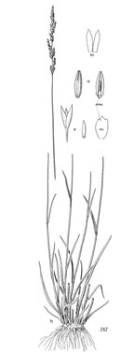

*Line drawing reprinted by permission, University of Washington Press*

**Establishment:** Some recommend a light debearding to remove the seed appendage (awn) in order to facilitate further seed cleaning and sowing with a drill. The seed has no dormancy and germinates readily. There are approximately 5,600,000 seeds/lb (+/- 20%). A seeding rate of 1 lb/acre of pure live seed would result in 125 live seeds per square foot. Given the small seed size, the single species seeding rate is generally 1-3 lbs/acre, but some literature recommends a rate of 3-5 or up to 8 lbs/acre to attain a full stand. The species establishes easily on moist, mineral soil in spring or fall. However, the seed readily migrates in flood prone areas so a thin mulch layer coupled with a late summer or early fall plantings may be preferred.

**Management:** Information on this species is limited. Moderate amounts of forage are produced and utilized by livestock, large game, and other wildlife well into summer. The ability of spike bentgrass to easily volunteer on moist, disturbed ground and readily produce seed makes it a candidate for moist soil management of wetland habitat for waterfowl, shorebirds, and other wildlife.

**Limitations or environmental concerns:**

Due to its abundant seed production and broad adaptability, it may be considered weedy in certain environments. Please consult with your local NRCS Field Office, Cooperative Extension Service office, or state natural resource or agriculture department regarding its status and use.

**Commercial availability of seed:** Several seed sources are available for California and at least one for the Willamette Valley of Oregon. Ecotypes may be harder to locate for other western states.

Prepared By:

*Dale Darris* and *Amy Bartow*, USDA NRCS Plant Materials Center, Corvallis, Oregon.

Species Coordinator:

*Dale Darris*, USDA NRCS Plant Materials Center, Corvallis, Oregon.

Citation:

## Darris, D., and A. Bartow. 2006. Plant fact sheet for spike bentgrass (Agrostis exarata). USDA-Natural Resources Conservation Service, Plant Materials Center, Corvallis, OR.

Published 2006

Edited: 16Mar2006 jsp, 16Sep2008 dcd; 17Sep2008 jsp; 17Feb2012 aym

For more information about this and other plants, please contact your local NRCS field office or Conservation District <<http://www.nrcs.usda.gov/>>, and visit the PLANTS Web site <[http://plants.usda.gov](http://plants.usda.gov/)> or the Plant Materials Program Web site <<http://plant-materials.nrcs.usda.gov>>

**USDA IS AN EQUAL OPPORTUNITY PROVIDER AND EMPLOYER**