

Plant Fact Sheet

# desert madwort

## Alyssum desertorum Stapf

Plant Symbol = ALDE

Contributed by: USDA NRCS Montana PM Program

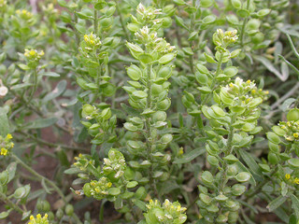

Figure 1. Desert madwort fruits are glabrous and compressed in the same plane as the septum. Photo by Matt Lavin, Montana State University, Bozeman, Montana. Used with permission.

### Alternative Names

*Common Alternate Names:* desert alyssum

*Scientific Alternate Names: Alyssum minimum*, *Psilomema minimum*

### Uses

Pronghorn antelope (*Antilocapra americana*) in Yellowstone National Park consistently use desert madwort in their winter diets.

Western harvester ants (*Pogonomyrmex occidentalis*) harvested up to 100% of desert madwort seeds from the seed bank of a site near Kemmerer, Wyoming.

### Status

Please consult the PLANTS Web site and your State Department of Natural Resources for this plant’s current status (e.g., threatened or endangered species, state noxious status, and wetland indicator values).

### Weediness

This plant may become weedy or invasive on disturbed sites in some regions or habitats, particularly on overgrazed or otherwise disturbed arid and semi-arid regions and may displace desirable vegetation if not properly managed. Desert madwort is considered a weak invader requiring disturbance for population expansion. Please consult with your local NRCS Field Office, Cooperative Extension Service office, state natural resource, or state agriculture department regarding its status and use. Weed information is also available from the PLANTS Web site at [http://plants.usda.gov](http://plants.usda.gov/). Please consult the Related Web Sites on the Plant Profile for this species for further information.

### Description and Adaptation

Desert madwort is an herbaceous annual native to Africa, Asia, and Europe. Stems are erect, ascending, or decumbent, often several growing from the base two to 11 inches tall. Leaves are alternately arranged on the stem, linear in shape or broadest at the tip, tapering to a petiole-like base (sub-sessile), the tip sharply pointed, and 0.2 to 1 inch long by 0.04 to 0.12 inch wide. The entire plant except the fruit is covered with 8- to 20-rayed stellate hairs (trichomes) giving the plant a pale to grayish appearance (canescent). The inflorescent grows up to four inches in length with 30 to 40 flowers on stout, strait, ascending pedicels 0.06 to 0.12 inch long. The flowers form from the bottom up as the inflorescence grows. Flowers are small, less than a tenth of an inch wide, with four pale yellow or dull-whitish, blunt- or notch-tipped petals that are widest at the tip and early deciduous. The fruiting pods (silicles) are 0.1 to 0.16 inch in diameter, circular in outline with a shallow notch at the tip where the short style persists, uniformly inflated at the middle and broadly flattened at the margins. There are two chambers in the pod each capable of producing two seeds. The chambers are separated by a thin membrane that persists and is obvious on the dried, senescent plant. The seeds are egg-shaped in outline, slightly compressed and vary narrowly winged at the margins, brown, and 0.06 inches long. Plants flower and fruit from April to July in North America. The chromosome number is 2n = 32.

Similar to its native range, desert madwort grows in deserts, rocky areas, disturbed sites, along roadsides, in fields, meadows, and sagebrush flats in North America from 2,600 to 6,500 feet above sea level. In the Tianshan Mountains of central Asia, desert madwort has similar ecological requirements and habitats with mouseear cress (Arabidopsis thaliana).

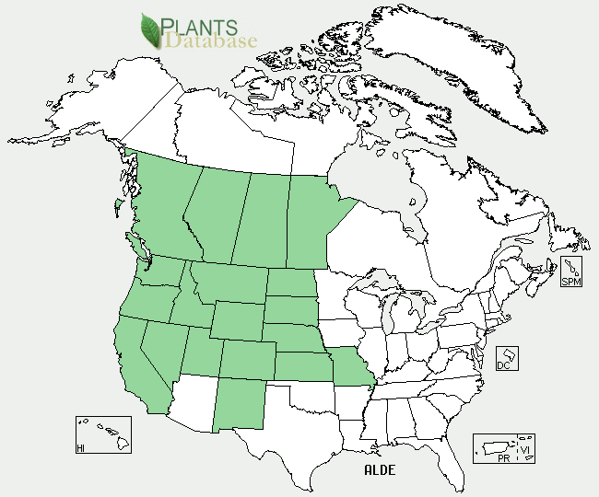

Desert madwort distribution from USDA-NRCS PLANTS Database.

For updated distribution, please consult the Plant Profile page for this species on the PLANTS Web site.

### Establishment

Desert madwort establishes from seed germinating predominantly in the spring.

### Pests and Potential Problems

Desert madwort plants infected with powdery mildew (*Erysiphe cruciferarum*) have been reported from Turkey and Romania.

### Environmental Concerns

In Republic of Armenia, increased water erosion of the soil resulted from increased development of desert madwort and other drought-resistant annual weeds that provided no soil cover following overgrazing of Volga fescue (*Festuca rupicola*).

### Control

A native grass restoration project in the northern boundary area of Yellowstone National Park north of Gardner, Montana, used prescribed burns applied on October 13, 2011 to reduce (p<0.0001) desert madwort from 527 to 5 plants per square foot at the Cinnabar site and from 657 to 237 plants per square foot at the Reese Creek site the year following the burns.

A number of herbicides temporarily reduce populations of desert madwort including metsulfuron methyl and glyphosate. Please contact your local agricultural extension specialist or county weed specialist to learn what works best in your area and how to use it safely. Always read label and safety instructions for each control method. Trade names and control measures appear in this document only to provide specific information. USDA NRCS does not guarantee or warranty the products and control methods named, and other products may be equally effective.

### Cultivars, Improved, and Selected Materials (and area of origin). None

### Prepared By *Jim Jacobs, USDA-NRCS, Bozeman, Montana*

### Citation

Jacobs, J. 2012. Plant fact sheet for desert madwort (*Alyssum desertorum)*. USDA-Natural Resources Conservation Service, Bozeman State Office, MT.

Published September 2012

Edited: 091112js; 091812rg

For more information about this and other plants, please contact your local NRCS field office or Conservation District <<http://www.nrcs.usda.gov/>>, and visit the PLANTS Web site <[http://plants.usda.gov](http://plants.usda.gov/)> or the Plant Materials Program Web site <<http://plant-materials.nrcs.usda.gov>>

**USDA IS AN EQUAL OPPORTUNITY PROVIDER AND EMPLOYER**