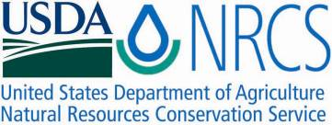

Plant Fact Sheet

**SITKA ALDER**

***Alnus viridis* (Chaix) DC. ssp. *sinuata* (Regel) A. Löve & D. Löve**

Plant Symbol = ALVIS

Contributed by: USDA NRCS Plant Materials Center, Corvallis, Oregon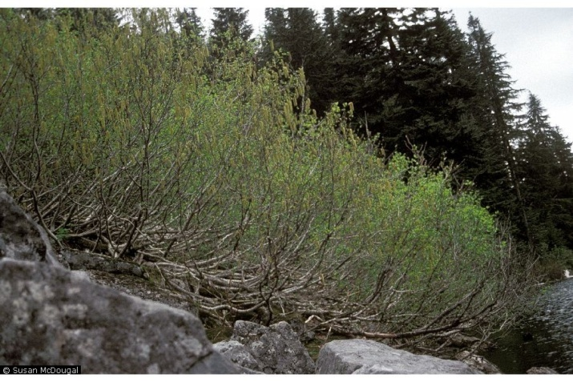

Susan McDougall @ USDA-NRCS PLANTS Database

**Alternate names**

Synonyms include *Alnus sinuata*, *Alnus sitchensis*, and *Alnus crispa* subsp. *sinuata*. Other names include green alder, mountain alder, slide alder, and wavy-leaf alder.

**Uses**

Sitka alder is a valuable species for stabilizing drastically disturbed, nutrient poor sites such as eroded streambanks, landslide chutes, steep rocky slopes, areas of flood deposition and scour, and exposed mineral soils following glacial retreat, avalanches, and massive soil slumping. It is also suitable for reclaiming acid, coal, and copper mine spoils and other soil enriching, revegetation efforts where a nitrogen fixing shrub (via bacteria in its root nodules) is desired. At the proper densities, the species may also be useful in improving forest site productivity as a companion or nurse shrub in young conifer plantations.

The palatability of Sitka alder is considered poor and forage value low for most ungulates, but others report that it is one of the most palatable of the native alders, especially for sheep. Moose, elk, and certain deer will browse young shoots, leaves, or twigs, as will rabbits, snowshoe hares, and squirrels. The seeds, buds, or catkins are an important source of food in winter for numerous song and game birds. Beavers eat the bark and use the stems to build lodges and dams. Thickets provide thermal and hiding cover for big game and other wildlife, as well as nesting habitat for many small birds.

Native Americans used the bark and its extracts to make a red-brown dye, cure several internal ailments, and treat skin wounds, itching, and swelling, including poison oak. Leaves and roots were used medicinally as well. The wood was preferred by some tribes for smoking salmon, woodworking, and making bows, baskets, and snowshoes.

**Description**

Sitka alder is a deciduous shrub or small tree that grows to height of 3 to 20 ft, occasionally taller. The form is upright, multi-stemmed, and freely branching at the base with a rounded crown. Male flowers are in the form of long catkins that begin opening in late winter. Found separately on the same plant are the female flowers which are cone-like (short catkins called strobiles) and bloom in early spring when the leaves appear. The seeds are winged nutlets that mature in autumn or early winter within the egg shaped woody cones. The leaves are broadly oval, 1 to 5 in. long, shiny above, wavy and finely toothed on the margins, and slightly scented and sticky beneath when young. Nodules containing nitrogen fixing bacteria form on the strong fibrous roots. The bark is smooth and grey. Twigs form a zigzag branch pattern.

**Status**

Please consult the Plants Web site and your State Department of Natural Resources for this plant’s current status, such as state noxious and wetland indicator values.

**Adaptation**

Sitka alder is a pioneer species that prefers full sun to partial shade and soils that range from mineral to rich, humus covered substrates, acid to neutral pH (3.8 to 7.5), and coarse to medium texture (gravelly, sandy, silty, loamy). However, it will tolerate moist clay soils and sites that are nutritionally poor. This species prefers moderate to good drainage. It is less tolerant to flooding and poor drainage than red alder. Plants resprout from the crown after fire.

*Distribution*- Sitka alder occurs naturally from central Alaska south to northern California and east to Alberta, northwest Wyoming, and western Montana. The elevation range is sea-level to 9000 ft in the mountains. Habitat includes moist montane woods, rocky or sandy coastlines and talus slopes, streambanks, lakeshores, and the north face of rocky outcrops.

**Limitations or environmental concerns**

Sitka alder is host to a number of insect pests including root weevils, flea beetles, leaf rollers, borers, sawflies, leaf minors, scales, and aphids. Pathogens include leaf spots, powdery mildew, alder top-kill, and stem cankers. Some of these diseases can show up in nursery stock. The species readily volunteers into disturbed areas, making it potentially weedy and a competitor with valuable timber trees. Toxicity for this plant has not been reported.

**Establishment**

Sitka alder cannot be propagated by dormant hardwood cuttings but success may be possible with green stem cuttings treated with 2000 ppm IBA (indole-butyric acid) plus a rooting powder and placed in a mist bench with bottom heat.

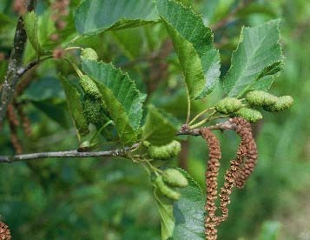

2 Photo by dale Darris

Propagation from seed is reliable. Cones are collected in fall when they turn brown and begin to open. Once the seed is extracted it can be sown immediately without treatment or stored under cool, dry conditions. Stored seed is often dormant and requires 14 days to 3 months of prechilling (cold moist stratification) at 34 to 38°F, or fall sowing. Seed can be surface sown or covered with a very thin layer of soil, potting media, or mulch. Seedling establishment can benefit from the inoculation of roots with appropriate strains of *Frankia* bacteria (to stimulate nodule formation) and ectomychor-rhizal fungi. Fall planting is best along with the use of mulch and protection from animals.

**Improved cultivars and selected materials (and area of origin)**

For revegetation at low elevation in western Oregon and Washington, the Plant Materials Center in Corvallis, OR, released Skamania Germplasm, a selected class pre-variety from Skamania Co., WA. Studies in British Columbia showed clear geographic patterns in frost hardiness, growth, and other traits that related to latitude and distance from the Coast. This and other work suggests that for land rehabilitation, material originating from the same region and similar habitat should be favored.

**Prepared by**

Dale Darris and Pete Gonzalves, USDA NRCS Plant Materials Center, Corvallis, Oregon.

**Species coordinator**

Dale Darris, USDA NRCS Plant Materials Center, Corvallis, Oregon.

Published October, 2009

Edited: [e.g., 08Sep2009 rg, 08Sep2009 jfh; 17Sep2009 jfe]

For more information about this and other plants, please contact your local NRCS field office or Conservation District <<http://www.nrcs.usda.gov/>>, and visit the PLANTS Web site <[http://plants.usda.gov](http://plants.usda.gov/)> or the Plant Materials Program Web site <http://plant-materials.nrcs.usda.gov.

**USDA IS AN EQUAL OPPORTUNITY PROVIDER AND EMPLOYER**