

Plant Fact Sheet

# showy milkweed

## Asclepias speciosa Torr.

Plant Symbol = ASSP

*Contributed by: USDA NRCS Corvallis Plant Materials Center, Corvallis, OR, and Great Basin Plant Materials Center, Fallon, NV*

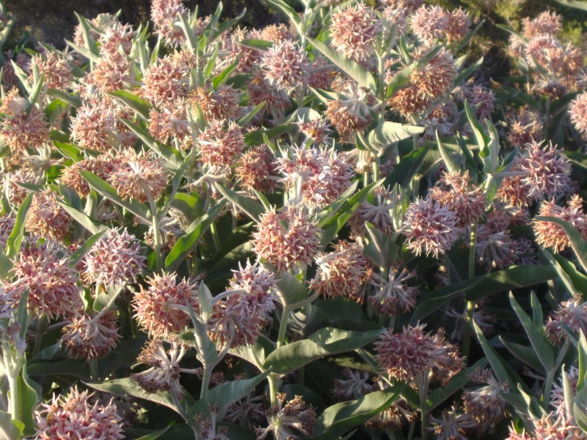

Photo by E. Eldredge, NRCS, Fallon, NV, 2011.

### Alternative Names

*Alternate Common Names:* showy butterfly weed, creek milkweed, Greek milkweed

*Alternate Scientific Names: Asclepias giffordii* Eastw., *Asclepias douglasii* Hook.

**Warning: Without sufficient preparation, milkweed can be toxic when taken internally.**

### Uses

*Pollinators*: The abundant nectar of milkweed flowers attracts hummingbirds, butterflies, honey bees, native bees, and other beneficial insects. Accordingly, this is a wonderful horticultural plant for butterfly gardens, borders, meadows, or native plant landscaping. Milkweed plants (*Asclepias* spp.) are the only larval host for monarch butterflies (*Danaus plexippus*). It is important to have large, dense clumps of milkweeds for monarch caterpillars. Monarch, queen (*Danaus gilippus*) and viceroy butterflies (*Limenitis archippus*) get chemicals from the milkweed plant that make them distasteful to predators, and all have similar orange and black patterns to warn predators.

*Restoration*: Showy milkweed's tough, extensive root system, drought tolerance, and minimal nutrient requirements make it a good species for stabilizing and restoring degraded or disturbed sites.

#### Ethnobotany: People have used milkweed plants for fiber, food, and medicine. The young shoots, stems, flower buds, flowers, and immature fruits of showy milkweed were eaten raw or boiled as a vegetable by indigenous groups of North America. The most common use for the plant among tribes of California was as cordage. The sticky white sap was also made into a type of chewing gum by heating it until it became solid, and mixing it with salmon fat or deer grease.

The sap of showy milkweed was used by some desert tribes to heal sores and cuts, and to cure warts and ringworm. The ripe seeds were ground and made into a salve for sores. Seeds were boiled and the liquid used to draw the venom from rattlesnake bites. Tea made from the rhizomes was a remedy for measles or coughs. It was also used as a wash to cure rheumatism. The rhizomes, mashed with water, were used as a poultice to reduce swelling.

#### Fiber: Stem fibers of milkweed are used by Native Americans to make course cloth, string, cords, and ropes. At Zuni, NM, the silky seed floss is spun into yarn and woven into a special fabric for dancers. Hybrids of A. speciosa and A. syriaca are being tested for commercial seed floss production as a hypo-allergenic substitute for goose down.

*Toxicity*: Milkweed contains toxic alkaloids and cardenolides, which can cause nausea and vomiting in low doses, and death in high doses. Animals avoid milkweed if other forage is available.

### Status

Showy milkweed is listed as a threatened species in Iowa. In most regions showy milkweed is considered a facultative species, meaning it is equally likely to occur in wetlands or non-wetlands. Please consult the PLANTS Web site and your State Department of Natural Resources for this plant’s current status (e.g., threatened or endangered species, state noxious status, and wetland indicator values).

### Weediness

Due to its vigorous vegetative growth, showy milkweed may become weedy and outcompete or displace other vegetation if not properly managed. Please consult your local NRCS Field Office, Cooperative Extension Service office, state natural resource office, or state agriculture department regarding its status and use. Weed information is also available from the PLANTS Web site at [http://plants.usda.gov](http://plants.usda.gov/).

### Description and Adaptation

Showy milkweed is a member of the milkweed family Asclepiadaceae (now placed in Apocynaceae, the dogbane family). Showy milkweed is a native herbaceous perennial from widespread rhizomes, which produce stems that grow to 1½ to 5 ft tall in summer. The gray-green leaves are opposite, 4 to 7 inches long, oval, and covered in velvety hairs. Stems and foliage exude milky latex sap when cut. Flowers are in loose clusters at the top of the stems and are rose-purple, aging to yellow. Individual *Asclepias* flowers look like crowns, with the corolla (petals) reflexed, and hoods above the corolla. Plants flower from May to September. Thick seed pods 3 to 5 inches long split down one side in fall to release reddish-brown, flat seeds. Each seed has a tuft of white, silky hairs that allows them to be dispersed by wind.

Showy milkweed grows in well-drained soil in full or nearly full sun, in pastures, meadows, forest clearings, untilled fields, roadsides, and ditch banks, from sea level to 6,250 ft. For updated distribution, please consult the Plant Profile for this species on the PLANTS Web site.

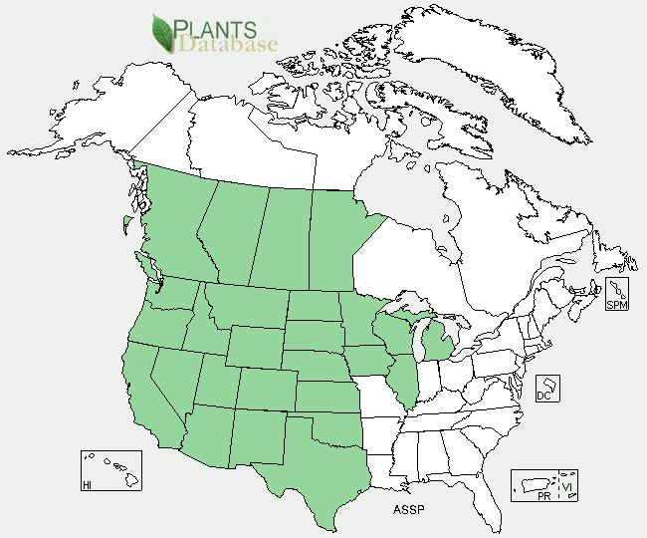

Showy milkweed distribution from USDA-NRCS PLANTS Database.

### Establishment

Seed can be collected after pods have ripened. Seeds do not store well, and should be sown in the fall, as seedlings are delicate and generally transplant poorly, and potted plants do not overwinter well. Cold, moist stratification for up to three months may improve seed germination in showy milkweed. Showy milkweed has 70,000 to 100,000 seeds per pound, so sowing at a rate of one pound pure live seed per acre will result in 1- 2 seeds per square foot.

Propagation by rhizome cuttings is easy and reliable. The cuttings should be dug when the plant is dormant (generally by October). Each piece of rhizome should have at least one bud. Plant the rhizomes 4 to 6 inches deep in late fall. Irrigation the first year will improve survival. Both seedlings and cuttings will usually bloom in the second year, although cuttings will occasionally bloom their first year.

### Management

Milkweed stems die in winter, and new stems emerge in spring. For fiber, old milkweed stems were collected by breaking them off at the ground after the leaves dried in fall. Milkweed was burned in the fall by California Indian tribes to eliminate dead stems, stimulate flower and seed production, and stimulate new growth with tall, straight stems and long fibers in the following year.

### Pests and Potential Problems

Insects besides butterflies that tolerate milkweed toxins include the large milkweed bug (*Oncopeltus fasciatus*), common milkweed bug (*Lygaeus kalmii*), red milkweed beetle (*Tetraopes tetrophthalmus*), blue milkweed beetle (*Chrysochus cobaltinus*), and some aphids (*Aphis* spp.). These insects can occasionally cause feeding damage.

### Environmental Concerns

Milkweed plants are toxic to livestock, but animals will avoid them when other forage is available. Milkweed should be excluded from hay or prepared feeds.

### Control

Please contact your local agricultural extension specialist or county weed specialist to learn what works best in your area and how to use it safely. Always read label and safety instructions for each control method.

### Cultivars, Improved, and Selected Materials (and area of origin)

Seeds and plants of showy milkweed are sometimes available commercially. Seed from plants growing in your area will be best adapted to local conditions.

### Prepared By

### *Annie Young-Mathews,* Conservation Agronomist, USDA NRCS Corvallis Plant Materials Center, Oregon

### *Eric Eldredge,* Manager, USDA NRCS Great Basin Plant Materials Center, Fallon, Nevada

### Citation

Young-Mathews, A., and E. Eldredge. 2012. Plant fact sheet for showy milkweed (*Asclepias speciosa)*. USDA-Natural Resources Conservation Service, Corvallis Plant Materials Center, OR and Great Basin Plant Materials Center, Fallon, NV.

Published August 2012

Edited: 15May2012 dcd; 25Jun2012jab; 29Aug2012 gm

For more information about this and other plants, please contact your local NRCS field office or Conservation District <<http://www.nrcs.usda.gov/>>, and visit the PLANTS Web site <[http://plants.usda.gov](http://plants.usda.gov/)> or the Plant Materials Program Web site <<http://plant-materials.nrcs.usda.gov>>

**USDA IS AN EQUAL OPPORTUNITY PROVIDER AND EMPLOYER**