

Plant Fact Sheet

# Fourwing saltbush

## Atriplex canescens (Pursh) Nutt.

Plant Symbol = ATCA2

*Contributed by*: USDA NRCS Idaho Plant Materials Program

### Large Photo of Atriplex canescensFourwing saltbush. Photo by Steven Perkins @ USDA-NRCS PLANTS Database

**Alternate Names**

Chamise, chamize, chamiso, white greasewood, saltsage, fourwing shadscale, bushy atriplex

### Uses

Fourwing saltbush is highly palatable browse for most livestock and big game. Protein, fat and carbohydrate levels of fourwing saltbush have been compared to those of alfalfa. It is utilized primarily in the winter at which time it is high in carotene and digestible protein averages near 8%. Fourwing saltbush provides excellent season long browse for deer. It is a good browse plant for bighorn sheep, antelope, and elk in fall and winter. It is also a food source and excellent cover for upland birds, rabbits, songbirds, and small mammals.

Fourwing saltbush makes an excellent vegetative barrier. It is especially useful on saline-sodic soils. It has excellent drought tolerance and has been planted in highway medians and on road shoulders, slopes, and other disturbed areas near roadways. Its root system provides excellent erosion control. Fourwing saltbush is used extensively for reclamation of disturbed sites (mine lands, drill pads, exploration holes, etc,).

### Status

Please consult the PLANTS Web site and your State Department of Natural Resources for this plant’s current status (e.g., threatened or endangered species, state noxious status, and wetland indicator values).

### Description and Adaptation

Fourwing saltbush can be deciduous or evergreen, depending on climate. Its much-branched stems are stout with whitish bark. Mature plants range from 1 to 8 ft in height, depending on ecotype, the soil, and climate. Its leaves are simple, and ½ to 2 inches long. Its root system can reach depths of up to 20 ft when soil depth allows.

Fourwing saltbush is mostly dioecious, with male and female flowers on separate plants. Fourwing saltbush plants can also have male and female parts in one flower. Male flowers are red to yellow and form dense spikes at the ends of the branches. The female flowers are axillary and nondescript. The seed is contained in a winged utricle that turns a dull yellow when ripe and may remain attached to the plant throughout winter.

Fourwing saltbush is one of the most widely distributed and important native shrubs on rangelands in the western United States. It can be found from the Pacific Coast to the Missouri River, from Mexico to southern Alberta. For current distribution, consult the Plant Profile page for this species on the PLANTS Web site.

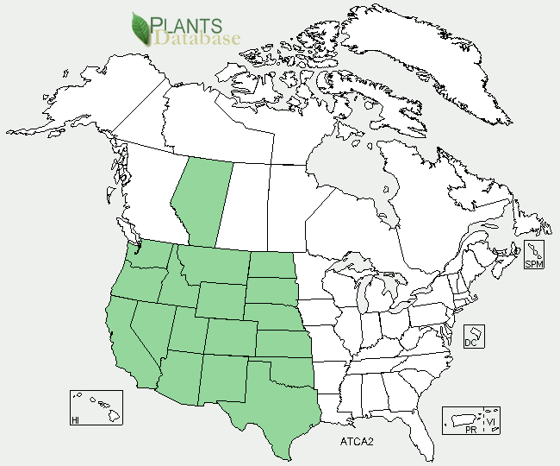

Fourwing saltbush distribution from USDA-NRCS PLANTS Database.

Fourwing saltbush is adapted to most soils but is best suited to deep, well drained; loamy to sandy to gravely soils. It is very tolerant of saline and somewhat tolerant of sodic soil conditions. Fourwing saltbush also has high tolerance to boron. It does not tolerate high water tables or late winter inundation. It is extremely drought tolerant and has fair shade tolerance. It is not especially tolerant of fire, but may resprout to some degree if fire intensity is not too severe. Its ability to tolerate extreme cold conditions varies with ecotype. Fourwing saltbush occurs most commonly in salt-desert scrub communities in the desert areas of western North America in areas that receive 200 to 360 mm (8 to 14 in) of annual precipitation. It can be found from sea level in Texas to over 2,400 m (8,000 ft) in Wyoming.

### Establishment

An adapted cultivar/release or local seed source should be used to ensure the ecotype is compatible with the site. On moist fine soils, seed should be planted ½ inch deep. On sandy to coarse gravely soils, plant up to ¾ inch deep. Seeding rates of 0.25 to 0.50 lbs PLS (pure live seed) per acre is recommended for rangeland seeding mixtures (3 to 7 percent of the seeding mix). De-winged seed is preferred as seed flow through a drill and planting depth can be controlled more easily. There is no prechilling requirement for fourwing saltbush seed. Seedling vigor is generally outstanding and depending on ecotype.

### Management

Animals should be removed from new plantings for at least two growing seasons or until plants are well established and reproducing. Irrigation may be needed for transplants on harsh sites to ensure establishment. Young seedings are not tolerant of excessive insect, rabbit, and rodent damage and plantings may require control measures if severe damage appears.

In established plantings, deferred rotation grazing is recommended for fourwing saltbush. Plants can be grazed from late spring through winter, but plant health is best maintained if used primarily as a winter browse. Fourwing saltbush tolerates browsing very well, but will decrease in abundance under continuous close browsing (>40-50% of annual growth). Damaged plants generally recover if rested, but production will be reduced until fully recovered. Fourwing saltbush can cause bloat and scours in spring if it is the primary dietary source.

### Environmental Concerns

Fourwing saltbush is native to western North America It is not considered "weedy", but can spread into adjoining vegetative communities under ideal conditions.

### Cultivars, Improved, and Selected Materials (and area of origin)

'Marana' fourwing saltbush was released in 1979 by the NRCS Lockeford Plant Materials Center. It originated from plants near El Cajon, California and was selected for ease of establishment and drought resistance. It is best adapted to areas in the southwest including southern New Mexico, southern Arizona and southern to central California.

‘Rincon’ fourwing saltbush was selected by the Forest Service, Shrub Science Laboratory in Provo, Utah and released with the NRCS Plant Materials Center, Meeker, Colorado in 1983. The original seed was collected near Canjilon, New Mexico at 7,800 feet elevation. Rincon is an erect, leafy form with early green-up. It is best adapted to the southwest areas of Utah, Nevada, western Colorado, New Mexico and central Arizona.

‘Santa Rita’ fourwing saltbush was cooperatively released by the NRCS Plant Materials Center, Tucson, Arizona, ARS, and University of Arizona in 1987. It is best adapted to areas in the southwest including southern New Mexico, southern Arizona and southern to central California.

‘Wytana’ fourwing saltbush was released by the NRCS Plant Materials Center, Bridger, Montana in 1976. Wytana is a natural cross between fourwing saltbush and Gardner saltbush. It is a short, herbaceous type that is best adapted to the Great Plains and mountain foothills of Idaho, Montana and Wyoming.

**Prepared By**:

Derek Tilley, USDA NRCS Plant Materials Center, Aberdeen, ID

Loren St. John, USDA NRCS Plant Materials Center, Aberdeen, ID

### Citation

Tilley, D. and L. St. John, L., and D. Tilley. 2012. Plant Fact Sheet for fourwing saltbush (*Atriplex canescens*). USDA-Natural Resources Conservation Service, Aberdeen, ID Plant Materials Center. 83210-0296.

Published January, 2013

Edited: 18dec2012djt; 10Jan2013jab

For more information about this and other plants, please contact your local NRCS field office or Conservation District at <http://www.nrcs.usda.gov/> and visit the PLANTS Web site at <http://plants.usda.gov/> or the Plant Materials Program Web site <http://plant-materials.nrcs.usda.gov>.

PLANTS is not responsible for the content or availability of other Web sites.

**USDA IS AN EQUAL OPPORTUNITY PROVIDER AND EMPLOYER**